WEEK-2 PROJECT REPORT

TELECOM DATA GOVERNANCE & SECURITY

Internship Domain:
Telecom Data Governance & Security
Duration:
6 Weeks
Submitted by:
DUDATI RASIKA
Week:
Week2 - Data Quality and Compliance Framework Development

INTRODUCTION
Introduction
Telecom companies generate large amounts of data through customer registration, billing, network services, subscriptions, and customer support.
Maintaining good-quality data is important because incorrect or incomplete data can cause billing errors, duplicate records, incorrect reports, and poor customer service.
Compliance is also important because telecom organizations need to follow applicable legal, regulatory, privacy, and security requirements.
Therefore, this week's work focuses on developing a Data Quality and Compliance Framework for a telecom organization.
Week 2 Objective
The main objective is to develop a framework that helps an organization:
- Maintain accurate data
- Reduce missing and duplicate records
- Validate data
- Improve consistency
- Monitor compliance
- Identify risks
- Measure performance using KPIs

SCOPE AND DATA TYPES
Scope of the Framework
The framework covers:
- Data capture
- Data validation
- Data cleansing
- Data standardization
- Data integration
- Compliance monitoring
- Risk management
- KPI measurement
- Reporting
Major Telecom Data Types
Data Type | Examples
Customer Data | Name, Customer ID, Mobile Number
Subscription Data | Plan, Activation Date
Billing Data | Invoice, Payment, Charges
Network Data | Usage, Service Status
Support Data | Complaints, Service Requests

PAGE 5 — DATA QUALITY CHALLENGES
5. Common Data Quality Problems
1. Missing Data
Required information may not be entered.
2. Duplicate Data
The same customer may be recorded more than once.
3. Incorrect Data
Information may contain manual or system errors.
4. Invalid Data
Values may not follow the required format.
5. Inconsistent Data
Different systems may contain different values for the same customer.
6. Outdated Data
Old information may remain in the system after changes.
Effects
Poor data quality can result in:
- Billing problems
- Incorrect reports
- Poor customer service
- Increased manual work
- Compliance problems
- Poor decision-making

Data Type | Examples
Customer Data | Name, Customer ID, Mobile Number
Subscription Data | Plan, Activation Date
Billing Data | Invoice, Payment, Charges
Network Data | Usage, Service Status
Support Data | Complaints, Service Requests

DATA QUALITY CHALLENGES
Common Data Quality Problems
1. Missing Data
Required information may not be entered.
2. Duplicate Data
The same customer may be recorded more than once.
3. Incorrect Data
Information may contain manual or system errors.
4. Invalid Data
Values may not follow the required format.
5. Inconsistent Data
Different systems may contain different values for the same customer.

6. Outdated Data
Old information may remain in the system after changes.
Effects
Poor data quality can result in:
- Billing problems
- Incorrect reports
- Poor customer service
- Increased manual work
- Compliance problems
- Poor decision-making
Data Quality Dimensions
Dimension | Meaning
Accuracy | Data is correct
Completeness | Required information is available
Consistency | Data agrees across systems
Validity | Data follows defined rules
Uniqueness | Duplicate records are minimized
Timeliness | Data is sufficiently current

Data Quality Diagram
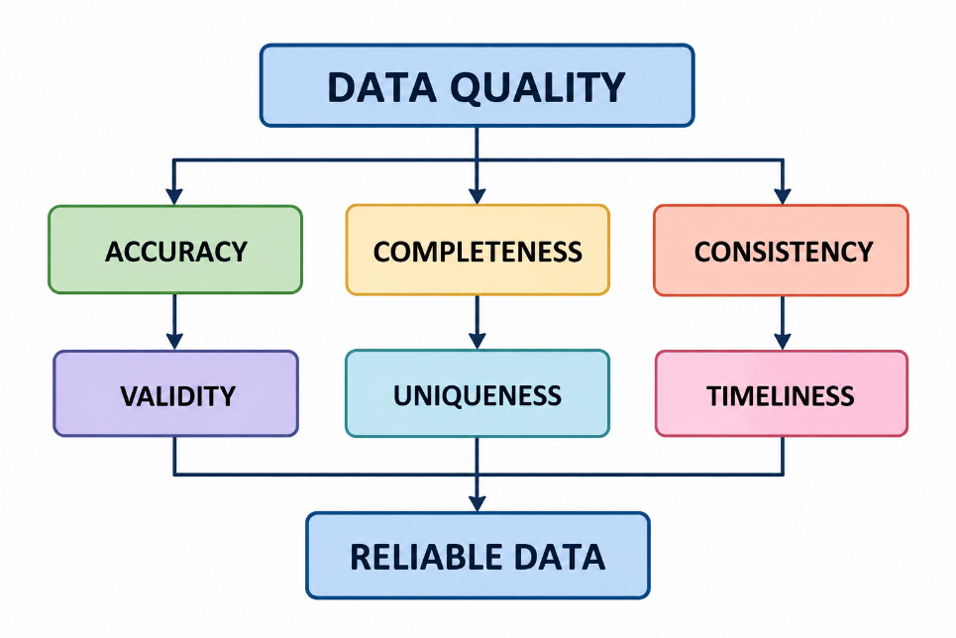

DATA CAPTURE AND VALIDATION
Data Capture
Data may be collected through:
- Websites
- Mobile applications
- Customer-care systems
- Billing systems
- Registration forms
- Network systems
Data quality should be checked when information is entered.
Data Capture Process
DATA SOURCE
↓
DATA ENTRY
↓
MANDATORY CHECK
↓
FORMAT CHECK
↓
VALIDATION
↓
ACCEPT / FLAG

Data Validation
Example validation rules:
Field | Validation
Customer ID | Correct format
Mobile Number | Valid format
Email | Valid structure
Plan | Approved plan
Date | Valid date

DATA CLEANSING
Data Cleansing
Data cleansing is the process of identifying and correcting data-quality problems.
The main steps are:
- Identify errors
- Classify errors
- Correct the information
- Validate corrected data
- Record important changes
Common Cleansing Activities
- Removing unnecessary duplicates
- Correcting invalid values
- Filling missing information where appropriate
- Standardizing formats
- Removing incorrect records according to approved procedures

Data Standardization
Standardization ensures that similar information uses a common format.
Example:
Before:
5g
5-G
Fifth Generation
After:
5G
Standardization improves reporting and data integration.

DATA INTEGRATION
Data Integration and Consistency
Telecom organizations use multiple systems such as:
- CRM
- Billing
- Network
- Customer Support
The information between these systems should remain consistent.
Example:
System | Plan
CRM | 5G
Billing | 4G

Integration Process
CRM
↓
BILLING → CONSISTENCY CHECK
↑
SUPPORT
↓
VERIFIED DATA

COMPLIANCE REQUIREMENTS
Regulatory and Compliance Framework
Telecom organizations need to identify the legal and regulatory requirements applicable to their activities.
For an Indian telecom context, relevant official sources include:
- Digital Personal Data Protection Act, 2023
- Telecommunications Act, 2023
- Telecommunications (Telecom Cyber Security) Rules, 2024
- Applicable TRAI requirements
- Relevant information-security standards
TRAI's official Acts & Policies resources list the Digital Personal Data Protection Act, 2023 and Telecommunications Act, 2023. The Department of Telecommunications provides information on the Telecommunications (Telecom Cyber Security) Rules, 2024.
ISO/IEC 27001 can also provide a structured information-security management approach. It is a standard rather than telecom legislation.

Compliance Mapping
Requirement | Area | Proposed Control
DPDP Act | Personal Data | Privacy Controls
Telecommunications Act | Telecom Operations | Applicable Controls
Cyber Security Rules | Cybersecurity | Security Procedures
ISO/IEC 27001 | Information Security | ISMS Controls

COMPLIANCE MONITORING
Compliance Monitoring
Compliance should be monitored regularly rather than checked only once.
Monitoring Process
IDENTIFY REQUIREMENT
↓
DEFINE CONTROL
↓
ASSIGN OWNER
↓
MONITOR
↓
COLLECT EVIDENCE
↓
IDENTIFY GAP
↓
CORRECT
↓
REPORT

Monitoring Activities
The organization may monitor:
- Access controls
- Data-quality controls
- Security controls
- Policies
- Audit records
- Corrective actions
- Compliance requirements
Compliance status can be classified as:
Status | Meaning
Compliant | Requirement is being met
Partially Compliant | Some gaps exist
Non-Compliant | Requirement is not adequately met
Under Review | Assessment is ongoing

POLICIES AND RESPONSIBILITIES
Required Policies
Data Quality Policy
Defines data-quality standards, ownership, monitoring, and issue management.
Data Validation Procedure
Defines validation rules and handling of invalid information.
Data Cleansing Procedure
Defines how data-quality problems are corrected.
Compliance Monitoring Procedure
Defines monitoring, evidence collection, reporting, and corrective actions.

Roles and Responsibilities
Role | Responsibility
Data Owner | Responsible for defined data
Data Steward | Monitors data quality
IT Team | Supports technical systems
Security Team | Supports security controls
Compliance Team | Reviews compliance
Management | Reviews risks and performance

RISK MANAGEMENT
Risk Management
Poor data quality and compliance failures can create operational, financial, security, and reputational risks.
Risk Management Process
IDENTIFY
↓
ASSESS
↓
PRIORITIZE
↓
MITIGATE
↓
MONITOR
↓
REVIEW

Risk Register
Risk | Impact | Mitigation
Missing Data | High | Mandatory validation
Duplicate Records | Medium | Duplicate detection
Incorrect Data | High | Validation rules
Data Inconsistency | High | Reconciliation
Compliance Gap | High | Regular monitoring
Unauthorized Access | High | Access controls
Delayed Correction | Medium | Issue tracking

KPIs AND CONTINUOUS MONITORING
Key Performance Indicators
KPIs help measure the effectiveness of the framework.
Accuracy Rate
Correct Records / Total Records × 100
Completeness Rate
Complete Records / Total Records × 100
Duplicate Rate
Duplicate Records / Total Records × 100
Compliance Rate
Compliant Controls / Controls Assessed × 100
KPI Table
KPI | Purpose
Accuracy Rate | Measures correctness
Completeness Rate | Measures missing data
Duplicate Rate | Measures duplication
Validity Rate | Measures valid data
Consistency Rate | Measures consistency
Compliance Rate | Measures compliance

Continuous Improvement
MONITOR
↓
DETECT
↓
CORRECT
↓
VERIFY
↓
REPORT
↓
IMPROVE

IMPLEMENTATION AND CONCLUSION
Implementation Plan
Phase | Activity
1 | Identify important data
2 | Assess data quality
3 | Define validation rules
4 | Establish cleansing process
5 | Identify compliance requirements
6 | Define controls
7 | Establish KPIs
8 | Monitor and improve

Expected Outcomes
The proposed framework is expected to help an organization:
- Improve data accuracy
- Reduce duplicate records
- Reduce missing information
- Improve consistency
- Improve compliance visibility
- Identify risks
- Track performance
Limitations
This Week 2 activity focuses on framework development and planning. It does not claim that a complete production telecom system has been deployed.
Actual implementation would require organization-specific data, validation rules, systems, regulatory assessment, testing, and approvals.
Conclusion
Week 2 focused on developing a Data Quality and Compliance Framework for the telecom sector.
The framework covers data capture, validation, cleansing, standardization, integration, compliance monitoring, risk management, KPIs, and continuous improvement.
The proposed framework provides a practical foundation that can be adapted by a telecom organization to improve data reliability and support compliance management.
References
- Telecom Regulatory Authority of India (TRAI) – Acts & Policies.
- Department of Telecommunications – Telecom Cyber Security.
- ISO – ISO/IEC 27001:2022 Information Security Management Systems.
TRAI – Privacy, Security and Ownership of Data in the Telecom Sector.

