1. In the below elements which of them are values or an expression? eg:- values can be integer or string and expressions will be mathematical operators.

* : Expression

'hello' : String

-87.8 : Float

- : Expression

/ : Expression

* : Expression

6 : Integer

2. What is the difference between string and variable?

|  |  |
| --- | --- |
| String | Variable |
| String is sequence of one or more characters that can be constant or variable. | Variables are character that can be used to store data. |
| Eg: my_string = “Hello”  Print(my_string) | Eg: a = 10  Print(a) |

3. Describe three different data types.  
 Data types are used to store multiple items in single variable. 3 different types or data types are:

String: It is a series of character. you can use single or double quotes.

Eg:

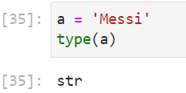

List: It is created by placing elements inside square brackets separated by commas.

Eg:

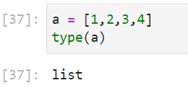

Tuple: It may include zero or more elements. The elements are stored in round brackets separated by commas.

Eg:

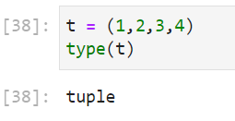

4. What is an expression made up of? What do all expressions do?

An expression is a combination of operators and operands that is used to produce some value.  
+ addition

- subtraction

* multiplication

/ division

Eg:

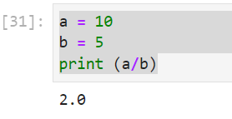

5. This assignment statements, like spam = 10. What is the difference between an expression and a statement?

|  |  |
| --- | --- |
| Expression | Statement |
| An expression is a combination of operators and operands that is used to produce some value | Statement is single line or set of Instruction that a Python interpreter can execute |
| Eg: | Eg: |

6. After running the following code, what does the variable bacon contain?

bacon = 22

bacon + 1

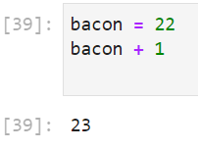

7. What should the values of the following two terms be?

'spam' + 'spamspam'

'spam' * 3

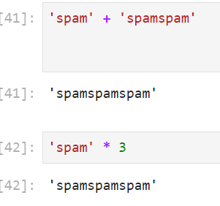

8. Why is eggs a valid variable name while 100 is invalid?

A variable name cannot begin with a number.

9. What three functions can be used to get the integer, floating-point number, or string version of a value?

str() int() float()

10. Why does this expression cause an error? How can you fix it?

'I have eaten ' + 99 + ' burritos.'

Are first value is string the + symbol will work as concatenate, but as 2nd value is an integer python will thrown an error, once 2nd value is enclosed by quotes it will treat 99 as a string and then provide ‘ I have eaten 99 burritos.’ As output.

