1. What does RGBA stand for?

🡪 Red-Green-Blue-Alpha

2. From the Pillow module, how do you get the RGBA value of any images?

🡪 Pillow module has ImageColor.getcolor() function , wher you pass colour and RGBA   
eg: ImageColor.getcolor(‘black’,’RBGA’)

3. What is a box tuple, and how does it work?

🡪 The box.tuple submodule provides read-only access for the tuple userdata type.  
you can use box.tuple.new() to create a tuple, box.tuple.bsize() to get count of bytes in tuple

4. Use your image and load in notebook then, How can you find out the width and height of an Image object?

🡪 from PIL import Image

filepath = "bg.JPG"

img = Image.open(filepath)

width = img.width

height = img.height

print("The height of the image is: ", height)

print("The width of the image is: ", width)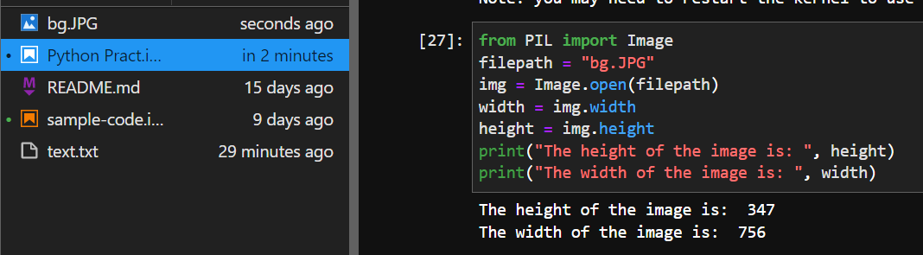

5. What method would you call to get Image object for a 100×100 image, excluding the lower-left quarter of it?

🡪 from PIL import Image

img = Image.open('Pic.jpg')

new_img = img.crop((0,50,50,50))

6. After making changes to an Image object, how could you save it as an image file?

🡪 Image.save()

7. What module contains Pillow’s shape-drawing code?

🡪Pillows ImageDraw module contains Shape drawing methods

8. Image objects do not have drawing methods. What kind of object does? How do you get this kind of object?

🡪 ImageDraw objects have shape-drawing methods such as point(), line(), or rectangle().They are returned by passing the Image object to the ImageDraw.Draw() function.