1.How many seconds are in an hour? Use the interactive interpreter as a calculator and multiply the number of seconds in a minute (60) by the number of minutes in an hour (also 60).

sol. 60   
🡪 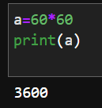

2. Assign the result from the previous task (seconds in an hour) to a variable called seconds_per_hour.  
🡪 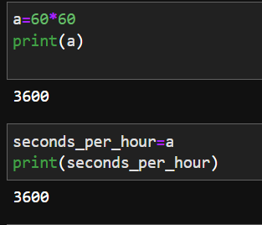

3. How many seconds do you think there are in a day? Make use of the variables seconds per hour and minutes per hour.  
🡪 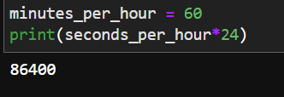

4. Calculate seconds per day again, but this time save the result in a variable called seconds_per_day

🡪 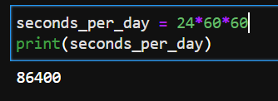

5. Divide seconds_per_day by seconds_per_hour. Use floating-point (/) division.

🡪 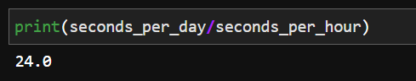

6. Divide seconds_per_day by seconds_per_hour, using integer (//) division. Did this number agree with the floating-point value from the previous question, aside from the final .0?

🡪 yes the number agree with the floating point value from previous question

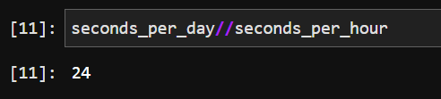

7. Write a generator, genPrimes, that returns the sequence of prime numbers on successive calls to its next() method: 2, 3, 5, 7, 11, ...

🡪 