1. Add the current date to the text file today.txt as a string.  
🡪 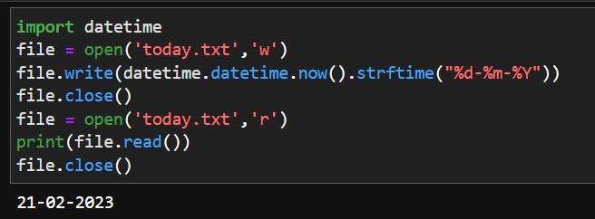

2. Read the text file today.txt into the string today_string  
🡪 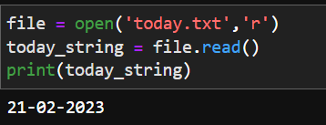

3. Parse the date from today_string.

🡪 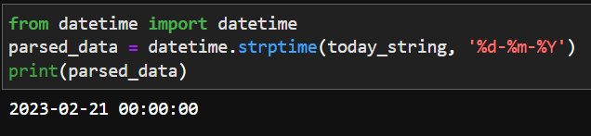

4. List the files in your current directory

🡪 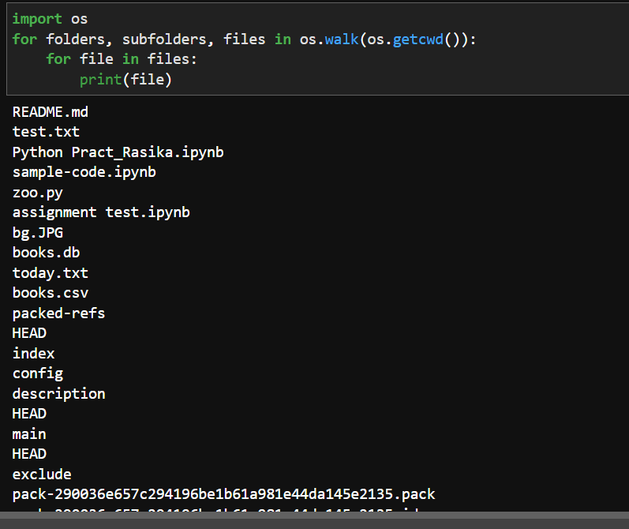

README.md

test.txt

Python Pract_Rasika.ipynb

sample-code.ipynb

zoo.py

assignment test.ipynb

bg.JPG

books.db

today.txt

books.csv

packed-refs

HEAD

index

config

description

HEAD

main

HEAD

exclude

pack-290036e657c294196be1b61a981e44da145e2135.pack

pack-290036e657c294196be1b61a981e44da145e2135.idx

pre-push.sample

prepare-commit-msg.sample

applypatch-msg.sample

pre-applypatch.sample

commit-msg.sample

pre-rebase.sample

pre-receive.sample

update.sample

fsmonitor-watchman.sample

pre-merge-commit.sample

pre-commit.sample

push-to-checkout.sample

post-update.sample

main

HEAD

zoo.cpython-310.pyc

assignment test-checkpoint.ipynb

books-checkpoint.csv

sample-code-checkpoint.ipynb

today-checkpoint.txt

zoo-checkpoint.py

Python Pract_Rasika-checkpoint.ipynb

test-checkpoint.txt

5. Create a list of all of the files in your parent directory (minimum five files should be available).

🡪 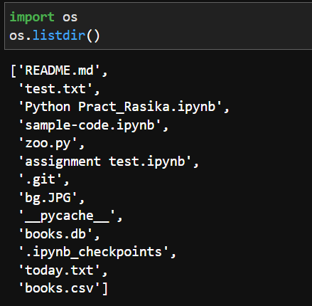

6. Use multiprocessing to create three separate processes. Make each one wait a random number of seconds between one and five, print the current time, and then exit.

🡪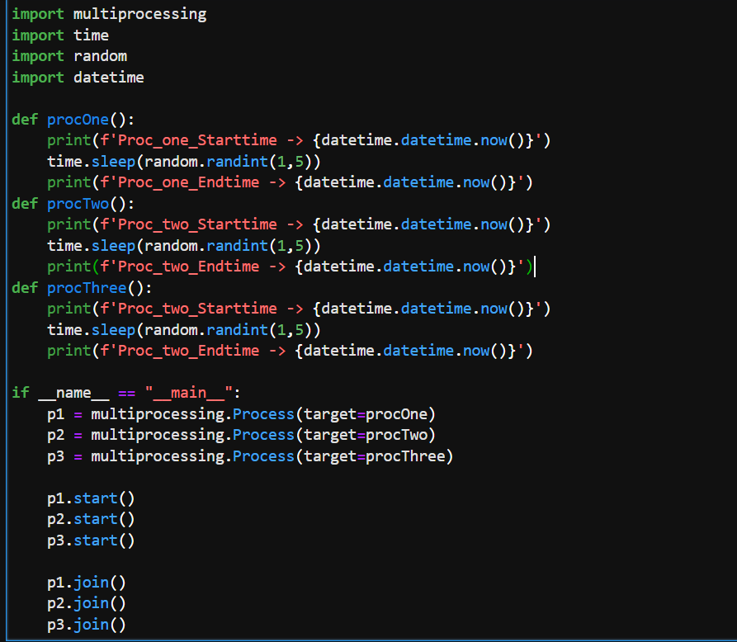

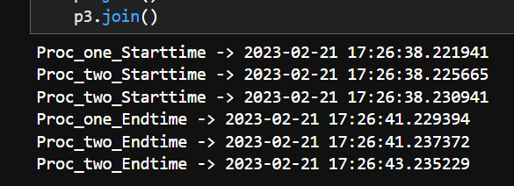

7. Create a date object of your day of birth.

🡪 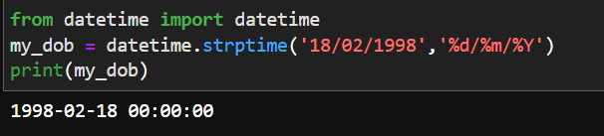

8. What day of the week was your day of birth?

🡪 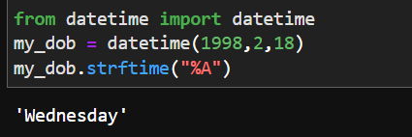

9. When will you be (or when were you) 10,000 days old?

