#### What is the result of the code, and explain?

>>> X = 'iNeuron'  
>>> def func():  
print(X)  
>>> func()

🡪 The Result of this code is iNeuron, it's because the function initially looks for the variable X in its local scope,But since there is no local variable X, its returns the value of global variable x ie iNeuron  
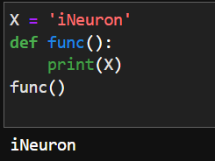

#### What is the result of the code, and explain?

>>> X = 'iNeuron'  
>>> def func():  
X = 'NI!'  
>>> func()  
>>> print(X)

🡪The Result of this code is NI!, because the function initially looks for the variable X in its local scope if X is not available then it checks for variable X in the global scope, Since here the X is present in the local scope. it prints the value NI!  
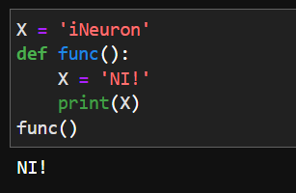

1. What does this code print, and why?

>>> X = 'iNeuron'

>>> def func():

X = 'NI'

print(X)

>>> func()

>>> print(X)

🡪The output of the code is NI and iNeuron. X=NI is in the local scope of the function func() hence the function prints the x value as NI. X = 'iNeuron' is in the global scope. hence print(X) prints output as iNeuron

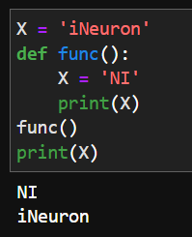

1. What output does this code produce? Why?

>>> X = 'iNeuron'

>>> def func():

global X

X = 'NI'

>>> func()

>>> print(X)

🡪The output of the code is NI. the global keyword allows a variable to be accessible in the current scope. since we are using global keyword inside the function func it directly access the variable in X in global scope. and changes its value to NI. hence the output of the code is NI  
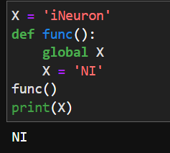

1. What about this code—what’s the output, and why?

>>> X = 'iNeuron'  
>>> def func():  
X = 'NI'  
def nested():  
print(X)  
nested()  
>>> func()  
>>> X

🡪The output of the code is NI. the reason for this output is if a function wants to access a variable, if it’s not available in its local scope. it looks for the variable in its global scope. similarly, here also function nested looks for variable X in its global scope. hence the output of the code is NI

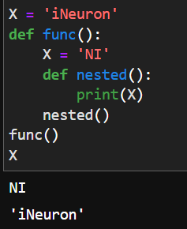

1. How about this code: what is its output in Python 3, and explain?

>>> def func():  
X = 'NI'  
def nested():  
nonlocal X  
X = 'Spam'  
nested()  
print(X)  
>>> func()

🡪 The output of the code is Spam. nonlocal keyword in python is used to declare a variable as not local. Hence, the statement X = "Spam" is modified in the global scope. hence the output of print(X) statement is Spam

