1) . What is the difference between enclosing a list comprehension in square brackets and parentheses?

🡪 Enclosing a list comprehension in square brackets returns a list, in parentheses returns a generator object

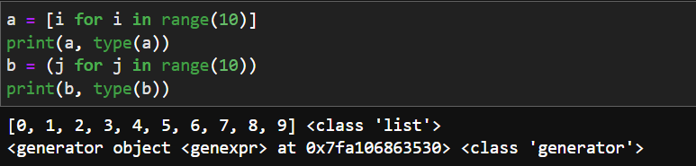

2) What is the relationship between generators and iterators?

🡪**Iterator** is an object used to iterate over iterable objects such as lists, tuples, dictionaries, and sets. iter() keyword is used to create an iterator containing an iterable object.next() keyword is used to call the next element in the iterable object.

**Generators** are an another way of creating iterators in a simple way where it uses the keyword yield statement instead of return statement in a defined function.Generators are implemented using a function

3) What are the signs that a function is a generator function?

🡪A generator function uses a yield statement instead of a return statement. A generator function will always return a iterable object called generator.

4) What is the purpose of a yield statement?

🡪The yield statement suspends function’s execution and sends a value back to the caller, but retains enough state to enable function to resume where it is left off. When resumed, the function continues execution immediately after the last yield run.

5) What is the relationship between map calls and list comprehensions? Make a comparison and contrast between the two.

🡪

* List comprehension is more concise and easier to read as compared to map.
* List comprehension allows filtering. In map, we have no such facility.
* List comprehension are used when a list of results is required as final output.but map only returns a map object. it needs to be explicitly coverted to desired datatype.
* List comprehension is faster than map when we need to evaluate expressions that are too long or complicated to express
* Map is faster in case of calling an already defined function on a set of values.