1. What exactly is []?

🡪 it is used to define list literals, it allows you to declare list and its content in the program.

2. In a list of values stored in a variable called spam, how would you assign the value 'hello' as the third value? (Assume [2, 4, 6, 8, 10] are in spam.)

🡪 spam[2] = ‘hello’

Let's pretend the spam includes the list ['a', 'b', 'c', 'd'] for the next three queries.

3. What is the value of spam[int(int('3' * 2) / 11)]?

🡪 output will be: d

4. What is the value of spam[-1]?

🡪 output will be: d

5. What is the value of spam[:2]?

🡪 output will be: [‘a’ , ‘b’]

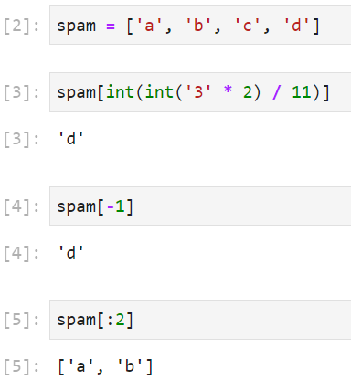

Let's pretend bacon has the list [3.14, 'cat,' 11, 'cat,' True] for the next three questions.

6. What is the value of bacon.index('cat')?

🡪 output will be: 1

7. How does bacon.append(99) change the look of the list value in bacon?

🡪 Output will be : [3.14, 'cat', 11, 'cat', True, 99]

8. How does bacon.remove('cat') change the look of the list in bacon?

🡪 Output will be : [3.14, 11, 'cat', True, 99]

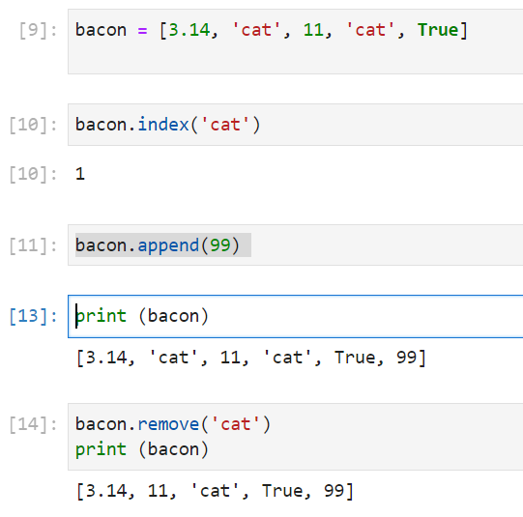

9. What are the list concatenation and list replication operators?

🡪 Concatenation: +

Replication: *

10. What is difference between the list methods append() and insert()?

🡪 append() will add value to end of list.

Insert() will add the value anywhere in list.

11. What are the two methods for removing items from a list?

🡪 del statement and remove() are two methods to remove items from list

12. Describe how list values and string values are identical.

🡪 Both lists and strings can be passed to len()

they have indexes and slices

they can be used in for loops

they can be concatenated or replicated

they can be used with the in and not in operators

13. What's the difference between tuples and lists?

|  |  |
| --- | --- |
| List | Tuple |
| Lists are mutable | Tuples are immutable |
| they can have values added, removed, or changed | they cannot be changed at all |
| tuples are written using parentheses () | lists use the square brackets [] |

14. How do you type a tuple value that only contains the integer 42?

🡪 (42,)

15. How do you get a list value's tuple form? How do you get a tuple value's list form?

🡪 tuple()

list()

16. Variables that "contain" list values are not necessarily lists themselves. Instead, what do they contain?

🡪 reference for list values.

17. How do you distinguish between copy.copy() and copy.deepcopy()?

|  |  |
| --- | --- |
| copy.copy() | copy.deepcopy()? |
| will do a shallow copy of a list | will do a deep copy of a list it will duplicate any lists inside the list |