1. Write a Python program to print "Hello Python"?  
   🡪 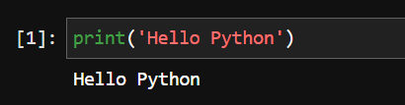
2. Write a Python program to do arithmetical operations addition and division.?

🡪 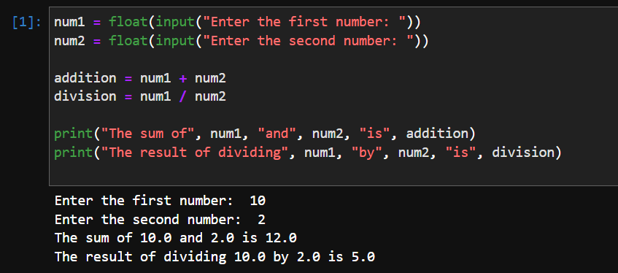

1. Write a Python program to find the area of a triangle?

🡪 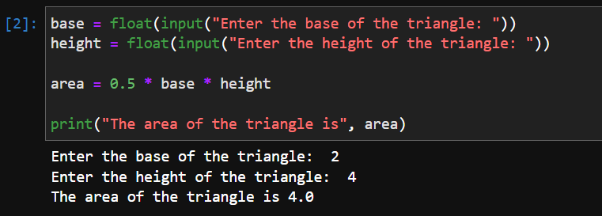

1. Write a Python program to swap two variables?

🡪 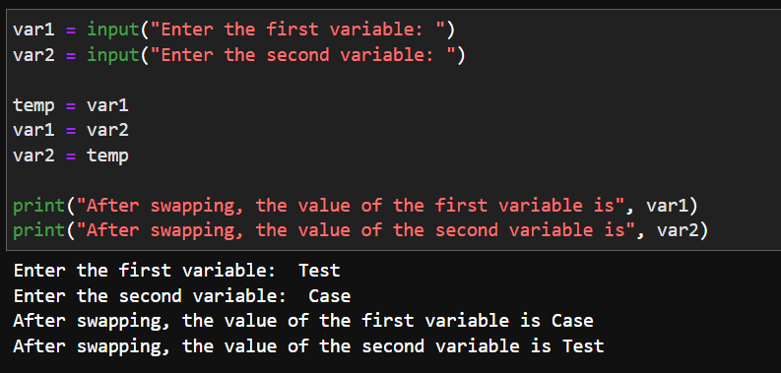

1. Write a Python program to generate a random number?

🡪 