1. Write a Python program to Extract Unique values dictionary values?

🡪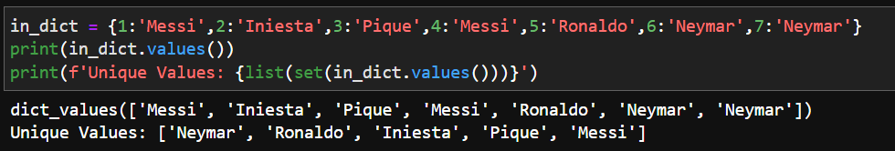

1. Write a Python program to find the sum of all items in a dictionary?

🡪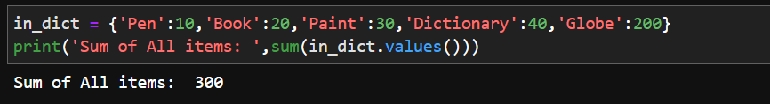

1. Write a Python program to Merging two Dictionaries?

🡪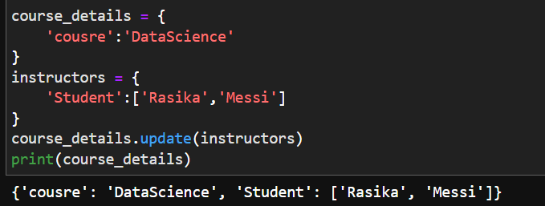

1. Write a Python program to convert key-values list to flat dictionary?

🡪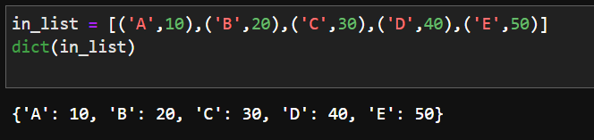

1. Write a Python program to insertion at the beginning in OrderedDict?

🡪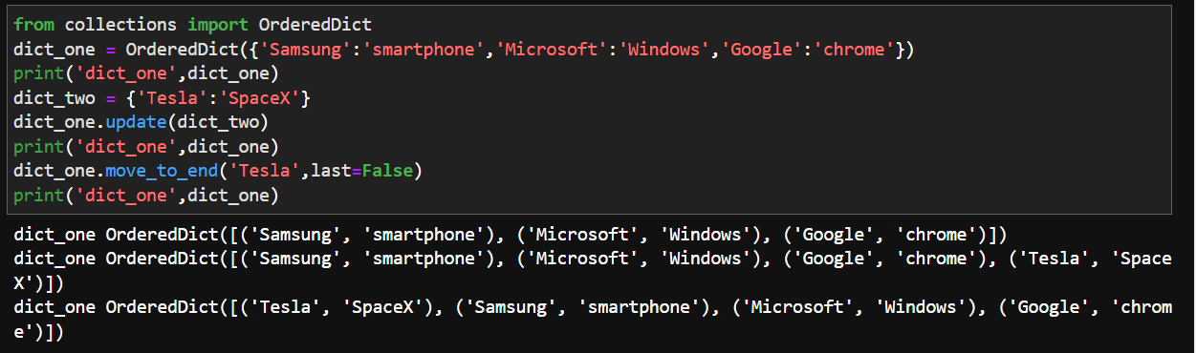

1. Write a Python program to check order of character in string using OrderedDict()?

🡪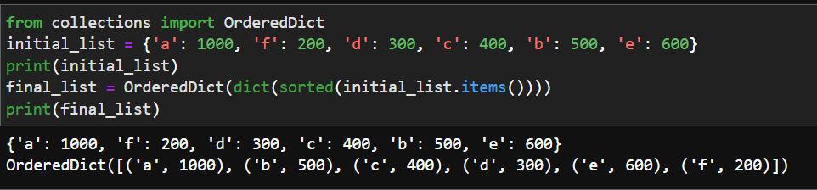

1. Write a Python program to sort Python Dictionaries by Key or Value?

🡪