|  |
| --- |
| Question 1: |
|  |

Define a class with a generator which can iterate the numbers, which are divisible by 7, between a given range 0 and n.

🡪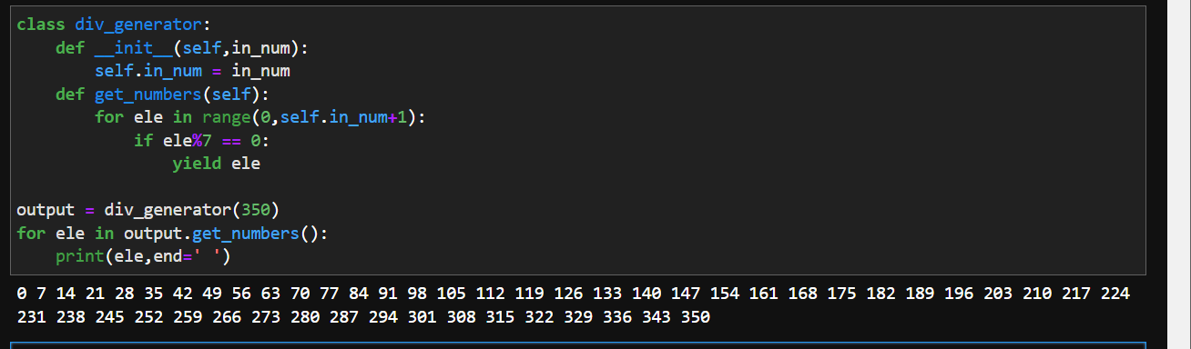

Question 2:

|  |
| --- |
| Write a program to compute the frequency of the words from the input. The output should output after sorting the key alphanumerically. |
|  |

|  |
| --- |
| Suppose the following input is supplied to the program: |
|  |

|  |
| --- |
| New to Python or choosing between Python 2 and Python 3? Read Python 2 or Python 3. |
|  |

|  |
| --- |
| Then, the output should be: |
|  |

|  |
| --- |
| 2:2 |
|  |

|  |
| --- |
| 3.:1 |
|  |

|  |
| --- |
| 3?:1 |
|  |

|  |
| --- |
| New:1 |
|  |

|  |
| --- |
| Python:5 |
|  |

|  |
| --- |
| Read:1 |
|  |

|  |
| --- |
| and:1 |
|  |

|  |
| --- |
| between:1 |
|  |

|  |
| --- |
| choosing:1 |
|  |

|  |
| --- |
| or:2 |
|  |

to:1

🡪 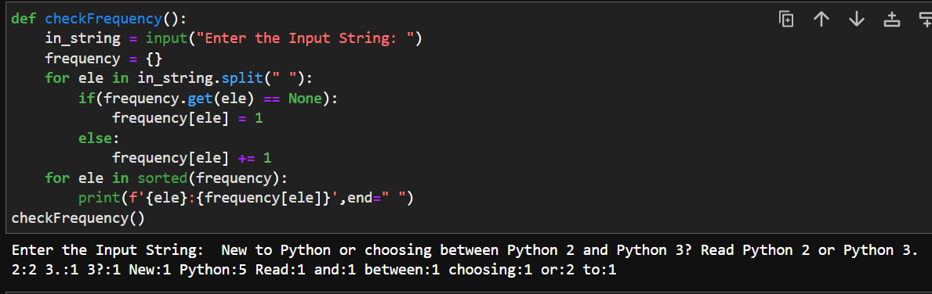

|  |
| --- |
| Question 3: |
|  |

|  |
| --- |
|  |
|  |

Define a class Person and its two child classes: Male and Female. All classes have a method "getGender" which can print "Male" for Male class and "Female" for Female class.

🡪 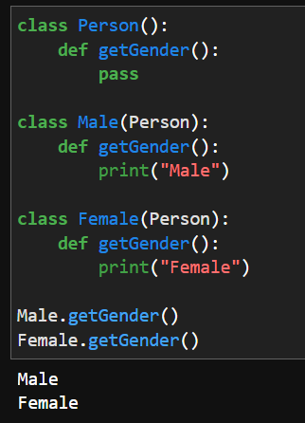

Question 4:

Please write a program to generate all sentences where subject is in ["I", "You"] and verb is in ["Play", "Love"] and the object is in ["Hockey","Football"].

🡪 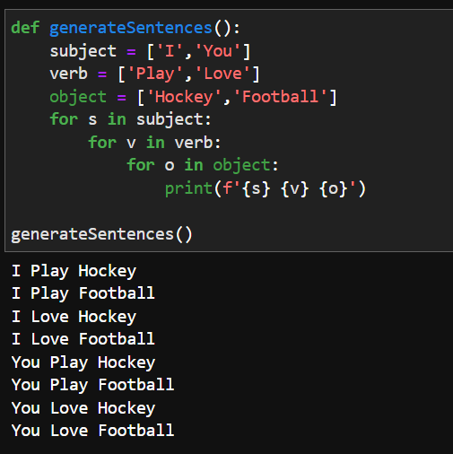

Question 5:

Please write a program to compress and decompress the string "hello world!hello world!hello world!hello world!".

🡪 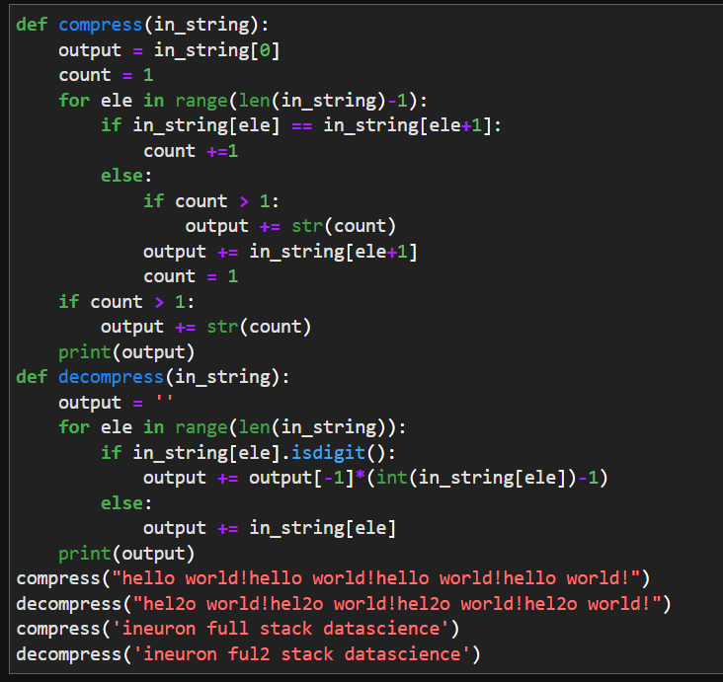

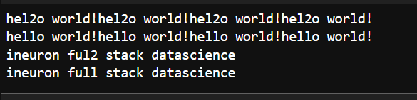

Question 6:

Please write a binary search function which searches an item in a sorted list. The function should return the index of element to be searched in the list.

🡪 