Question 1:

Please write a program using generator to print the numbers which can be divisible by 5 and 7 between 0 and n in comma separated form while n is input by console.

Example:  
If the following n is given as input to the program:

100

Then, the output of the program should be:

0,35,70

🡪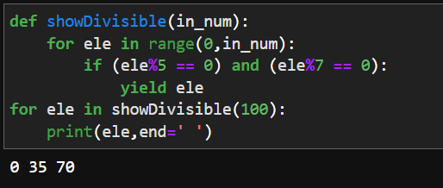

Question 2:

Please write a program using generator to print the even numbers between 0 and n in comma separated form while n is input by console.

Example:  
If the following n is given as input to the program:

10

Then, the output of the program should be:

0,2,4,6,8,10

🡪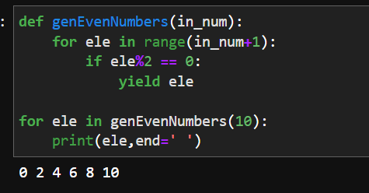

Question 3:

The Fibonacci Sequence is computed based on the following formula:

f(n)=0 if n=0  
f(n)=1 if n=1  
f(n)=f(n-1)+f(n-2) if n>1

Please write a program using list comprehension to print the Fibonacci Sequence in comma separated form with a given n input by console.

Example:  
If the following n is given as input to the program:

7

Then, the output of the program should be:

0,1,1,2,3,5,8,13

🡪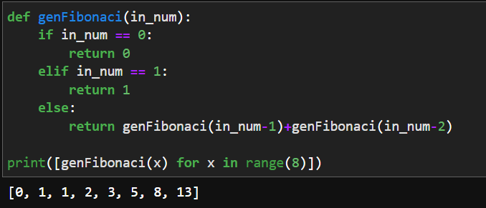

Question 4:

Assuming that we have some email addresses in the "[username@companyname.com](mailto:username@companyname.com)" format, please write program to print the user name of a given email address. Both user names and company names are composed of letters only.

Example:  
If the following email address is given as input to the program:

[john@google.com](mailto:john@google.com)

Then, the output of the program should be:

john

🡪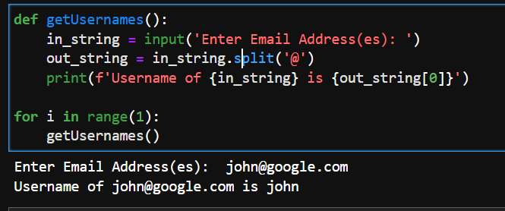

Question 5:

Define a class named Shape and its subclass Square. The Square class has an init function which takes a length as argument. Both classes have a area function which can print the area of the shape where Shape's area is 0 by default.

🡪