Question1. Create a function that takes three arguments a, b, c and returns the sum of the numbers that are evenly divided by c from the range a, b inclusive.

**Examples**

evenly_divisible(1, 10, 20) ➞ 0

# No number between 1 and 10 can be evenly divided by 20.

evenly_divisible(1, 10, 2) ➞ 30

# 2 + 4 + 6 + 8 + 10 = 30

evenly_divisible(1, 10, 3) ➞ 18

# 3 + 6 + 9 = 18

🡪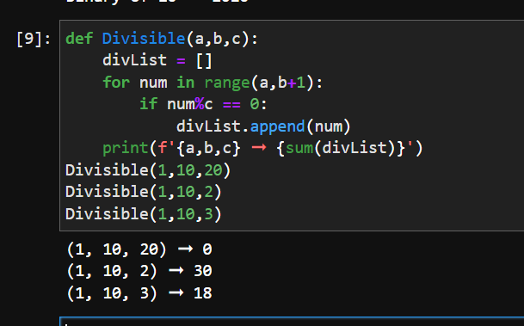

Question2. Create a function that returns True if a given inequality expression is correct and False otherwise.

### Examples

correct_signs("3 < 7 < 11") ➞ True

correct_signs("13 > 44 > 33 > 1") ➞ False

correct_signs("1 < 2 < 6 < 9 > 3") ➞ True

🡪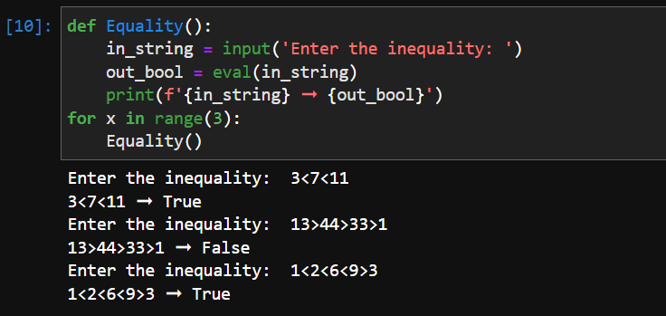

Question3. Create a function that replaces all the vowels in a string with a specified character.

### Examples

replace_vowels("the aardvark", "#") ➞ "th# ##rdv#rk"

replace_vowels("minnie mouse", "?") ➞ "m?nn?? m??s?"

replace_vowels("shakespeare", "*") ➞ "sh*k*sp**r*"

🡪 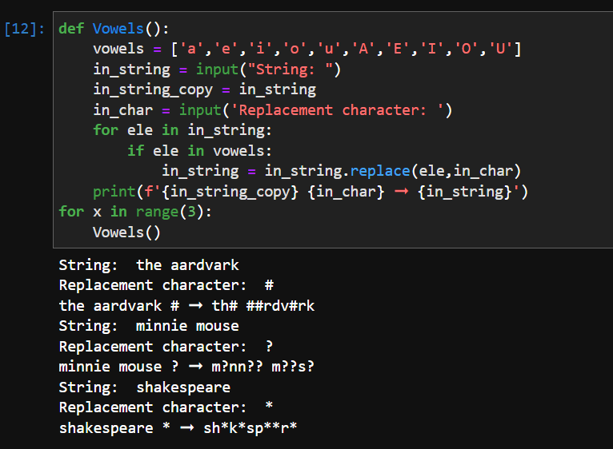

Question4. Write a function that calculates the **factorial** of a number **recursively**.

### Examples

factorial(5) ➞ 120

factorial(3) ➞ 6

factorial(1) ➞ 1

factorial(0) ➞ 1

🡪 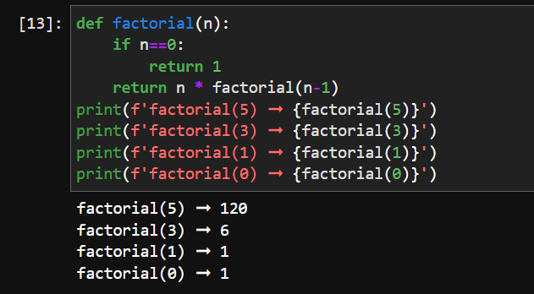

**Question 5**

**Hamming distance** is the number of characters that differ between two strings.

To illustrate:

String1: "abcbba"

String2: "abcbda"

Hamming Distance: 1 - "b" vs. "d" is the only difference.

Create a function that computes the **hamming distance** between two strings.

### Examples

hamming_distance("abcde", "bcdef") ➞ 5

hamming_distance("abcde", "abcde") ➞ 0

hamming_distance("strong", "strung") ➞ 1

* 