Question1

Create a function that takes a string and returns a string in which each character is repeated once.

**Examples**

double_char("String") ➞ "SSttrriinngg"

double_char("Hello World!") ➞ "HHeelllloo WWoorrlldd!!"

double_char("1234!_ ") ➞ "11223344!!__ "

🡪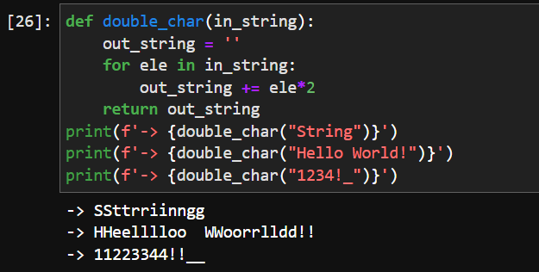

Question2

Create a function that reverses a boolean value and returns the string "boolean expected" if another variable type is given.

### Examples

reverse(True) ➞ False

reverse(False) ➞ True

reverse(0) ➞ "boolean expected"

reverse(None) ➞ "boolean expected"

🡪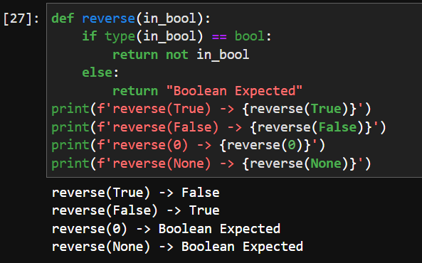

Question3

Create a function that returns the **thickness (in meters)** of a piece of paper after folding it n number of times. The paper starts off with a thickness of **0.5mm**.

### Examples

num_layers(1) ➞ "0.001m"

# Paper folded once is 1mm (equal to 0.001m)

num_layers(4) ➞ "0.008m"

# Paper folded 4 times is 8mm (equal to 0.008m)

num_layers(21) ➞ "1048.576m"

# Paper folded 21 times is 1048576mm (equal to 1048.576m)

🡪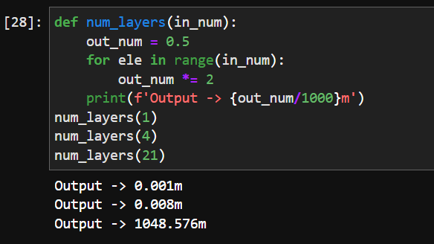

Question4

Create a function that takes a single string as argument and returns an ordered list containing the indices of all capital letters in the string.

### Examples

index_of_caps("eDaBiT") ➞ [1, 3, 5]

index_of_caps("eQuINoX") ➞ [1, 3, 4, 6]

index_of_caps("determine") ➞ []

index_of_caps("STRIKE") ➞ [0, 1, 2, 3, 4, 5]

index_of_caps("sUn") ➞ [1]

🡪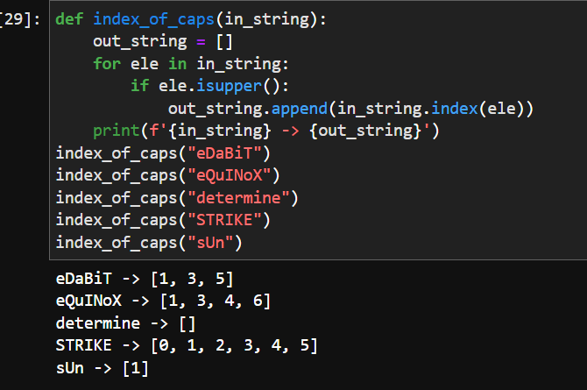

Question5

Using list comprehensions, create a function that finds all even numbers from 1 to the given number.

### Examples

find_even_nums(8) ➞ [2, 4, 6, 8]

find_even_nums(4) ➞ [2, 4]

find_even_nums(2) ➞ [2]

🡪