1. Write a Python program to convert kilometers to miles?

🡪 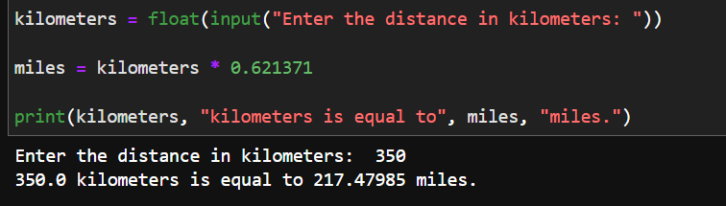

1. Write a Python program to convert Celsius to Fahrenheit?

* 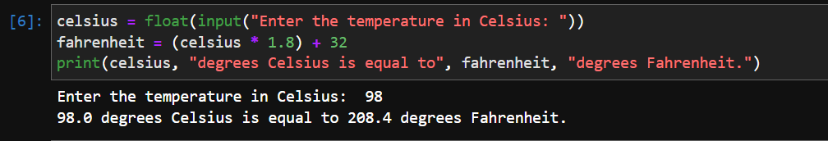

1. Write a Python program to display calendar?

🡪 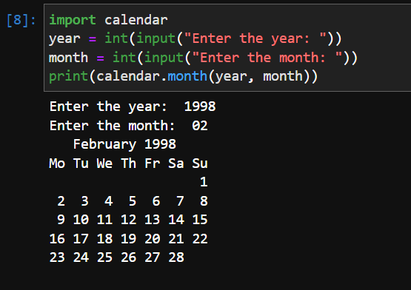

1. Write a Python program to solve quadratic equation?

🡪 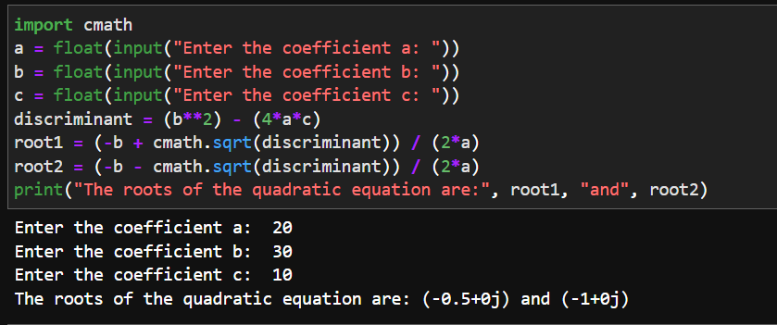

1. Write a Python program to swap two variables without temp variable?

🡪 