Question 1

Create a function that takes a number as an argument and returns True or False depending on whether the number is symmetrical or not. A number is symmetrical when it is the same as its reverse.

**Examples**

is_symmetrical(7227) ➞ True

is_symmetrical(12567) ➞ False

is_symmetrical(44444444) ➞ True

is_symmetrical(9939) ➞ False

is_symmetrical(1112111) ➞ True

🡪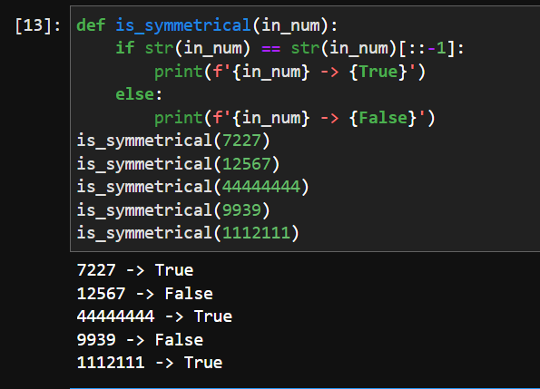

Question 2

Given a string of numbers separated by a comma and space, return the product of the numbers.

### Examples

multiply_nums("2, 3") ➞ 6

multiply_nums("1, 2, 3, 4") ➞ 24

multiply_nums("54, 75, 453, 0") ➞ 0

multiply_nums("10, -2") ➞ -20

🡪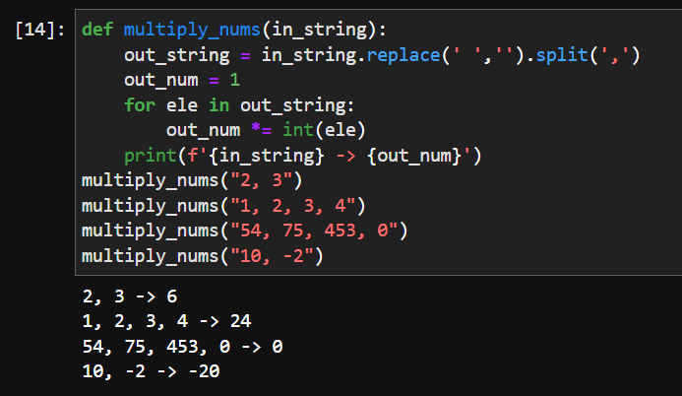

Question 3

Create a function that squares every digit of a number.

### Examples

square_digits(9119) ➞ 811181

square_digits(2483) ➞ 416649

square_digits(3212) ➞ 9414

### Notes

The function receives an integer and must return an integer.

🡪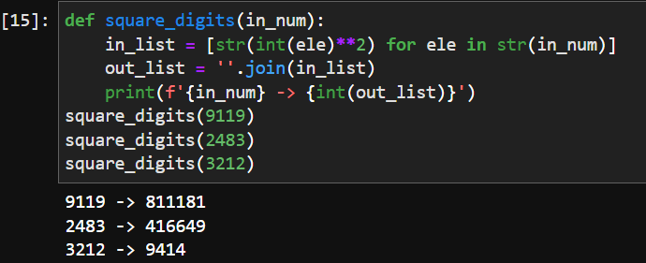

Question 4

Create a function that sorts a list and removes all duplicate items from it.

### Examples

setify([1, 3, 3, 5, 5]) ➞ [1, 3, 5]

setify([4, 4, 4, 4]) ➞ [4]

setify([5, 7, 8, 9, 10, 15]) ➞ [5, 7, 8, 9, 10, 15]

setify([3, 3, 3, 2, 1]) ➞ [1, 2, 3]

🡪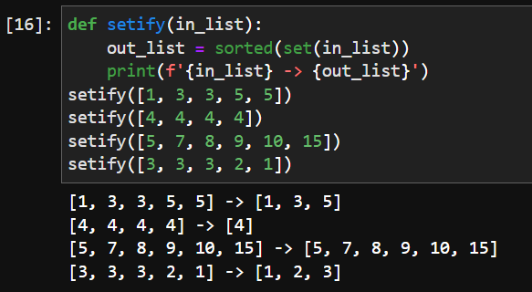

Question 5

Create a function that returns the mean of all digits.

### Examples

mean(42) ➞ 3

mean(12345) ➞ 3

mean(666) ➞ 6

### Notes

* The mean of all digits is the sum of digits / how many digits there are (e.g. mean of digits in 512 is (5+1+2)/3(number of digits) = 8/3=2).
* The mean will always be an integer.

🡪