Question1

Create a function that takes an integer and returns a list from 1 to the given number, where:

1. If the number **can be divided** evenly by 4, amplify it by 10 (i.e. return 10 times the number).
2. If the number **cannot be divided** evenly by 4, simply return the number.

**Examples**

amplify(4) ➞ [1, 2, 3, 40]

amplify(3) ➞ [1, 2, 3]

amplify(25) ➞ [1, 2, 3, 40, 5, 6, 7, 80, 9, 10, 11, 120, 13, 14, 15, 160, 17, 18, 19, 200, 21, 22, 23, 240, 25]

**Notes**

* The given integer will always be equal to or greater than 1.
* Include the number (see example above).
* To perform this problem with its intended purpose, try doing it with list comprehensions. If that's too difficult, just solve the challenge any way you can.

🡪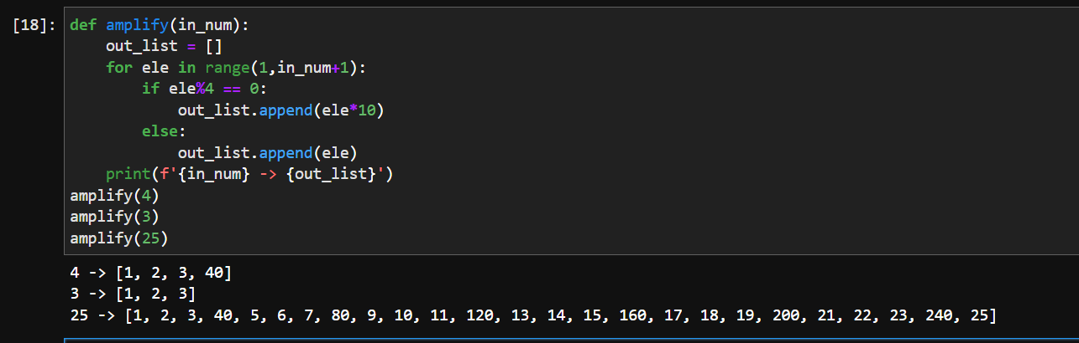

Question2

Create a function that takes a list of numbers and return the number that's unique.

### Examples

unique([3, 3, 3, 7, 3, 3]) ➞ 7

unique([0, 0, 0.77, 0, 0]) ➞ 0.77

unique([0, 1, 1, 1, 1, 1, 1, 1]) ➞ 0

### Notes

Test cases will always have exactly one unique number while all others are the same.

🡪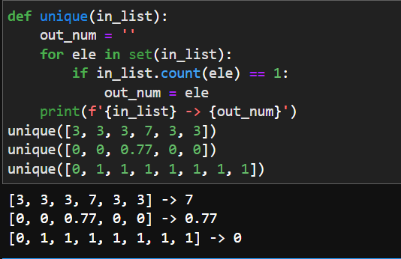

Question3

Your task is to create a Circle constructor that creates a circle with a radius provided by an argument. The circles constructed must have two getters getArea() (PIr^2) and *getPerimeter()* (2PI*r) which give both respective areas and perimeter (circumference).

For help with this class, I have provided you with a Rectangle constructor which you can use as a base example.

### Examples

circy = Circle(11)

circy.getArea()

# Should return 380.132711084365

circy = Circle(4.44)

circy.getPerimeter()

# Should return 27.897342763877365

### Notes

Round results up to the nearest integer.

🡪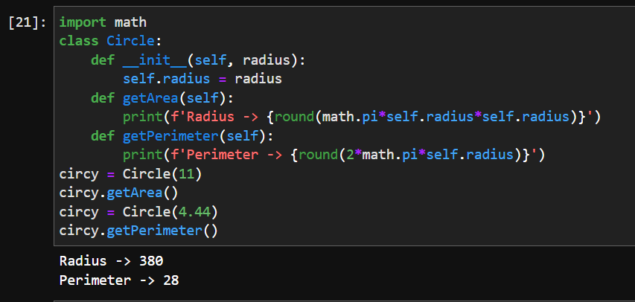

Question4

Create a function that takes a list of strings and return a list, sorted from shortest to longest.

### Examples

sort_by_length(["Google", "Apple", "Microsoft"])

➞ ["Apple", "Google", "Microsoft"]

sort_by_length(["Leonardo", "Michelangelo", "Raphael", "Donatello"])

➞ ["Raphael", "Leonardo", "Donatello", "Michelangelo"]

sort_by_length(["Turing", "Einstein", "Jung"])

➞ ["Jung", "Turing", "Einstein"]

### Notes

All test cases contain lists with strings of different lengths, so you won't have to deal with multiple strings of the same length.

🡪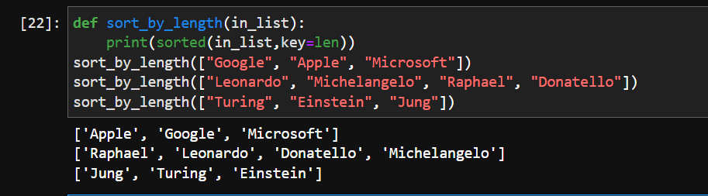

Question5

Create a function that validates whether three given integers form a **Pythagorean triplet**. The sum of the squares of the two smallest integers must equal the square of the largest number to be validated.

### Examples

is_triplet(3, 4, 5) ➞ True

# 3² + 4² = 25

# 5² = 25

is_triplet(13, 5, 12) ➞ True

# 5² + 12² = 169

# 13² = 169

is_triplet(1, 2, 3) ➞ False

# 1² + 2² = 5

# 3² = 9

### Notes

Numbers may not be given in a sorted order.

🡪