1. Write a Python Program to Find the Factorial of a Number?

🡪 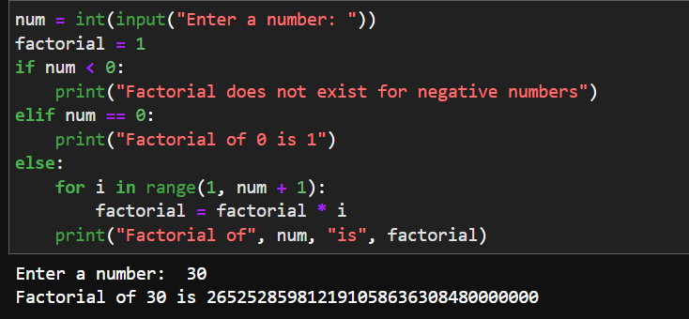

1. Write a Python Program to Display the multiplication Table?

🡪 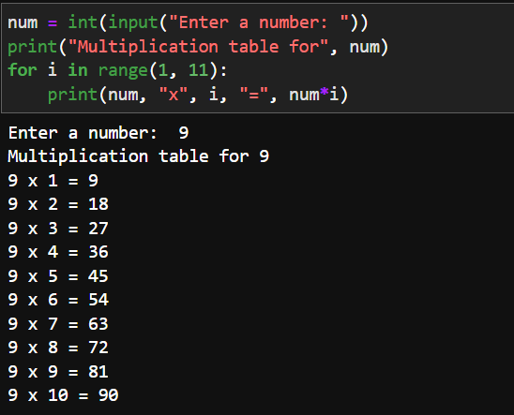

1. Write a Python Program to Print the Fibonacci sequence?

🡪 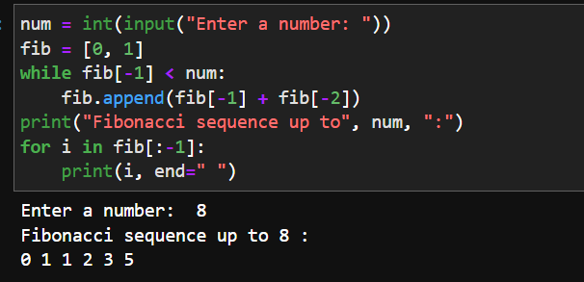

1. Write a Python Program to Check Armstrong Number?  
   🡪 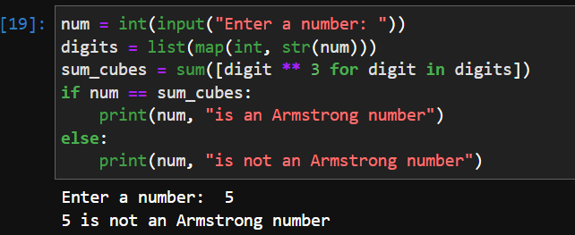
2. Write a Python Program to Find Armstrong Number in an Interval?

🡪 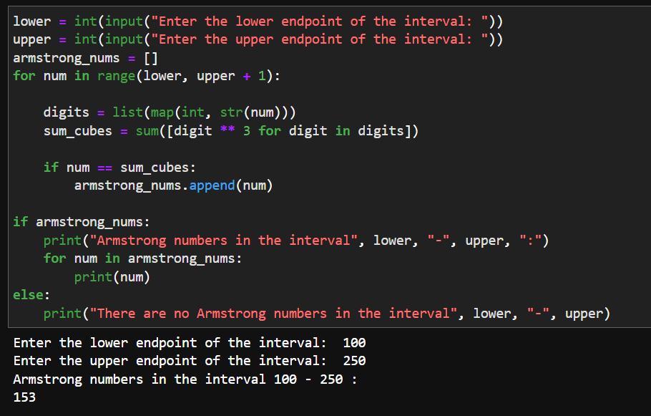

1. Write a Python Program to Find the Sum of Natural Numbers?

🡪 