1. Write a Python Program to Find LCM?

🡪 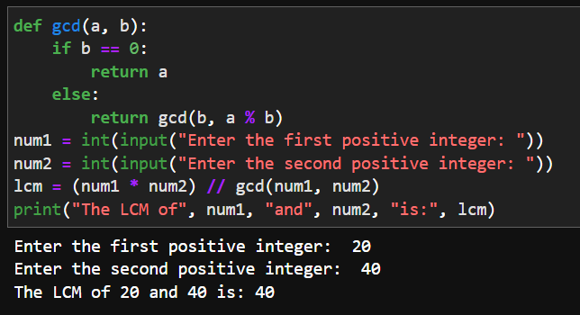

1. Write a Python Program to Find HCF?

🡪 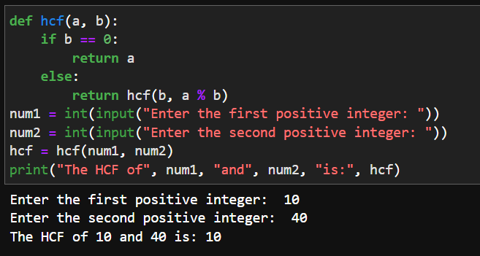

1. Write a Python Program to Convert Decimal to Binary, Octal and Hexadecimal?

🡪 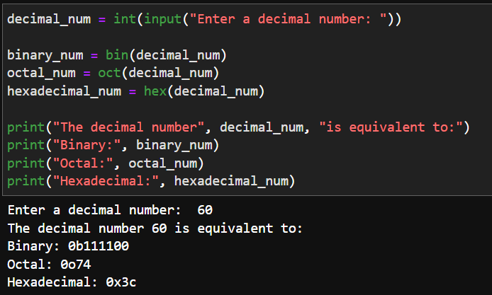

1. Write a Python Program To Find ASCII value of a character?  
   🡪 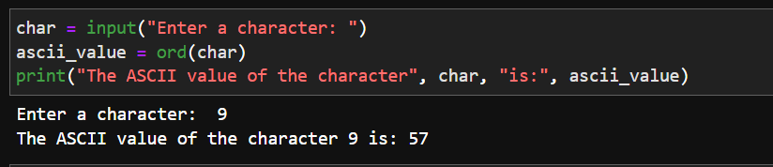
2. Write a Python Program to Make a Simple Calculator with 4 basic mathematical operations?

🡪 