1. Write a Python Program to find sum of array?

🡪 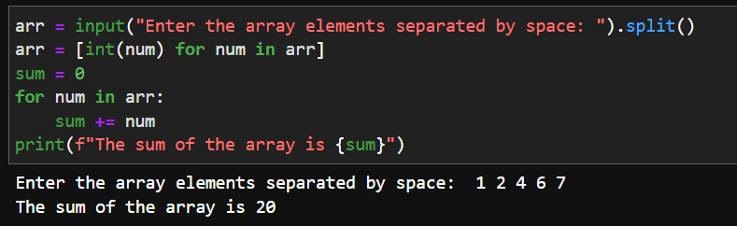

1. Write a Python Program to find largest element in an array?

🡪 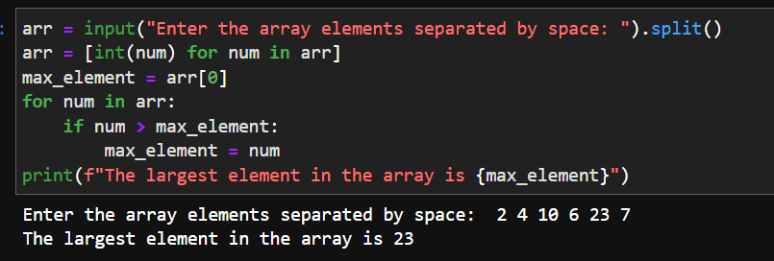

1. Write a Python Program for array rotation?

🡪 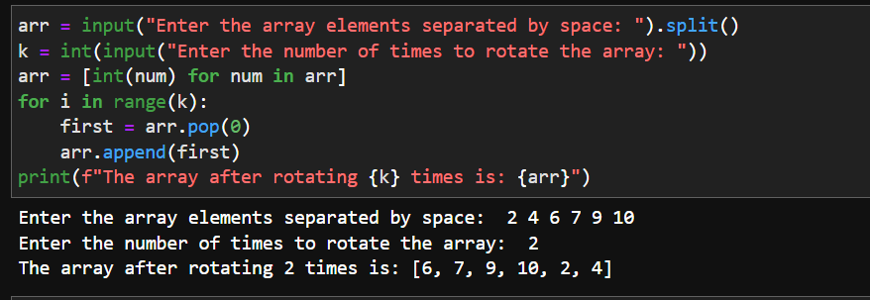

1. Write a Python Program to Split the array and add the first part to the end?  
   🡪 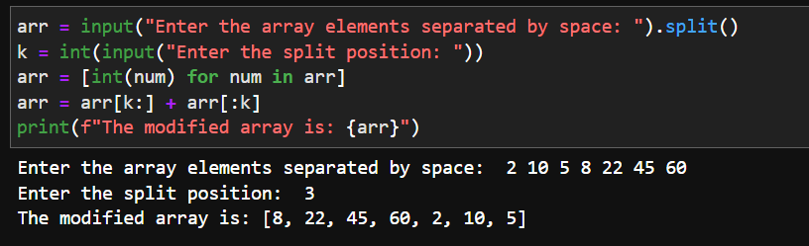
2. Write a Python Program to check if given array is Monotonic?

🡪 