1. Write a Python Program to Add Two Matrices?

🡪 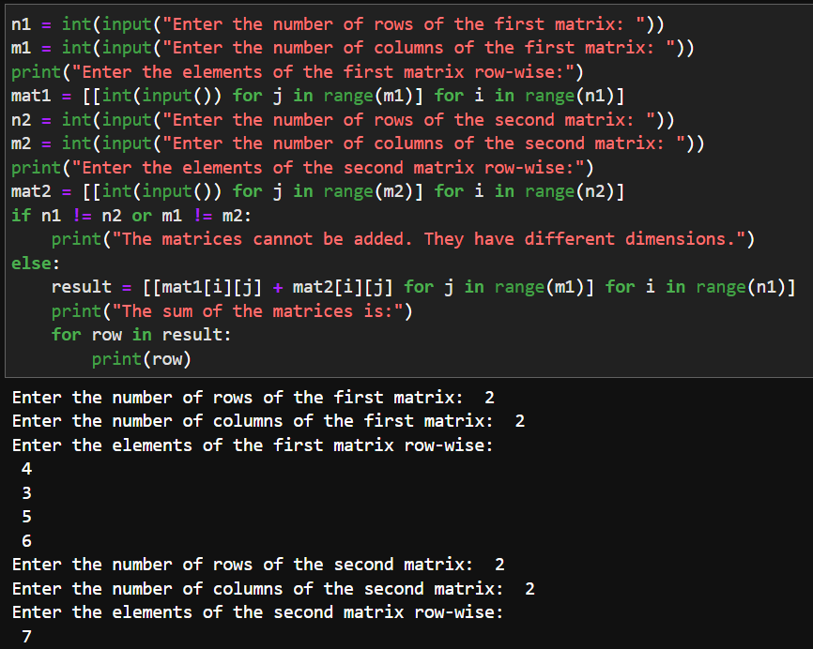

1. Write a Python Program to Multiply Two Matrices?

🡪 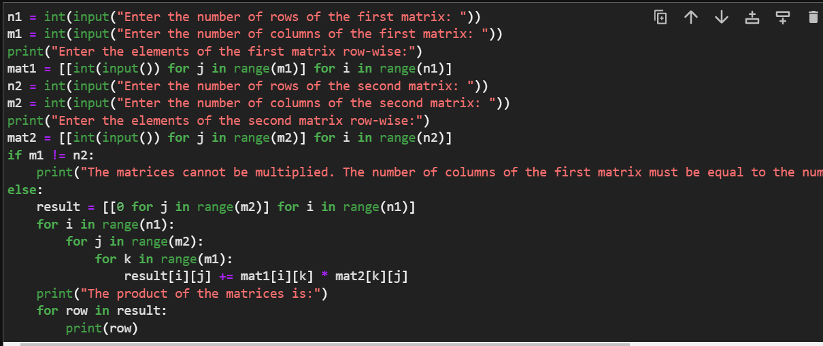

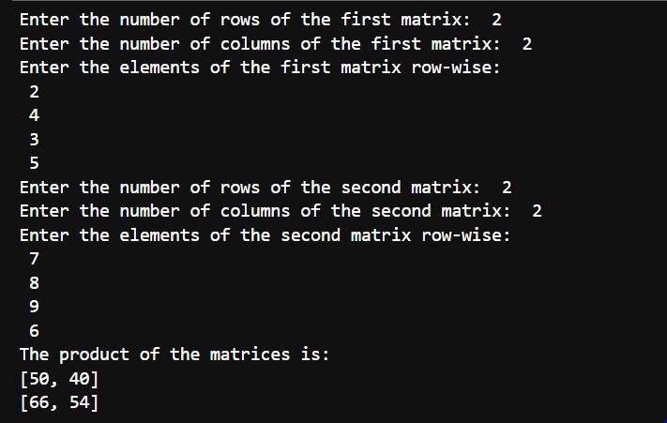

1. Write a Python Program to Transpose a Matrix?

🡪 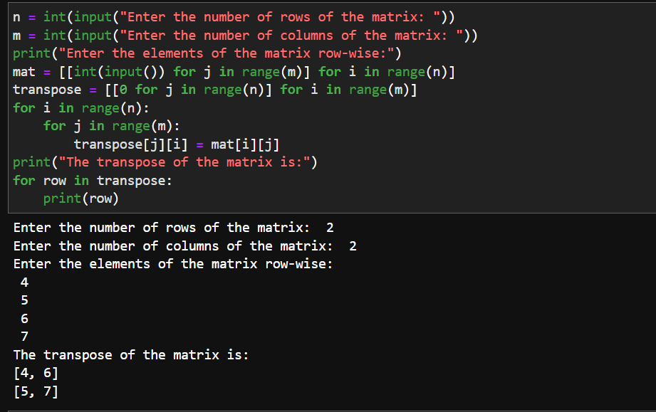

1. Write a Python Program to Sort Words in Alphabetic Order?

🡪 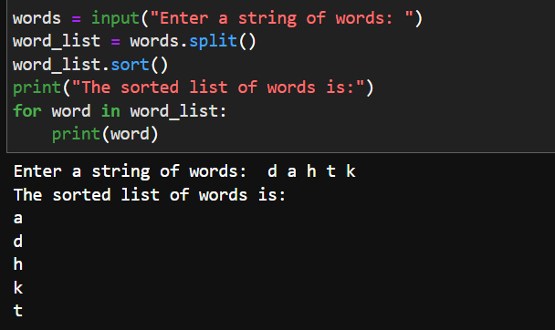

1. Write a Python Program to Remove Punctuation From a String?

🡪 