1. Write a Python program to check if the given number is a Disarium Number?

🡪 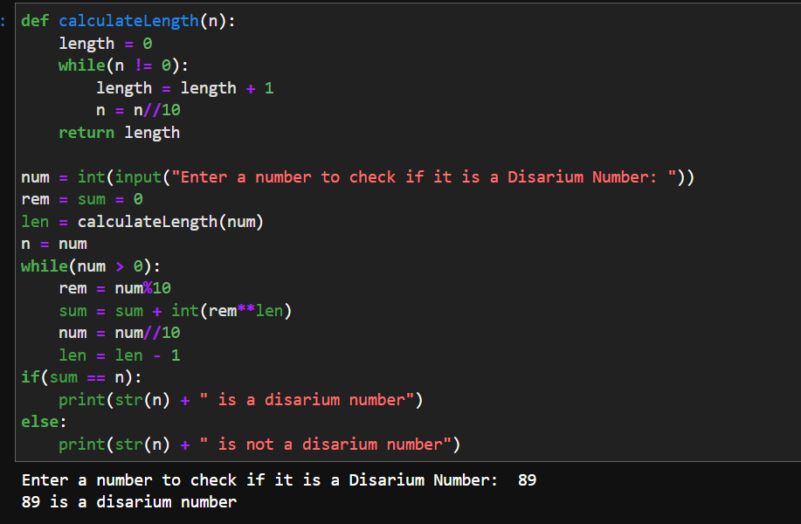

1. Write a Python program to print all disarium numbers between 1 to 100?

🡪 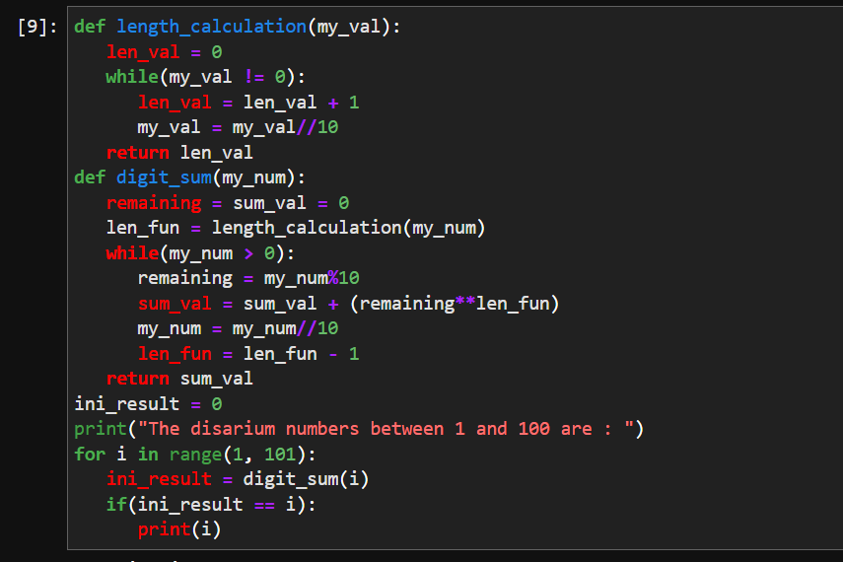

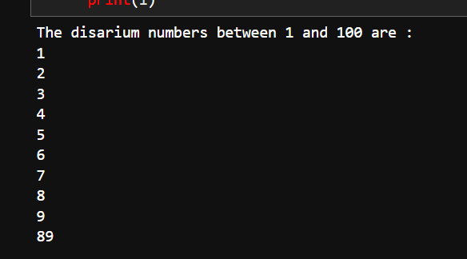

1. Write a Python program to check if the given number is Happy Number?

🡪 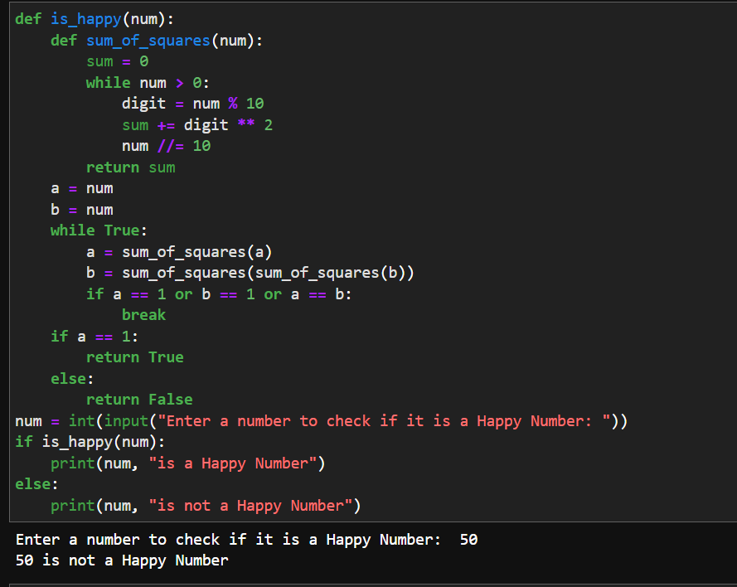

1. Write a Python program to print all happy numbers between 1 and 100?

🡪 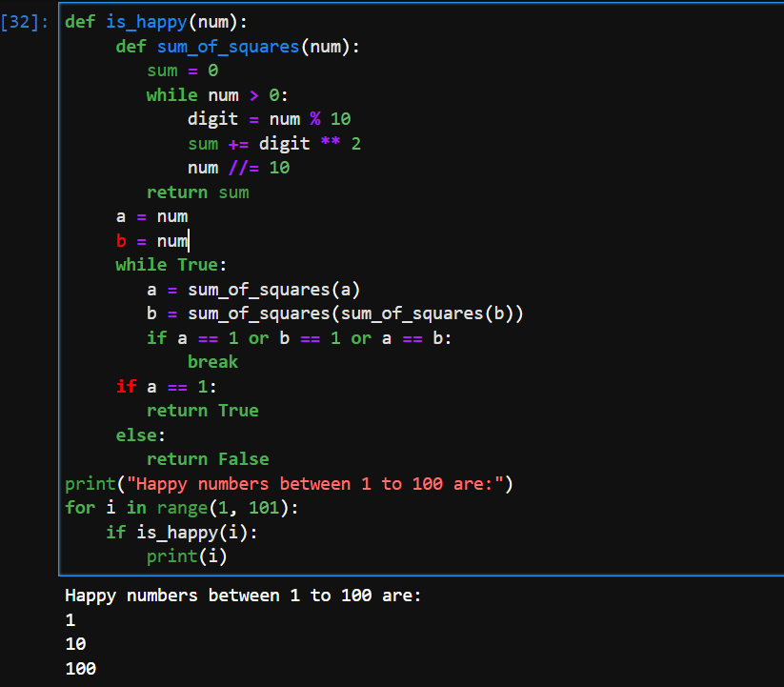

1. Write a Python program to determine whether the given number is a Harshad Number?

🡪 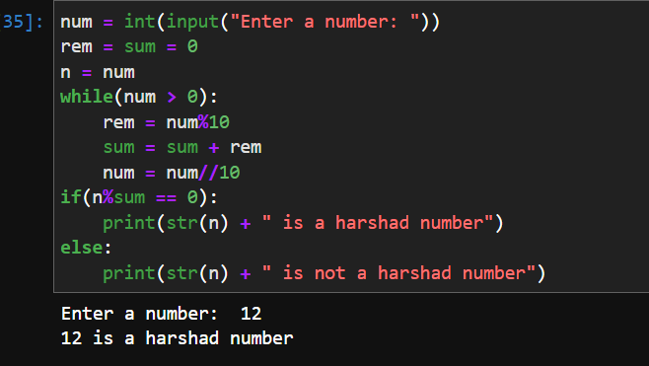

1. Write a Python program to print all pronic numbers between 1 and 100?

🡪 