Project Report Template

1. INTRODUCTION
   1. Over View

PLUGGING INTO THE FUTURE:AN EXPLORATION OF ELECTRICITY CONSUMPTION PATTERNS:

Access tob energy and in particular electricity is viewed as a fundamental right of every house hold . The accisible source of electricity gets distributed to different electrical loads within the household without people being aware of the individual consumption per load with that the over all cost is reported as a single number in the electricity bill

In the study we investigate the awareness and knowledge of household consumer eith regard to issue associated with electricity consumption and cost .

* 1. PURPOSE

Global electricity consumption has continued to go up rapidly at a rate faster than energy consumption. Between 1980 and 2013, the world’s annual electricity consumption rose from 7300 TWh to 22,100 TWh. Since the twenty first century, global electricity consumption has seen even faster growth, as evidenced by an average annual increase of 3.4%, 1.2 percentage points higher than average annual growth of energy consumption

2 PROBLEM DEFINITION & DESIGN THINKING

2.1 Empathy Map

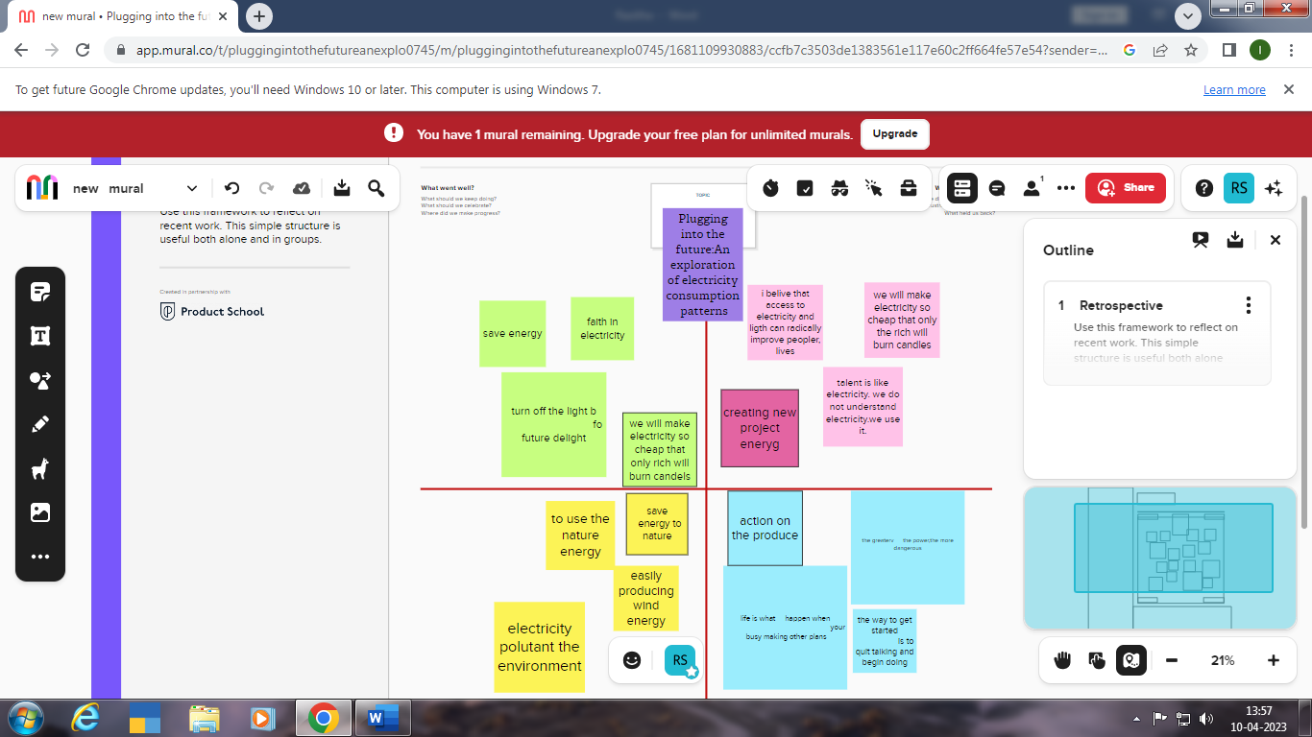

2.2 .Identation & Brainstroming Map

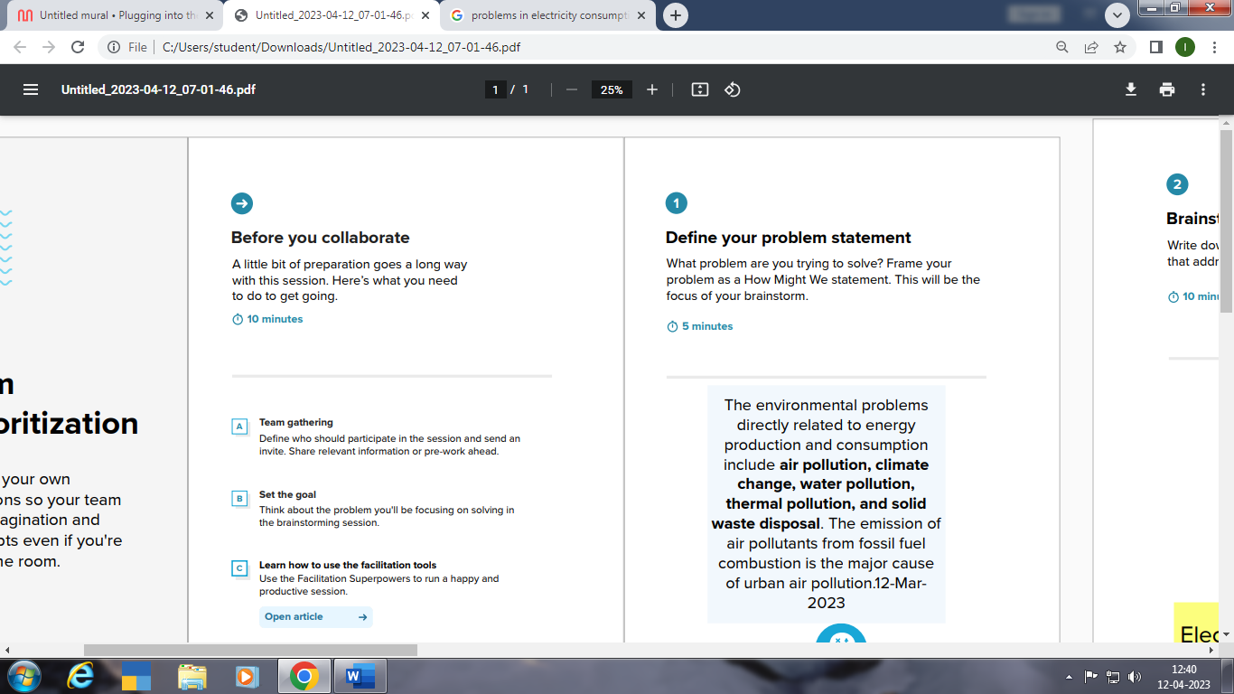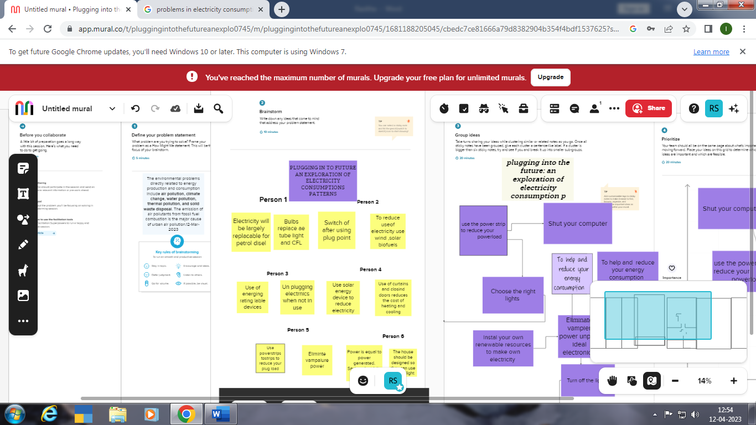

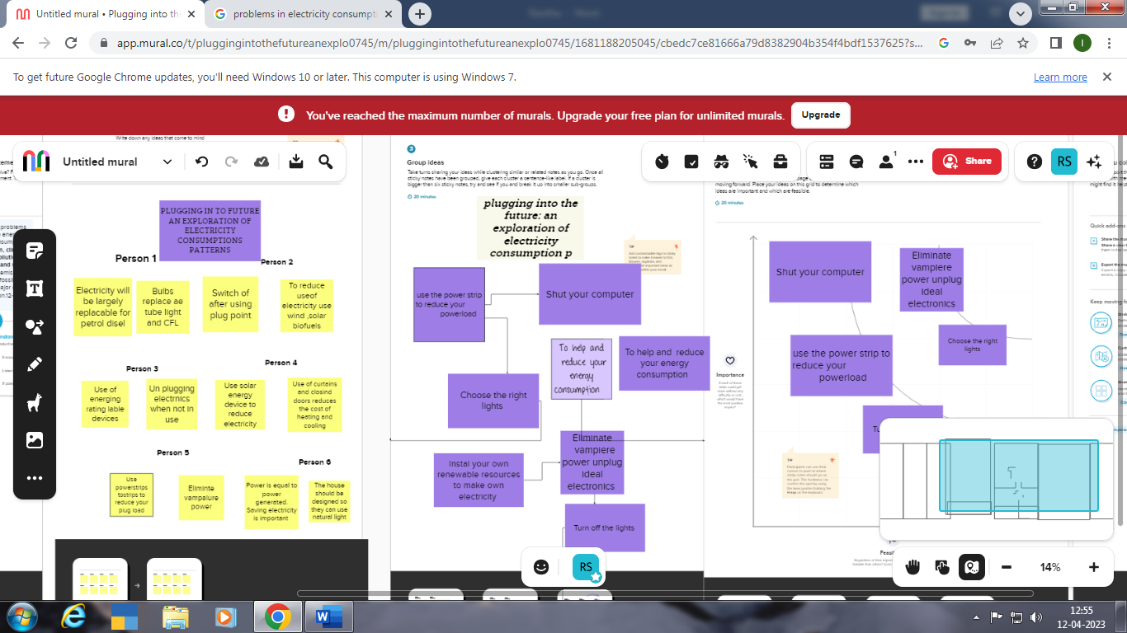

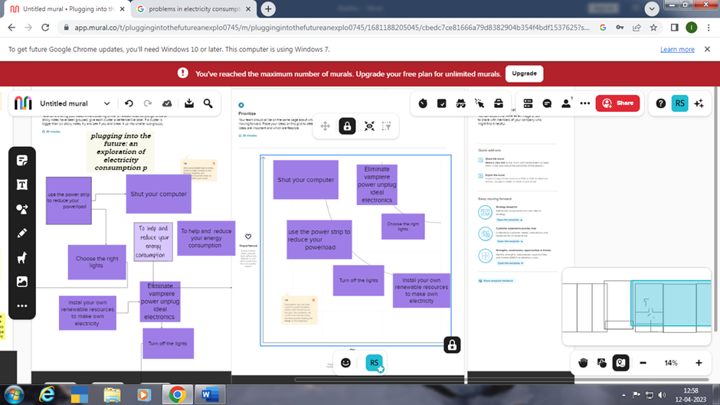

3.**RESULT**

**I** Had Created The Empathy Map With My Own idea

Then we create the Brainstrom Prioritization and we tell about the problem in electricity and had a group discussion and make some ideas and then priotization about the topic with our ideas

4.ADVANTAGES AND DISADVANTAGES

lectricity consumption in the United States, as a whole, has increased dramatically with the implementation of new and innovative uses for this versatile energy form. Fig. 1.8 depicts the increase in use of electricity in the United States from the turn of the 20th century forward. It is possible to calculate the percentage rate of increase in electrical usage for various blocks of time. Alternatively it is instructive to show that the consumption of electricity over time conforms to a sound polynomial equation where x represents the year and y represents annual consumption in billions kilowatt hours (109 kWh)/year.

ADVANTAGES

Appliances and electronics -- Purchase energy-efficient products and operate them efficiently. Use an advanced power strip to reduce "vampire loads"--electricity that is wasted when electronics are not in use.

Lighting -- Purchase energy-efficient products, operate them efficiently, and incorporate more daylighting into your home using energy-efficient windows and skylights.

Electric space heating and cooling -- Purchase energy-efficient electric systems and operate them efficiently. Incorporate passive solar design concepts into your home, which include using energy-efficient windows. Properly insulate and air seal your home. Select an energy-efficient heating system that doesn't use electricity.

Electric water heating -- Purchase an Energy Star heat pump water heater and operate it efficiently.

DISADVANTAGES

Higher Energy Costs

A natural consequence of overusing energy is increased costs for you. This can come in the form of fuel and energy bills; you will be paying more without an appreciable return on your investment. You may also risk lowering the expected lifespan of appliances and other electronics.

More expensive than gasoline.

Loss of fish species.

Sometimes messes up wildlife.

Dependent on precipitation.

More power plants and more pollution.

Damming can cause loss of land suitable for agriculture as well as recreation.

Cost for construction.

Change in river or stream quality.

APPLICATION

* Cooling and heating: 47% of energy use.
* Water heater: 14% of energy use.
* Washer and dryer: 13% of energy use.
* Lighting: 12% of energy use.
* Refrigerator: 4% of energy use.
* Electric oven: 3-4% of energy use.
* TV, DVD, cable box: 3% of energy use.
* Cooling and heating: 47% of energy use.
* Water heater: 14% of energy use.
* Washer and dryer: 13% of energy use.
* Lighting: 12% of energy use.
* Refrigerator: 4% of energy use.
* Electric oven: 3-4% of energy use.
* TV, DVD, cable box: 3% of energy use.
* Dishwasher: 2% of energy use.
* Dishwasher: 2% of energy use.

CONCLUSION

This paper has introduced an explory experiment of plugging in to the future an explotion of electricity consumption

The output shows that energy consumptions are highly correlated to the

weekdays; for instance, Thursdays and Fridays are usually identified as the high peak,

while weekend days and holidays present the lowest energy usage. The next step of this

work is to investigate more deeply the importance of other influential factors.