🐱 drive info

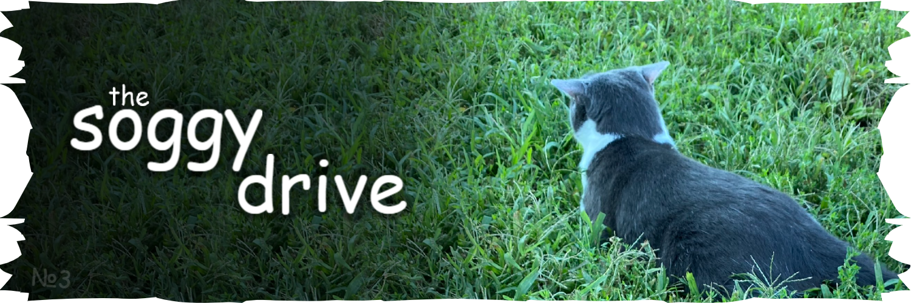

heyo!! hey!!!
this is a google drive for all known images of shark. biscuit, the owner, vanished from the internet and we are now trying to find any remaining photos taken of the cat..

the current search is mostly halted, as after searching through all of the web archives there are no candidates for places to search through.. still, there are fixes / missed images being uploaded from time to time

you can leave comments on images if you'd like, doesn't matter if they're serious or notHello im jude case 17 from X .com you should accept this suggestion it would be SO COOL!!!!
(don't resolve other people's comments, it's a flaw in gdrive's permission system and i'll have to manually reopen all of them.. i can also catch you red-handed through email notifications 😼)

drive #1 (by lily) - drive #2 (by cv)
discord // twitter // other

file names
each image has a random self-explanatory name (or an inside joke) assigned for convenience.
despite keeping the exact same data, all of the .jpeg files should be renamed to .jpg to be compatible with other services. if there are any jpegs that i missed then just mention me on soggy world!!

quality
there are so many shark images that new ones sometimes get found in the most bizzare places, or might just not be fully processed in the web archives. that's why the uploads here might have really low resolution. check google lens / messages on soggy world, there might be higher quality versions just laying out there

image-specific
(uncropped) - a lower quality image but with less / no space around it cropped.
(hq) - a notable higher quality version. they're mostly unlabeled

"IT'S SNOWING IT'S SNOWING IT'S SNOWING.png" was taken from biscuit's old tiktok video and has the file name as the caption. i've included a captionless image ^{(*gulp* ai cleanup..)} since that one is used more often

“wire.mp4” was ripped from a now deleted youtube video named “soggy cat found footage”, that’s why there was a siren going off
it was found by marcus3205, and is now replaced with the full quality video

ssoggycat software division (2022-2026)

