**First Tab:**

**Our Services:**

- Translation:

We offer translation service from any language to any language with competitive rates. We will provide you with high quality translation and you will touch the difference with us.

- Proofreading:

We provide proofreading and linguistic testing in all areas. Our professionals will add accuracy, efficacy and completeness to your translation.

- Subtitling:

We provide subtitling services for videos and audios with taking the sequence into high consideration. Now, you can listen to any audio or watch any video with a translation in your native language.

- Researches:

Contact us if you find difficulty in doing any research in any field of specification. Our professional researchers will the needful for you in unbelievable time 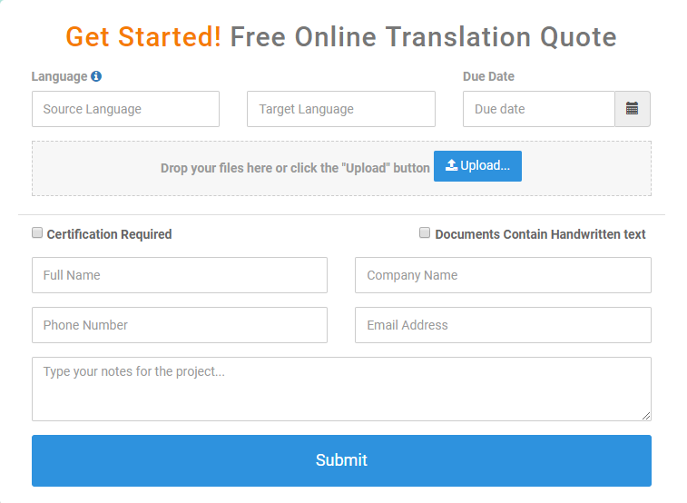

Second Tab:

Our Team:

We have an experienced team of translators, proofreaders and reviewers with more than10 years of professional experience.

We are ready to convey your message, reinforce your reputation, maintain your success and flourish your existence as a business.

This is our promise and our pledge, for long-term partnerships, built on commitment, honesty and trust.

**Third Tab:**

**About Us:**

We are a newly established translation company with professional and experienced translators. We provide translation services in English, Spanish, German, French, Chinese, Urdu, Tamil and Indian and other languages per request. Our rates are highly competitive. We will provide you with accurate translation beside saving your money and time.

**Our Mission**

To elevate the standards of the translation industry into new heights of excellence and quality adherence through utilizing an experienced team of translators.

**Vision** To provide a wholesome approach to translation services that extends to cover all the needs of our clients, provide them with a reliable translation partner that they can depend upon in meeting and exceeding their expectations.

**Code of Ethics**

Confidentiality  
Accuracy  
Completeness  
Conveying cultural frameworks  
Non-judgmental attitude  
Client self-determination  
Develop a relationship of trust  
Professionalism.

**Fourth Tab:**

**Our Rates**

|  |
| --- |
| We take an individual approach to every translation project. **The rates are determined by the following factors:** |
| * **Languages** * **Number of words** * **Type of text: general or specialized** * **Deadline: Standard or Express** * **Other special requirements** |
| **Note:** Discounts are allowed on large products and returning customers. |

**Fifth Tab:**

**Jobs**:

Are you an established professional or a fresh graduate seeking to start a career in the newly established translation company with qualified and experienced staff ?   
  
We, at AIR Translation Services, are always looking for experienced employees and fresh talent with the passion and strive to be the greatest in their respective fields.   
  
Send us your C.V. and not just the dull piece of paper, enclose it with a cover letter saying why do you want to work in the field, tell us about your drive and dreams, what you think you are capable of and what you believe you can achieve with experience, training and hard work. Send you C.V at [hello@airtranslationservices.com](mailto:hello@airtranslationservices.com)

**Sixth Tab:**   
**Contacts**:

Email: hello@airtranslationservices.com

[Facebook](https://www.facebook.com/Air.Translation.services/?ref=settings)

[Twitter](https://twitter.com/AIR_translation)