**Streams**

Not a data structure, but it takes an input from a data structure.

A stream does not change the data structure but takes them through a pipeline and something comes out in the end.

The meaning tis to do all the stream operations in one go during the stream.  
  
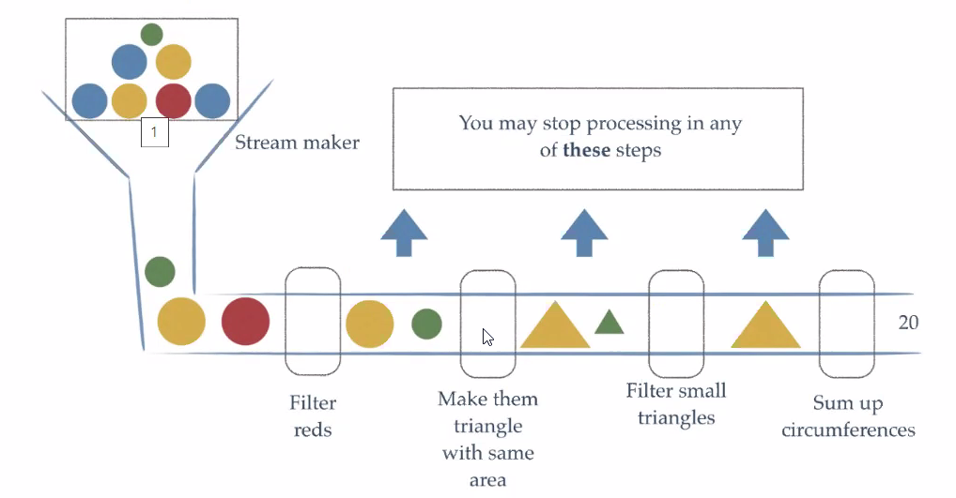

**Start stream source**

**Intermediate operations (There can be as many as we like)**

* Any operations we want to do in the stream
  + Filters
  + map functions
    - Take elements of one type and convert them to another type
  + Sorting functions

**Terminal operation**

* What comes out in the end
  + Collect
  + For each
  + Reduce
    - Reduces all elements to one element
    - For example, summing up an array of numeric

**Example:**

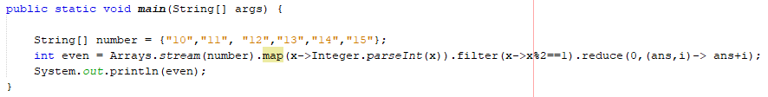

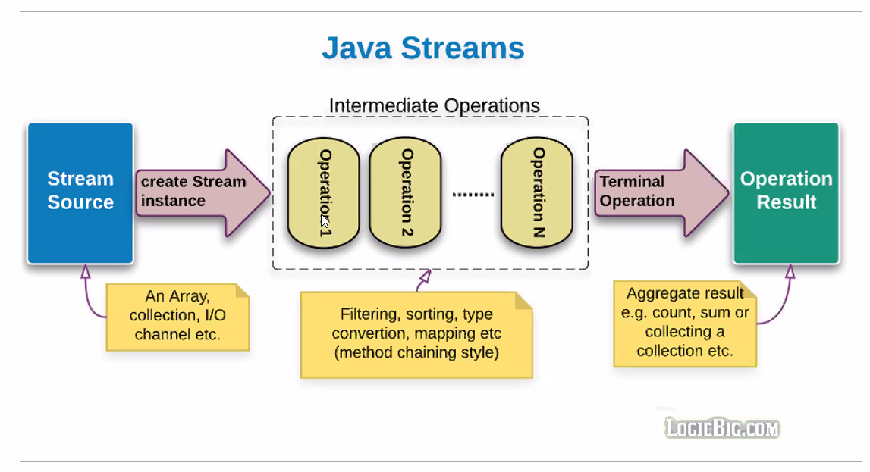

**Streams Opgaver**  
Lave en text med navne

Læs hvordan man laver en stream fra en fil:

https://www.tutorialspoint.com/how-to-convert-file-into-a-stream-in-java

Find på en opgave med streams og denne tekstfil.

Find a list of names on google and copy past them into a .txt file with line separation.

Create a simple java main and convert the file into a stream

Do Intermediate operations on this stream to find the average length of the names for each first letter.

Do a terminal operation to map these with first letter as key and average name length as value.

“Optional” Write the content of the map into another file.

læs en liste af navne indfiltrer alle navne der er over 6 bogstaver langt udalle navne der starter med a e og c skal starte med stort bogstav alle andre navne skal skrives med stort bogstav hele vejen igennem gem alle navne der starter med a e eller c i en liste og alle de andre i en anden liste

hvis der er tid:

kør de nye lister igennem og print hvor mange bogstaver der er tilsammen i hele listen.