**A**

**LAB REPORT**

**ON**

**JAVA pROGRAMMING II**

**By**

**RASMI JATI**

**Exam Roll No: 7930/17**



**Submitted to:**

**Dinesh Bajracharya (Lecturer)**

**Roshan Rijal (Lab Report Supervisor)**

**Kantipur College of Management and Information Technology**

In Partial Fulfillment of the Requirements for the Course Java Programming II

Mid Baneshwor, Kathmandu

March, 2020

Table of Contents

1 Write a program to check if given number is prime or not. 3

1.1 Introduction: 3

1.2 Source Code: 3

1.3 Output: 5

2 Write a program to add, subtract, divide, multiple two numbers given by user, use our different buttons to perform mentioned operations. 6

2.1 Introduction: 6

2.2 Source Code: 6

2.3 Output: 9

3 Write a program to convert the temperature. 10

3.1 Introduction: 10

3.2 Source Code: 10

3.3 Output: 12

4 Write a program that allow the user to enter his/her weight and calculate the amount of water he/she should every day. 13

4.1 Introduction: 13

4.2 Source Code: 13

4.3 Output: 15

5 Write a program to take string from user and display length of the given string. 16

5.1 Introduction: 16

5.2 Source Code: 16

5.3 Output: 17

6 Write a program to take string and integer (position) from user and display character at that given position of that user given string. 18

6.1 Introduction: 18

6.2 Source Code: 18

6.3 Output: 20

7 Write a program to display series of numbers between two given numbers by user. 21

7.1 Introduction: 21

7.2 Source Code: 21

7.3 Output: 23

# Write a program to check if given number is prime or not.

## Introduction:

This program is used to check if a given number is prime or not. It contains one textfield and a button. A message according to the nature of number (prime or not prime) is displayed in a message box to response to the button. If button is clicked without any number in textfield error message is shown in a dialog box.

This program is developed using JFrame, JLabel, JTextField, JButton and JOptionPane objects. Layout of frame is set null and set bound of the frame is given. Frame listens to ActionListener interface and ActionListener is added to button. If a given number is prime or not is checked in the actionPerformed function.

## Source Code:

importjavax.swing.*;

importjava.awt.*;

importjava.awt.event.*;

public class PrimeOrNot extends JFrame implements ActionListener{

JLabellblInput;

JTextFieldtfInput;

JButtonbtnOk;

publicPrimeOrNot(){

lblInput = new JLabel("Enter a Number");

tfInput =new JTextField(80);

lblInput.setBounds(10,5,100,30);

tfInput.setBounds(115,5,100,30);

btnOk = new JButton("OK");

btnOk.setBounds(115,40,100,30);

add(lblInput);

add(tfInput);

add(btnOk);

btnOk.addActionListener(this);

setTitle("RasmiJati");

setLayout(null);

setSize(600,400);

setVisible(true);

setDefaultCloseOperation(JFrame.EXIT_ON_CLOSE);

}

public void actionPerformed(ActionEvent e){

String num = tfInput.getText();

inti;

try{

int n = Integer.parseInt(num);

if(e.getSource() == btnOk){

for(i = 2; i<n ; i++)

if(n%i == 0)

break;

if(i == n){

JOptionPane.showMessageDialog(null,"Prime");

}

else{

JOptionPane.showMessageDialog(null,"Not Prime");

}

}

}catch(Exception f){

JOptionPane.showMessageDialog(this,"Error");

}

}

public static void main(String[] args){

newPrimeOrNot();

}

}

## Output:

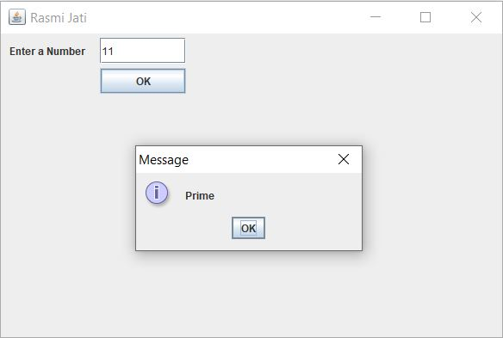

# Write a program to add, subtract, divide, multiple two numbers given by user, use our different buttons to perform mentioned operations.

## Introduction:

This program is used to add, subtract, divide and multiply two number given by user. It contains two textfield and four buttons. A message according to the nature of number (add, subtract, multiply and divide) is displayed in a message box to response to the buttons. If button is clicked without any number in textfield error message is shown in dialog box.

This program is developed using JFrame, JLabel, JTextField, JButton and JOptionPane objects. Layout of frame is set null and set bound of the frame is given.Frame listens to ActionListener interface and ActionListener is added to button. The addition, subtraction, multiplication and division is checked in the actionPerformed function.

## Source Code:

importjavax.swing.*;

importjava.awt.*;

importjava.awt.event.*;

public class calculator extends JFrame implements ActionListener{

JLabel lblNumber1,lblNumber2;

JTextField tfNumber1,tfNumber2;

JButtonbtnAdd,btnSubtract,btnMultiply,btnDivide;

public calculator(){

lblNumber1 = new JLabel("Enter first number:"); lblNumber1.setBounds(5,10,110,30);

lblNumber2 = new JLabel("Enter second number:"); lblNumber2.setBounds(5,50,110,30);

tfNumber1 = new JTextField(20); tfNumber1.setBounds(115,10,100,30);

tfNumber2 = new JTextField(20); tfNumber2.setBounds(115,50,100,30);

btnAdd = new JButton("+");

btnAdd.setBounds(5,90,100,30);

btnSubtract = new JButton("-");

btnSubtract.setBounds(115,90,100,30);

btnMultiply = new JButton("*");

btnMultiply.setBounds(5,130,100,30);

btnDivide = new JButton("/"); btnDivide.setBounds(115,130,100,30);

add(lblNumber1);add(tfNumber1);

add(lblNumber2);add(tfNumber2);

add(btnAdd);add(btnSubtract);

add(btnMultiply);add(btnDivide);

btnAdd.addActionListener(this);

btnSubtract.addActionListener(this);

btnMultiply.addActionListener(this);

btnDivide.addActionListener(this);

setLayout(null);

setSize(600,400);

setTitle("RasmiJati");

setVisible(true);

setDefaultCloseOperation(JFrame.EXIT_ON_CLOSE);

}

public void actionPerformed(ActionEvent e){

String num1 = tfNumber1.getText();

String num2 = tfNumber2.getText();

int output;

int n1 = Integer.parseInt(num1);

int n2 = Integer.parseInt(num2);

try{

if(e.getSource() == btnAdd){

output = n1 + n2;

JOptionPane.showMessageDialog(null,"Sum is: "+output);

}

else if(e.getSource() == btnSubtract){

output = n1 - n2;

JOptionPane.showMessageDialog(null,"Subtract is: "+output);

}

else if(e.getSource() == btnMultiply){

output = n1 * n2;

JOptionPane.showMessageDialog(null,"Product is: "+output);

}

else{

output = n1 / n2;

JOptionPane.showMessageDialog(null,"Divide is: "+output);

}

}catch(Exception f){

JOptionPane.showMessageDialog(this,"Error");

}

}

public static void main(String[] args){

new calculator();

}

}

## Output:

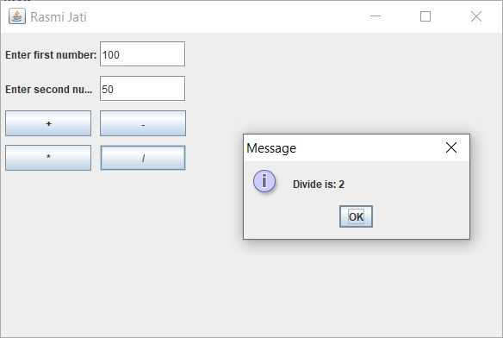

# Write a program to convert the temperature.

## Introduction:

This program is used to convert the temperature i.e. to convert Celsius into Fahrenheit and vice-versa. It contains one textfield and two radio buttons. A message according to the given input is displayed in a message box to response to the radio buttons. If button is clicked without any number in textfield error message is shown in dialog box.

This program is developed using JFrame, JLabel, JTextField, JRadioButton and JOptionPane objects. Layout of frame is set null and set bound of the frame is given. Frame listens to ActionListener interface and ActionListener is added to radio buttons. The temperature conversion is checked in the actionPerformed function.

## Source Code:

importjavax.swing.*;

importjava.awt.*;

importjava.awt.event.*;

public class TemperatureConverter extends JFrame implements ActionListener{

JLabellblInput;

JTextFieldtfInput;

JRadioButtonrbFahrenheit,rbCelsius;

ButtonGrouprbg;

publicTemperatureConverter(){

lblInput = new JLabel("Enter a number"); lblInput.setBounds(5,10,110,30);

tfInput = new JTextField(20); tfInput.setBounds(115,10,100,30);

rbFahrenheit = new JRadioButton("F"); rbFahrenheit.setBounds(5,50,110,30);

rbCelsius = new JRadioButton("C"); rbCelsius.setBounds(115,50,110,30);

rbg = new ButtonGroup();

rbg.add(rbFahrenheit);

rbg.add(rbCelsius);

add(lblInput);

add(tfInput);

add(rbFahrenheit);

add(rbCelsius);

rbFahrenheit.addActionListener(this);

rbCelsius.addActionListener(this);

setSize(600,400);

setLayout(null);

setVisible(true);

setDefaultCloseOperation(JFrame.EXIT_ON_CLOSE);

}

public void actionPerformed(ActionEvent e){

String num = tfInput.getText();

int value;

try{

int n = Integer.parseInt(num);

if(e.getSource() == rbFahrenheit){

value = ((n-32)*5)/9;

JOptionPane.showMessageDialog(null,value+" degree in celsius.");

}

else{

value = ((n*9)/5)+32;

JOptionPane.showMessageDialog(null,value+" degree in Fahrenheit.");

}

}catch(Exception f){

JOptionPane.showMessageDialog(this,"Error");

}

}

public static void main (String[] args){

newTemperatureConverter();

}

}

## Output:

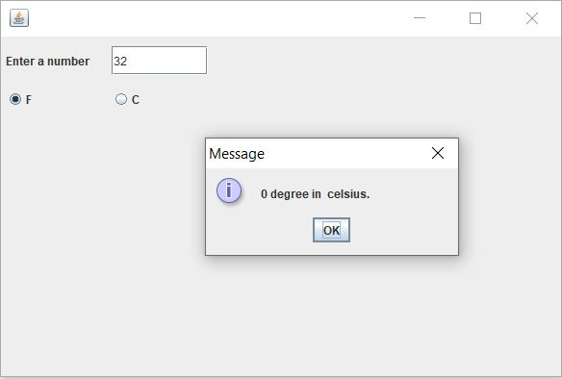

# Write a program that allow the user to enter his/her weight and calculate the amount of water he/she should every day.

## Introduction:

This program is used to calculate the litres of water to drink in a day according to the weight given by user. It contains one textfield and one buttons. A message according to the nature of number (weight(kg)) is displayed in a message box to response to the buttons. If button is clicked without any number in textfield error message is shown in dialog box.

This program is developed using JFrame, JLabel, JTextField, JButton and JOptionPane objects. Layout of frame is set to flow layout. Frame listens to ActionListener interface and ActionListener is added to button. The calculation of litres of water to drink is checked in the actionPerformed function.

## Source Code:

importjavax.swing.*;

importjava.awt.*;

importjava.awt.event.*;

public class WaterCalculator extends JFrame implements ActionListener{

JLabellblQuestion, lblWeight;

JTextFieldtfWeight;

JButtonbtnTellMe;

publicWaterCalculator(){

lblQuestion = new JLabel("How much water should I drink?");

lblWeight = new JLabel("My Weight(kg) is: ");

tfWeight = new JTextField(10);

btnTellMe = new JButton("Tell Me");

add(lblQuestion);

add(lblWeight);

add(tfWeight);

add(btnTellMe);

btnTellMe.addActionListener(this);

setDefaultCloseOperation(JFrame.EXIT_ON_CLOSE);

setLayout(new FlowLayout());

setSize(600,400);

setVisible(true);

setTitle("RasmiJati");

}

public void actionPerformed(ActionEvent e){

String weights = tfWeight.getText();

try{

Float weight = Float.parseFloat(weights);

Float output = (weight/10f) * 0.4f;

String message = "You should drink " + output + " L of water a day!";

JOptionPane.showMessageDialog(this,message);

}catch(Exception f){

JOptionPane.showMessageDialog(this,"Error");

}

}

public static void main(String[] args)

{

newWaterCalculator();

}

}

## Output:

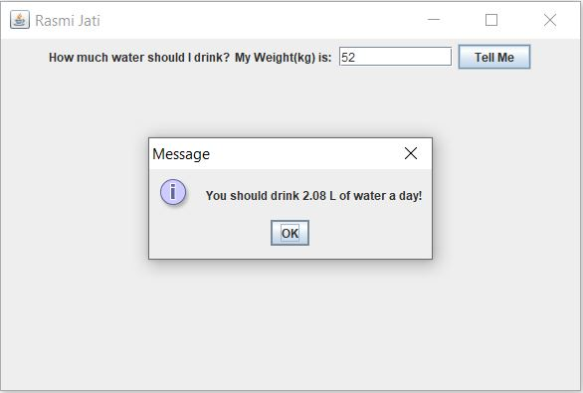

# Write a program to take string from user and display length of the given string.

## Introduction:

This program is used to take a string from user and display the length of the given string. It contains onetextfield and one buttons. A message according to the nature of string is displayed in a message box to response to the buttons. If button is clicked without any number in textfield error message is shown in dialog box.

This program is developed using JFrame, JLabel, JTextField, JButton and JOptionPane objects. Layout of frame is set null and set bound of the frame is given. Frame listens to ActionListener interface and ActionListener is added to button. The length of string is displayed through the actionPerformed function.

## Source Code:

importjavax.swing.*;

importjava.awt.*;

importjava.awt.event.*;

public class LengthOfString extends JFrame implements ActionListener{

JLabellblString;

JTextFieldtfString;

JButtonbtnOK;

publicLengthOfString(){

lblString = new JLabel("Enter a String:"); lblString.setBounds(30,40,140,30);

tfString = new JTextField(80); tfString.setBounds(180,40,150,30);

btnOK = new JButton("Ok");

btnOK.setBounds(80,100,75,30);

add(lblString);add(tfString);add(btnOK);

btnOK.addActionListener(this);

setTitle("RasmiJati");

setLayout(null);

setSize(600,400);

setVisible(true);

}

public void actionPerformed(ActionEvent e){

String s = tfString.getText();

int length = 0;

try{

length = s.length();

JOptionPane.showMessageDialog(this,length);

}catch(Exception f){

JOptionPane.showMessageDialog(this,"Error");

}

}

public static void main(String[] args){

newLengthOfString();

}

}

## Output:

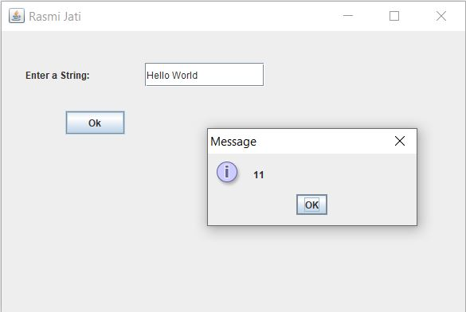

# Write a program to take string and integer (position) from user and display character at that given position of that user given string.

## Introduction:

This program is used to take a string and position from user and display the character of given position. It contains two textfield and one buttons. A message according to the nature of string and number is displayed in a message box to response to the buttons. If button is clicked without any number in textfield error message is shown in dialog box.

This program is developed using JFrame, JLabel, JTextField, JButton and JOptionPane objects. Layout of frame is set null and set bound of the frame is given. Frame listens to ActionListener interface and ActionListener is added to button. The character of given position of string is displayed through the actionPerformed function.

## Source Code:

importjavax.swing.*;

importjava.awt.*;

importjava.awt.event.*;

public class CharacterOfGivenPosition extends JFrame implements ActionListener{

JLabellblString, lblPosition;

JTextFieldtfString, tfPosition;

JButtonbtnShow;

publicCharacterOfGivenPosition(){

lblString = new JLabel("Enter a String"); lblString.setBounds(5,10,110,30);

lblPosition = new JLabel("Enter a Position"); lblPosition.setBounds(5,50,110,30);

tfString = new JTextField(100); tfString.setBounds(115,10,100,30);

tfPosition = new JTextField(100); tfPosition.setBounds(115,50,100,30);

btnShow = new JButton("Show"); btnShow.setBounds(65,100,100,30);

add(lblString);

add(tfString);

add(lblPosition);

add(tfPosition);

add(btnShow);

btnShow.addActionListener(this);

setLayout(null);

setTitle("RasmiJati");

setSize(600,400);

setVisible(true);

setDefaultCloseOperation(JFrame.EXIT_ON_CLOSE);

}

public void actionPerformed(ActionEvent e){

String str = tfString.getText();

String pos = tfPosition.getText();

try{

int n = Integer.parseInt(pos);

JOptionPane.showMessageDialog(this,str.charAt(n));

}catch(Exception f){

JOptionPane.showMessageDialog(this,"Error");

}

}

public static void main(String[] args){

newCharacterOfGivenPosition();

}

}

## Output:

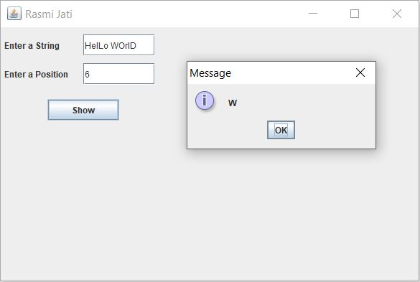

# Write a program to display series of numbers between two given numbers by user.

## Introduction:

This program is used to take two numbers and display the series of numbers between those numbers. It contains two textfield and one buttons. A message according to the nature of number is displayed in a JLabel to response to the button. If button is clicked without any number in textfield error message is shown in dialog box.

This program is developed using JFrame, JLabel, JTextField, JButton and JOptionPane objects. Layout of frame is set null and set bound of the frame is given. Frame listens to ActionListener interface and ActionListener is added to button. The series of number between two numbers is displayed through the actionPerformed function.

## Source Code:

importjavax.swing.*;

importjava.awt.*;

importjava.awt.event.*;

public class SeriesOfNumber extends JFrame implements ActionListener{

JLabel lblnumber1, lblnumber2, lblOutput;

JTextField tfnumber1, tfnumber2;

JButtonbtnDisplay;

publicSeriesOfNumber(){

lblnumber1 = new JLabel("Enter first number");

lblnumber2 = new JLabel("Enter last number");

tfnumber1 = new JTextField(100);

tfnumber2 = new JTextField(100);

lblnumber1.setBounds(10,5,110,30);

lblnumber2.setBounds(10,40,110,30);

tfnumber1.setBounds(115,5,100,30);

tfnumber2.setBounds(115,40,100,30);

lblOutput = new JLabel("................");

lblOutput.setBounds(50,120,600,30);

btnDisplay = new JButton("Display");

btnDisplay.setBounds(10,80,100,30);

add(lblnumber1);

add(tfnumber1);

add(lblnumber2);

add(tfnumber2);

add(btnDisplay);

add(lblOutput);

btnDisplay.addActionListener(this);

setLayout(null);

setTitle("RasmiJati");

setSize(600,400);

setVisible(true);

setDefaultCloseOperation(JFrame.EXIT_ON_CLOSE);

}

public void actionPerformed(ActionEvent e){

String num1 = tfnumber1.getText();

String num2 = tfnumber2.getText();

inti;

try{

int n1 = Integer.parseInt(num1);

int n2 = Integer.parseInt(num2);

String result = new String();

for(i = n1; i<=n2; i++){

result = result + i +" ";

lblOutput.setText(result);

}

}catch(Exception f){

JOptionPane.showMessageDialog(this,"Error");

}

}

public static void main(String[] srgs){

newSeriesOfNumber();

}

}

## Output:

`

