Chapter Exams
H1-4

Which four steps are needed to configure a voice VLAN on a switch port?
(Choose four).
- Assign the voice VLAN to the switch port.
- Ensure that voice traffic is trusted and tagged with a CoS priority value.
- Add a voice VLAN.
- Configure the switch port in access mode.

Refer to the exhibit. A technician is programming switch SW3 to manage voice and data traffic through port Fa0/20. What, if anything, is wrong with the configuration?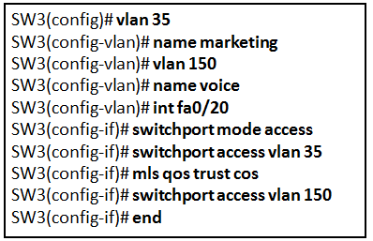
The command used to assign the voice VLAN to the switch port is incorrect.

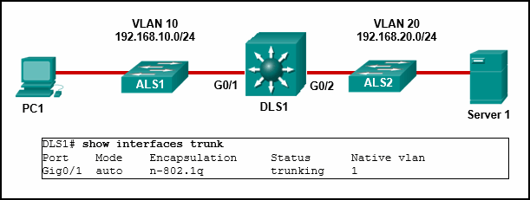

Interface G0/2 is not configured as a trunk.

A network contains multiple VLANs spanning multiple switches. What happens when a device in VLAN 20 sends a broadcast Ethernet frame?
Only devices in VLAN 20 see the frame.

Port Fa0/11 on a switch is assigned to VLAN 30. If the command “no switchport access vlan 30” is entered on the Fa0/11 interface, what will happen?
Port Fa0/11 will be returned to VLAN 1.

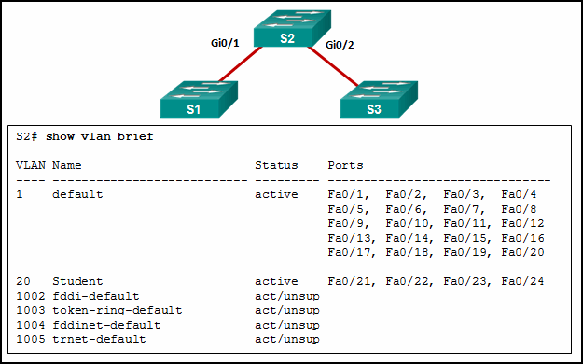
Refer to the exhibit. A network administrator is reviewing port and VLAN assignments on switch S2 and notices that interfaces Gi0/1 and Gi0/2 are not included in the output. Why would the interfaces be missing from the output?
They are configured as trunk interfaces.

On a switch that is configured with multiple VLANs, which command will remove only VLAN 100 from the switch?
no vlan 100
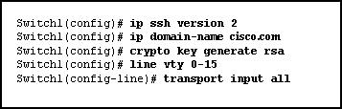

Refer to the exhibit. The network administrator wants to configure Switch1 to allow SSH connections and prohibit Telnet connections. How should the network administrator change the displayed configuration to satisfy the requirement?
Modify the transport input command.

Which two statements are correct with respect to SVI inter-VLAN routing?
(Choose two.)
- There is no need for a connection to a router.
- Switching packets is faster with SVI.

A network administrator issues the ”show vlan brief” command while troubleshooting a user support ticket. What output will be displayed?
the VLAN assignment and membership for all switch ports
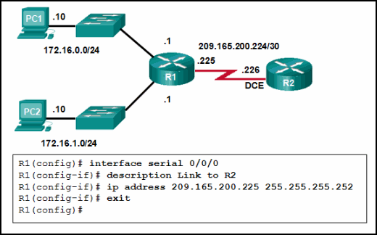
Refer to the exhibit. A network administrator has configured R1 as shown. When the administrator checks the status of the serial interface, the interface is shown as being administratively down. What additional command must be entered on the serial interface of R1 to bring the interface up?
no shutdown
Which type of VLAN is used to designate which traffic is untagged when crossing a trunk port?
native

Which solution would help a college alleviate network congestion due to collisions?
a high port density switch

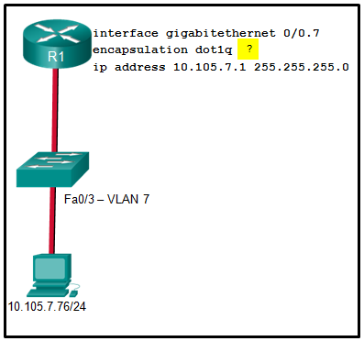
Refer to the exhibit. A network administrator is configuring inter-VLAN routing on a network. For now, only one VLAN is being used, but more will be added soon. What is the missing parameter that is shown as the highlighted question mark in the graphic?
It identifies the VLAN number.

Which message is displayed when 10.10.10.1 is entered into the PC1 Web Browser address bar?
File Server
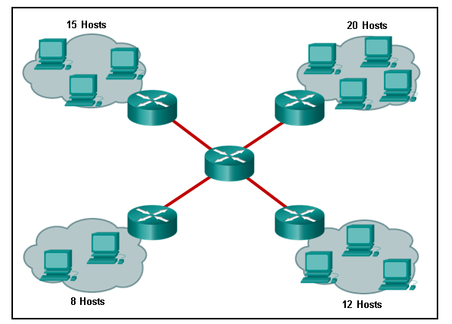
Refer to the exhibit. How many broadcast domains are displayed?
8
How do switch buffers affect network performance?
They store frames received, thus preventing premature frame discarding when network congestion occurs.

Which characteristic describes cut-through switching?
Frames are forwarded without any error checking.

Which statement is correct about Ethernet switch frame forwarding decisions?
Frame forwarding decisions are based on MAC address and port mappings in the CAM table.

Which switch characteristic helps keep traffic local and alleviates network congestion?
high port density

Which switching method ensures that the incoming frame is error-free before forwarding?
Store-and-forward

What is the significant difference between a hub and a Layer 2 LAN switch?
A hub extends a collision domain, and a switch divides collision domains.

What is a characteristic of an IPv4 loopback interface on a Cisco IOS router?​
It is a logical interface internal to the router.

After which step of the switch bootup sequence is the boot loader executed?
after POST execution

What does a switch use to locate and load the IOS image?
BOOT environment variable

A technician is configuring a new Cisco 2960 switch. What is the effect of issuing the “BranchSw(config-if)# mdix auto” command?
It automatically adjusts the port to allow device connections to use either a straight-through or a crossover cable.

A high school uses VLAN15 for the laboratory network and VLAN30 for the faculty network. What is required to enable communication between these two VLANs while using the router-on-a-stick approach?
A switch with a port that is configured as a trunk is needed when connecting to the router.
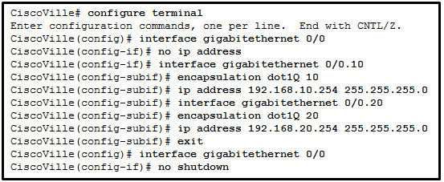
Refer to the exhibit. A network administrator has configured router CiscoVille with the above commands to provide inter-VLAN routing. What command will be required on a switch that is connected to the Gi0/0 interface on router CiscoVille to allow inter-VLAN routing?
switchport mode trunk

What is a characteristic of a routed port on a Layer 3 switch?
It is not assigned to a VLAN.

When routing a large number of VLANs, what are two disadvantages of using the router-on-a-stick inter-VLAN routing method rather than the multilayer switch inter-VLAN routing method? (Choose two.)
- A dedicated router is required.
- Multiple subinterfaces may impact the traffic flow speed.

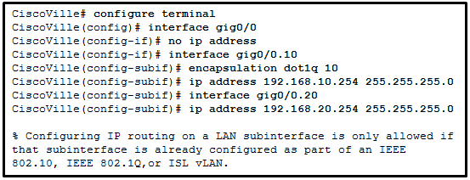
Refer to the exhibit. What is the cause of the error that is displayed in the configuration of inter-VLAN routing on router CiscoVille?
The encapsulation dot1Q 20 command has not been configured.

What type of VLAN is designed to have a delay of less than 150 ms across the network?
voice VLAN
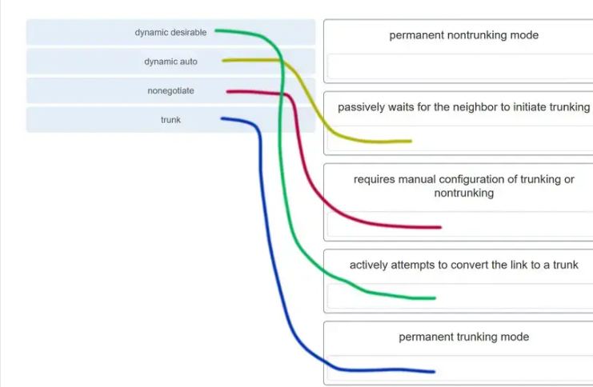

H5-6
Refer to the exhibit. Which switching technology would allow each access layer switch link to be aggregated to provide more bandwidth between each Layer 2 switch and the Layer 3 switch?
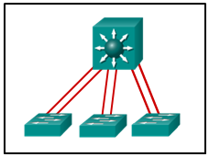

EtherChannel

Which set of configuration commands issued on SW1 will successfully complete the EtherChannel link between SW1 and SW2?
interface GigabitEthernet0/1
channel-group 1 mode desirable

Refer to the exhibit. What are the possible port roles for ports A, B, C, and D in this RSTP-enabled network?
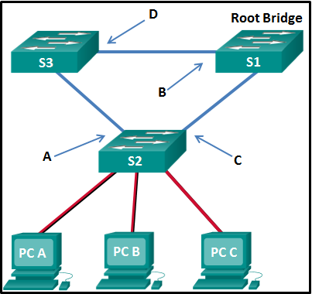
alternate, designated, root, root

Refer to the exhibit. An administrator wants to form an EtherChannel between the two switches by using the Port Aggregation Protocol. If switch S1 is configured to be in auto mode, which mode should be configured on S2 to form the EtherChannel?
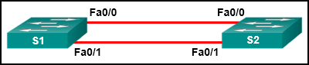
desirable

Which statement describes an EtherChannel implementation?
A trunked port can be part of an EtherChannel bundle.

Refer to the exhibit. A network administrator is configuring an EtherChannel link between two switches, SW1 and SW2. Which statement describes the effect after the commands are issued on SW1 and SW2?
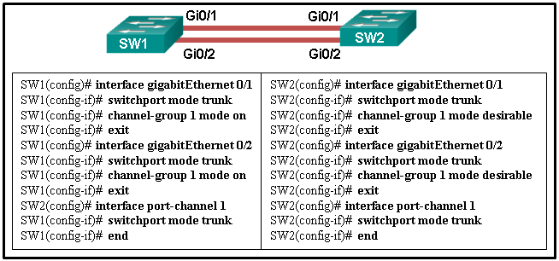
The EtherChannel fails to establish.

A network administrator has configured an EtherChannel between two switches that are connected via four trunk links. If the physical interface for one of the trunk links changes to a down state, what happens to the EtherChannel?
The EtherChannel will remain functional.

Refer to the exhibit. An EtherChannel was configured between switches S1 and S2, but the interfaces do not form an EtherChannel. What is the problem?
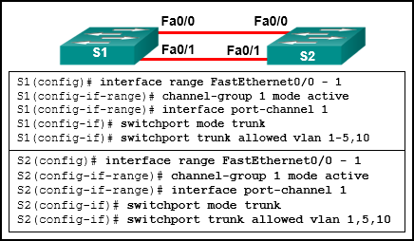
The EtherChannel was not configured with the same allowed range of VLANs on each interface.

What is a requirement to configure a trunking EtherChannel between two switches?
The allowed range of VLANs must be the same on both switches.

Which technology is an open protocol standard that allows switches to automatically bundle physical ports into a single logical link?
LACP

Which mode configuration setting would allow formation of an EtherChannel link between switches SW1 and SW2 without sending negotiation traffic?
SW1: on
SW2: on
Which statement is true regarding the use of PAgP to create EtherChannels?
It is Cisco proprietary.
Which statement describes a characteristic of EtherChannel?
It is made by combining multiple physical links that are seen as one link between two switches.

Refer to the exhibit. The administrator tried to create an EtherChannel between S1 and the other two switches via the commands that are shown, but was unsuccessful. What is the problem?
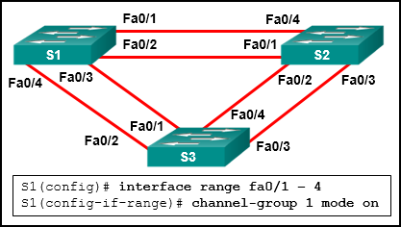
Traffic cannot be sent to two different switches through the same EtherChannel link.

A network administrator configured an EtherChannel link with three interfaces between two switches. What is the result if one of the three interfaces is down?
The remaining two interfaces continue to load balance traffic.

Which two parameters must match on the ports of two switches to create a PAgP EtherChannel between the switches? (Choose two.)
- VLAN information
- speed
What are two advantages of EtherChannel? (Choose two.)
- Spanning Tree Protocol views the physical links in an EtherChannel as one logical connection.
- Configuring the EtherChannel interface provides consistency in the configuration of the physical links.

What is the function of STP in a scalable network?
It disables redundant paths to eliminate Layer 2 loops.
Which three components are combined to form a bridge ID?
- MAC address
- extended system ID
- bridge priority

Which spanning tree standard supports only one root bridge so that traffic from all VLANs flows over the same path?
802.1D

Refer to the exhibit. Which switch will be the root bridge after the election process is complete?
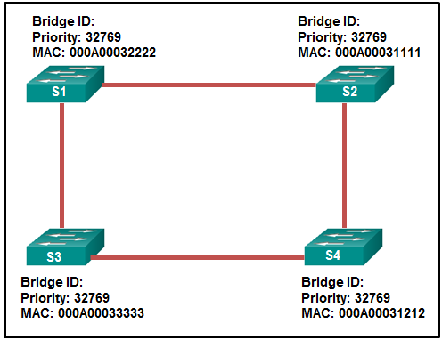
S2
What is the purpose of the Spanning Tree Protocol (STP)?
prevents Layer 2 loops
What is the value used to determine which port on a non-root bridge will become a root port in a STP network?
the path cost
A small company network has six interconnected Layer 2 switches. Currently all switches are using the default bridge priority value. Which value can be used to configure the bridge priority of one of the switches to ensure that it becomes the root bridge in this design?
28672
A set of switches is being connected in a LAN topology. Which STP bridge priority value will make it least likely for the switch to be selected as the root?
61440

Which two network design features require Spanning Tree Protocol (STP) to ensure correct network operation? (Choose two.)
- redundant links between Layer 2 switches
- removing single points of failure with multiple Layer 2 switches
If no bridge priority is configured in PVST, which criteria is considered when electing the root bridge?
lowest MAC address
Which protocol provides up to 16 instances of RSTP, combines many VLANs with the same physical and logical topology into a common RSTP instance, and provides support for PortFast, BPDU guard, BPDU filter, root guard, and loop guard?
MST

What is a characteristic of spanning tree?
It is enabled by default on Cisco switches.

A switch is configured to run STP. What term describes a field used to specify a VLAN ID?extended system ID
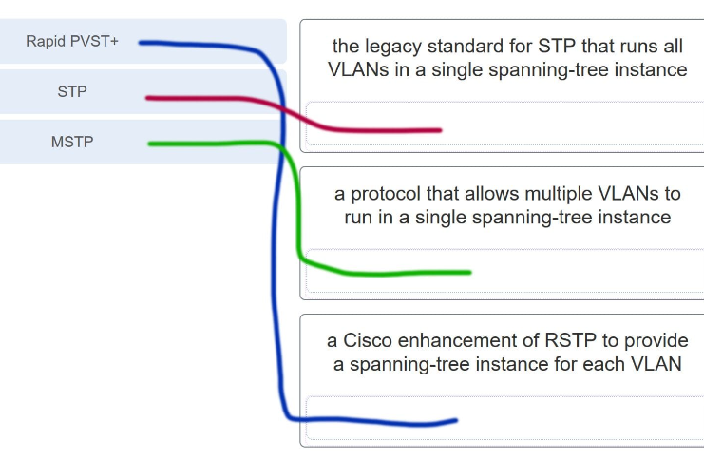

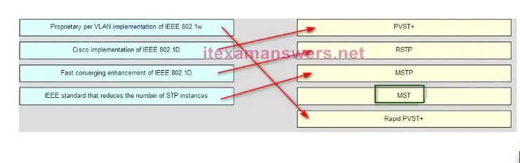

H7-9
Which statement describes HSRP?
It is used within a group of routers for selecting an active device and a standby device to provide gateway services to a LAN.
What is the keyword that is displayed on www.netacad.com?
Router

After a host has generated an IPv6 address by using the DHCPv6 or SLAAC process, how does the host verify that the address is unique and therefore usable?
The host sends an ICMPv6 neighbor solicitation message to the DHCP or SLAAC-learned address and if no neighbor advertisement is returned, the address is considered unique.
What is one indication that a Windows computer did not receive an IPv4 address from a DHCP server?
The computer receives an IP address that starts with 169.254.
Which protocol automates assignment of IP addresses on a network, and which port number does it use? (Choose two.)
- DHCP
- 67
Which command, when issued in the interface configuration mode of a router, enables the interface to acquire an IPv4 address automatically from an ISP, when that link to the ISP is enabled?
ip address dhcp

What is an advantage of configuring a Cisco router as a relay agent?
It can provide relay services for multiple UDP services.

Which command will allow a network administrator to check the IP address that is assigned to a particular MAC address?
Router#:show ip dhcp binding

What is the reason that an ISP commonly assigns a DHCP address to a wireless router in a SOHO environment?
easy IP address management

Which statement is true about DHCP operation?
When a device that is configured to use DHCP boots, the client broadcasts a DHCPDISCOVER message to identify any available DHCP servers on the network.

Which set of commands will configure a router as a DHCP server that will assign IPv4 addresses to the 192.168.100.0/23 LAN while reserving the first 10 and the last addresses for static assignment?
ip dhcp excluded-address 192.168.100.1 192.168.100.10
ip dhcp excluded-address 192.168.101.254
ip dhcp pool LAN-POOL-100
network 192.168.100.0 255.255.254.0
default-router 192.168.100.1

Which message does an IPv4 host use to reply when it receives a DHCPOFFER message from a DHCP server?
DHCPREQUEST

A company uses DHCP to manage IP address deployment for employee workstations. The IT department deploys multiple DHCP servers in the data center and uses DHCP relay agents to facilitate the DHCP requests from workstations. Which two UDP ports are used to forward DHCP traffic? (Choose two.)
67
68
A host PC is attempting to lease an address through DHCP. What message is sent by the server to let the client know it is able to use the provided IP information?
DHCPACK

Refer to the exhibit. PC1 is configured to obtain a dynamic IP address from the DHCP server. PC1 has been shut down for two weeks. When PC1 boots and tries to request an available IP address, which destination IP address will PC1 place in the IP header?
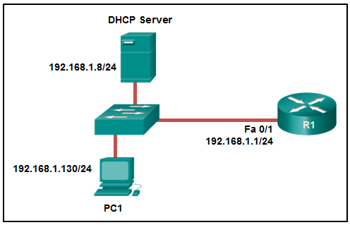
255.255.255.255

Which DHCPv4 message will a client send to accept an IPv4 address that is offered by a DHCP server?
broadcast DHCPREQUEST

What is the result of a network technician issuing the command ip dhcp excluded-address 10.0.15.1 10.0.15.15 on a Cisco router?
The Cisco router will exclude 15 IP addresses from being leased to DHCP clients.
Which FHRP implementation is a Cisco-proprietary protocol that suppports IPv4 load sharing?
GLBP
Refer to the exhibit. A network administrator is configuring a router as a DHCPv6 server. The administrator issues a “show ipv6 dhcp pool”command to verify the configuration. Which statement explains the reason that the number of active clients is 0?
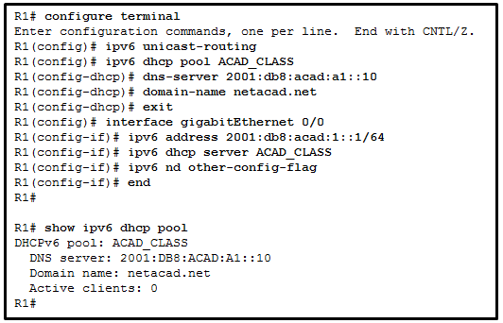
The state is not maintained by the DHCPv6 server under stateless DHCPv6 operation.

A network administrator configures a router to send RA messages with M flag as 0 and O flag as 1. Which statement describes the effect of this configuration when a PC tries to configure its IPv6 address?
It should use the information that is contained in the RA message and contact a DHCPv6 server for additional information.

Refer to the exhibit. What should be done to allow PC-A to receive an IPv6 address from the DHCPv6 server?
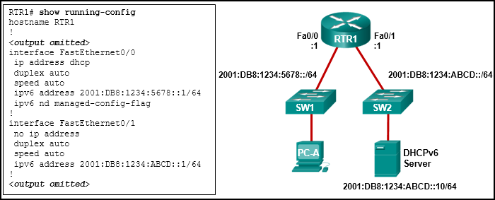
Add the “ipv6 dhcp relay” command to interface Fa0/0.

Refer to the exhibit. Based on the output that is shown, what kind of IPv6 addressing is being configured?
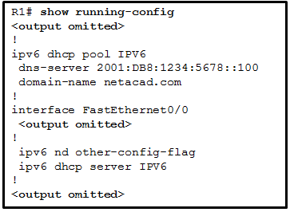
stateless DHCPv6

A company uses the method SLAAC to configure IPv6 addresses for the workstations of the employees. A network administrator configured the IPv6 address on the LAN interface of the router. The interface status is UP. However, the workstations on the LAN segment did not obtain the correct prefix and prefix length. What else should be configured on the router that is attached to the LAN segment for the workstations to obtain the information?
ipv6 unicast-routing

Refer to the exhibit. What protocol can be configured on gateway routers R1 and R2 that will allow traffic from the internal LAN to be load balanced across the two gateways to the Internet?
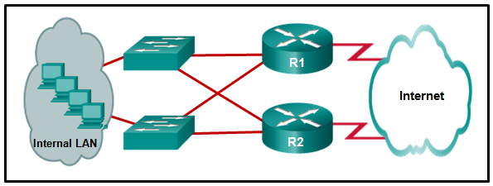
GLBP

Refer to the exhibit. A network engineer is troubleshooting host connectivity on a LAN that uses a first hop redundancy protocol. Which IPv4 gateway address should be configured on the host?
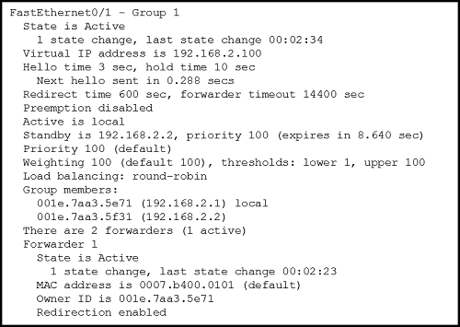
192.168.2.100
Refer to the exhibit. Which destination MAC address is used when frames are sent from the workstation to the default gateway?
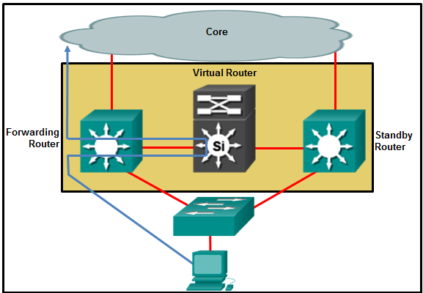
MAC address of the virtual router
A network administrator is analyzing the features that are supported by different first-hop router redundancy protocols. Which statement describes a feature that is associated with HSRP?
HSRP uses active and standby routers.
The address pool of a DHCP server is configured with 192.168.184.0/26. The network administrator reserves 18 IP addresses for access points. How many IP addresses
are left in the pool to be assigned to other hosts?
44

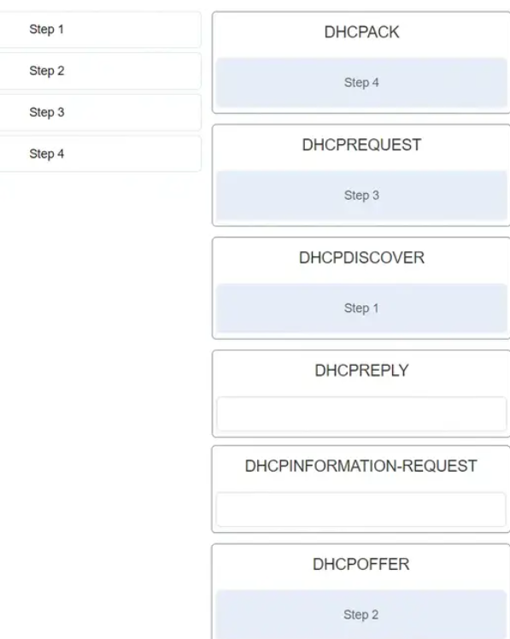
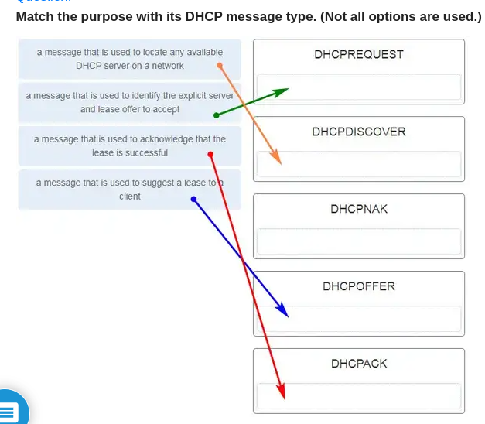

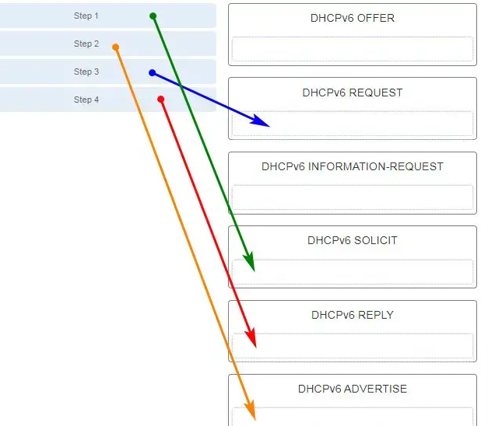
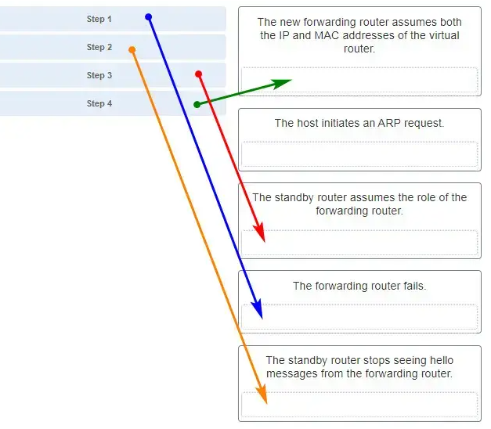
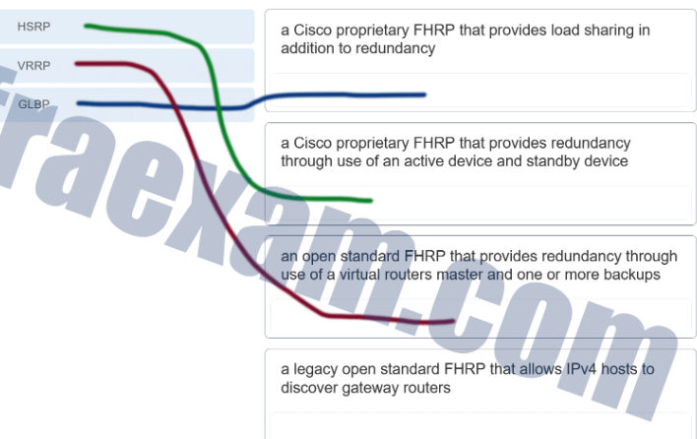

H10-13
Which two commands can be used to enable BPDU guard on a switch? (Choose two.)
- S1(config)#:spanning-tree portfast bpduguard default
- S1(config-if)#:spanning-tree bpduguard enable

A network administrator enters the following commands on the switch SW1.
SW1(config)#:interface range fa0/5 – 10
SW1(config-if)#:ip dhcp snooping limit rate 6
What is the effect after these commands are entered?
FastEthernet ports 5 through 10 can receive up to 6 DHCP discovery messages per second.

Refer to the exhibit. The Fa0/2 interface on switch S1 has been configured with the “switchport port-security mac-address 0023.189d.6456” command and a workstation has been connected. What could be the reason that the Fa0/2 interface is shutdown?
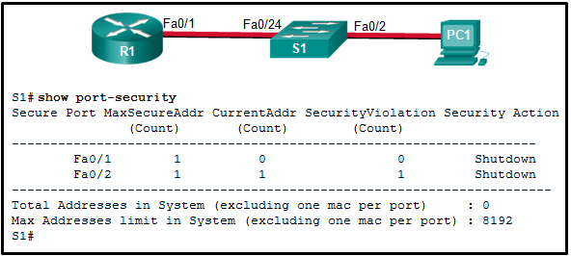
The MAC address of PC1 that connects to the Fa0/2 interface is not the configured MAC address.

As part of the new security policy, all switches on the network are configured to automatically learn MAC addresses for each port. All running configurations are saved at the start and close of every business day. A severe thunderstorm causes an extended power outage several hours after the close of business. When the switches are brought back online, the dynamically learned MAC addresses are retained. Which port security configuration enabled this?
sticky secure MAC addresses

Refer to the exhibit. PC1 and PC2 should be able to obtain IP address assignments from the DHCP server. How many ports among switches should be assigned as trusted ports as part of the DHCP snooping configuration?
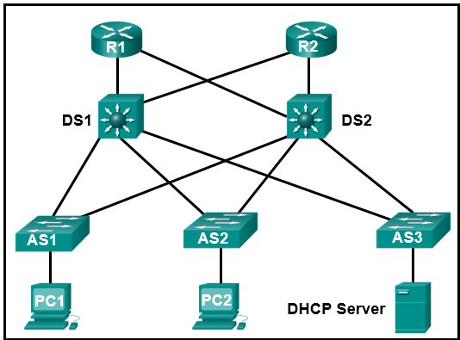
7

An IT security specialist enables port security on a switch port of a Cisco switch. What is the default violation mode in use until the switch port is configured to use a different violation mode?
Shutdown

A network engineer is troubleshooting a newly deployed wireless network that is using the latest 802.11 standards. When users access high bandwidth services such as streaming video, the wireless network performance is poor. To improve performance the network engineer decides to configure a 5 Ghz frequency band SSID and train users to use that SSID for streaming media services. Why might this solution improve the wireless network performance for that type of service?
The 5 GHz band has more channels and is less crowded than the 2.4 GHz band, which makes it more suited to streaming multimedia.
A network administrator is working to improve WLAN performance on a dual-band wireless router. What is a simple way to achieve a split-the-traffic result?
Make sure that different SSIDs are used for the 2.4 GHz and 5 GHz bands.
A network administrator deploys a wireless router in a small law firm. Employee laptops join the WLAN and receive IP addresses in the 10.0.10.0/24 network. Which service is used on the wireless router to allow the employee laptops to access the internet?
NAT

A laptop cannot connect to a wireless access point. Which two troubleshooting steps should be taken first? (Choose two.)
- Ensure that the wireless SSID is chosen.
- Ensure that the wireless NIC is enabled.
On a Cisco 3504 WLC dashboard, which option provides access to the full menu of features?
Advanced

A technician is about to install and configure a wireless network at a small branch office. What is the first security measure the technician should apply immediately upon powering up the wireless router?
Change the default user-name and password of the wireless router.

Which access control component, implementation, or protocol controls what users can do on the network?
Authorization

Refer to the exhibit. What can be determined about port security from the information that is shown?
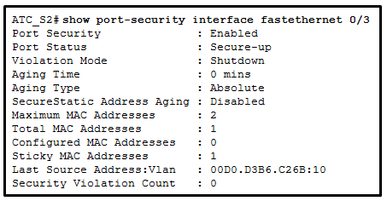
The port violation mode is the default for any port that has port security enabled.

What is the function provided by CAPWAP protocol in a corporate wireless network?
CAPWAP provides the encapsulation and forwarding of wireless user traffic between an access point and a wireless LAN controller.

A technician is troubleshooting a slow WLAN that consists of 802.11b and 802.11g devices . A new 802.11n/ac dual-band router has been deployed on the network to replace the old 802.11g router. What can the technician do to address the slow wireless speed?
Split the wireless traffic between the 802.11n 2.4 GHz band and the 5 GHz band.

The company handbook states that employees cannot have microwave ovens in their offices. Instead, all employees must use the microwave ovens located in the employee cafeteria. What wireless security risk is the company trying to avoid?
accidental interference
A network administrator of a college is configuring the WLAN user authentication process. Wireless users are required to enter username and password credentials that will be verified by a server. Which server would provide such service?
RADIUS
Open the PT Activity. Perform the tasks in the activity instructions and then answer the question. Which event will take place if there is a port security violation on switch S1 interface Fa0/1?
Packets with unknown source addresses will be dropped.
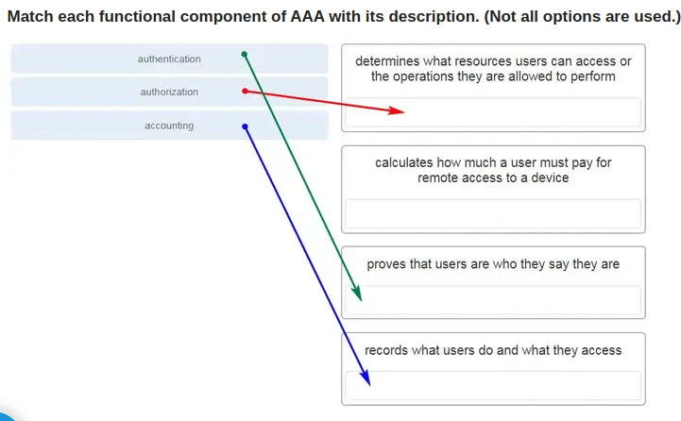

What are three techniques for mitigating VLAN attacks? (Choose three.)
- Set the native VLAN to an unused VLAN.
- Enable trunking manually.
- Disable DTP.
Which two Cisco solutions help prevent DHCP starvation attacks? (Choose two.)
- DHCP Snooping
- Port Security
Which type of wireless network is suitable for use in a home or office?
wireless local-area network

A company has recently implemented an 802.11n wireless network. Some users are complaining that the wireless network is too slow. Which solution is the best method to enhance the performance of the wireless network?
Split the traffic between the 2.4 GHz and 5 GHz frequency bands.
A network administrator is required to upgrade wireless access to end users in a building. To provide data rates up to 1.3 Gb/s and still be backward compatible with older devices, which wireless standard should be implemented?
802.11ac

What is a wireless security mode that requires a RADIUS server to authenticate wireless users?
Enterprise

What are the two methods that are used by a wireless NIC to discover an AP? (Choose two.)
- receiving a broadcast beacon frame
- transmitting a probe request

What type of wireless antenna is best suited for providing coverage in large open spaces, such as hallways or large conference rooms?
Omnidirectional

Which statement describes the behavior of a switch when the MAC address table is full?
It treats frames as unknown unicast and floods all incoming frames to all ports within the local VLAN.
Which component of AAA is used to determine which resources a user can access and which operations the user is allowed to perform?
Authorization
What are two protocols that are used by AAA to authenticate users against a central database of usernames and password? (Choose two.)
TACACS+
RADIUS
Which feature or configuration on a switch makes it vulnerable to VLAN double-tagging attacks?
the native VLAN of the trunking port being the same as a user VLAN

What represents a best practice concerning discovery protocols such as CDP and LLDP on network devices?
Disable both protocols on all interfaces where they are not required.

H14-16
Consider the following command:
ip route 192.168.10.0 255.255.255.0 10.10.10.2 5
How would an administrator test this configuration?
Manually shut down the router interface used as a primary route.

Refer to the exhibit. The network engineer for the company that is shown wants to use the primary ISP connection for all external connectivity. The backup ISP connection is used only if the primary ISP connection fails. Which set of commands would accomplish this goal?
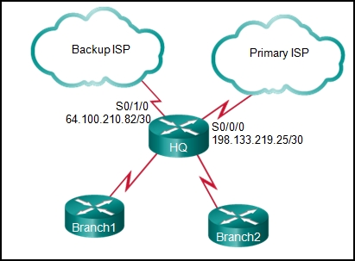
ip route 0.0.0.0 0.0.0.0 s0/0/0
ip route 0.0.0.0 0.0.0.0 s0/1/0 10

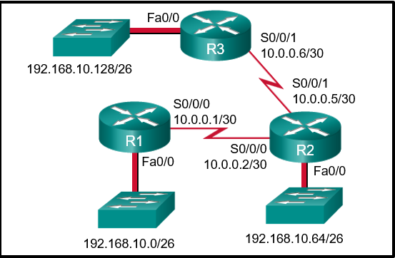
Refer to the exhibit. The routing table for R2 is as follows:
Gateway of last resort is not set
10.0.0.0/30 is subnetted, 2 subnets
C 10.0.0.0 is directly connected, Serial0/0/0
C 10.0.0.4 is directly connected, Serial0/0/1
192.168.10.0/26 is subnetted, 3 subnets
S 192.168.10.0 is directly connected, Serial0/0/0
C 192.168.10.64 is directly connected, FastEthernet0/0
S 192.168.10.128 [1/0] via 10.0.0.6
What will router R2 do with a packet destined for 192.168.10.129?
send the packet out interface Serial0/0/1

What is a characteristic of a floating static route?
It is configured with a higher administrative distance than the original dynamic routing protocol has.
An administrator issues the “ipv6 route 2001:db8:acad:1::/32 gigabitethernet0/0 2001:db8:acad:6::1 100” command on a router. What administrative distance is assigned to this route?
100
On which two routers would a default static route be configured? (Choose two.)
stub router connection to the rest of the corporate or campus network
edge router connection to the ISP

Refer to the exhibit. Which set of commands will configure static routes that will allow the Park and the Alta routers to a) forward packets to each LAN and b) direct all other traffic to the Internet?
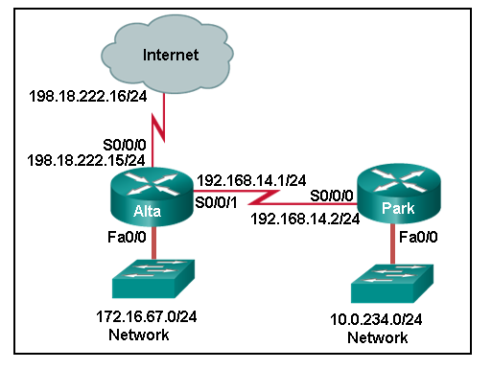
Park(config)#: ip route 0.0.0.0 0.0.0.0 192.168.14.1
Alta(config)#: ip route 10.0.234.0 255.255.255.0 192.168.14.2
Alta(config)#: ip route 0.0.0.0 0.0.0.0 s0/0/0

What network prefix and prefix-length combination is used to create a default static route that will match any IPv6 destination?
::/0

Refer to the graphic. Which command would be used on router A to configure a static route to direct traffic from LAN A that is destined for LAN C?
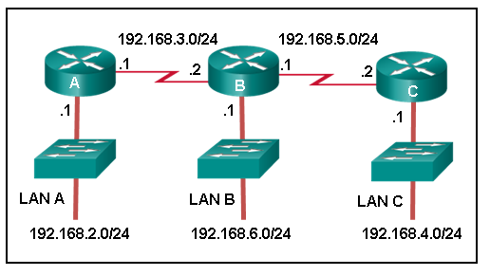
A(config)#: ip route 192.168.4.0 255.255.255.0 192.168.3.2

Consider the following command:
ip route 192.168.10.0 255.255.255.0 10.10.10.2 5
What does the 5 at the end of the command signify?
administrative distance

Consider the following command:
ip route 192.168.10.0 255.255.255.0 10.10.10.2 5
Which route would have to go down in order for this static route to appear in the routing table?
a static route to the 192.168.10.0/24 network

Refer to the exhibit. Which static route would an IT technician enter to create a backup route to the 172.16.1.0 network that is only used if the primary RIP learned route fails?
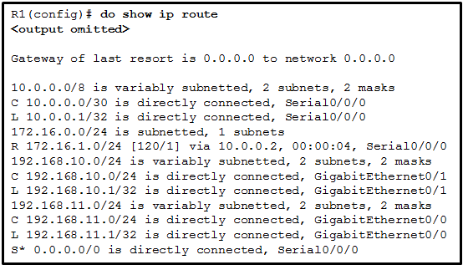

ip route 172.16.1.0 255.255.255.0 s0/0/0 121

Refer to the exhibit. What would happen after the IT administrator enters the new static route?
The 172.16.1.0 route learned from RIP would be replaced with the 172.16.1.0 static route.

What two pieces of information are needed in a fully specified static route to eliminate recursive lookups? (Choose two.)
- the IP address of the next-hop neighbor
- the interface ID exit interface

Refer to the exhibit. What routing solution will allow both PC A and PC B to access the Internet with the minimum amount of router CPU and network bandwidth utilization?
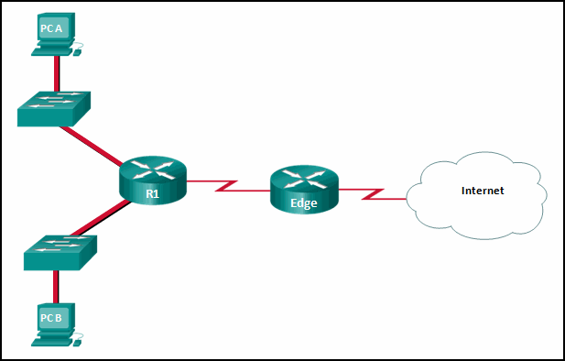
Configure a static default route from R1 to Edge, a default route from Edge to the Internet, and a static route from Edge to R1.

Open the PT Activity. Perform the tasks in the activity instructions and then answer the question. A user reports that PC0 cannot visit the web server “www.server.com”. Troubleshoot the network configuration to identify the problem.
What is the cause of the problem?
Routing between HQ and Branch is configured incorrectly.

Refer to the exhibit. Which command will properly configure an IPv6 static route on R2 that will allow traffic from PC2 to reach PC1 without any recursive lookups by router R2?
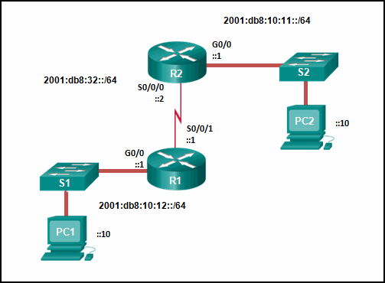
R2(config)#: ipv6 route 2001:db8:10:12::/64 S0/0/0

Refer to the exhibit. A ping from R1 to 10.1.1.2 is successful, but a ping from R1 to any address in the 192.168.2.0 network fails. What is the cause of this problem?
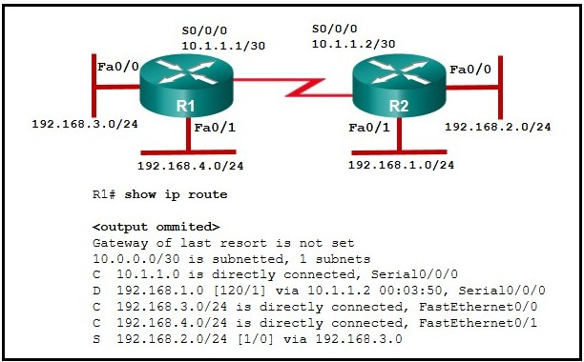
The static route for 192.168.2.0 is incorrectly configured.

Refer to the exhibit. The small company shown uses static routing. Users on the R2 LAN have reported a problem with connectivity. What is the issue?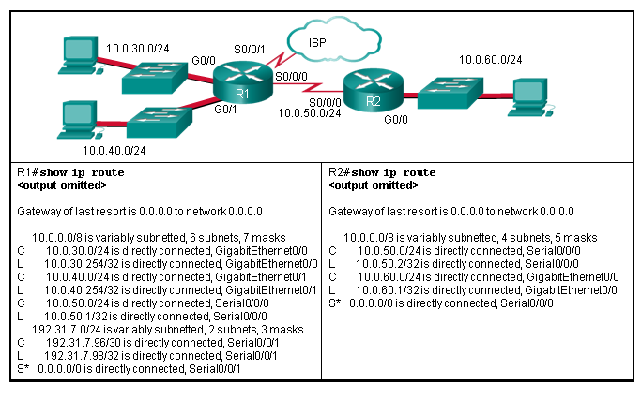
R1 needs a static route to the R2 LAN.

Refer to the exhibit. HostA is attempting to contact ServerB. Which two statements correctly describe the addressing that HostA will generate in the process? (Choose two.)
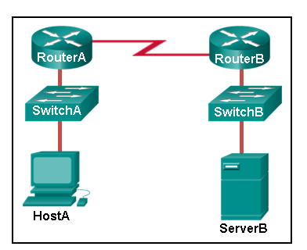
- A packet with the destination IP address of ServerB.
- A frame with the destination MAC address of RouterA.

Refer to the exhibit. How was the host route 2001:DB8:CAFE:4::1/128 installed in the routing table?
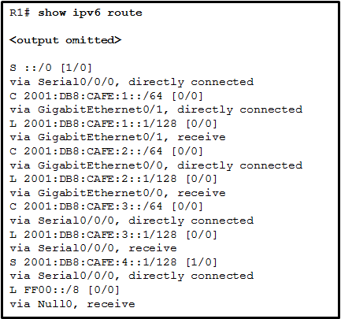
The route was manually entered by an administrator.

Refer to the exhibit. The Branch Router has an OSPF neighbor relationship with the HQ router over the 198.51.0.4/30 network. The 198.51.0.8/30 network link should serve as a backup when the OSPF link goes down. The floating static route command ip route 0.0.0.0 0.0.0.0 S0/1/1 100 was issued on Branch and now traffic is using the backup link even when the OSPF link is up and functioning. Which change should be made to the static route command so that traffic will only use the OSPF link when it is up?
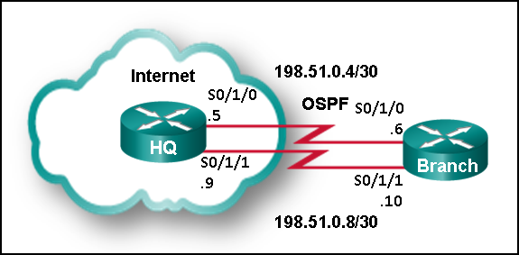
Change the administrative distance to 120.

Refer to the exhibit. An administrator is attempting to install an IPv6 static route on router R1 to reach the network attached to router R2. After the static route command is entered, connectivity to the network is still failing. What error has been made in the static route configuration?
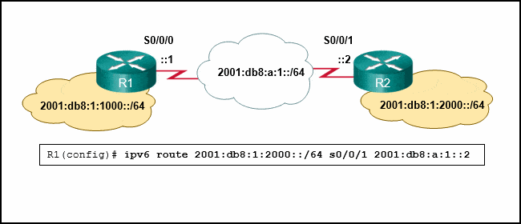
The interface is incorrect.

Refer to the exhibit. An administrator is attempting to install a default static route on router R1 to reach the Site B network on router R2. After entering the static route command, the route is still not showing up in the routing table of router R1. What is preventing the route from installing in the routing table?
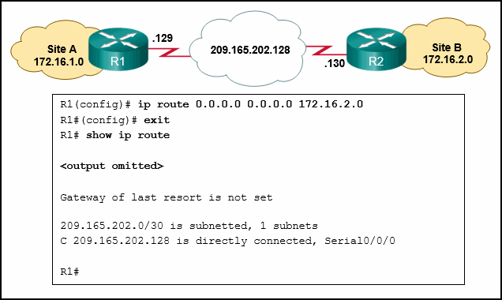
The next hop address is incorrect.

Refer to the exhibit. Which interface will be the exit interface to forward a data packet that has the destination IP address 10.55.99.78?
Gateway of last resort is not set.
10.55.99.0/26 is variously subnetted, 7 subnets, 3 masks
O 10.55.99.0/26 [110/10] via 10.55.18.1, 00:00:24, Serial0/0/0
O 10.55.99.64/26 [110/20] via 10.55.18.6, 00:00:56, Serial 0/0/1
O 10.55.99.128/26 [110/10] via 10.55.18.1, 00:00:24, Serial 0/0/0
C 10.55.99.192/27 is directly connected, GigabitEthernet0/0
L 10.55.99.193/27 is directly connected, GigabitEthernet0/0
C 10.55.99.224/27 is directly connected, GigabitEthernet0/1
L 10.55.99.225/27 is directly connected, GigabitEthernet0/1
10.55.18.0/24 is variably subnetted, 4 subnets, 2 masks
C 10.55.18.0/30 is directly connected, Serial0/0/0
L 10.55.18.2/32 is directly connected, Serial0/0/0
C 10.55.18.4/30 is directly connected, Serial0/0/1
L 10.55.18.5/32 is directly connected, Serial0/0/1
S 10.55.19.0/26 [1/0] via 10.55.18.1, 00:00:24, Serial0/0/0
R1#
Serial0/0/1
What characteristic completes the following statement?
When an IPv6 static route is configured, the installation of the route can be verified with ...…
the "show ipv6 route static" command.

Refer to the exhibit. PC A sends a request to Server B. What IPv4 address is used in the destination field in the packet as the packet leaves PC A?
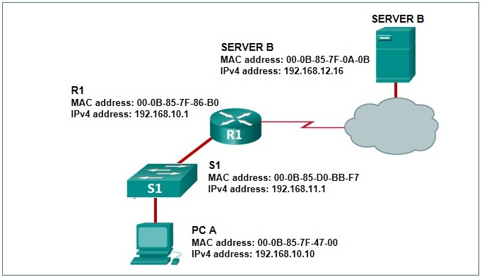
192.168.12.16

Which value in a routing table represents trustworthiness and is used by the router to determine which route to install into the routing table when there are multiple routes toward the same destination?
administrative distance
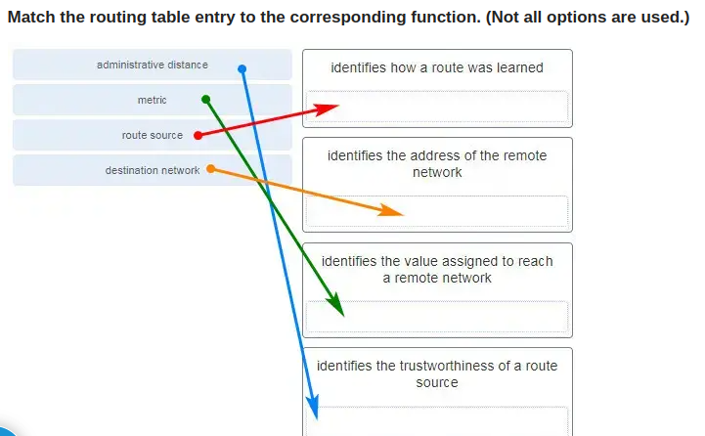
What is a characteristic of a static route that matches all packets?
It identifies the gateway IP address to which the router sends all IP packets for which it does not have a learned or static route.

When would it be more beneficial to use a dynamic routing protocol instead of static routing?
on a network where there is a lot of topology changes
Refer to the exhibit. What will the router do with a packet that has a destination IP address of 192.168.12.227?
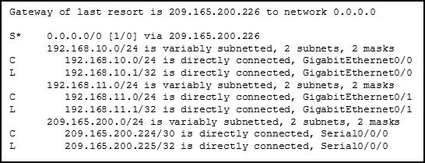
Send the packet out the Serial0/0/0 interface.
A network administrator configures the interface fa0/0 on the router R1 with the command “ip address 172.16.1.254 255.255.255.0”. However, when the administrator issues the command “show ip route” , the routing table does not show the directly connected network. What is the possible cause of the problem?
The interface fa0/0 has not been activated.

