Question 1 of 29
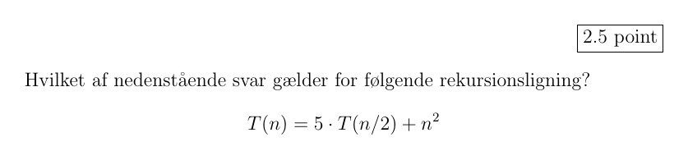
- Select the image in alternative 0
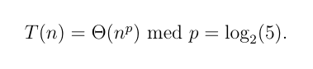
- Select the image in alternative 1
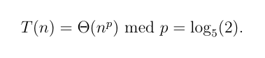
- Select the image in alternative 2
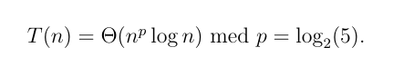
- Select the image in alternative 3
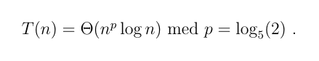
- Select the image in alternative 4
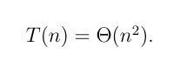
- Select the image in alternative 5

Clear answer

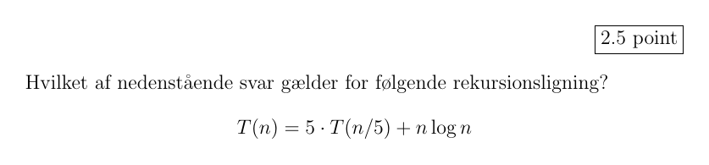
- Select the image in alternative 0
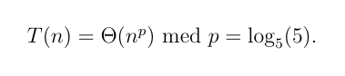
- Select the image in alternative 1
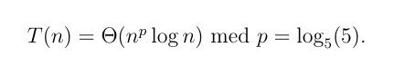
- Select the image in alternative 2


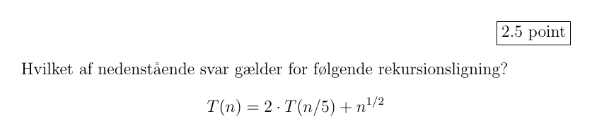
- Select the image in alternative 0

- Select the image in alternative 1

- Select the image in alternative 2

- Select the image in alternative 3
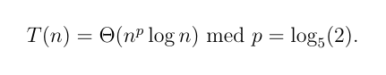
- Select the image in alternative 4
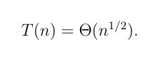
- Select the image in alternative 5


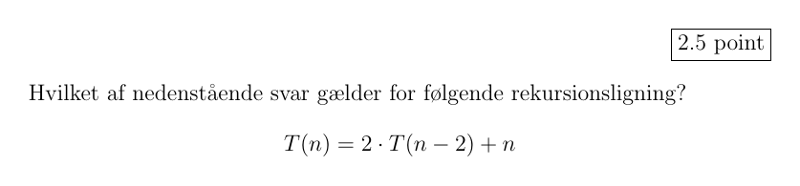
- Select the image in alternative 0
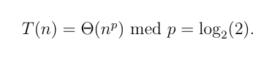
- Select the image in alternative 1
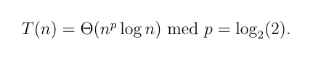
- Select the image in alternative 2



- Select the image in alternative 0
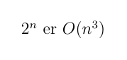
- Select the image in alternative 1
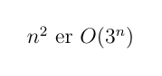
- Select the image in alternative 2
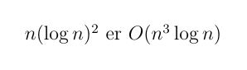
- Select the image in alternative 3
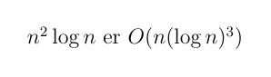
- Select the image in alternative 4
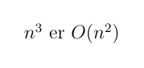
- Select the image in alternative 5
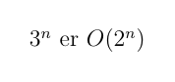
- Select the image in alternative 6
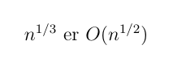
- Select the image in alternative 7
Question 6 of 29
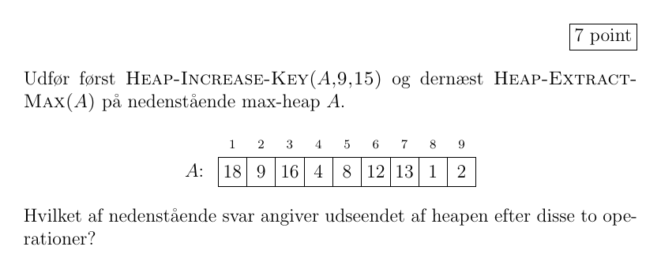
- Select the image in alternative 0
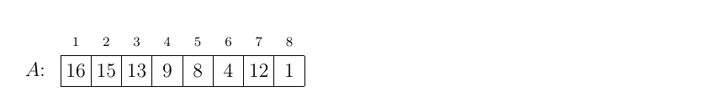
- Select the image in alternative 1
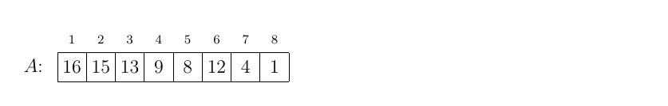
- Select the image in alternative 2
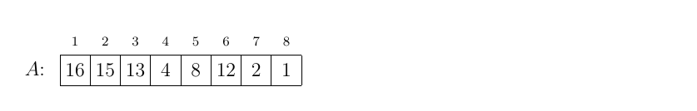
- Select the image in alternative 3
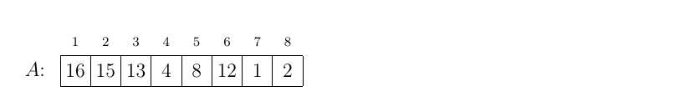
Clear answer

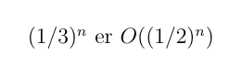
- Select the image in alternative 8
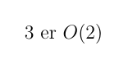
Question 7 of 29
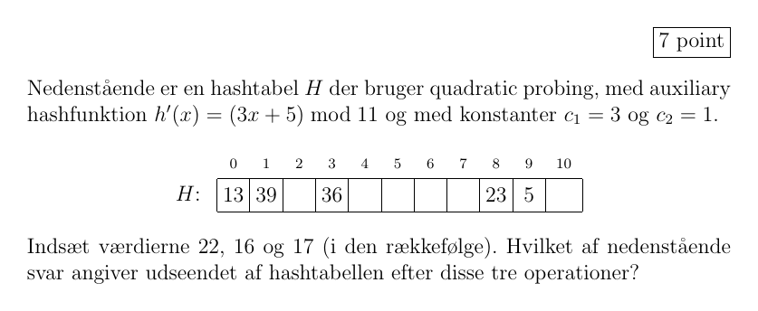
- Select the image in alternative 0
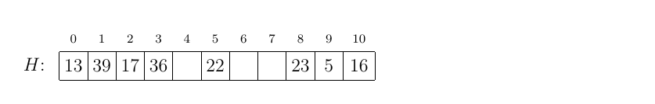
- Select the image in alternative 1
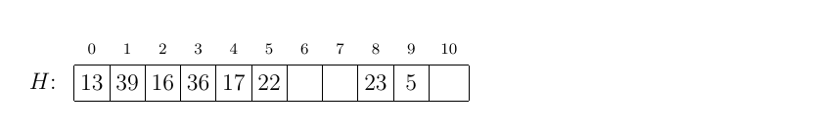
- Select the image in alternative 2
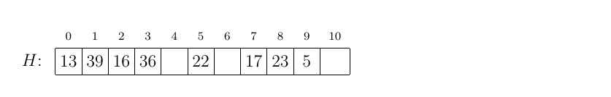
- Select the image in alternative 3
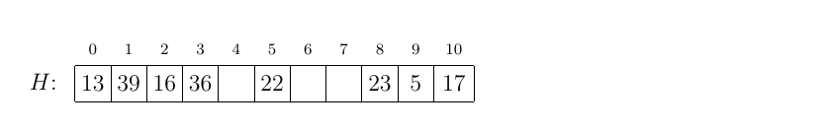
Clear answer

Question 8 of 29
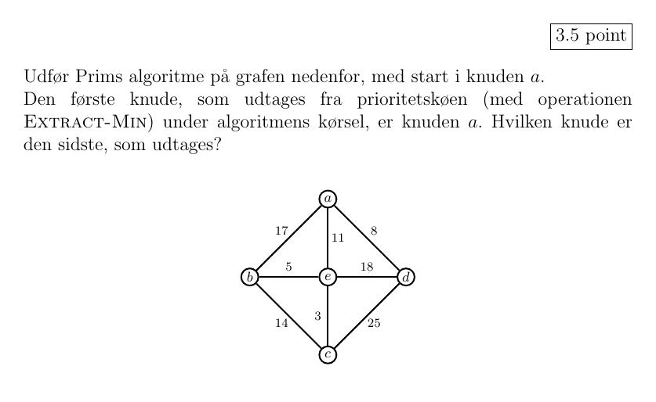
- Select the image in alternative 0
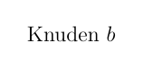
- Select the image in alternative 1

- Select the image in alternative 2
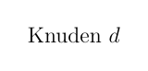
- Select the image in alternative 3

Clear answer

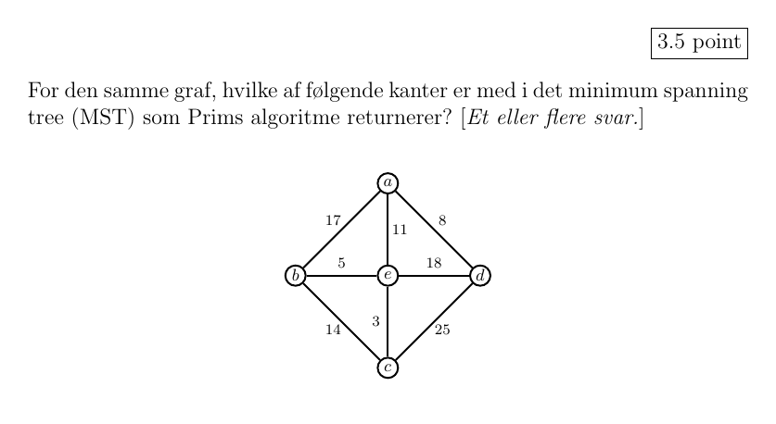
- Select the image in alternative 0
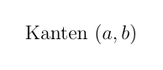
- Select the image in alternative 1

- Select the image in alternative 2
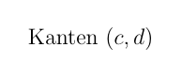
- Select the image in alternative 3
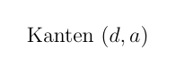
- Select the image in alternative 4

- Select the image in alternative 5
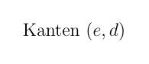
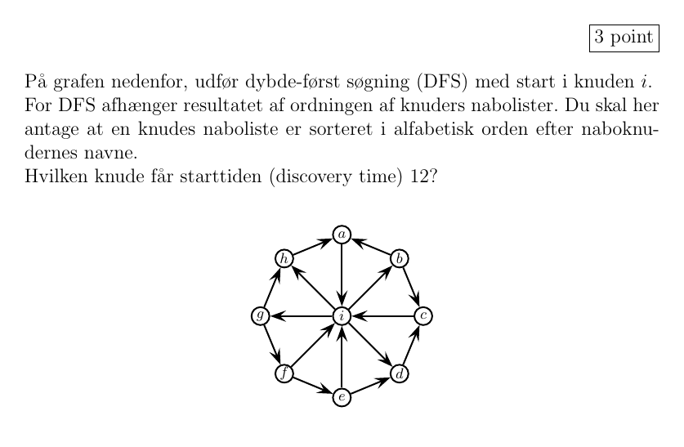
- Select the image in alternative 0

- Select the image in alternative 1

- Select the image in alternative 2
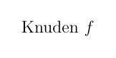
- Select the image in alternative 3
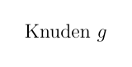
- Select the image in alternative 4
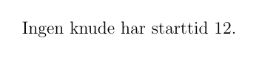
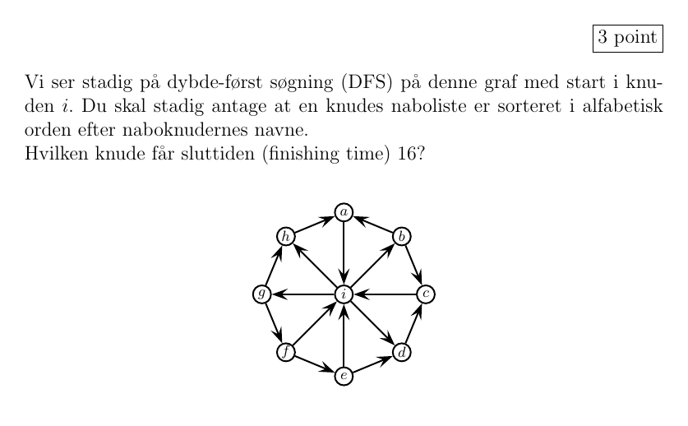
- Select the image in alternative 0

- Select the image in alternative 1

- Select the image in alternative 2

- Select the image in alternative 3
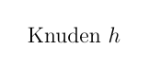
- Select the image in alternative 4
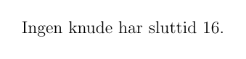
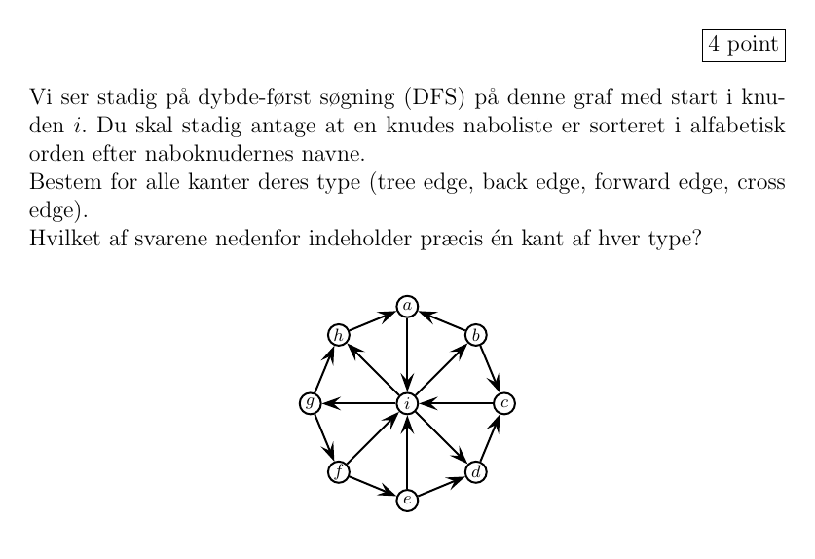
- Select the image in alternative 0
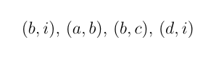
- Select the image in alternative 1
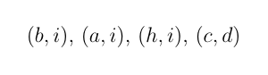
- Select the image in alternative 2
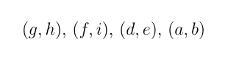
- Select the image in alternative 3
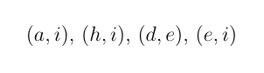
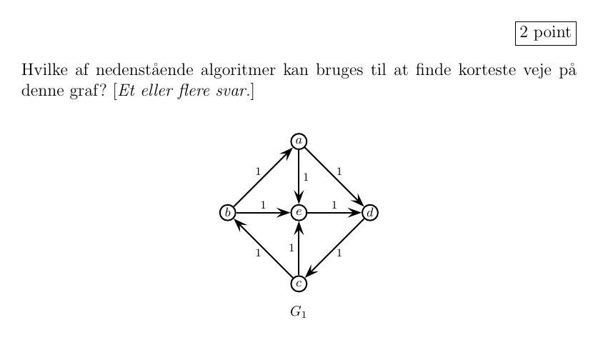
- Select the image in alternative 0
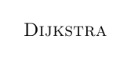
- Select the image in alternative 1

- Select the image in alternative 2
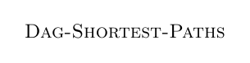
- Select the image in alternative 3

- Select the image in alternative 4

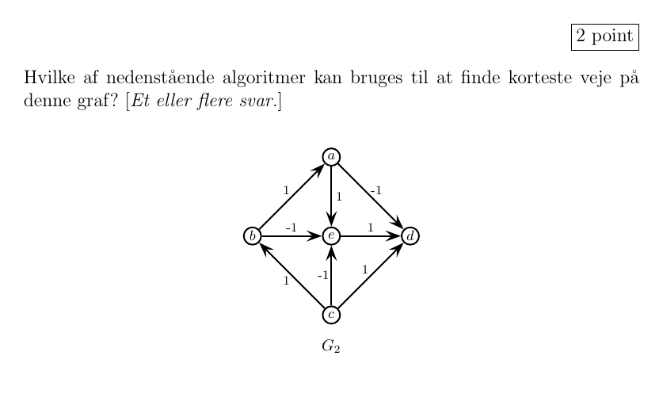
- Select the image in alternative 0

- Select the image in alternative 1

- Select the image in alternative 2

- Select the image in alternative 3

- Select the image in alternative 4

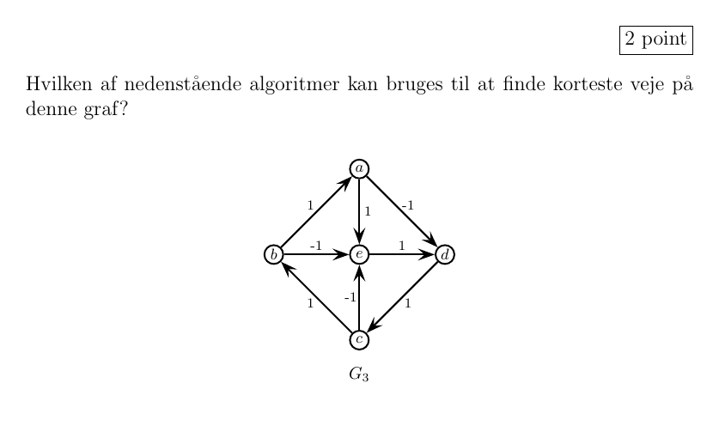
- Select the image in alternative 0

- Select the image in alternative 1

- Select the image in alternative 2

- Select the image in alternative 3

- Select the image in alternative 4


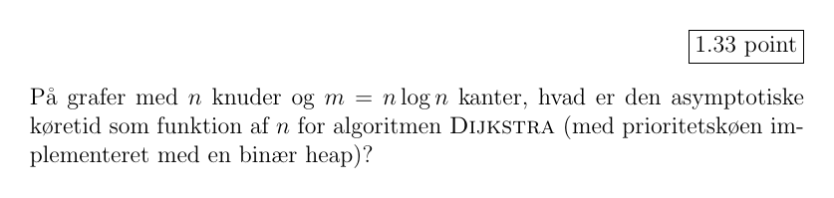
- Select the image in alternative 0
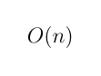
- Select the image in alternative 1
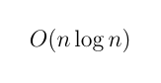
- Select the image in alternative 2
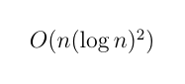
- Select the image in alternative 3
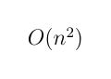
- Select the image in alternative 4
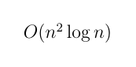
- Select the image in alternative 5
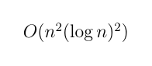

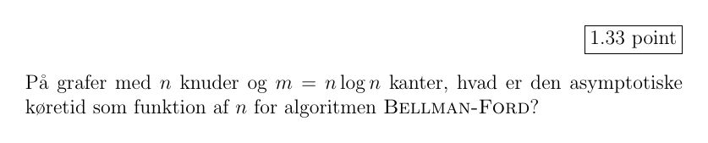
- Select the image in alternative 0

- Select the image in alternative 1

- Select the image in alternative 2

- Select the image in alternative 3

- Select the image in alternative 4

- Select the image in alternative 5

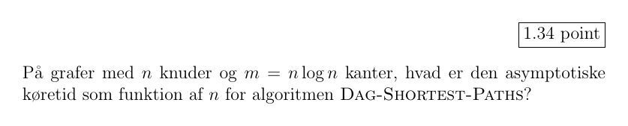
- Select the image in alternative 0

- Select the image in alternative 1

- Select the image in alternative 2

- Select the image in alternative 3

- Select the image in alternative 4

- Select the image in alternative 5

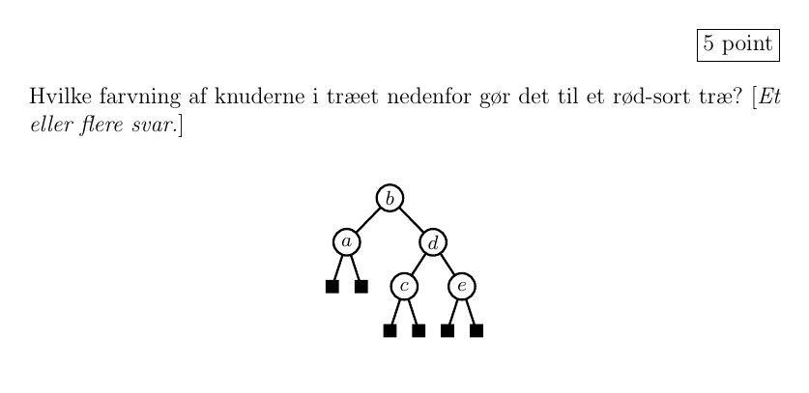
- Select the image in alternative 0
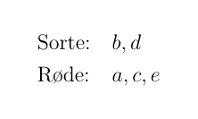
- Select the image in alternative 1
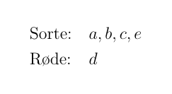
- Select the image in alternative 2
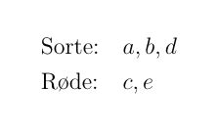
- Select the image in alternative 3
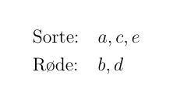
- Select the image in alternative 4
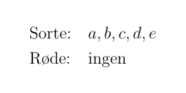

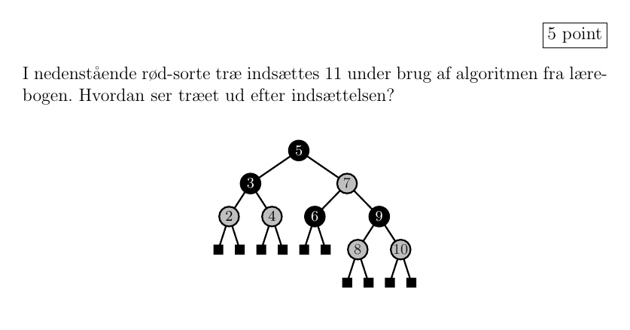
- Select the image in alternative 0
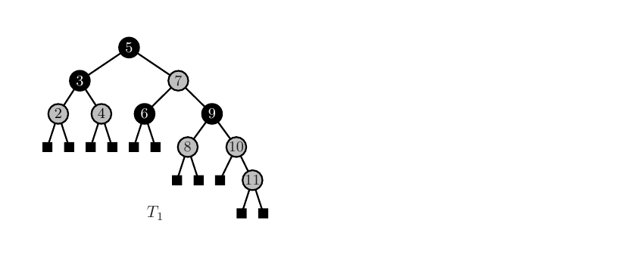
- Select the image in alternative 1
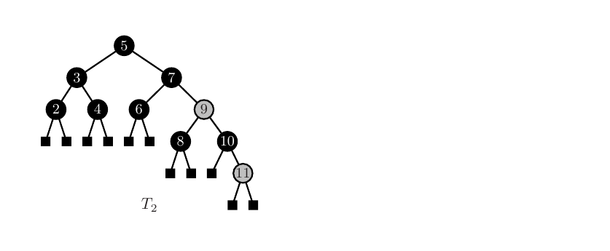
- Select the image in alternative 2
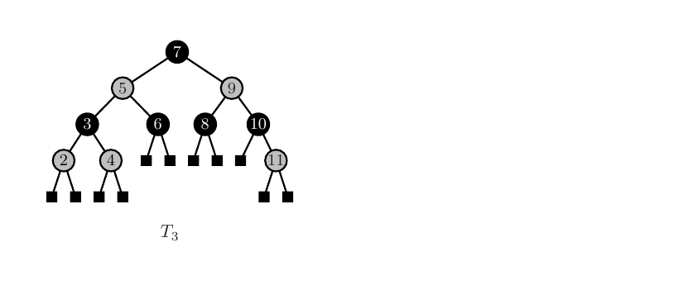
- Select the image in alternative 3
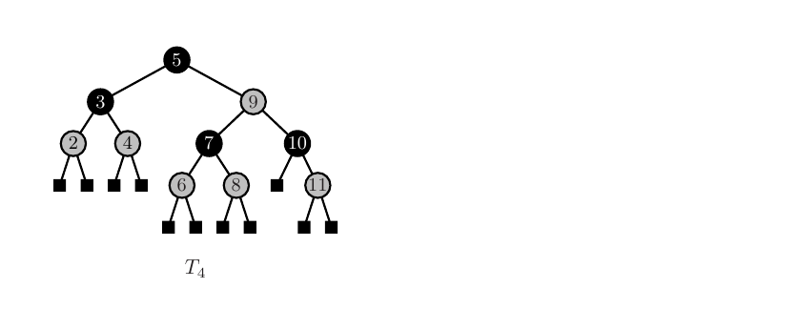

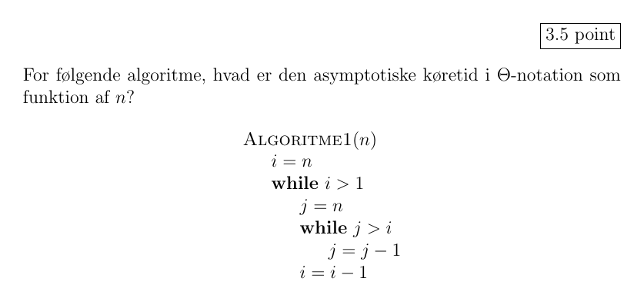
- Select the image in alternative 0
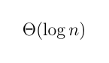
- Select the image in alternative 1
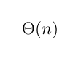
- Select the image in alternative 2
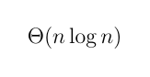
- Select the image in alternative 3
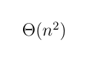
- Select the image in alternative 4
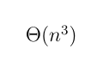
- Select the image in alternative 5
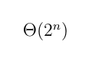
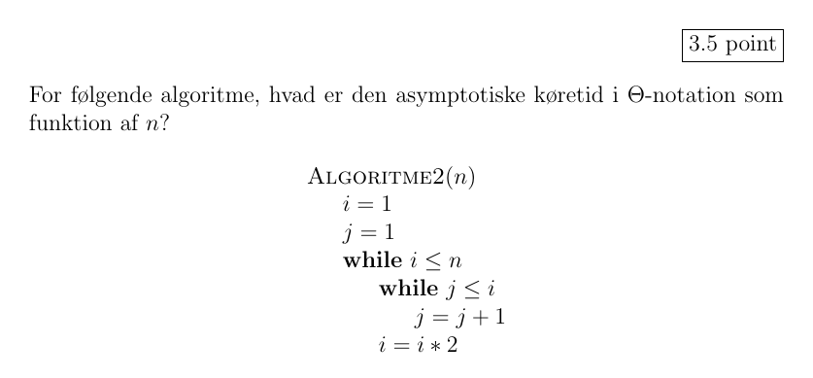
- Select the image in alternative 0

- Select the image in alternative 1

- Select the image in alternative 2

- Select the image in alternative 3

- Select the image in alternative 4

- Select the image in alternative 5

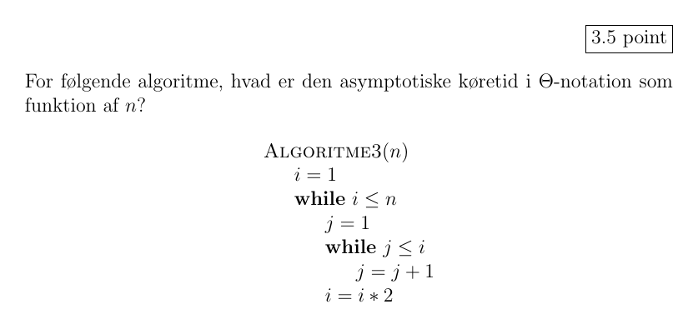
- Select the image in alternative 0

- Select the image in alternative 1

- Select the image in alternative 2

- Select the image in alternative 3

- Select the image in alternative 4

- Select the image in alternative 5

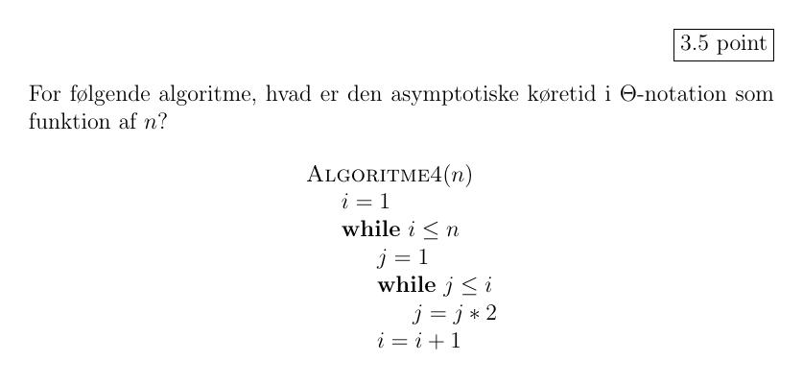
- Select the image in alternative 0

- Select the image in alternative 1

- Select the image in alternative 2

- Select the image in alternative 3

- Select the image in alternative 4

- Select the image in alternative 5


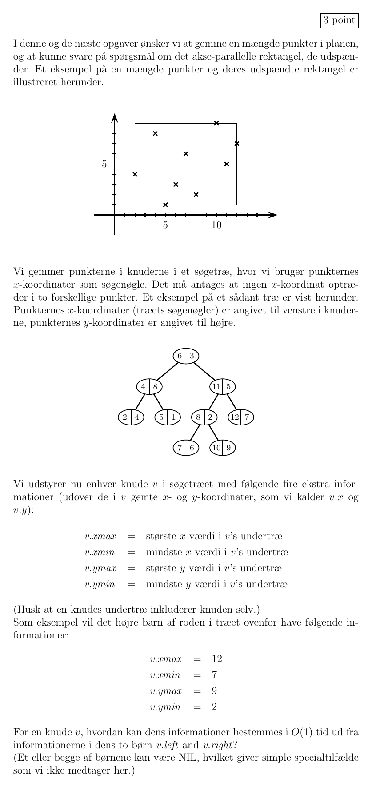
- Select the image in alternative 0
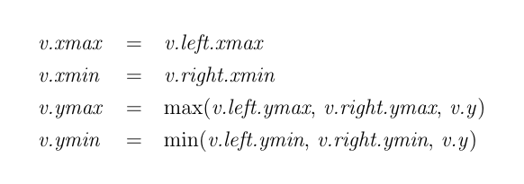
- Select the image in alternative 1
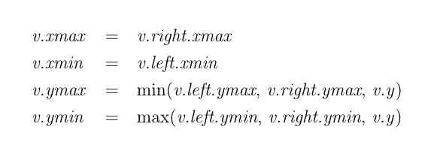
- Select the image in alternative 2
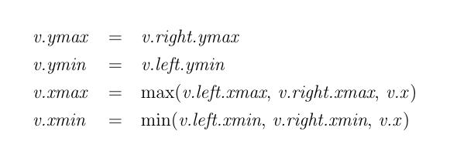
- Select the image in alternative 3
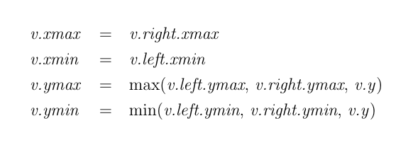

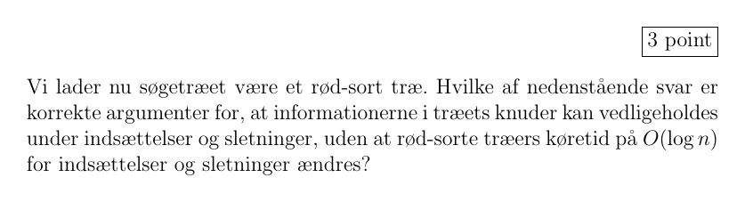
- Select the image in alternative 0
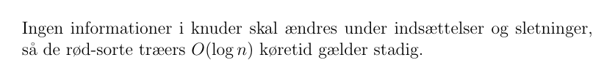
- Select the image in alternative 1

- Select the image in alternative 2
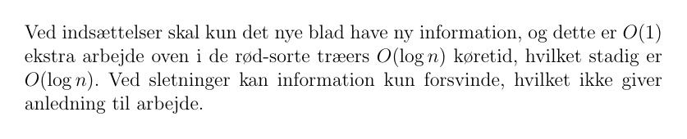
- Select the image in alternative 3

- Select the image in alternative 4
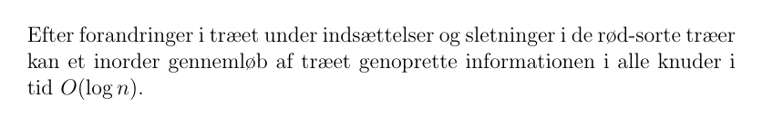

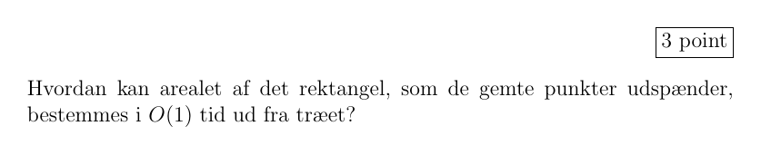
- Select the image in alternative 0
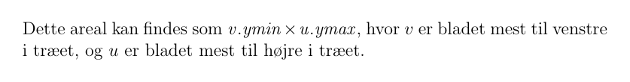
- Select the image in alternative 1
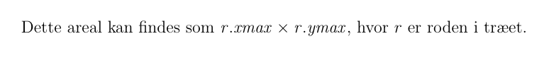
- Select the image in alternative 2
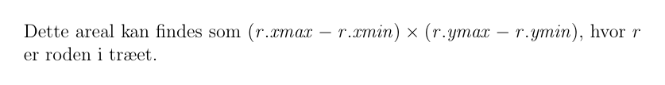
- Select the image in alternative 3

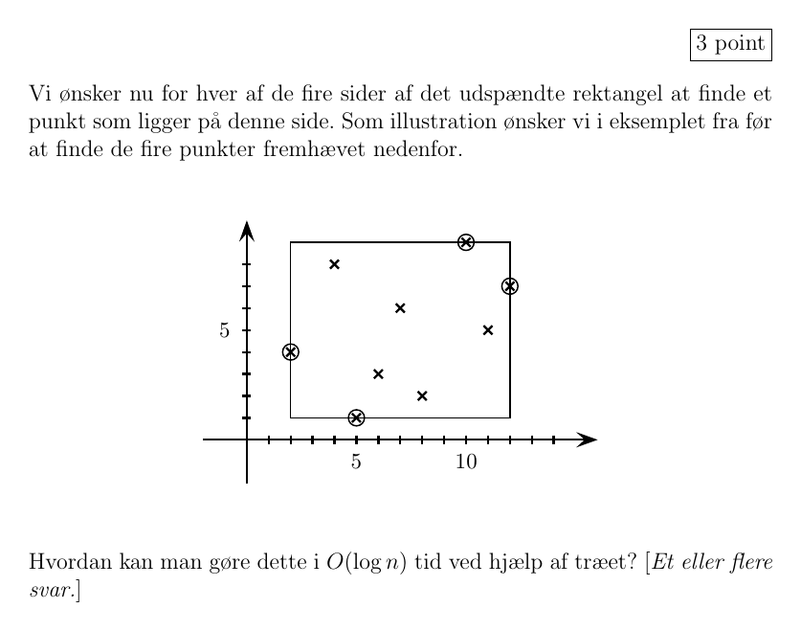
- Select the image in alternative 0
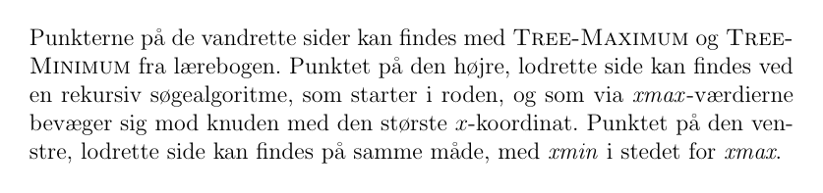
- Select the image in alternative 1
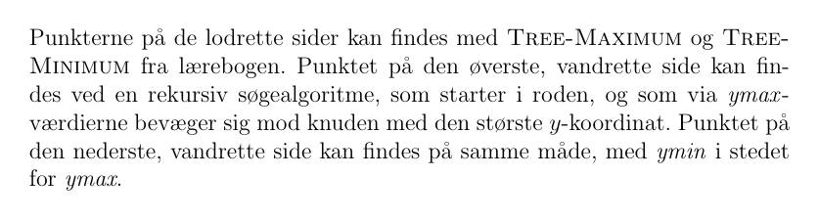
- Select the image in alternative 2

- Select the image in alternative 3
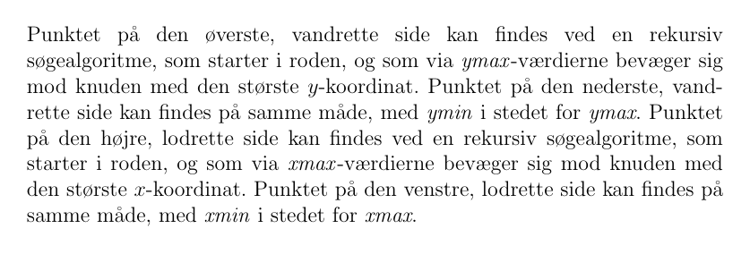
- Select the image in alternative 4
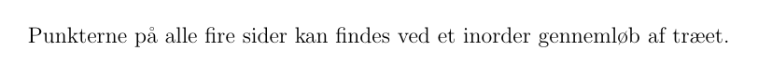
Question 29 of 29
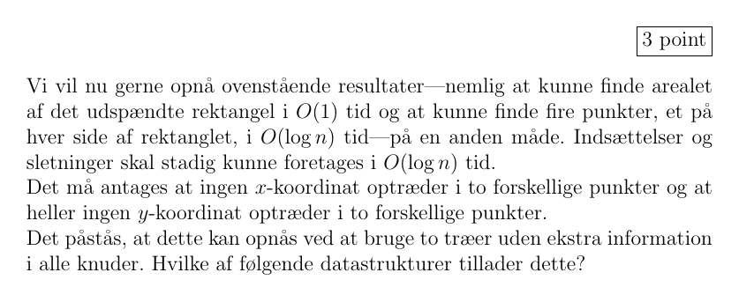
- Select the image in alternative 0
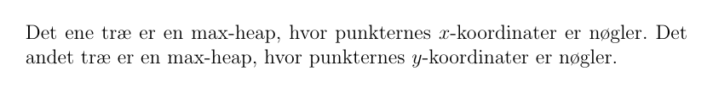
- Select the image in alternative 1
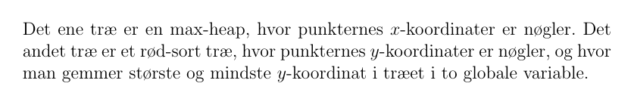
- Select the image in alternative 2

- Select the image in alternative 3
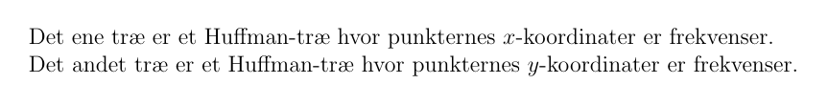
Clear answer

