Question 1 of 26
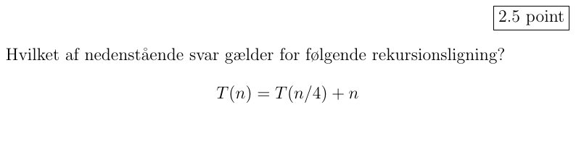
- Select the image in alternative 0
- Select the image in alternative 1
- Select the image in alternative 2
- Select the image in alternative 3
- Select the image in alternative 4
- Select the image in alternative 5
Clear answer

Question 2 of 26
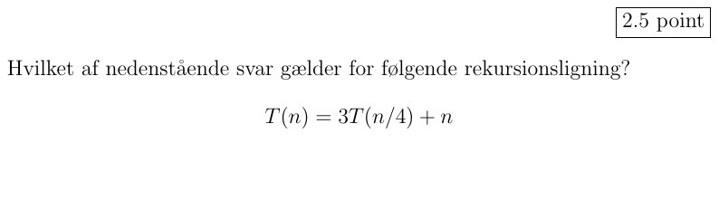
- Select the image in alternative 0
- Select the image in alternative 1
- Select the image in alternative 2
- Select the image in alternative 3
- Select the image in alternative 4
- Select the image in alternative 5
- Select the image in alternative 6
Clear answer

Question 3 of 26
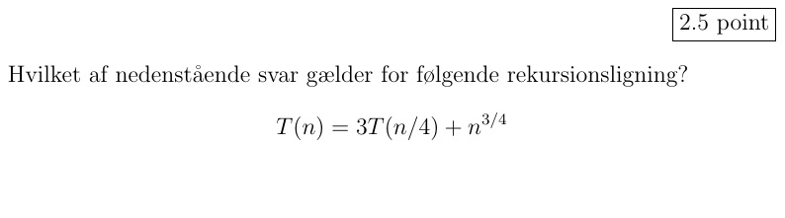
- Select the image in alternative 0
- Select the image in alternative 1
- Select the image in alternative 2
- Select the image in alternative 3
- Select the image in alternative 4
- Select the image in alternative 5
- Select the image in alternative 6
Clear answer

Question 4 of 26
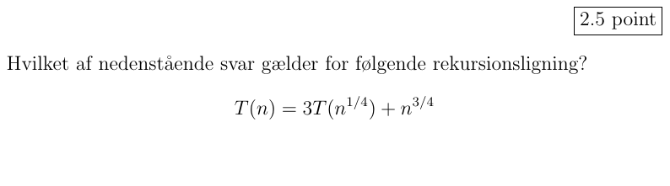
- Select the image in alternative 0
- Select the image in alternative 1
- Select the image in alternative 2
- Select the image in alternative 3
- Select the image in alternative 4
- Select the image in alternative 5
Clear answer

Question 5 of 26
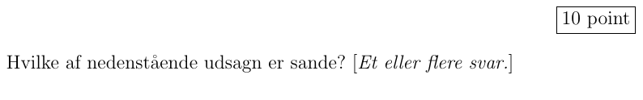
- Select the image in alternative 0
- Select the image in alternative 1
- Select the image in alternative 2
- Select the image in alternative 3
- Select the image in alternative 4
- Select the image in alternative 5
- Select the image in alternative 6
- Select the image in alternative 7
- Select the image in alternative 8
- Select the image in alternative 9
Clear answer

Question 6 of 26
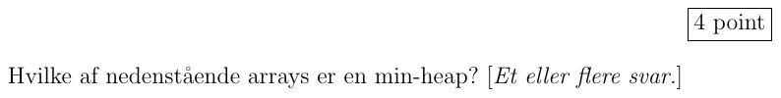
- Select the image in alternative 0
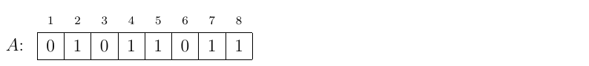
- Select the image in alternative 1
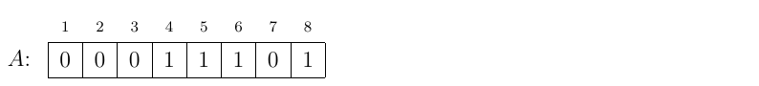
- Select the image in alternative 2
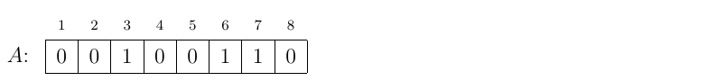
- Select the image in alternative 3
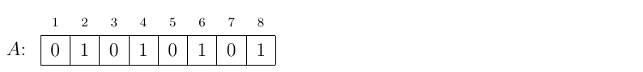
- Select the image in alternative 4
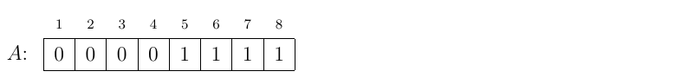
- Select the image in alternative 5
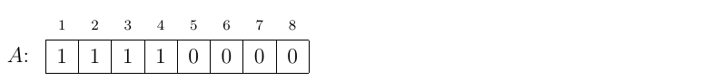
- Select the image in alternative 6
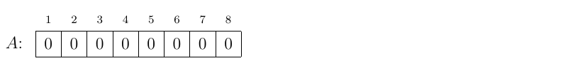
Clear answer

Question 7 of 26
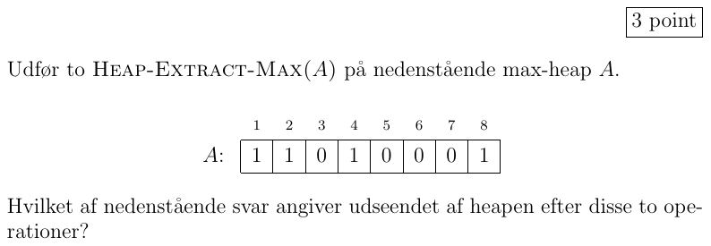
- Select the image in alternative 0
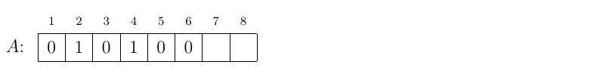
- Select the image in alternative 1
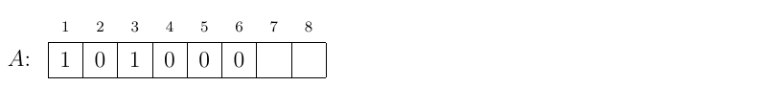
- Select the image in alternative 2
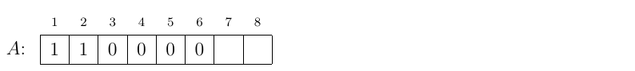
- Select the image in alternative 3
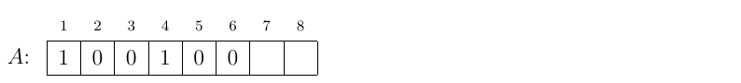
- Select the image in alternative 4
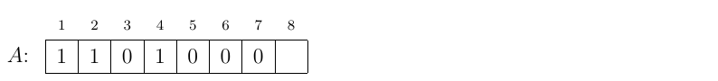
Clear answer

Question 8 of 26
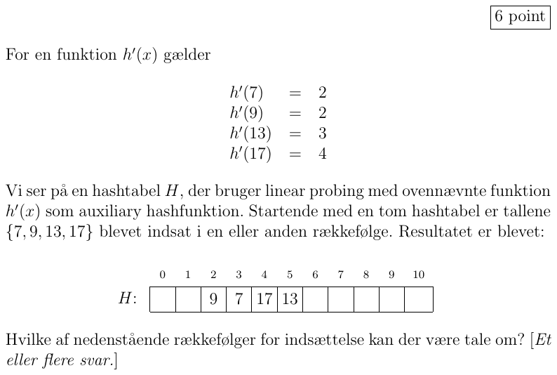
- Select the image in alternative 0
- Select the image in alternative 1
- Select the image in alternative 2
- Select the image in alternative 3
- Select the image in alternative 4
Clear answer

Question 9 of 26
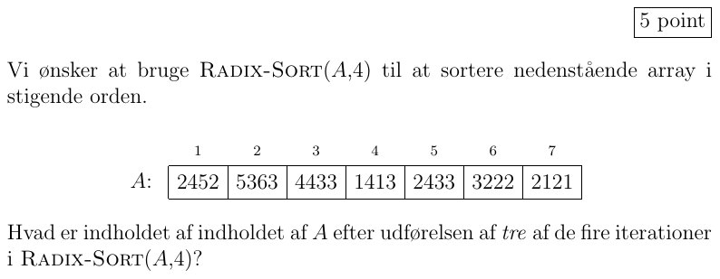
- Select the image in alternative 0
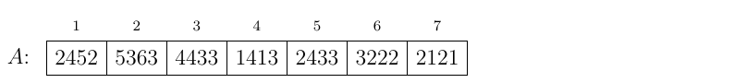
- Select the image in alternative 1
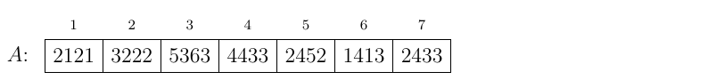
- Select the image in alternative 2
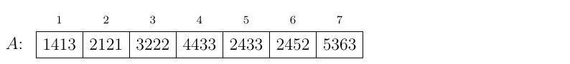
- Select the image in alternative 3
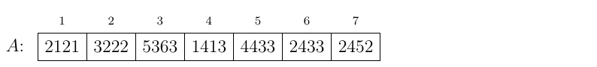
- Select the image in alternative 4
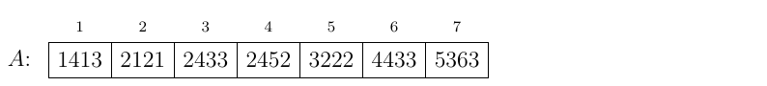
- Select the image in alternative 5
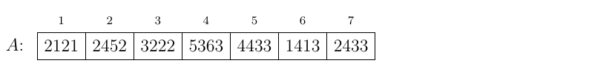
Clear answer

Question 10 of 26
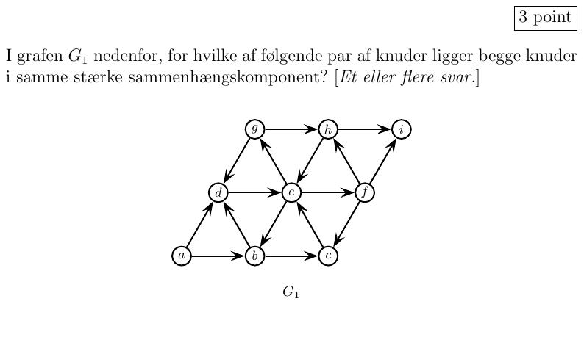
- Select the image in alternative 0
- Select the image in alternative 1
- Select the image in alternative 2
- Select the image in alternative 3
- Select the image in alternative 4
Clear answer

Question 11 of 26
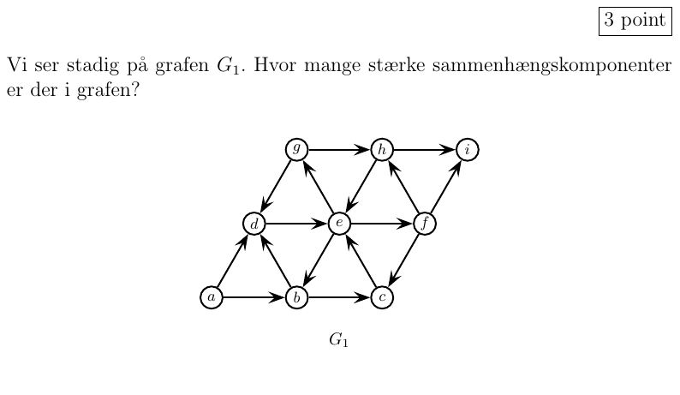
- Select the image in alternative 0
- Select the image in alternative 1
- Select the image in alternative 2
- Select the image in alternative 3
- Select the image in alternative 4
- Select the image in alternative 5
Clear answer

Question 12 of 26
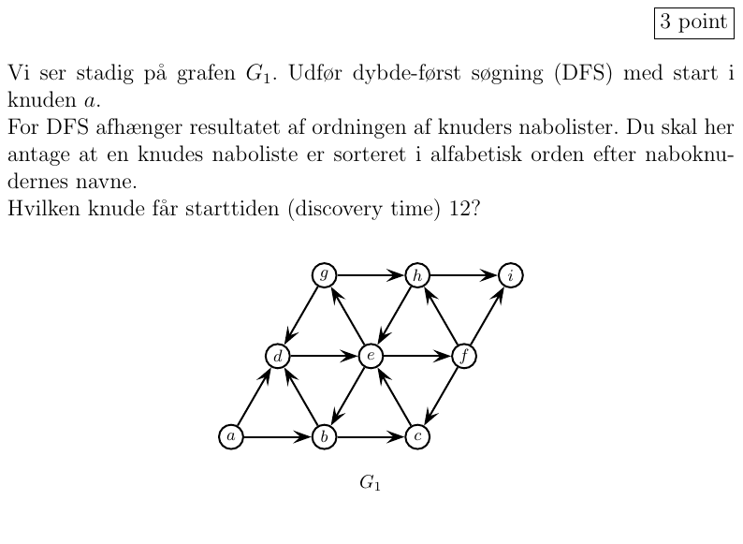
- Select the image in alternative 0
- Select the image in alternative 1
- Select the image in alternative 2
- Select the image in alternative 3
- Select the image in alternative 4
Clear answer

Question 13 of 26
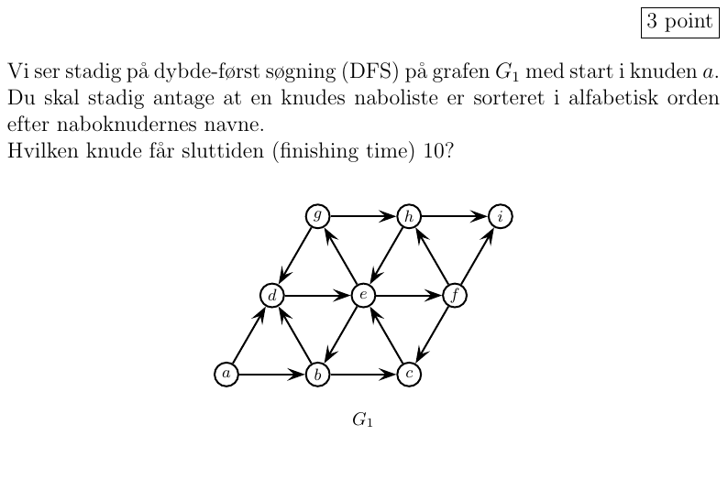
- Select the image in alternative 0
- Select the image in alternative 1
- Select the image in alternative 2
- Select the image in alternative 3
- Select the image in alternative 4
Clear answer

Question 14 of 26
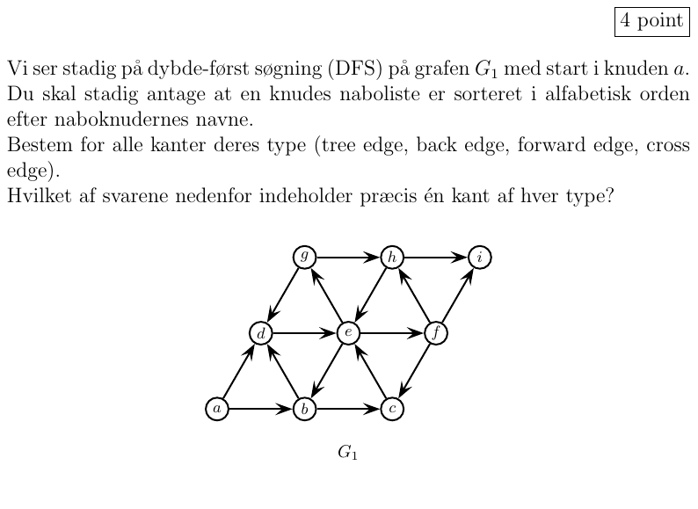
- Select the image in alternative 0
- Select the image in alternative 1
- Select the image in alternative 2
- Select the image in alternative 3
Clear answer

Question 15 of 26
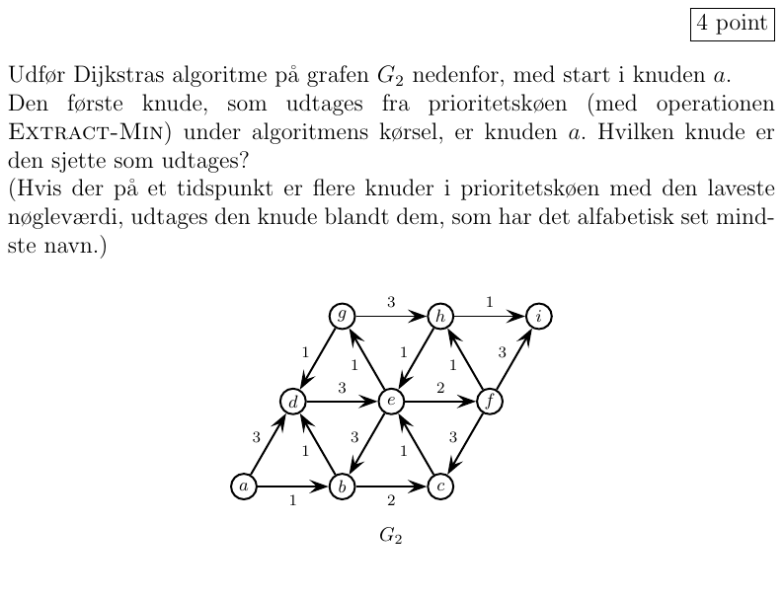
- Select the image in alternative 0
- Select the image in alternative 1
- Select the image in alternative 2
- Select the image in alternative 3
- Select the image in alternative 4
Clear answer

Question 16 of 26
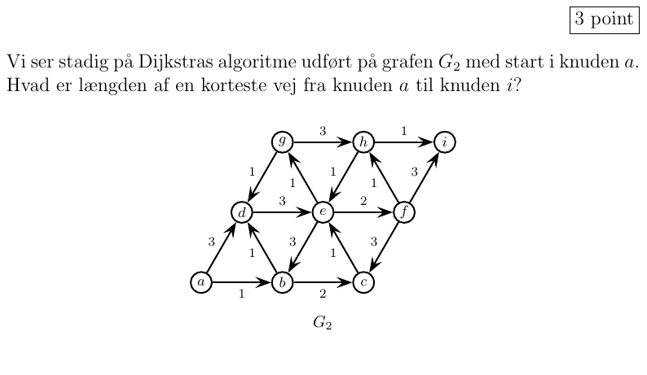
- Select the image in alternative 0
- Select the image in alternative 1
- Select the image in alternative 2
- Select the image in alternative 3
- Select the image in alternative 4
Clear answer

Question 17 of 26
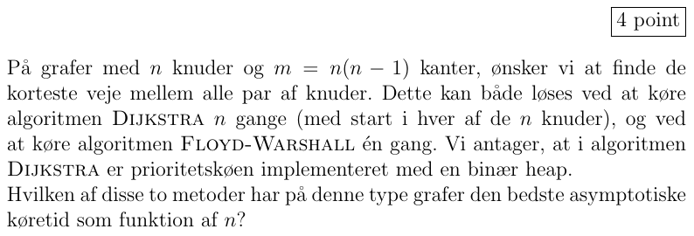
- Select the image in alternative 0
- Select the image in alternative 1
- Select the image in alternative 2
Clear answer

Question 18 of 26
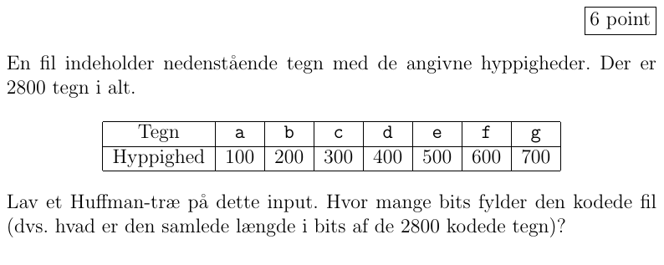
- Select the image in alternative 0
- Select the image in alternative 1
- Select the image in alternative 2
- Select the image in alternative 3
- Select the image in alternative 4
- Select the image in alternative 5
- Select the image in alternative 6
Clear answer

Question 19 of 26
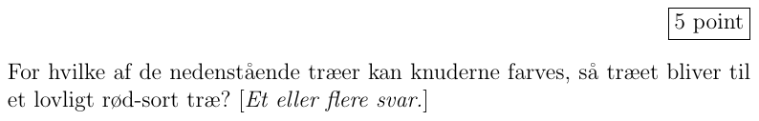
- Select the image in alternative 0

- Select the image in alternative 1

- Select the image in alternative 2

- Select the image in alternative 3

- Select the image in alternative 4

Clear answer

Question 20 of 26
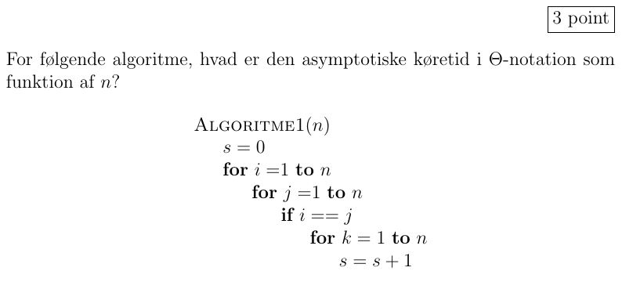
- Select the image in alternative 0
- Select the image in alternative 1
- Select the image in alternative 2
- Select the image in alternative 3
- Select the image in alternative 4
- Select the image in alternative 5
Clear answer

Question 21 of 26
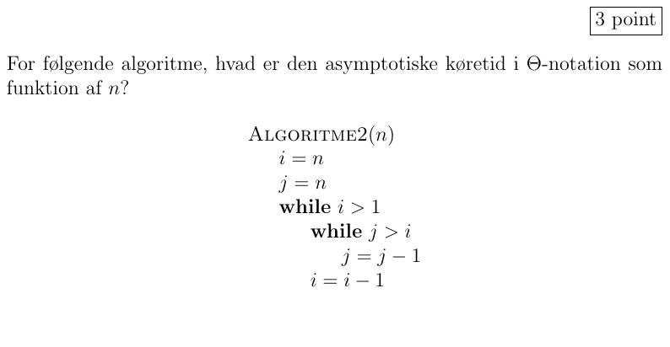
- Select the image in alternative 0
- Select the image in alternative 1
- Select the image in alternative 2
- Select the image in alternative 3
- Select the image in alternative 4
- Select the image in alternative 5
Clear answer

Question 22 of 26
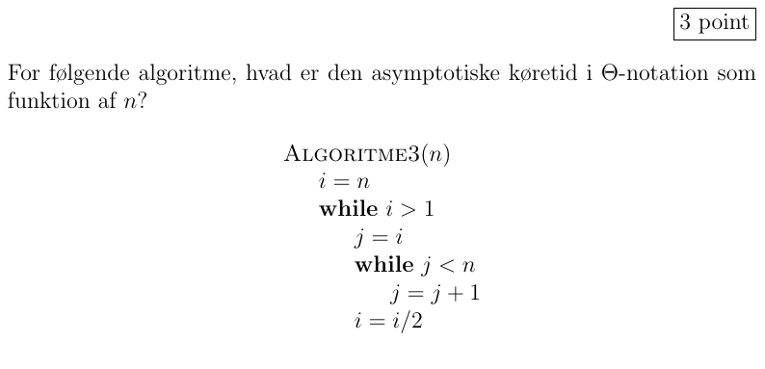
- Select the image in alternative 0
- Select the image in alternative 1
- Select the image in alternative 2
- Select the image in alternative 3
- Select the image in alternative 4
- Select the image in alternative 5
Clear answer

Question 23 of 26
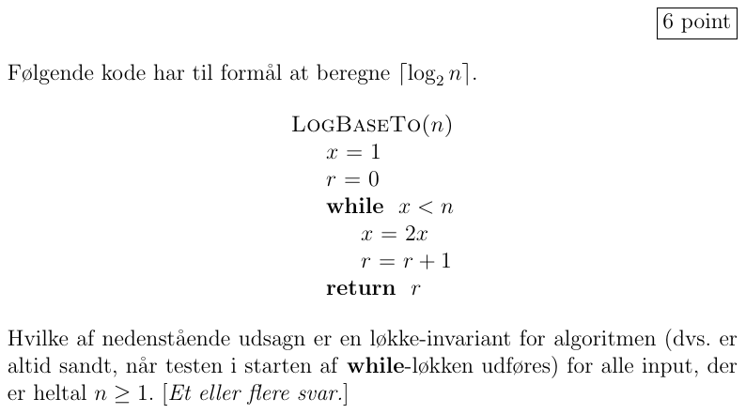
- Select the image in alternative 0
- Select the image in alternative 1
- Select the image in alternative 2
- Select the image in alternative 3
- Select the image in alternative 4
Clear answer

Question 24 of 26
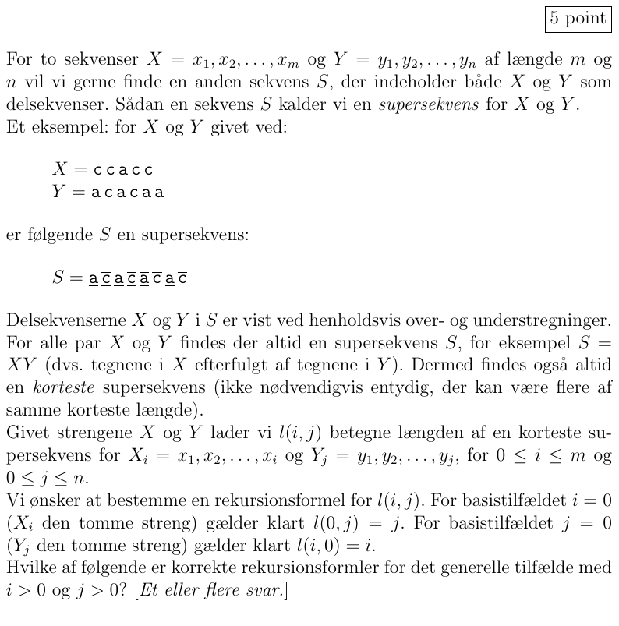
- Select the image in alternative 0
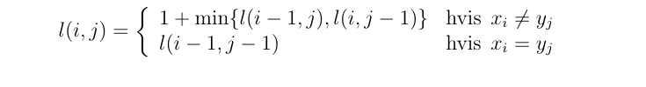
- Select the image in alternative 1
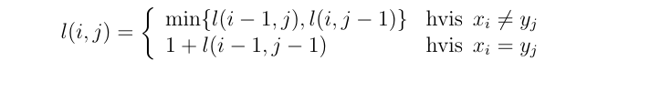
- Select the image in alternative 2
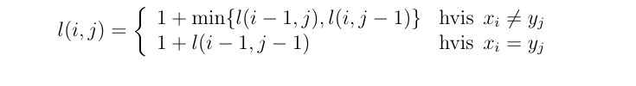
- Select the image in alternative 3
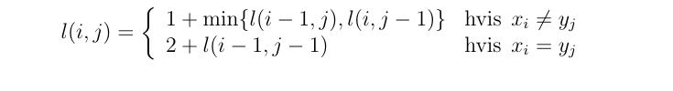
- Select the image in alternative 4
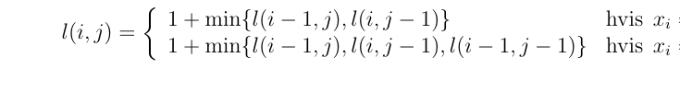
- Select the image in alternative 5
Clear answer

Question 25 of 26
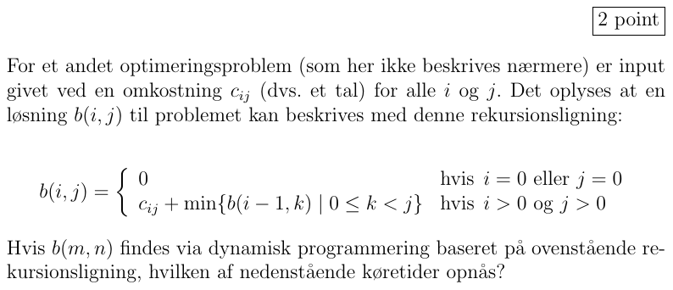
- Select the image in alternative 0
- Select the image in alternative 1
- Select the image in alternative 2
- Select the image in alternative 3
- Select the image in alternative 4
- Select the image in alternative 5
- Select the image in alternative 6
Clear answer

Question 26 of 26
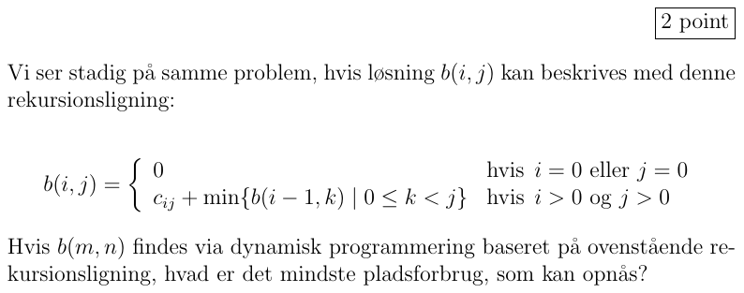
- Select the image in alternative 0
- Select the image in alternative 1
- Select the image in alternative 2
- Select the image in alternative 3
- Select the image in alternative 4
- Select the image in alternative 5
- Select the image in alternative 6
Clear answer

