SURF Project Control System Documentation

Environment:
The different devices in the SURF setup are each operated in different manners. Some are controlled through functions accesible from shared libraries, .so/.dll files (Linux/Windows respectively), and some are controlled via RS-232 communication protocol. Tango is a layer we can put on top of all of these different communication protocols, in order to homogenize the way the user controls them.
Figure 1: The different layers in the interaction with the equpment. Using Tango let’s the user interact with devices in the same way regardless of the underlying communication protocols.
Hardware
Driver
A:
native serial
port driver
B:
Manufactors
.so library)
Wrapper layer
A:
serial cmnds
B:
.so wrapper
C/C++->Py
Tango
Device
GUI

In this case device refers to different physical devices in the SURF setup, but a Tango device could also be purely software or perhaps a collection of hardware or a collection of other tango devices.
Once a tango device is written a simple GUI for the device can be opened and controlled via a gui or directly from a terminal.
Figure 2 shows an Ocean Optics UV spectrometer being accessed from Jive. First the device server is being started from a terminal and then jive is opened (alt+f2, jive). The scalar attributes as well as the spectrum and the wavelength arrays have been defined in the script ocean_optics.py, which was run from the terminal.
The PyTango API also allows you to control devices through Python. Figure 3 shows an example of how easily you can configure a spectrometer and acquire a spectrum through an IPython console. In the same manner you can integrate tango devices into your own guis.

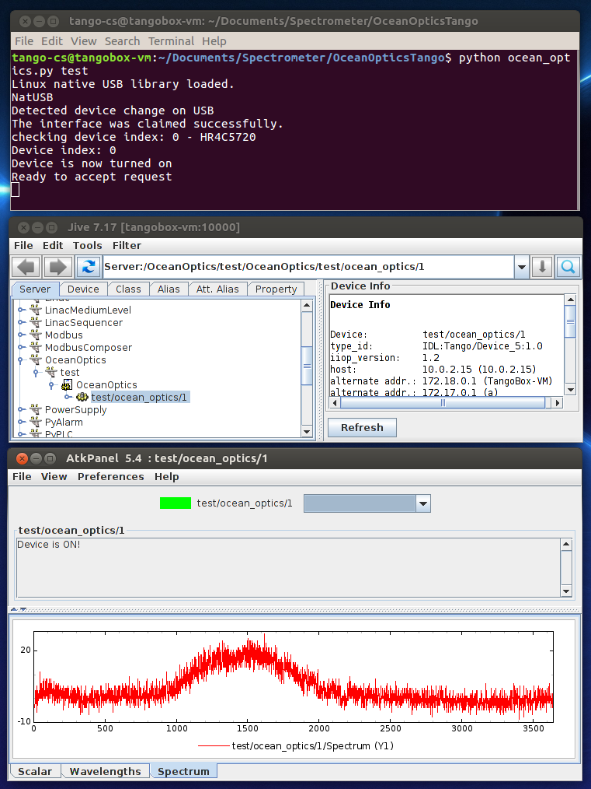
Figure 2: Controlling a spectrometer through Jive.
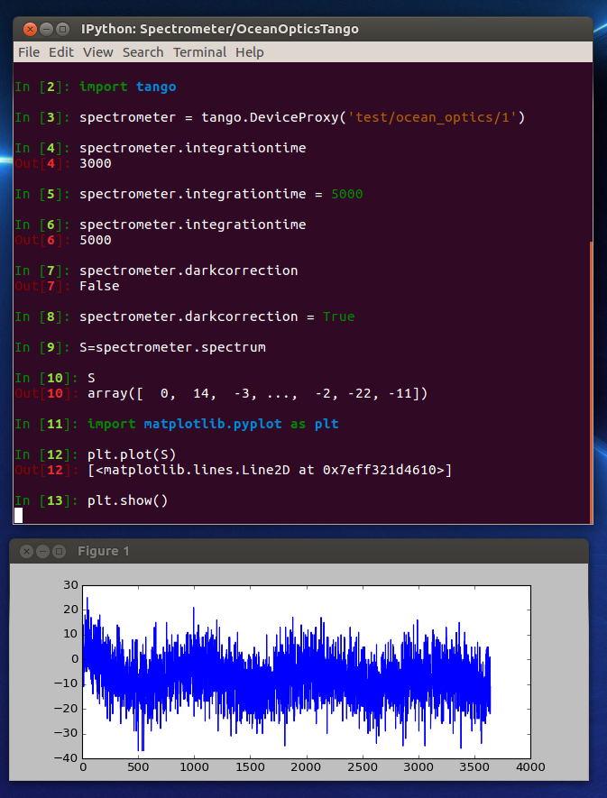
Figure 3: Controlling a spectrometer through an IPython console

The Status Table below shows the different devices in the SURF setup, their communication interface, how far the project was when I left it, and what has yet to be done. The end goal is to have a user friendly and intuitive graphical user interface, and having tango devices for each of the major components in the SURF setup will make this task much easier.
There are different ways to get Tango. Manual installation is tedious and will require you to install several dependencies and to configure MariaDB/MySQL correctly. Hopefully KITS can help you with an easy installation tool. Otherwise you can always download the virtual ubuntu machine, tangobox, from the Tango Controls website, note however that the driver for the daq, Nidaqmx, is only available for Red Hat Linux, Centos, Mandriva, and Windows, So working in the tangobox is only a temporary solution.

Status table
Physical devices | Communication protocol | Intermediate layer. fx C→py | Tango device classes | Graphical  User  Interface
HR4000  UV-Vis | “.so” libraries Omnidriver | Python wrapper  from old SURF project. | Tango Class  For both spectrometers | Graphical user interface  In the style of nomad
QE65000
Fluorescence
Monochromator | RS-232 protocol  int terminal | Python script:  using pyserial library | Tango Class  Monochromator | Graphical user interface  In the style of nomad
IRaman Setup | BW SDK,  (Windows only...) | Python wrapper | Tango Class  (one or more devices?) | Graphical user interface  In the style of nomad
NI-daq | “.so” libraries  Ni-DAQmx | SURF Windows machine has a working wrapper. | Tango Class  NI-daq | Graphical user interface  In the style of nomad
Tecan  Pumps | RS-232 protocol  int terminal | Python script:  using pyserial library | Tango Class  Tecan Pump | Graphical user interface  In the style of nomad
Temperature controller | RS-232 | Python script:  using pyserial library | Tango Class  Temp controller | Graphical user interface  In the style of nomad

Drivers etc:

Ocean Optics Spectrometers:
require Omnidriver, which can be downloaded from OceanOptics website. We have a password for the combined OmniDriver+SPAM software package. Password: Etm4QBn7gd. Note that this password does not work for the seperate Omnidriver installer. You must download the combined OmniDriver and spam installer even though we will only use OmniDriver. After installing it you must go to Home/OmnidriverSpam/utilities (or equivalent path) and run the utility script. It will instruct you on if and how to fix missing symbolic links. Then you need to fix the environmental variables. I added the following to my .bashrc file on a ubuntu tangobox machine:
export OMNIDRIVER_HOME="/home/tango-cs/OmniDriverSPAM"
export OOI_HOME="/home/tango-cs/OmniDriverSPAM/OOI_HOME"
export PATH="/home/tango-cs/OmniDriverSPAM/OOI_HOME:$PATH"
export JAVA_HOME="${OMNIDRIVER_HOME}/_jvm"
export JDK_HOME="/usr/lib/jvm/java-8-openjdk-amd64"
export JDK_INCLUDE_FILE_ROOT="/usr/lib/jvm/java-8-openjdk-amd64"
export JVM_ROOT="${OMNIDRIVER_HOME}/_jvm"
export LD_LIBRARY_PATH="$OOI_HOME:${JAVA_HOME}/lib/amd64/server"
But you an also just define these variables in your IDE, if you don’t want them to be globally defined.
The driver functions are accessed through the shared libraries omnidriver.so and common.so found in OmniDriverSPAM/OOI_HOME. On ubuntu I had to compile them, together with jvm.so into a new shared library, libw.so, to fix problems with missing references.
Once you have done this you can load the python wrapper PyOceansOpticsWrapper.py, written by Sylvio Haas, and use the functions to interact with ocean optics spectrometers.
I have written a tango device class for the spectrometers on top of this Wrapper.
Note: Occasionally the tango device can’t connect to the spectrometer. It is then necessary to unplug and plug back in the USB conection to the spectrometer. From the documentation of the old SURF project I can see that this was also neccesary back then. In tangobox you don’t need to physically remove it, just untick the device in the virtualbox command bar: Devices→USB→ Spectrometer_Name.

Monochromator Cornerstone 130:
There is an existing cpp project from SOLEIL. It comes with a makefile which needs to be thoroughly adapted to your systems architecture if used. It also depends on some tango extension, which you will need to install to use the device: yat, yat4tango.
As an alternative I have made a python library for communicating with the monochromator using pyserial. To connect to the spectrometer you will need to run python as sudo, to get access to the port.
An alternative approach is to use the RS-232 communication protocol that is described in the Cornerstone 130 user manual. For example in python via PySerial library.
In order to connect to the device you will need to run the python script or Ipython console as sudo. If you are still unable to connect to the device, then try rebooting the machine with the USB connection still plugged in, and try to connect again.
A problem is that the default device polling is too fast for the monochromators slow serial communication. This can cause “Timeout errors”. If you set the timeout property to 12000 ms then it should be solved. From Ipython:

In [1]: import tango

In [2]: M = tango.DeviceProxy('test/Cornerstone/1')

In [3]: M.get_timeout_millis()
Out[3]: 3000

In [4]: M.set_timeout_millis(12000)

In [5]: M.get_timeout_millis()
Out[5]: 12000

IRAMAN:
There are SDKs available for this device, BW SDK, and CleanLaze. However only for windows machines.

Tecan Pumps:
The RS-232 communication protocol is described in the XLP 6000 operating manual. Using PySerial will make it easy to make a tango device class for the pumps. In order to connect to the device you will need to run the python script or Ipython console as sudo.
Note: There is a top_speed, start_speed, cutoff_speed, and speed attribute. It is not entirely clear from the manufactorers documentation how speed and top_speed differ.

NiDAQ USB-6501:
The driver for the daq, Nidaqmx, is only supported for Red Hat Linux, Centos, Mandriva, and Windows, So working in the ubuntu tangobox. It can probably be made to work for ubuntu, but since MAXIV uses CentOS, it makes more sense to migrate everything to a CentOS machine.
Sylvio Haas wrote a python wrapper for this device in ctypes, which can be found on the old surf windows laptop. Since NidaqMX Linux version has not been updated since 2011 this wrapper will still work.
A small problem with the Nidaqmx is that it requires kernel 2.6. So you will need to install an extra (not a replacement) kernel.

Temperature Controller:
TC3212 conntroller

Proposed workplan for future development:
- Familiarize yourself with lab setup, the old SURF software as well as the existing SURF tango devices.
- Migrate to CentOS machine with Tango + PyTango installations.
- Install Omnidriver and Nidaqmx.
- Build a tango device class for NI USB-6501 using Sylvios driver wrapper.
- Make a demo script for performing an experiment with pumps, UV and fluorescence spectrometers and monochromator and perform measurements.
- Develop Tango device class for Temp controller
- Develop Tango device class for IRAMAN. This may have to be windows based, so ask KITS for advice on how best to integrate it with the rest of the setup.
- Develop a graphical user interface

