**Module 6 Final Project – Robert Hoppe**

**Site Description/Purpose:**

This site is a course project site designed to help learn JQuery Mobile Web App development. The purpose is to explore many of the features and functions within JQuery Mobile and apply that knowledge to a deployable site.

This particular site is a simple game site featuring some of my favorite video games. It is a basic framework that could be developed into a larger site with more games and features.

**Sitemap:**

Below is a visual sitemap showing the general layout and flow of the project.

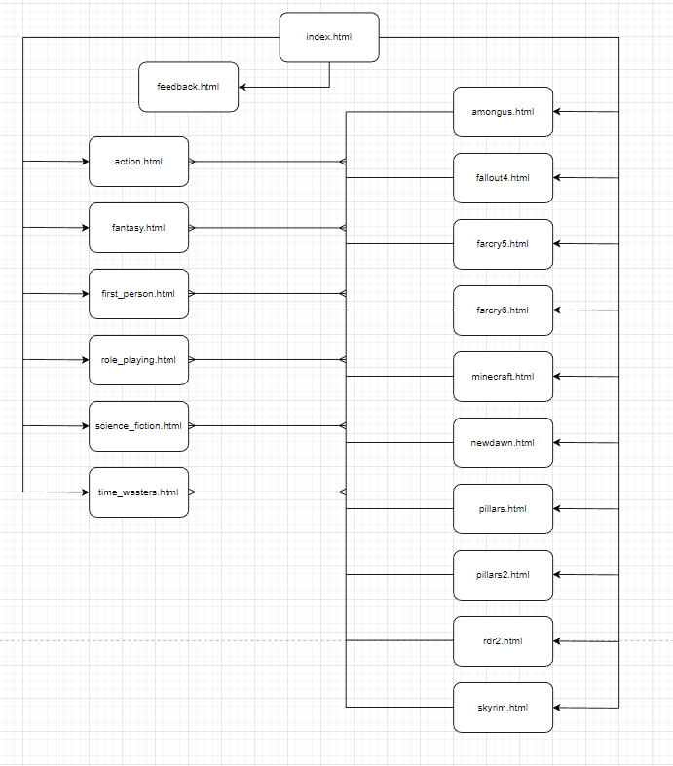

**Page Descriptions:**

Below are individual page descriptions that list the purpose and functionality of the page.

**Homepage:**

**File(s):** Index.html

**Description:** This is the homepage or landing page for the site. It provides a header and footer as well as the main content for the site. The site displays games and allows for selection to various types of games or more detailed information on specific games.

**Actions:** Within the header there is a back button that returns to the previously viewed page. Within the footer there is a favorites list which utilizes web storage to store a list of favorite games the user adds to the list and the user can clear the list. Beneath the header is a search bar that allows users to filter links to specific games. Below this search bar is a carousal of images that display using various special effects for the user. Following this is the navbar which has 6 buttons that each link to a page with a specific category of game. After the navbar there are large graphical buttons that link to specific games. Following this and before the footer there is a link to a feedback form where a user can enter site feedback.

**Category Pages:**

**File(s):** action.html, fantasy.html, first_person.html, role_playing.html, science_fiction.html, and time_wasters.html

**Description:** Each category page contains the same header as the homepage. The footer is similar, but does not contain the favorites link due to the limitations of how web storage works. Below the header is a dynamic navbar that includes a button to the home page and each of the other category pages except the page the user is currently on. There is a list of games that match the category listed for the user.

**Actions:** The navbar buttons, when clicked will bring the user to a specific game, similar to the large graphical buttons on the home page. The back button will return to whatever previous page the user was on.

**Game Pages:**

**File(s):** amongus.html, fallout4.html, farcry5.html, farcry6.html, minecraft.html, newdawn.html, pillars.html, pillars2.html, rdr2.html, and skyrim.html

**Description:** Each of the game pages provide the user with a description and a review of the game along with am advertising graphic for the game.

**Actions:** The only actionable item on the page is the back button to return to whatever page they were on previously.

**Feedback Page:**

**File(s):** feedback.html

**Description:** This is a feedback form which allows the user to enter their name, email address, and select if they wish the be contacted or not. They can also adjust the slider to rate the page and type in their feedback.

**Actions:** There are text fields for name and email, radio buttons for contact preferences, a slider that ranges from 0 to 10, a textbox for feedback, and a submit button. The submit button will alert the user to what was typed in the form. There is no backend development that sends the form anywhere.

**Sitemap Page:**

**File(s):** sitemap.html

**Description:** This is an HTML based sitemap generated by Google XML and HTML Sitemaps Generator and provides a basic sitemap for the project. This sitemap is not linked from the main pages of the site.

**Actions:** There are weblinks to each individual page and to Google.