**CICD – ToolChain**

1) Login to IBM Cloud

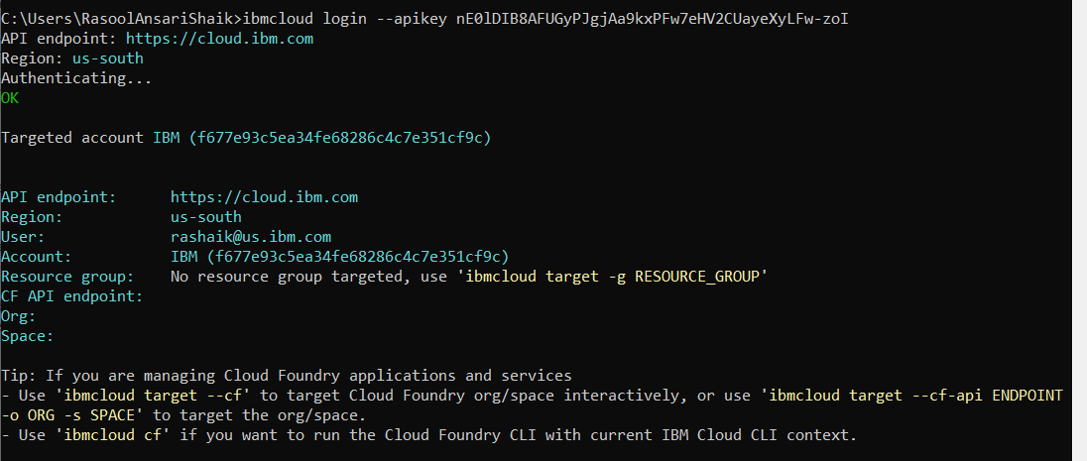

2) Configure Kubernetes Service

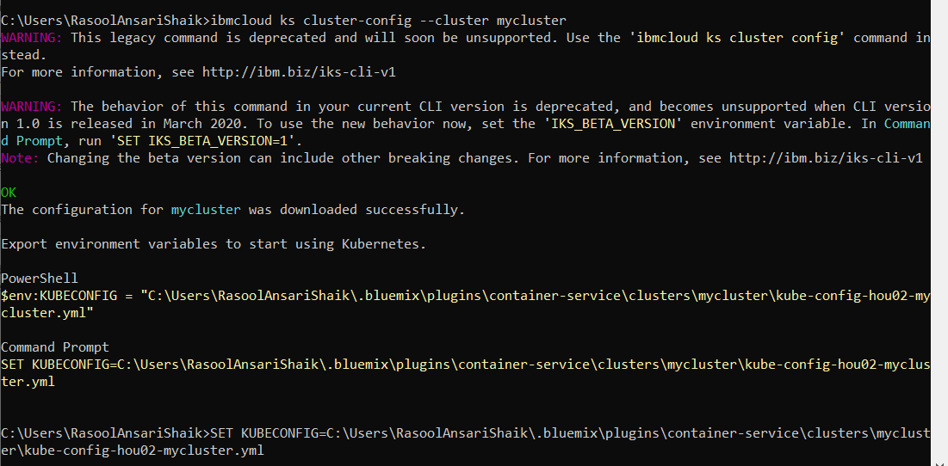

3) Check namespaces & pods

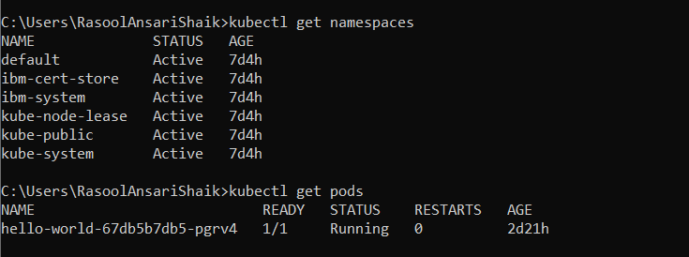

4) Install Tiller account

Reference: <https://pages.github.ibm.com/wh-ops/wh-ops-playbook/checklist/ready/sandbox-cluster/sandbox-cluster.html>

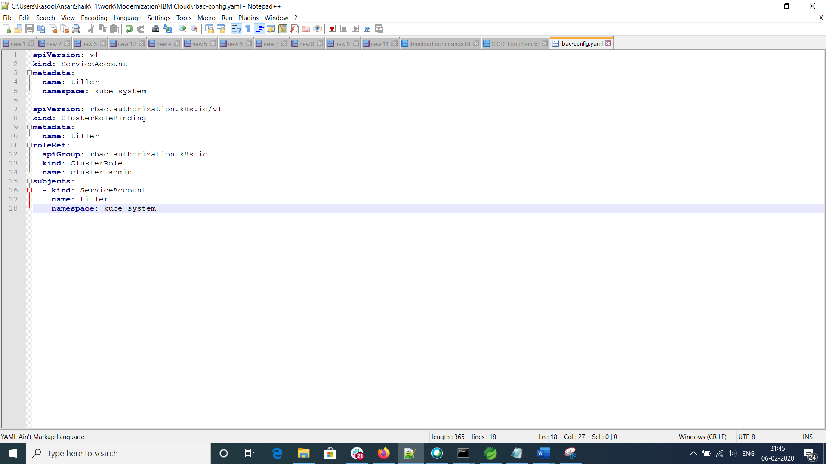

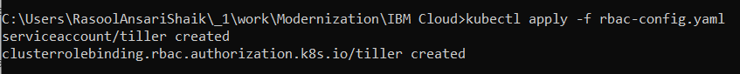

5) Validate the Tiller installation



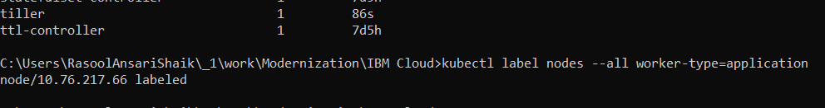

6) Label worker node as “application”

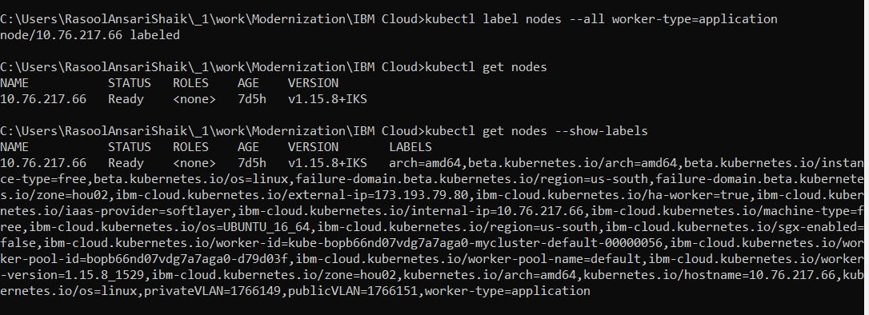

7) Generate WH DevOps Pipeline catalog

Reference: <https://pages.github.ibm.com/whc-toolchain/whc-pipeline-links/index.html>

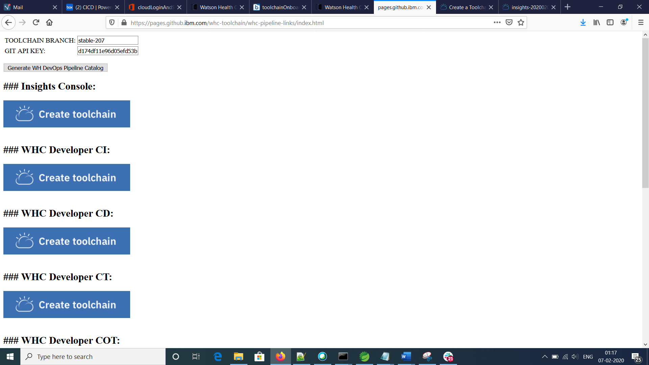

8) Create Toolchain for Insights Console

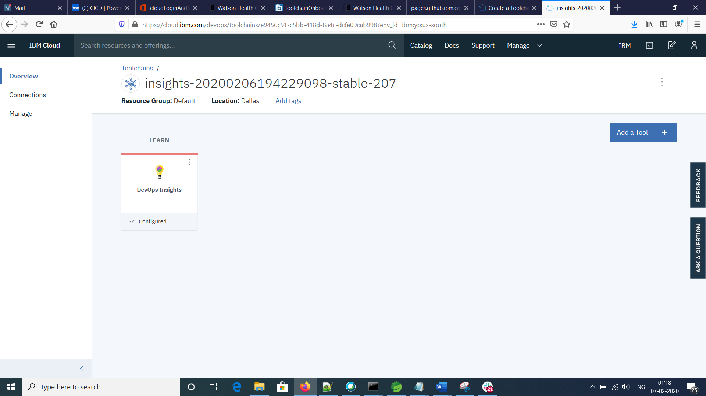

9) Create Toolchain for Developer CI

