<https://pages.github.ibm.com/wffh/nifi-umbrella/#getting-started/>

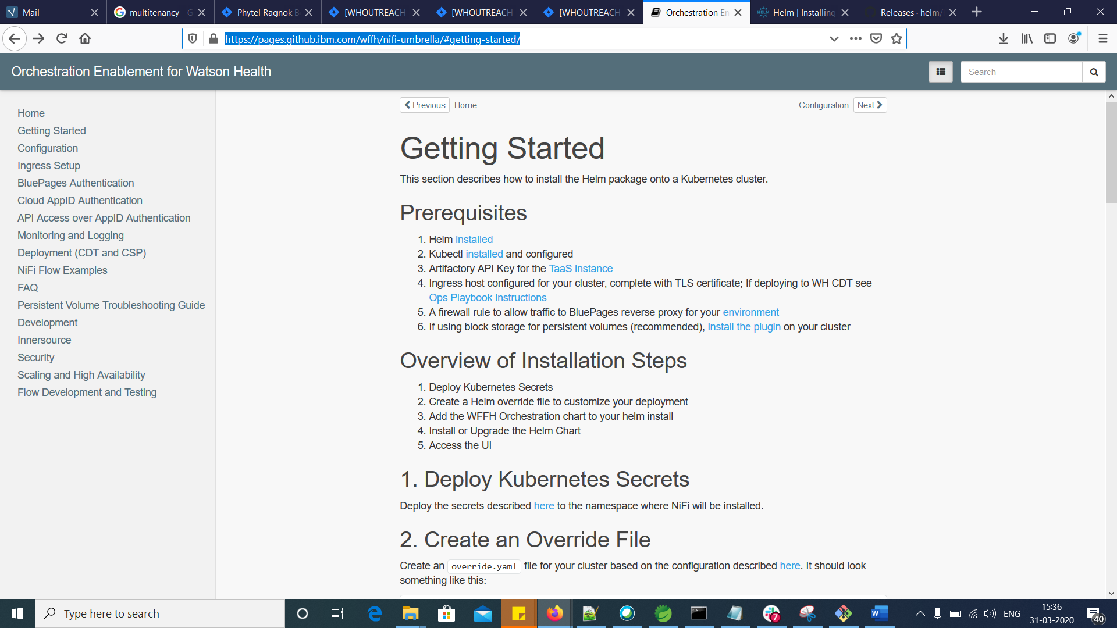

Prerequisites-1

<https://helm.sh/docs/intro/install/>

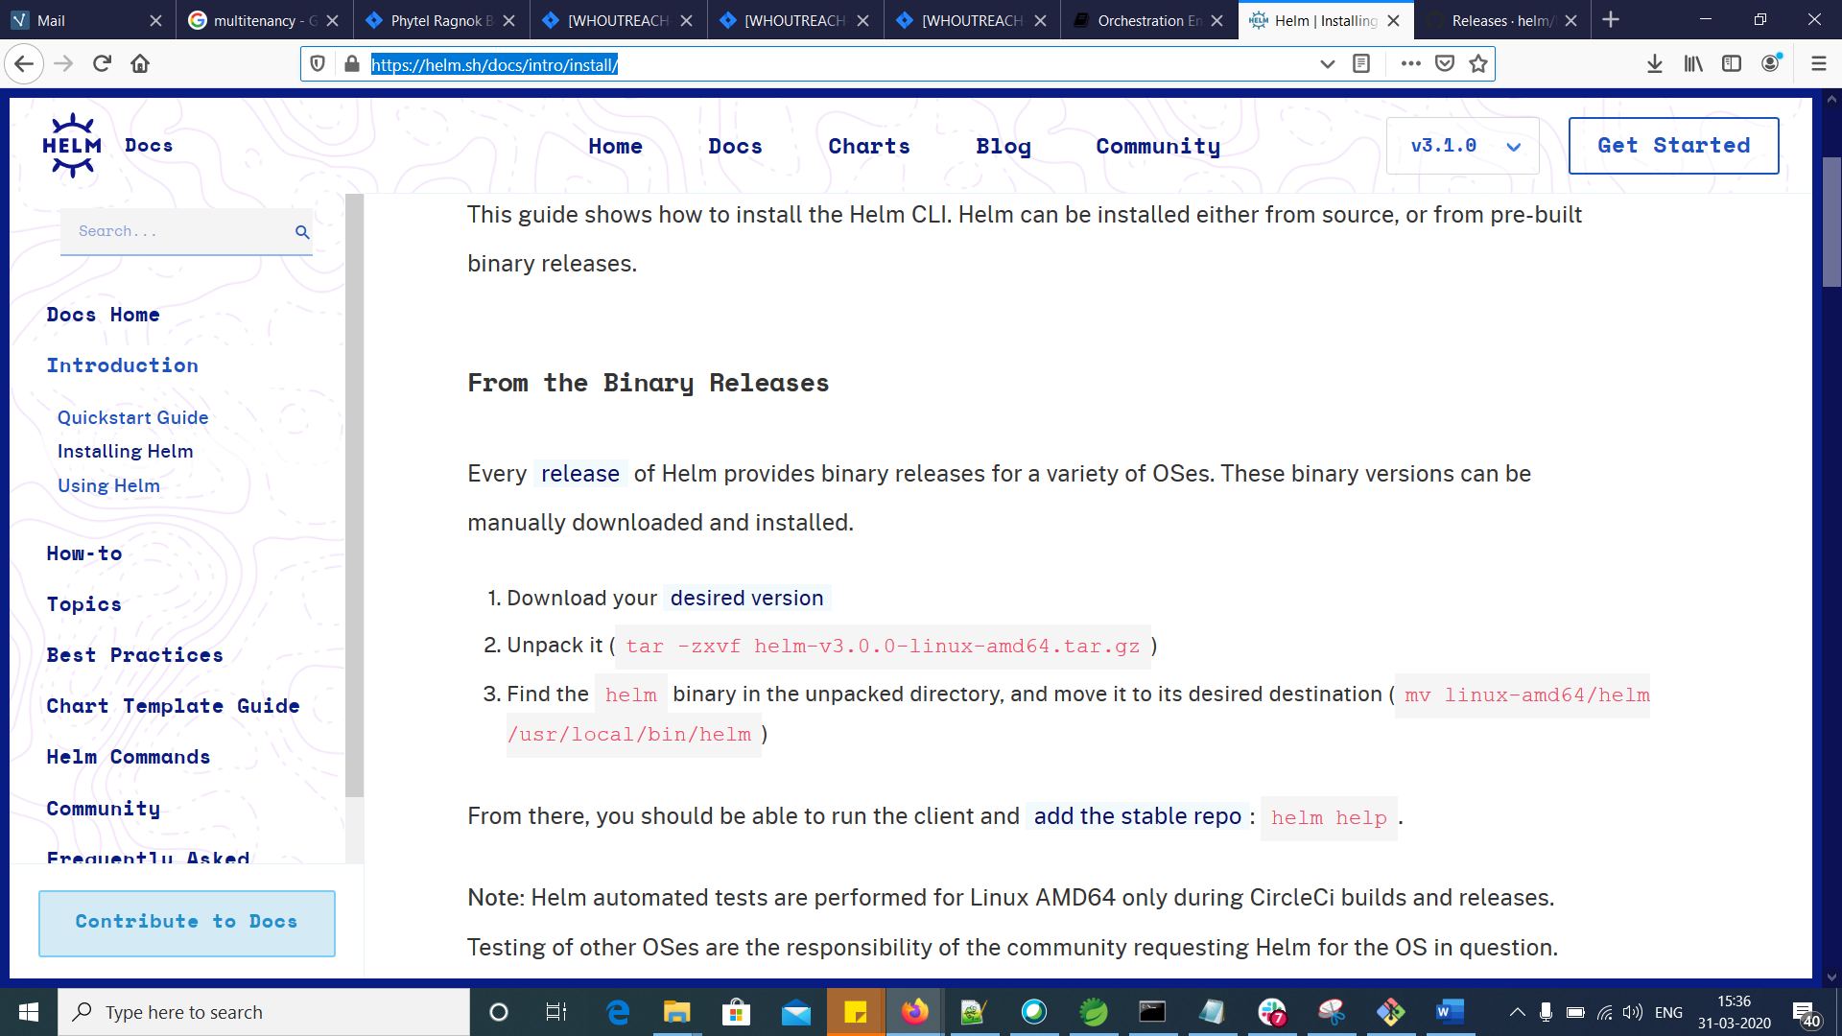

<https://github.com/helm/helm/releases>

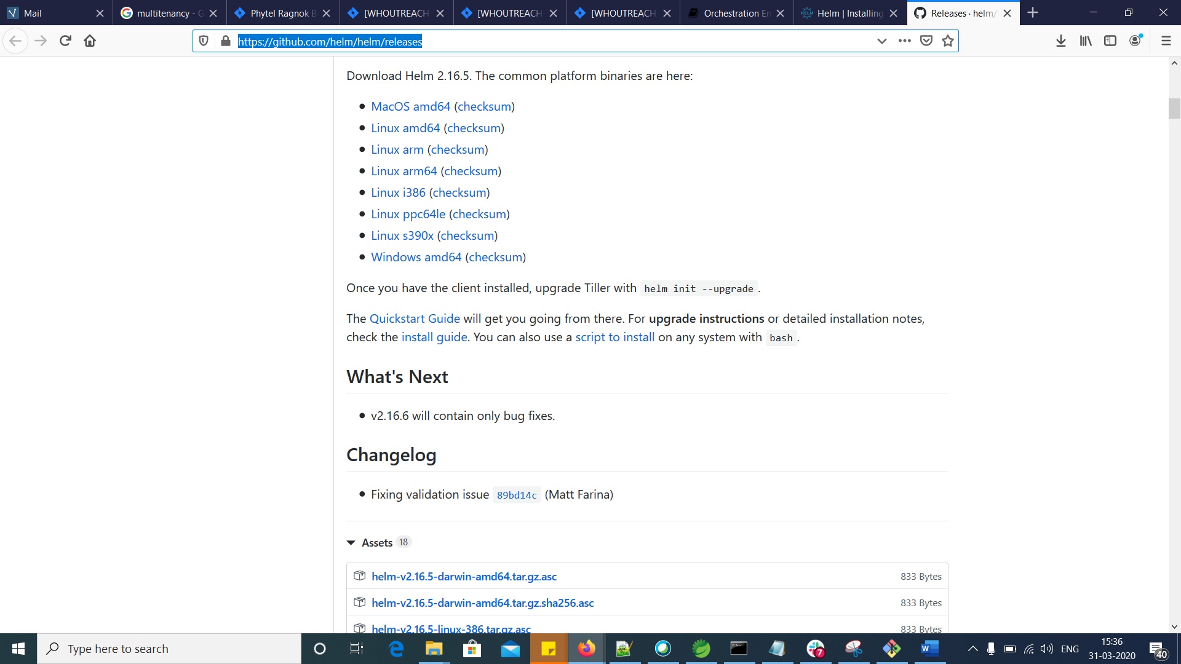

Download the Windows version and extract it

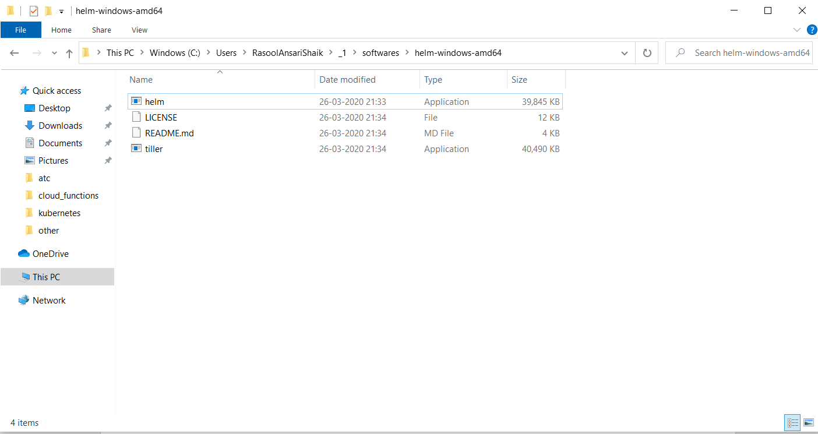

Set the PATH environment variable for helm

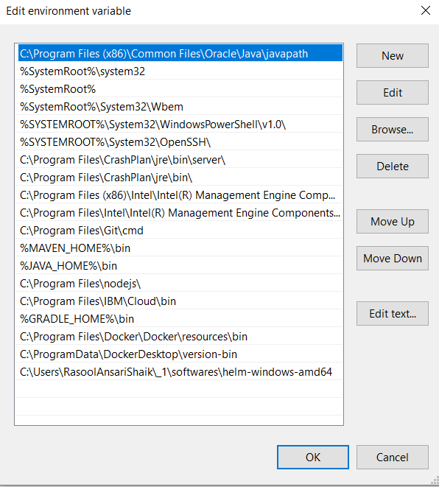

Check helm is installed and configured successfully

Execute command helm –help

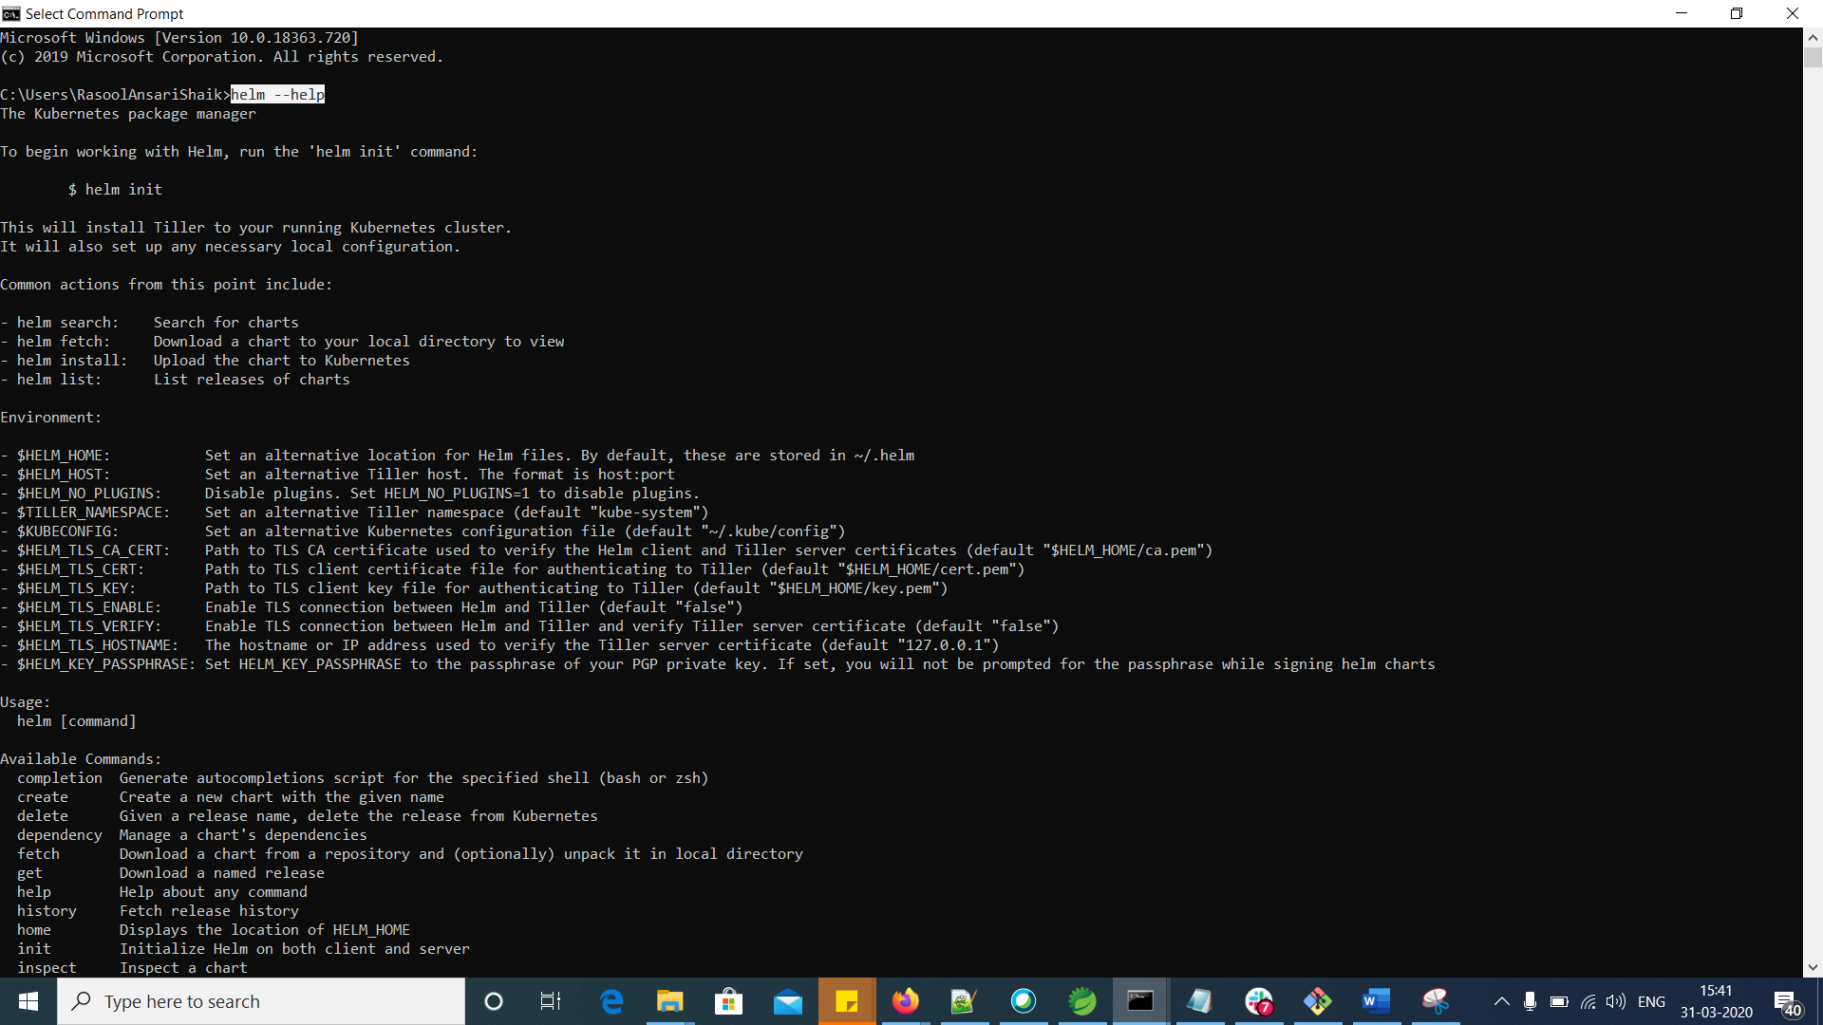

Execute command tiller –help

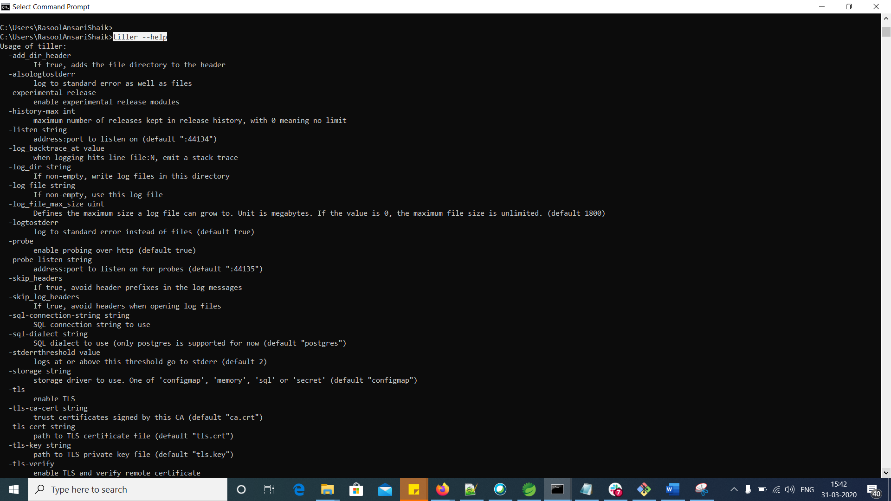

Once you have the client installed, upgrade Tiller with helm init --upgrade.

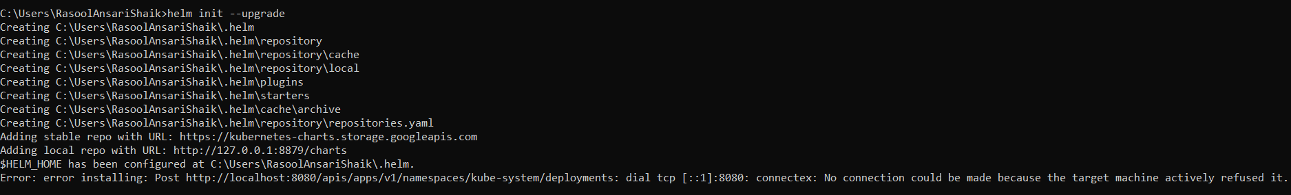

Prerequisites-2

<https://kubernetes.io/docs/tasks/tools/install-kubectl/>

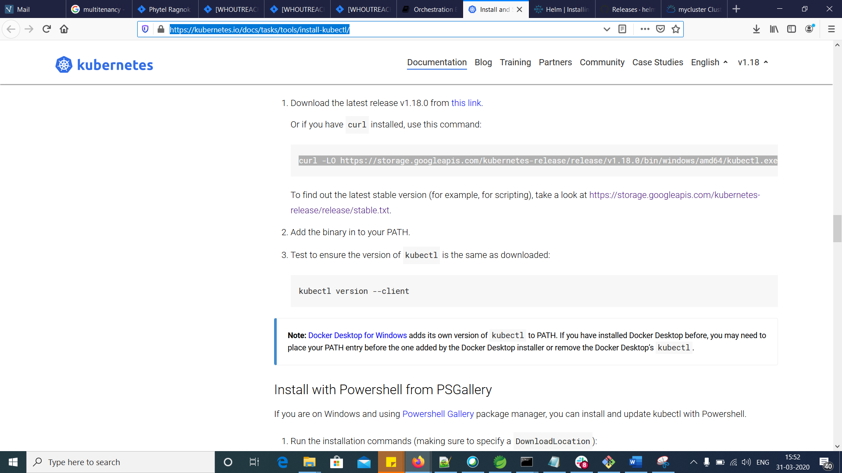

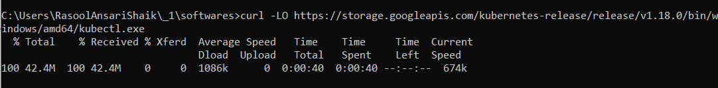

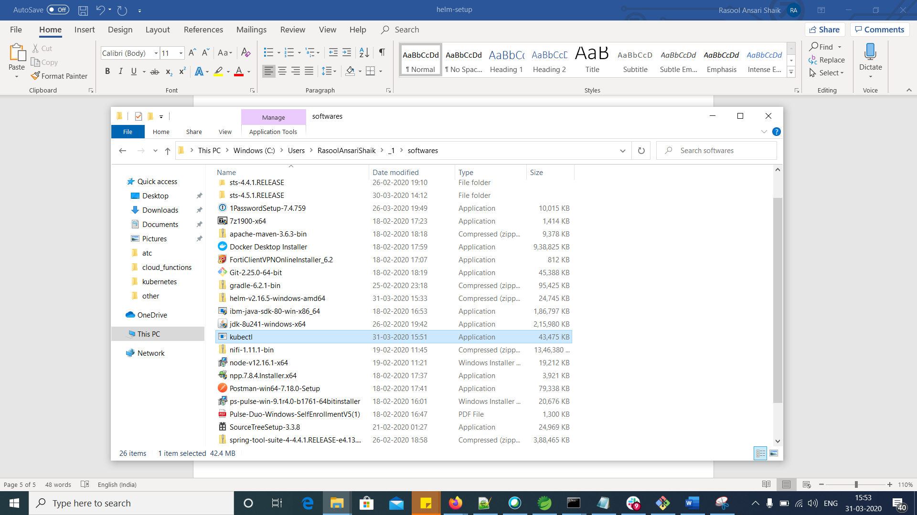

Create a folder and Move kubectl file in it.

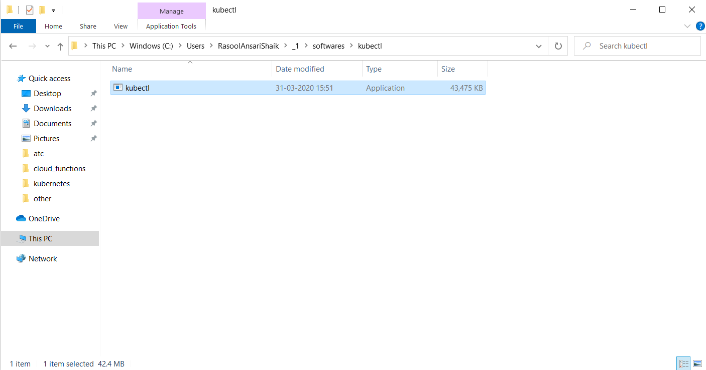

Set PATH environment variable

OR

If you are using IBM Cloud, then Using Kubernetes dashboard of the cluster, you can configure “kubectl”.

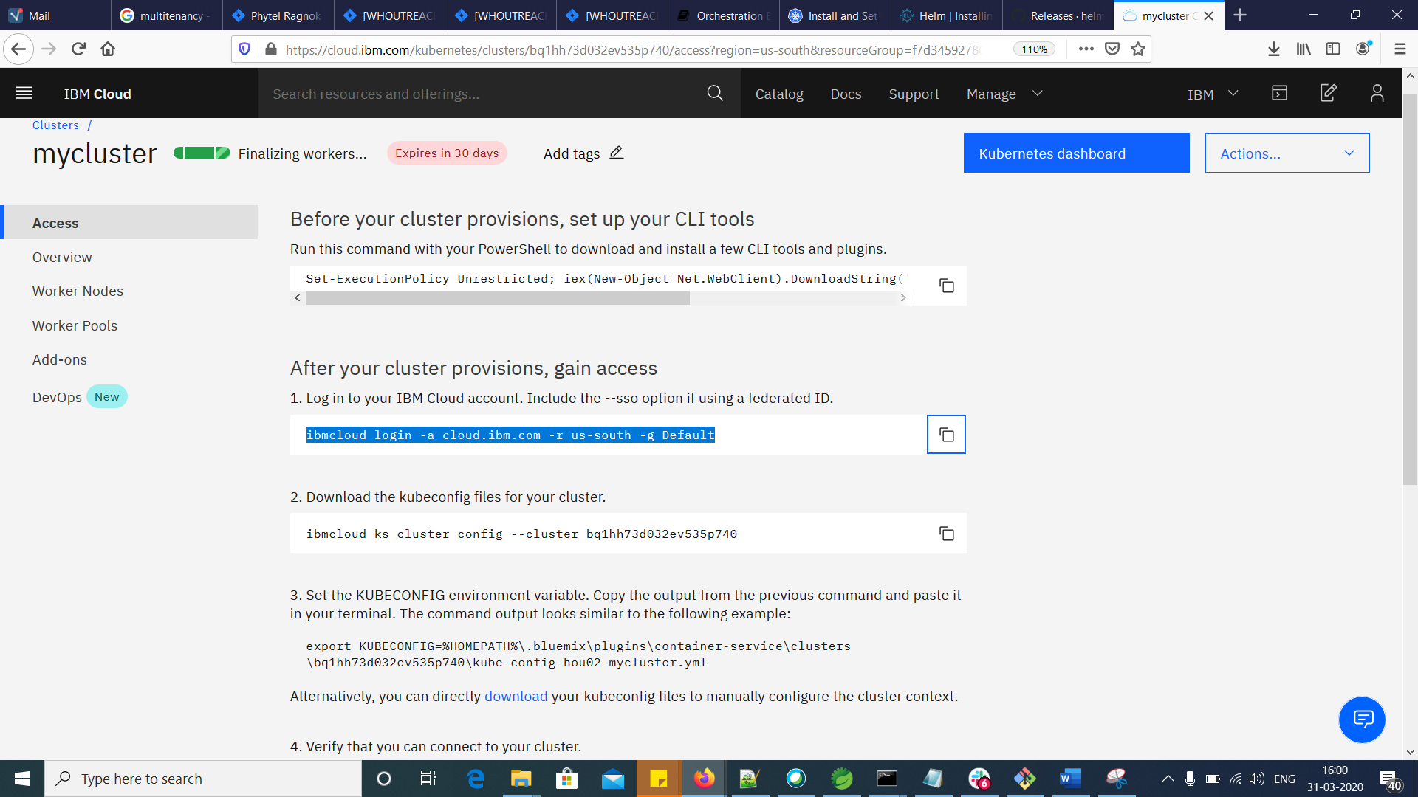

OR

Update the IBMCLOUD cli, then no need to set KUBECONFIG to get kubectl. Once you configure cluster, kubectl will be available.

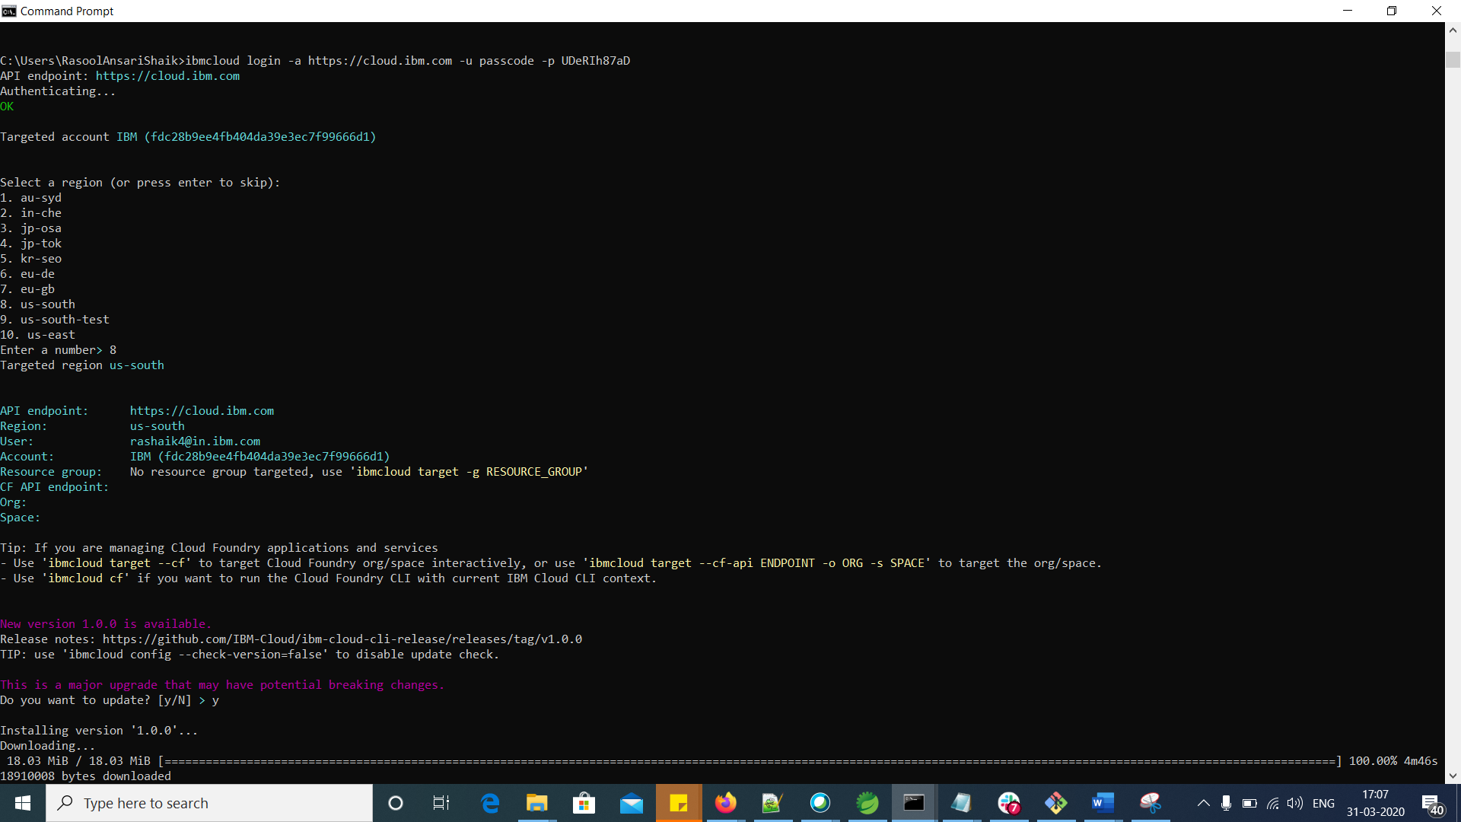

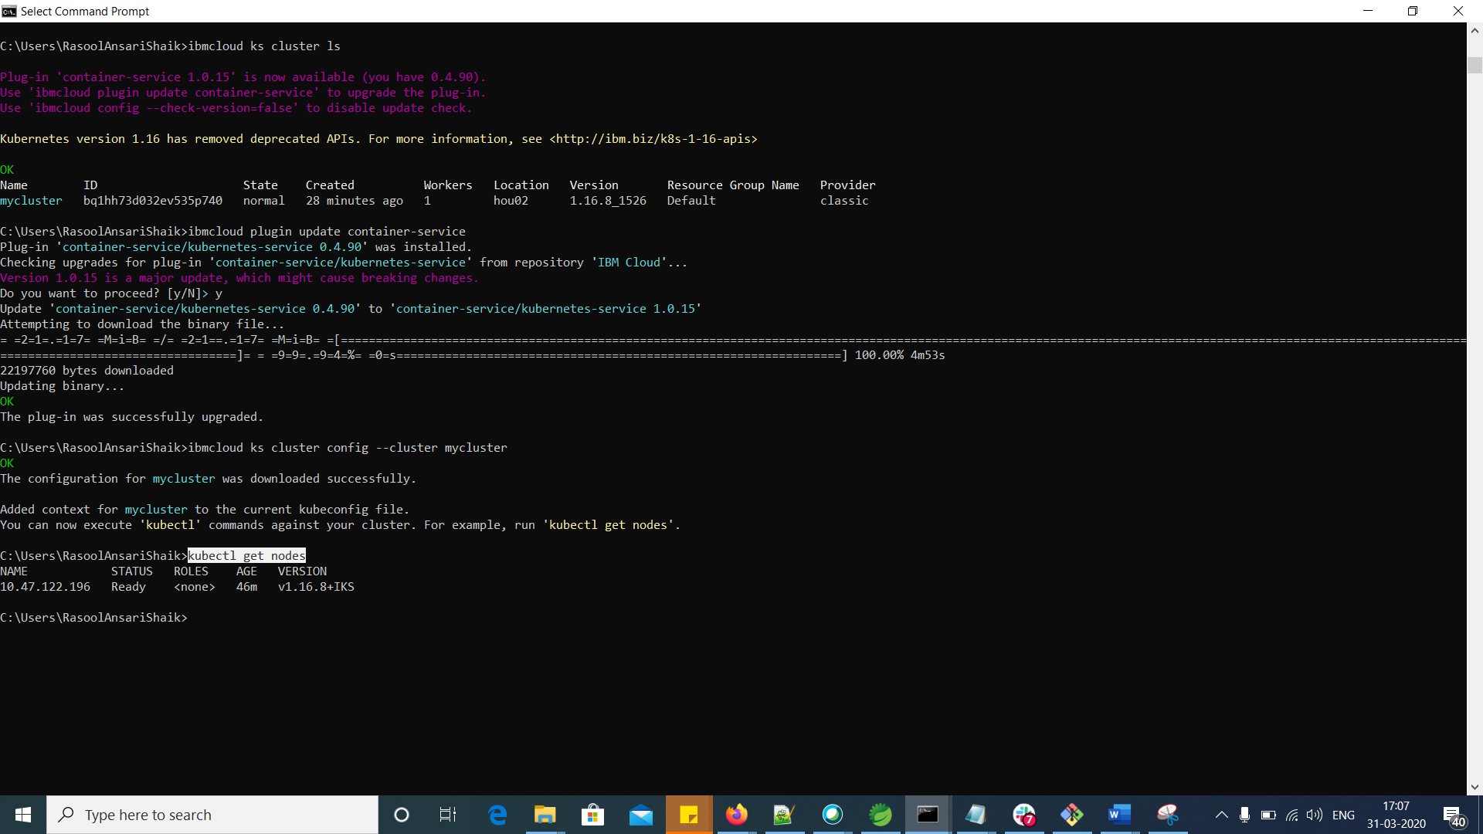

How to setup TILLER to your cluster (IBM Cloud)?

First check whether the TILLER setup to the cluster. Execute the command “kubectl get serviceaccounts --namespace kube-system | grep tiller”

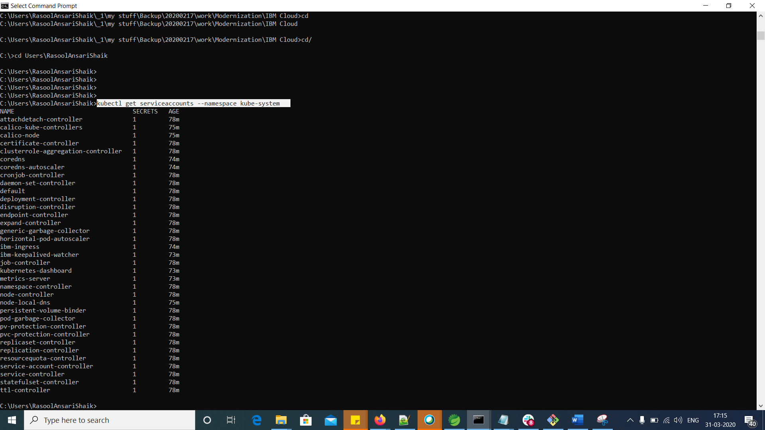

As “tiller” is not available in the list, tiller is to be configured to the cluster.

<https://pages.github.ibm.com/wh-ops/wh-ops-playbook/checklist/ready/sandbox-cluster/sandbox-cluster.html>



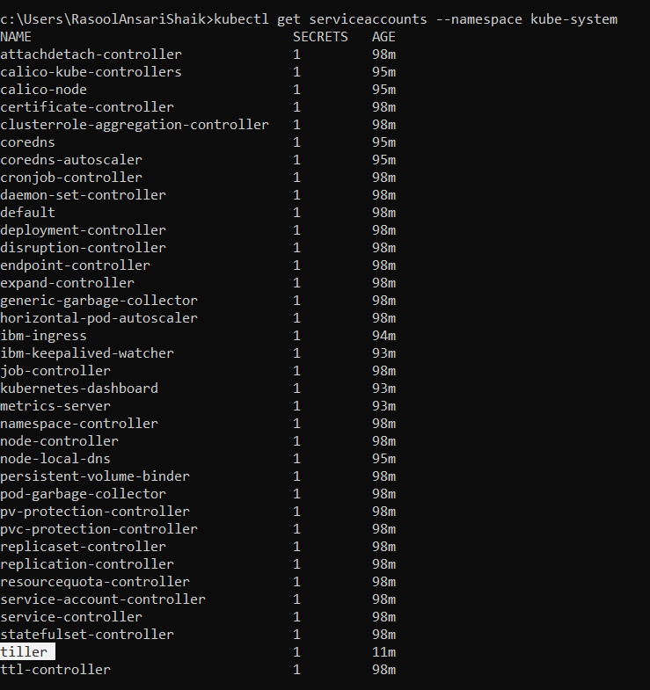

Once you have the client installed, upgrade Tiller with helm init --upgrade

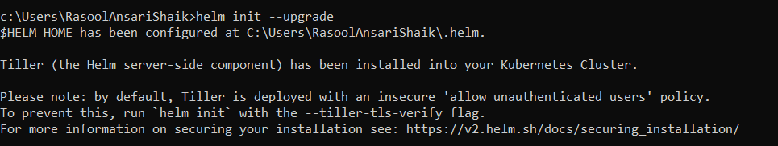

<https://v2.helm.sh/docs/securing_installation/>

**Securing your Helm Installation**