Master’s Research Project
Assignment 4 - Entity Relationships Diagram and Database Development
Developing an Information System to Optimize Supply Chain Operations for Sysco

School of Professional Studies, Saint Louis University
Professor: Annamaria Szakonyi
Due Date: 26th February 2025
By
Team 15

Bala Surya Peruri
Madhuri Pothu
Rasool Babu Yavara
Siva Ganesh Karthik Guptha Motamarri
Srikar Reddy Regatte
Venkata Rahithya Sopalli

Entity Relationship Diagram (ERD) Image

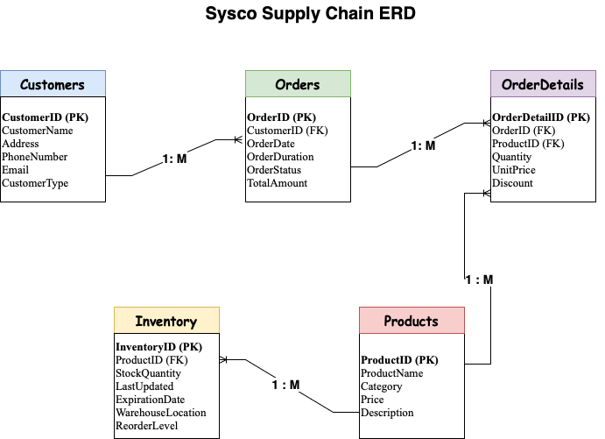
This ERD illustrates our database design for optimizing inventory management in Sysco’s meat department. It includes the core entities like Customers, Products, Orders, OrderDetails, and Inventory, with clearly marked primary keys, foreign keys, and relationship cardinalities (e.g., 1:M for Customers-to-Orders and Orders-to-OrderDetails). The diagram adheres to normalization principles to reduce redundancy and improve efficiency.

Sample Data and Data Generation Explanation
Below is a screenshot of the sample dataset we used. This dataset was sourced directly from Kaggle, providing real-world data on meat consumption that aligns well with our project on optimizing inventory management for Sysco’s meat department.
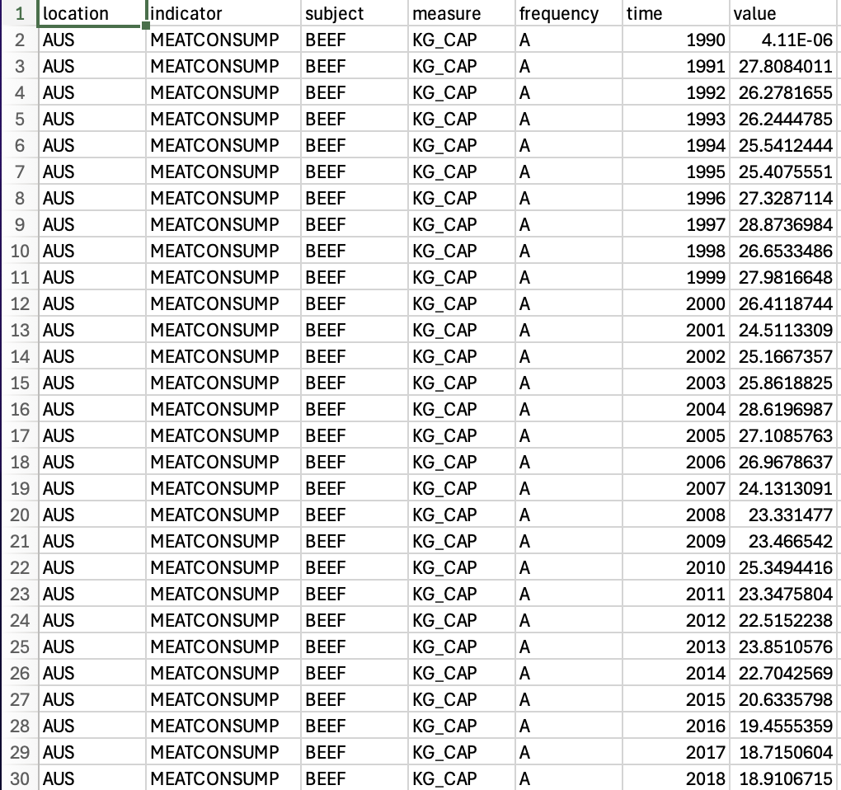
Data Generation Explanation:
- Source:
Our sample dataset was obtained from Kaggle, a reputable source for public datasets. This dataset provided realistic figures on meat consumption which we adapted for our project needs.
- Adaptation:
We used the dataset as a foundation and made necessary modifications to fit the specific requirements of our supply chain optimization project. For example, we ensured that the fields and values aligned with our entities such as Customers, Products, Orders, OrderDetails, and Inventory.
- Integration into Our Project:
The dataset’s values were used to generate sample records for our database tables. This approach allowed us to simulate a realistic supply chain environment while demonstrating our understanding of data relationships and SQL queries.
SQL Scripts for Table Creation, Inserts, and Queries
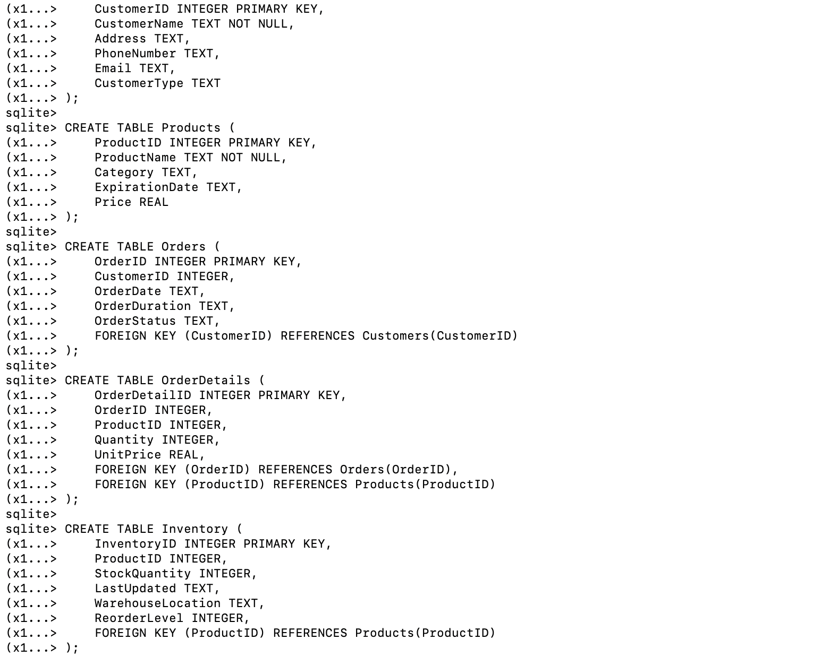
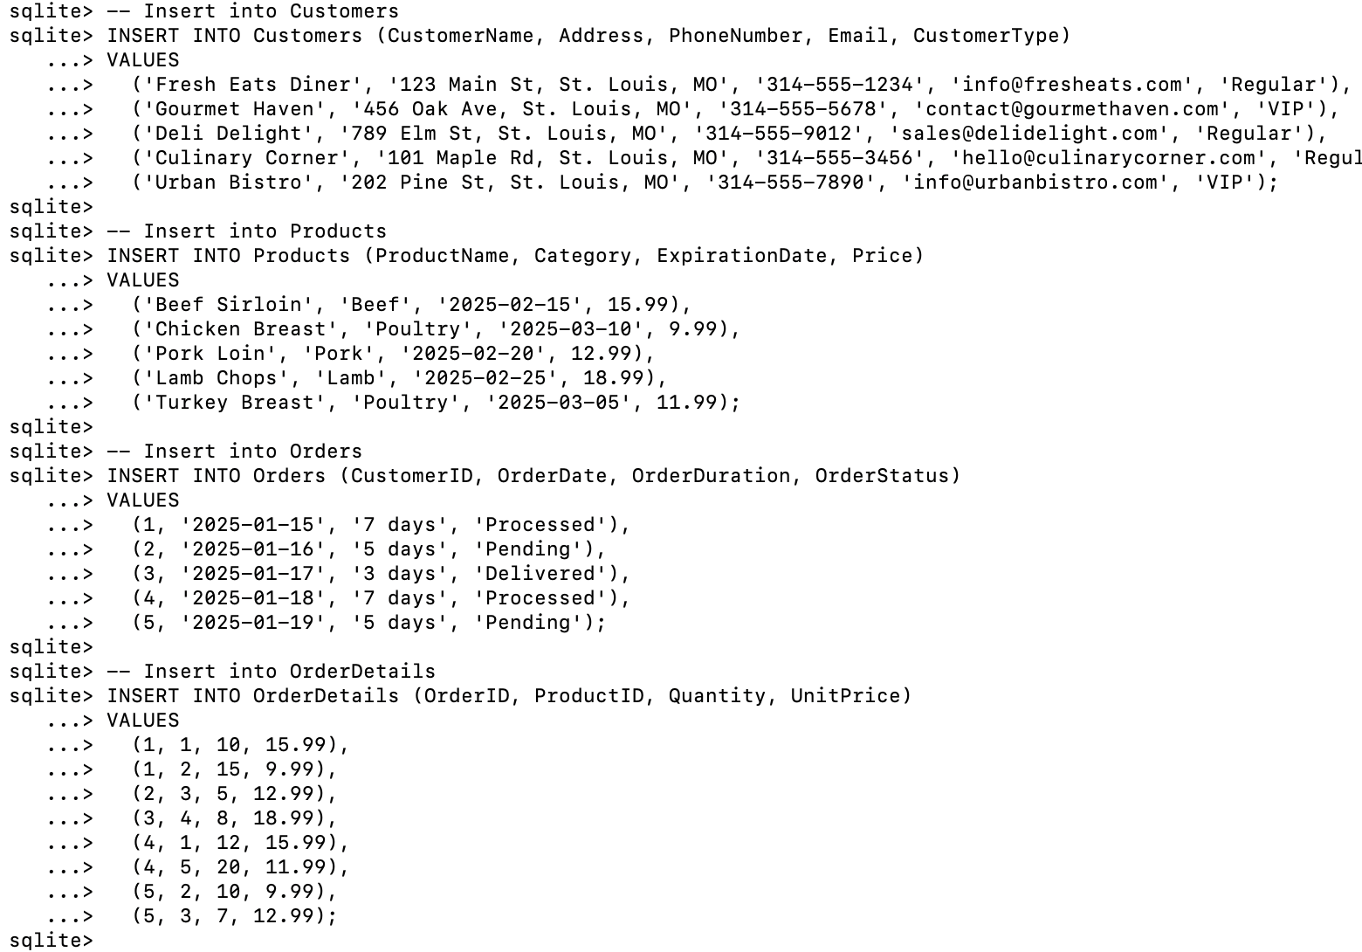
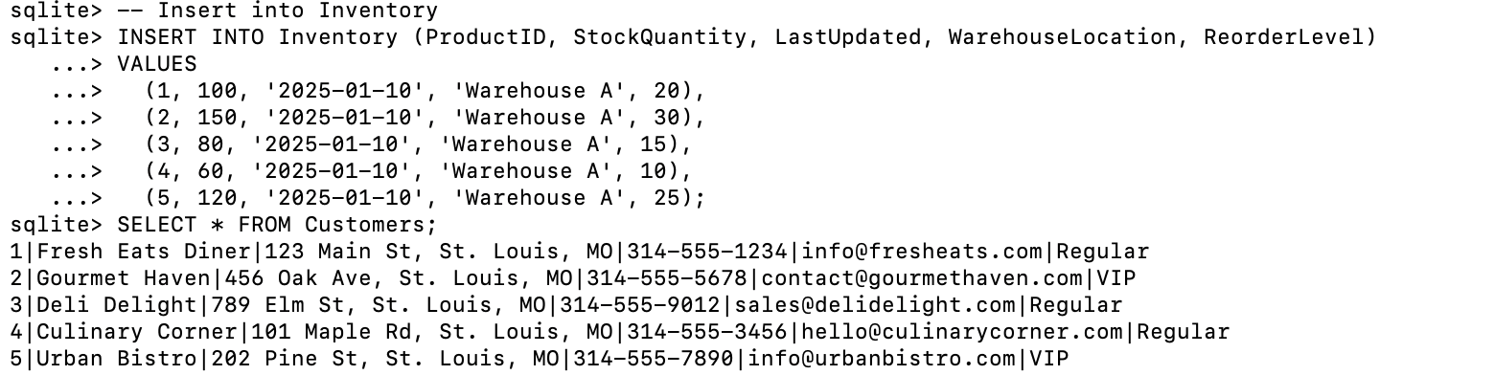
Database Prototype and Query Output
Below are screenshots that demonstrate our fully developed and working SQLite database prototype. These images confirm that our database is functioning as expected.
- Table Data Verification:
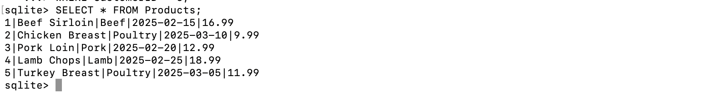
- Join Query Results:
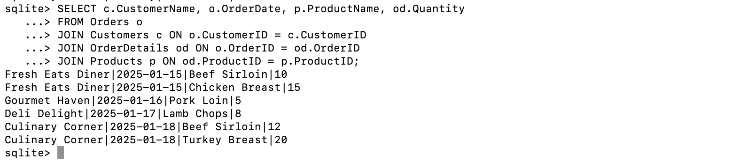
- Data Manipulation Operations:
