Master’s Research Project
Prototype
Developing an Information System to Optimize Supply Chain Operations for Sysco

School of Professional Studies, Saint Louis University
Professor: Annamaria Szakonyi
Due Date: 2nd April 2025
By
Team 15

Bala Surya Peruri
Madhuri Pothu
Rasool Babu Yavara
Siva Ganesh Karthik Guptha Motamarri
Srikar Reddy Regatte
Venkata Rahithya Sopalli

Overview
Our prototype is a fully interactive Power BI dashboard built to help Sysco’s meat department improve how they manage inventory, monitor supplier performance, forecast demand, and track order fulfillment.
This MVP brings together everything we worked on earlier in the project, including our data model, wireframes, and architecture. It demonstrates the core functionality of the system in a way that’s easy to navigate and user-friendly.
We designed this with the end user in mind warehouse managers, supply chain analysts, and procurement teams, so the experience is visual, interactive, and focused on the most important KPIs.
System Components
Database Structure
Our system is based on five main tables:
- Product: stores details like product name, stock quantity, category, shelf life, and reorder level
- Customer: stores customer name, type (retailer, restaurant, etc.), and location
- Supplier: stores supplier name, rating, and lead time in days
- Orders: tracks order ID, product ID, customer ID, quantity, date, order status, and delivery method
- Inventory: keeps track of expiration status and product value across time
This structure helped us build relationships between data and design the visual components in Power BI.
Architecture and Wireframes
We used a simple three-layer architecture:
- Input Layer: CSV and Excel files simulate the database
- Processing Layer: Data modeling, filters, and calculations using Power BI features like DAX and Power Query
- Presentation Layer: Dashboards and visuals designed to reflect our wireframes
The layout we created in our wireframes translated directly into the dashboard tabs and sections, keeping the design consistent and easy to use.

Screenshots of the MVP
We’ve included screenshots of each major dashboard tab to demonstrate how the system works. Each one has filters, charts, and data tables that update based on user input.
Pages included:
- Landing Page (with instructions and navigation)
- Inventory Overview
- Shelf-Life and Waste Management
- Order Management
- Customer Demand and Order Duration
- Demand Forecast and Supplier Performance

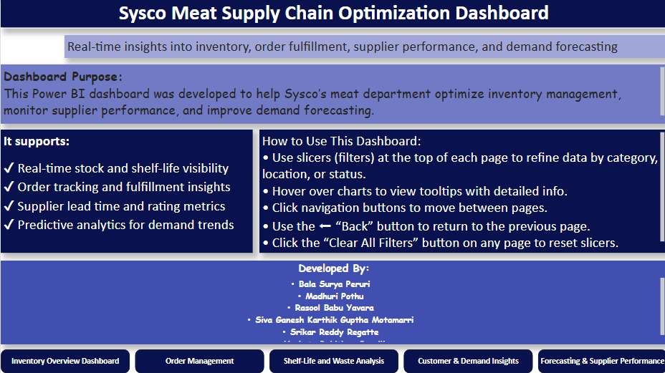
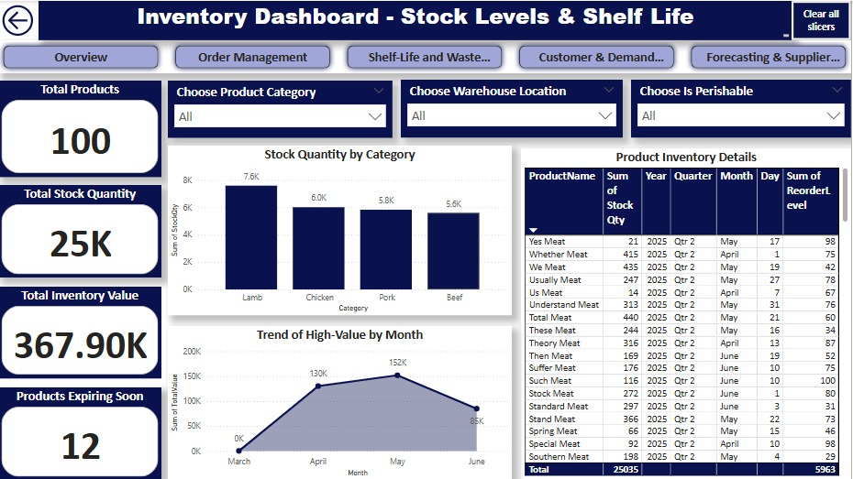

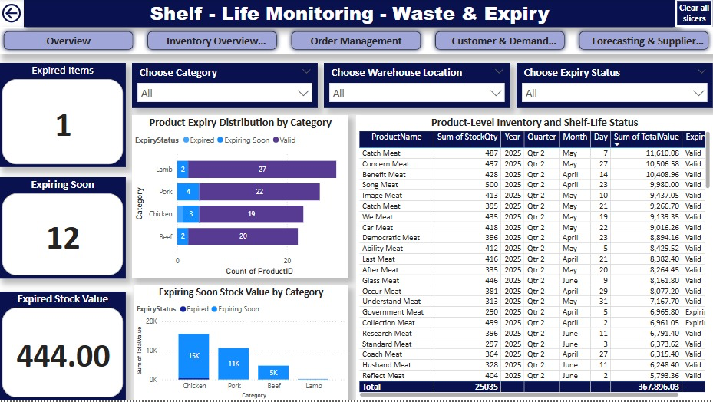

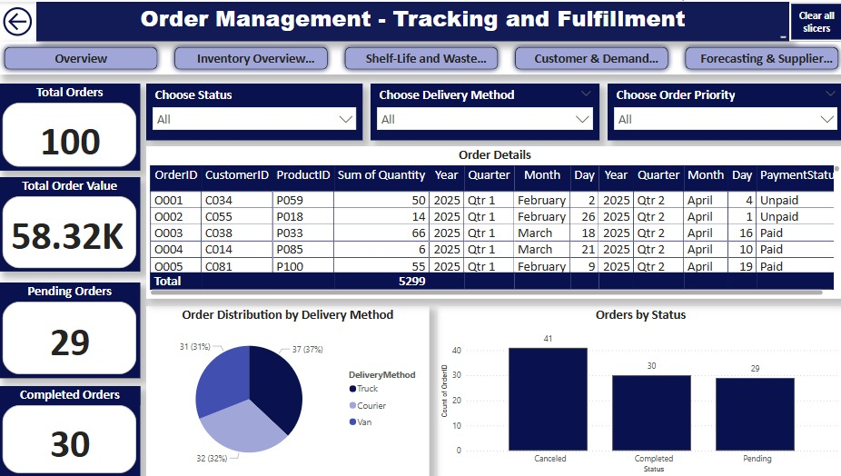

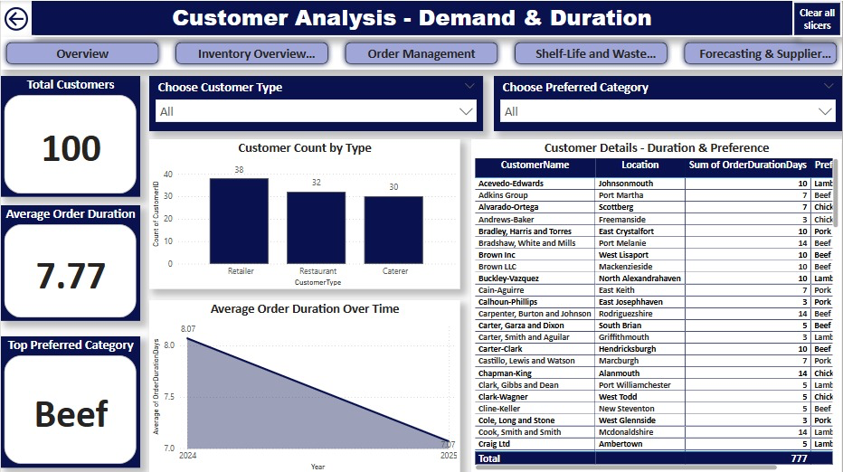

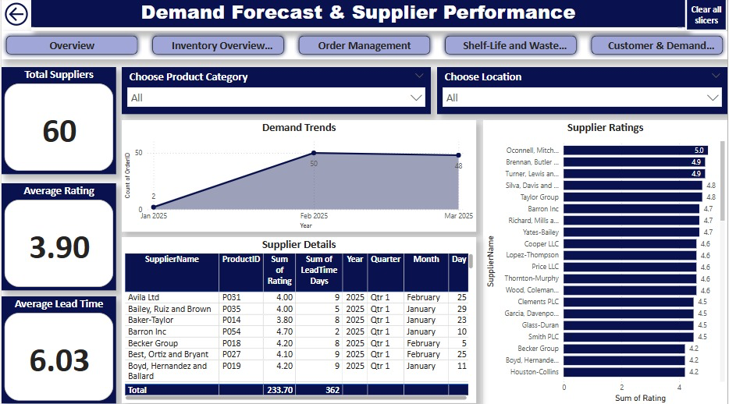
Testing Plan and Results
We tested the key features in our dashboard to make sure they worked as expected. The table below summarizes our testing process.
Test Item | What We Tested | Expected Outcome | Result | Issue Fixed
Filters | Filters on all pages update data correctly | Graphs and tables change when filters are used | Passed | Yes
Navigation | All navigation buttons work across pages | Pages switch properly when buttons are clicked | Passed | Yes
Inventory Data | Stock values and expiry statuses display correctly | Inventory tables match expected results | Passed | Yes
Order Status | Orders update by status (pending, complete, cancelled) | Charts show accurate counts | Passed | Yes
Supplier Ratings | Supplier bar chart and table reflect selected category | Visuals match filter values | Passed | Yes
Customer Analysis | Customer type and category filters update charts | Duration and preference graphs adjust | Passed | Yes
Reset Buttons | "Clear all filters" button resets each page | Filters return to default | Passed | Yes

