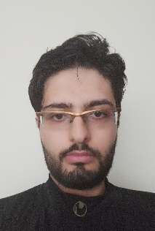
Python programmer in artificial intelligence, communication engineer, interested in machine learning specially computer vision field, also familiar with MatLab and c++.
Responsible and ability to research new scientific objects; team working (scrum framework)

About Me
ک
In His High Name

Rasoul Zamani
ک
Iran, Isfahan
(+98)9133837853
r.zamani72@gmail.com
https://github.com/RasoulZamani

Education and Courses
ک

Skills:
Isfahan University of Technology: BS in electrical engineer (2011-2015)
Isfahan University of Technology: Master in communication (2015-2018)

Python:
Scikit-learn, PyQt, OpenCV
REST API by Flask
Frameworks:
Tensorflow, Keras, Pytorch
Other language: MatLab, C++
Data Bases:
PostgreSQL, MongoDB

Embedded: Jetson
Linux (LPIC1)
Git
Docker
Rapid Miner, Image Pro

Teamwork and scrum skill

Udemy: Learn to Code with Python (Boris Paskhaver, 60h)
Coursera: Deep Learning Specialization (Andrew NG, 80 h)
Udemy: Python for Computer Vision with OpenCV and Deep Learning (10h)
Udemy: Complete Data Science Machine Learning Bootcamp (40h)
REST APIs with Flask and Python (Udemy, 20h)
Convolutional Neural Networks in TensorFlow (Coursera-L. Morony,20h)

Job experience
ک
Image processing and computer vision programming at VIRASAD (5 month)
Cooperation for Knowledge graph extraction from AI articles (1 month)

- Prediction of house price with linear regression (sklearn)
- Classification of comments by LSTM (keras)
- Image classification on MNIST and CFAR10 datasets by CNN
- Image processing such edge detection, object tracker and face recognition by openCV
- Segmentation and masking by RCNN (Detectron)
- Using Inception, vgg16 and YOLO models
- Car and plate detection by pruned and quantified YOLOv5
- Implementation of famous models on Jetson board

Projects

