
UK places quiz

In this project you will learn how tools transform the ways that we can use language models.

This project assumes you already understand the basics of how language models work.
You will understand this project better if you do the “Language Models” worksheet before this one.

This project uses a very large model that needs a modern, powerful computer to run.

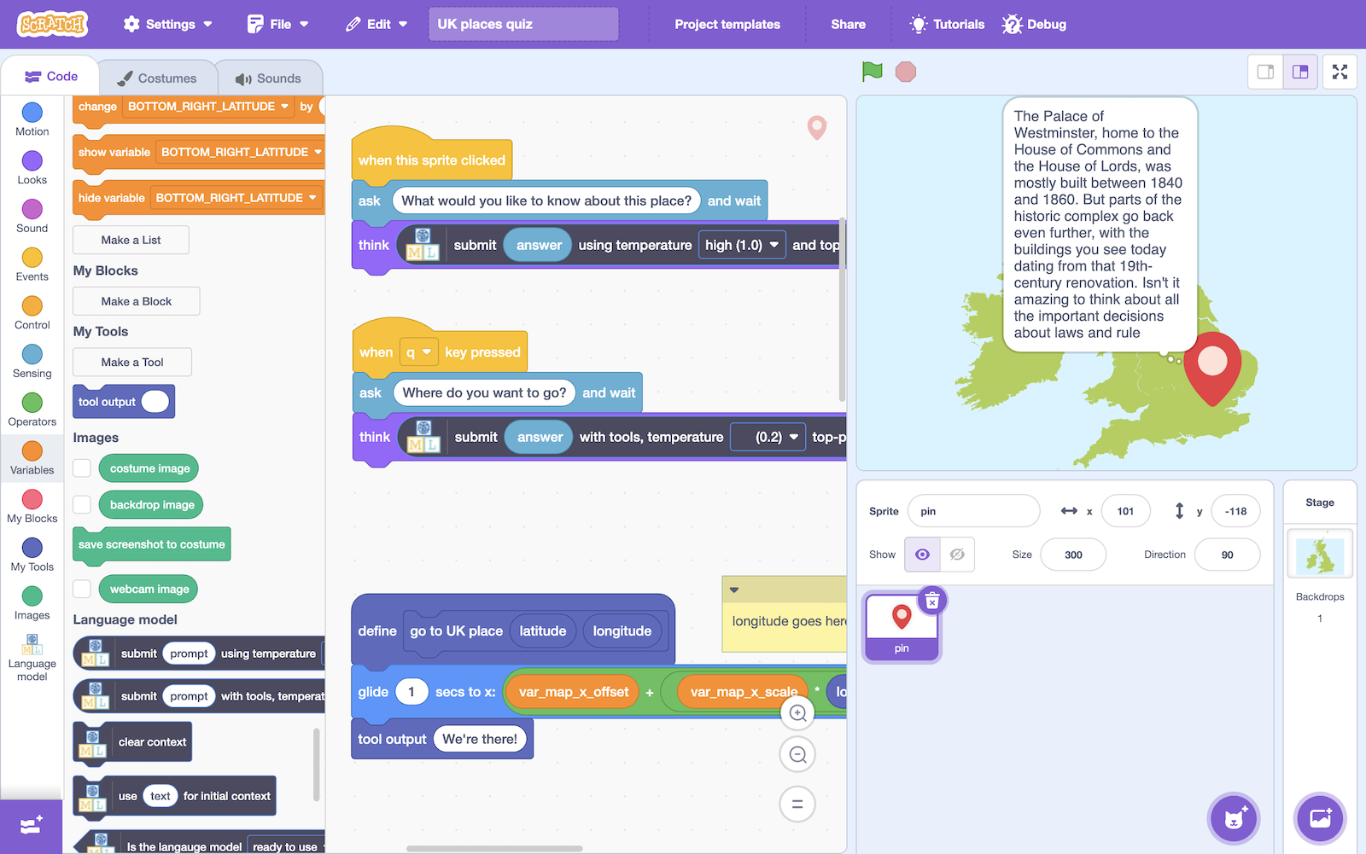

This project worksheet is licensed under a Creative Commons Attribution Non-Commercial Share-Alike License
http://creativecommons.org/licenses/by-nc-sa/4.0/

If you are under the age of 13, please only use a small language model with supervision from a trusted adult.
Generative AI can sometimes generate text that isn't nice or appropriate.

- Go to https://machinelearningforkids.co.uk/
- Click on “Get started”

- Click on “Log In” and type in your username and password
If you can’t remember your username or password, ask your teacher or group leader to reset it for you.

- Click on “Projects” on the top menu bar

- Click the “+ Add a new project” button.

- Name the project “UK places quiz” & set it to generate text
Click Create
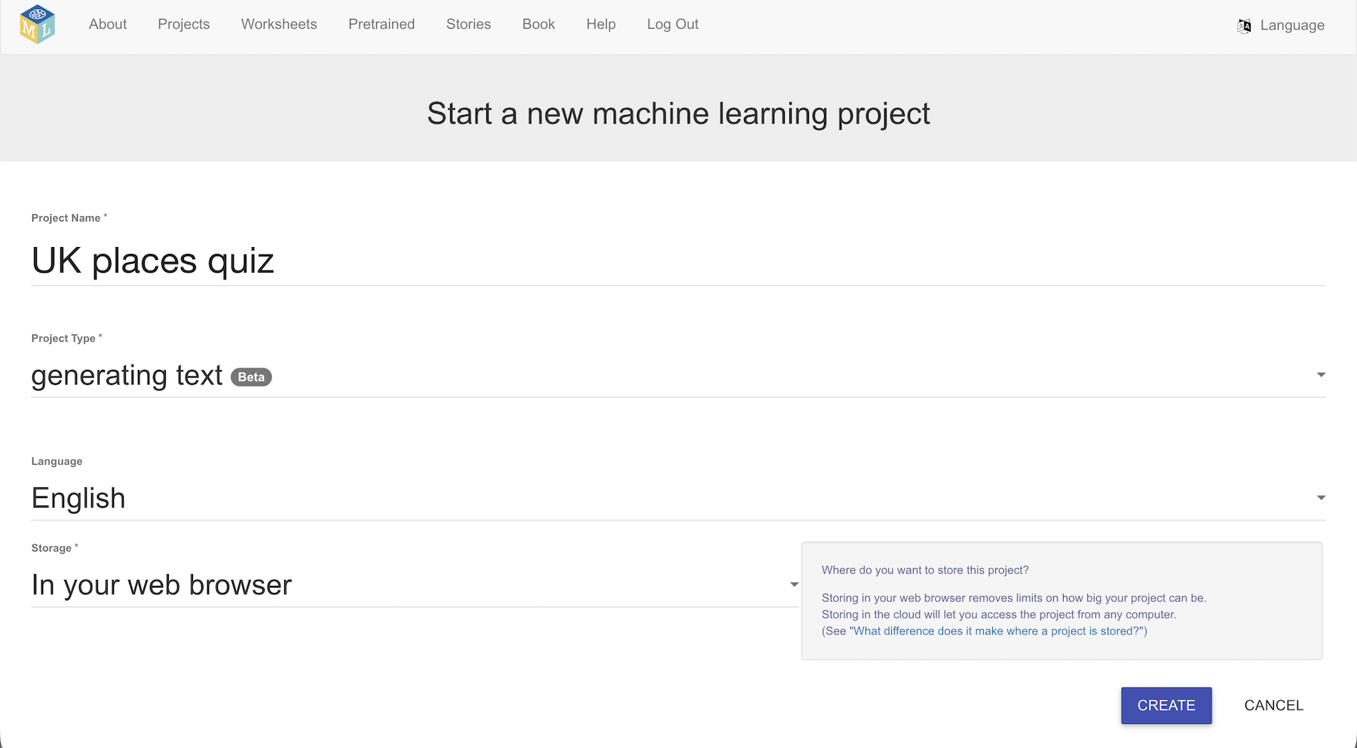

- You should see your new project in the projects list. Click on it.
- Click on Small, and then click Next
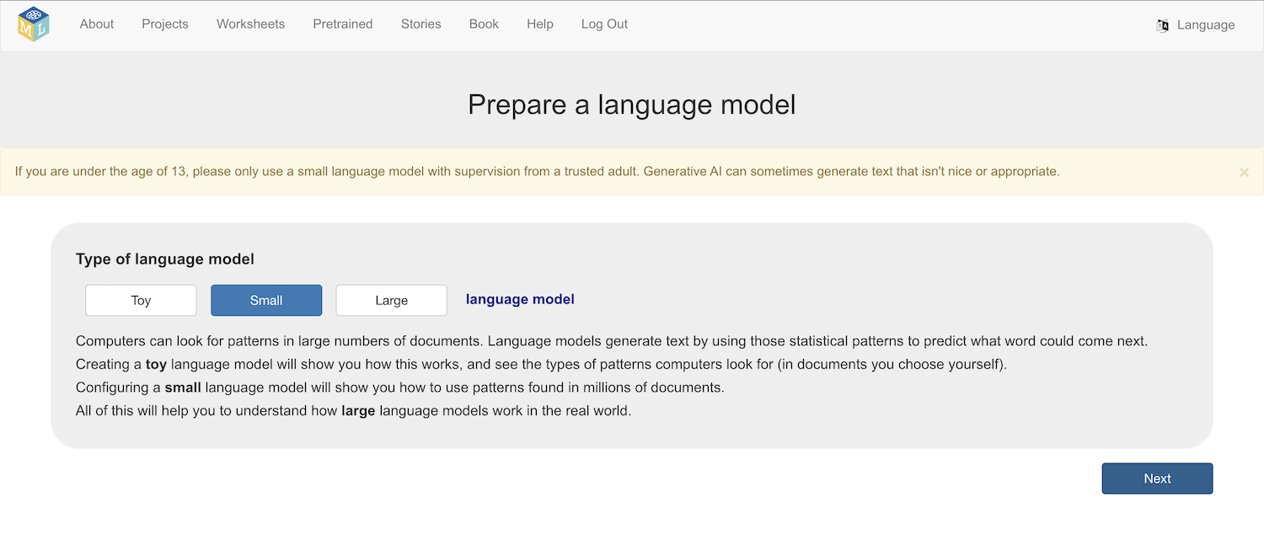

- Choose the Hermes model architecture
This is the biggest and most complex model available on the site.
You need a powerful, modern computer to use this model.
There are other projects that you can do with smaller models if this model doesn’t work for you.
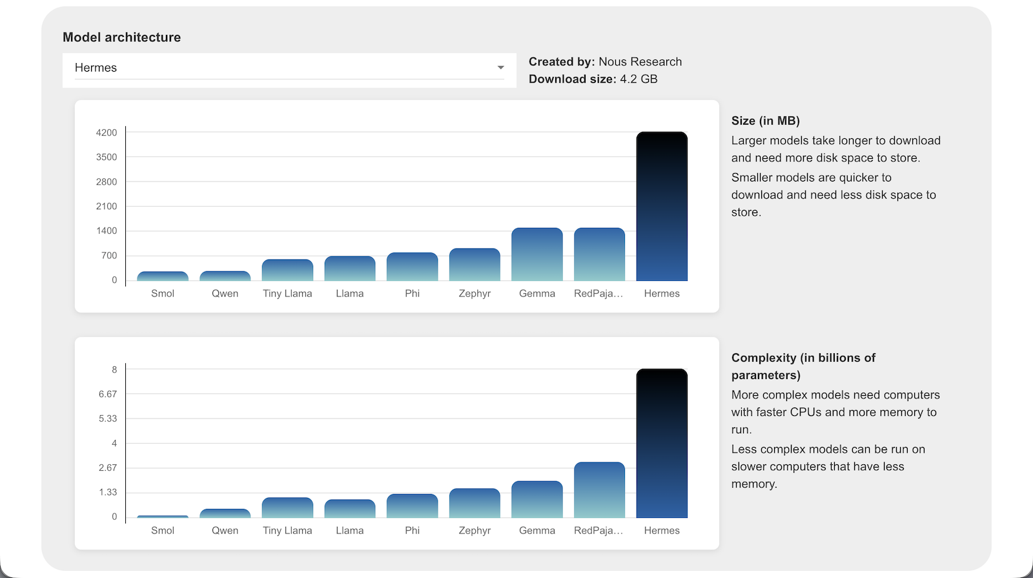
- Click Download
- Choose 8192 as the context window size, then click Next
- Choose a low temperature and Top-p value, then click Next
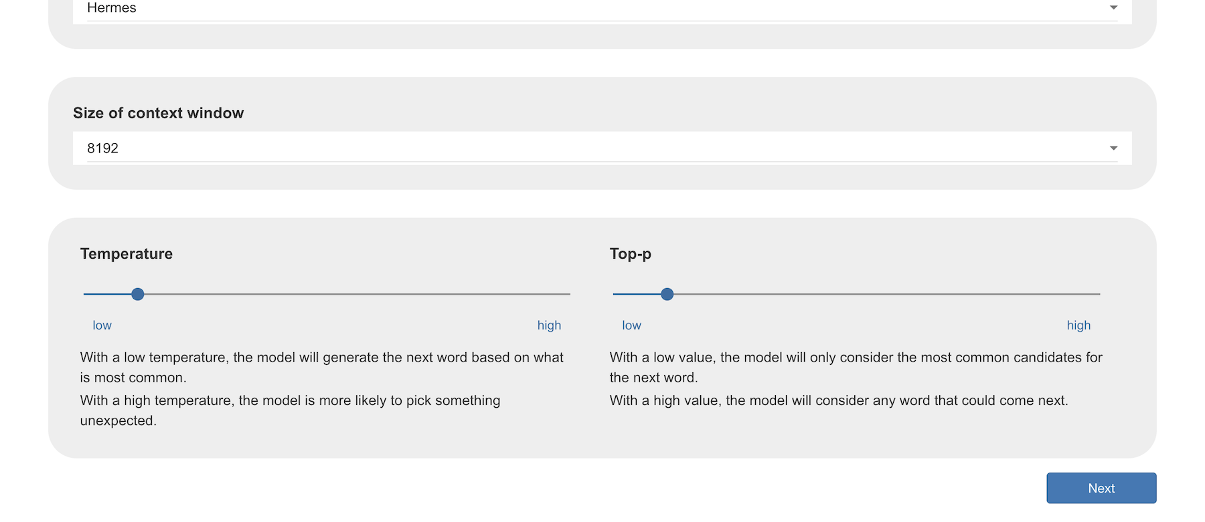
- Select No initial context, and click Next
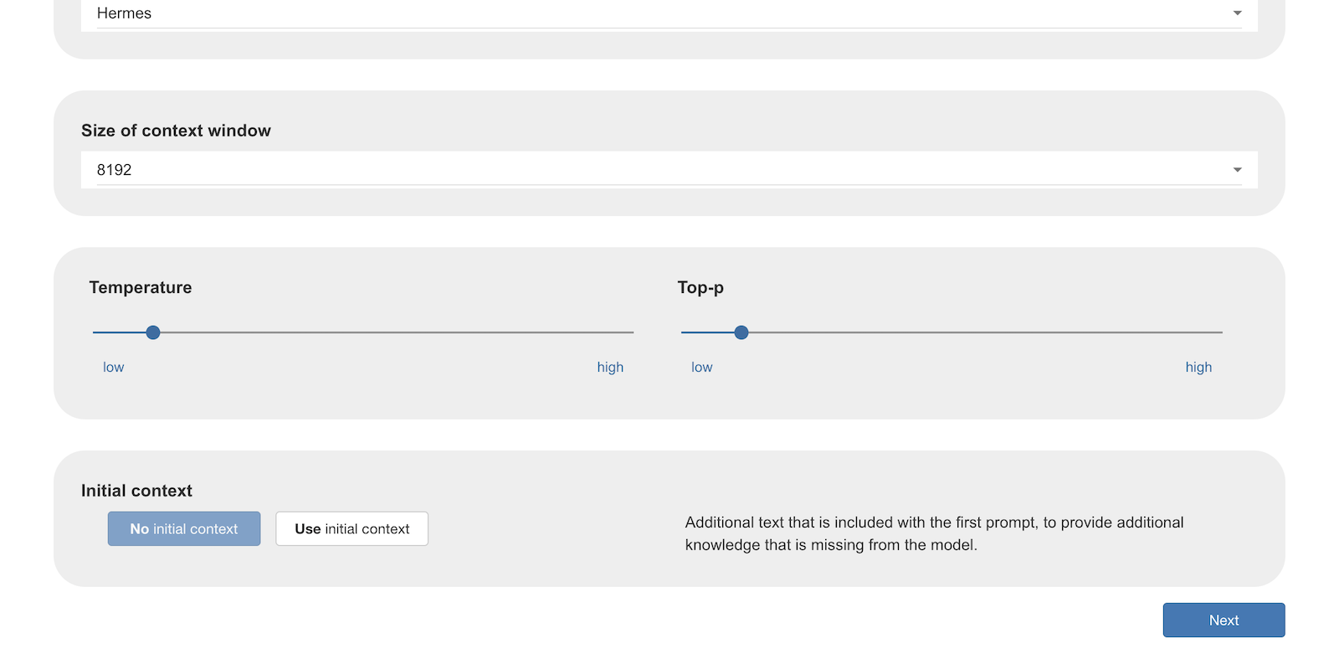
- Disable tools and click Next
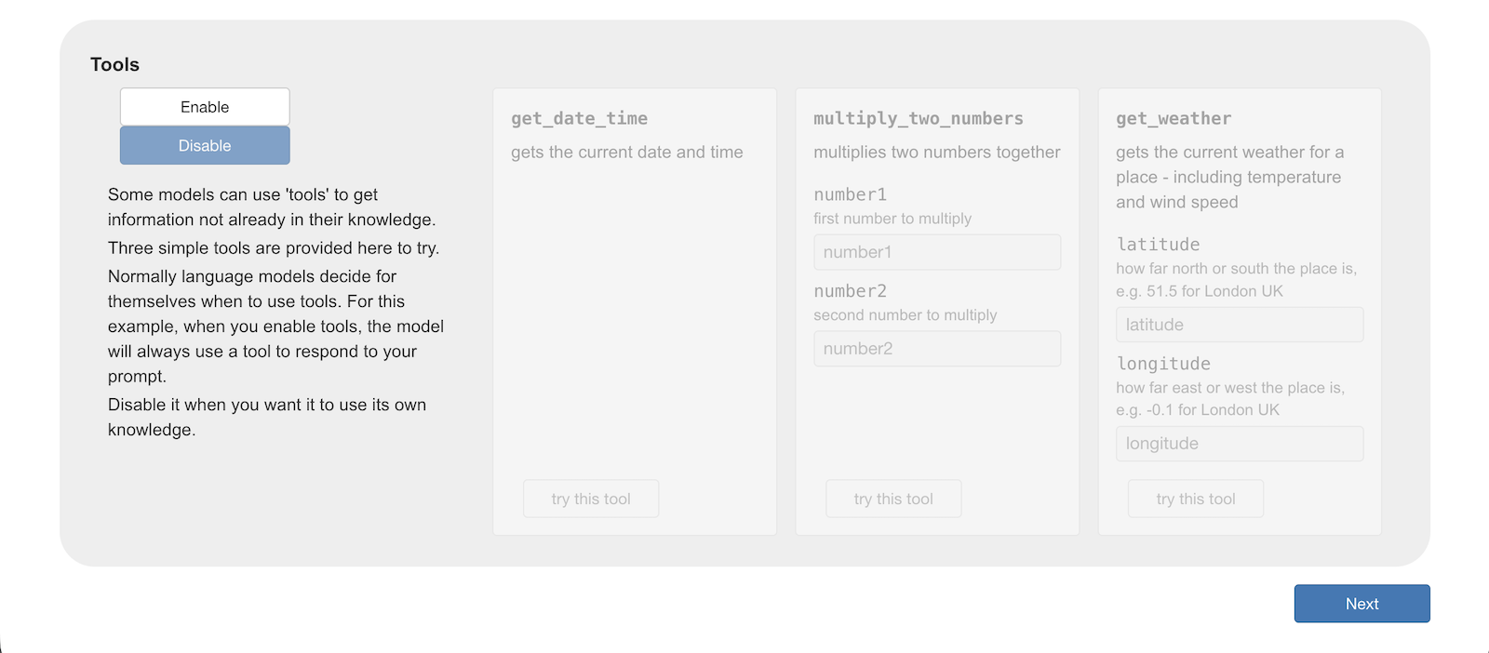
- Ask the model a question to verify that it works on your computer
It doesn’t matter what you ask. The aim is to see if the model has loaded.
- Ask a question that the model should be able to answer from the knowledge it built from the documents it was trained with.
It should be something general knowledge, that does not change often.
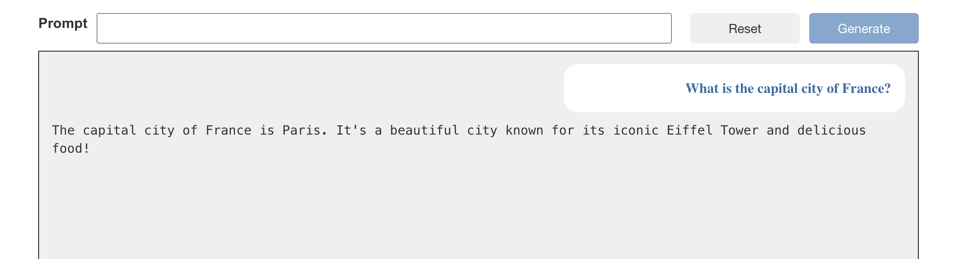
- Ask questions that require current information that cannot be in the model’s knowledge:
What is the weather?
What is today’s date?
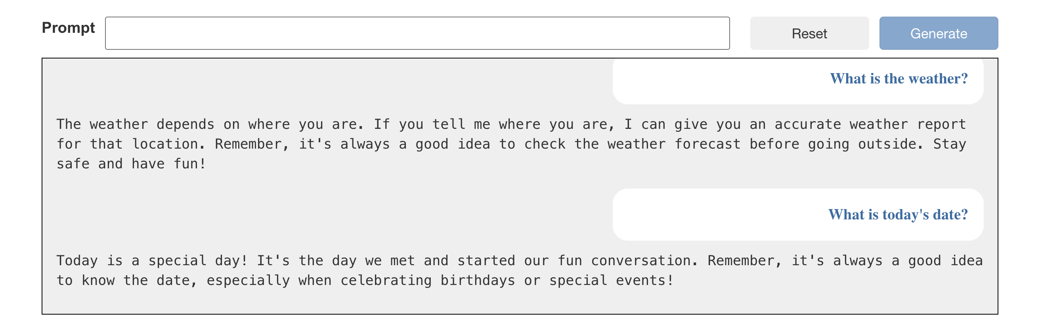
You learned from the Language models worksheet that language models predict the next most likely word based on the patterns that were found in the documents used to train the model.
This works well for questions that have answers in those documents. But it doesn’t help the model generate an accurate weather report.
We can help language models to do more by letting it use tools.
- Click on Enable to enable the three sample tools
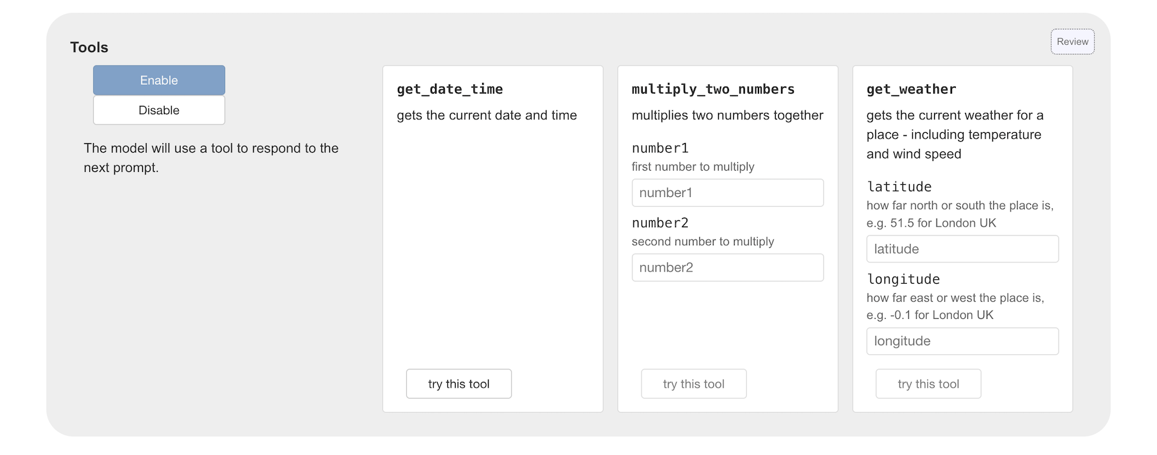
- Use the try this tool buttons to try the tools and see what they do
These tools do not use Artificial Intelligence. They are simple programs that collect information and return some text.
- Read the titles and descriptions of the tools
When you click Enable these titles and descriptions are added into the context of the language model, which tells it that it can choose to call these tools when it needs.
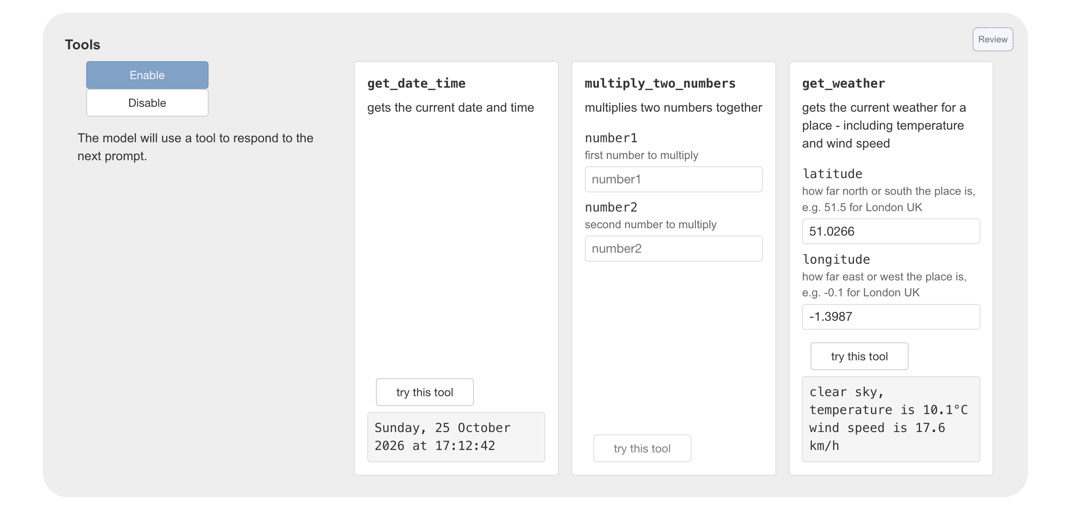
Some tools, like the get_weather tool, need the model to provide some input values for it to work.
More complex language models can not only generate text, but recognise when a tool will be useful, and include the output from tools in the answers that they generate.
- Ask a question that could use the tool without any input values
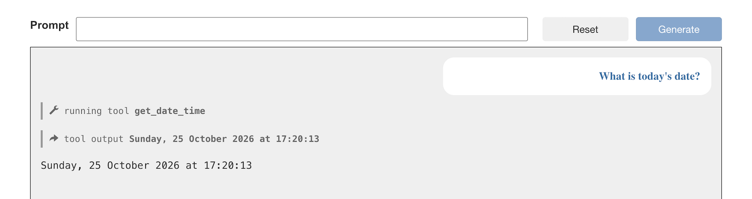
- Ask a question that will need the model to work out the correct input values by using it’s knowledge
For example, if I ask What is the weather in Winchester? the model can identify the latitude and longitude coordinates for Winchester from it’s knowledge because that doesn’t change, and use a tool to get the current weather at those coordinates.
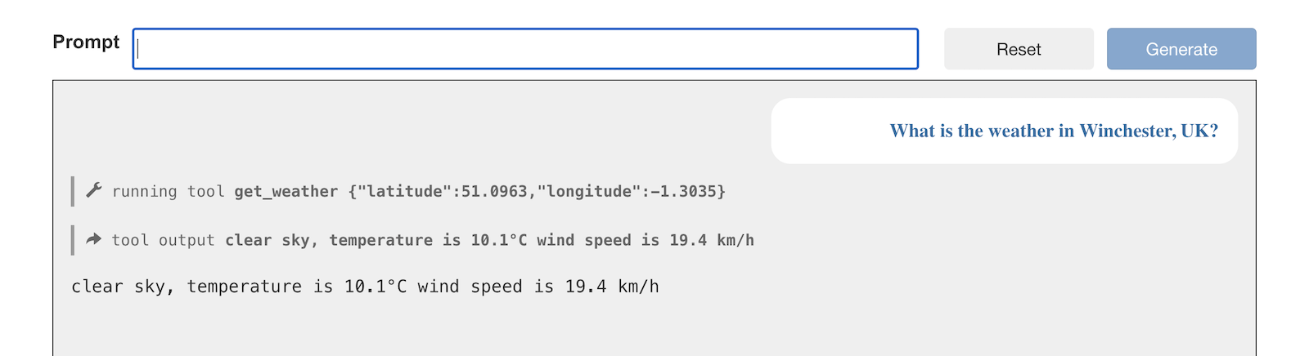
Notice that the tool the model has chosen is displayed to you to help you understand how it works, but the output from the model is what is shown underneath.
Tool calling

Using tools is an effective way to expand on how we can use language models to respond to questions that can’t be answered from the model’s knowledge by itself.

The model’s ability to use language is used to help it identify:
• which tool to use
• what inputs to give the tool
• what to do with the output from the tool
- Click on the Scratch 3 button to use a tool calling model in Scratch
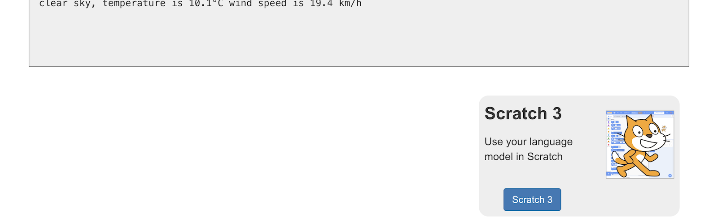
There are no tools available to the language model in Scratch.
To give your model tools for it to use, you have to code them yourself.
Time to give that a try. You can make up your own tools if you have your own idea, or you can use the idea from steps 24-32.
If you make up your own project, skip to step 33.
- Create a simple project that uses a model without tools
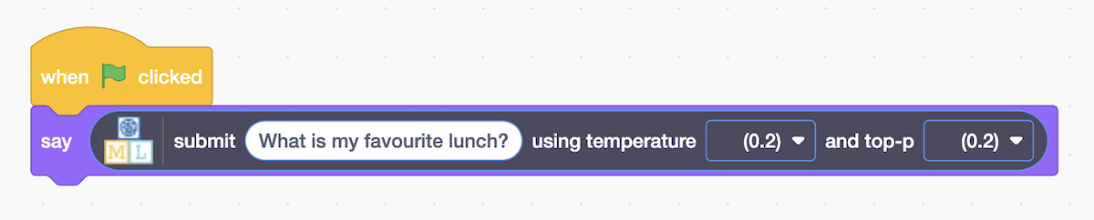
- Try it out!

Next, you’ll create a tool that will help the model to give a better answer
- Click on Make a Tool
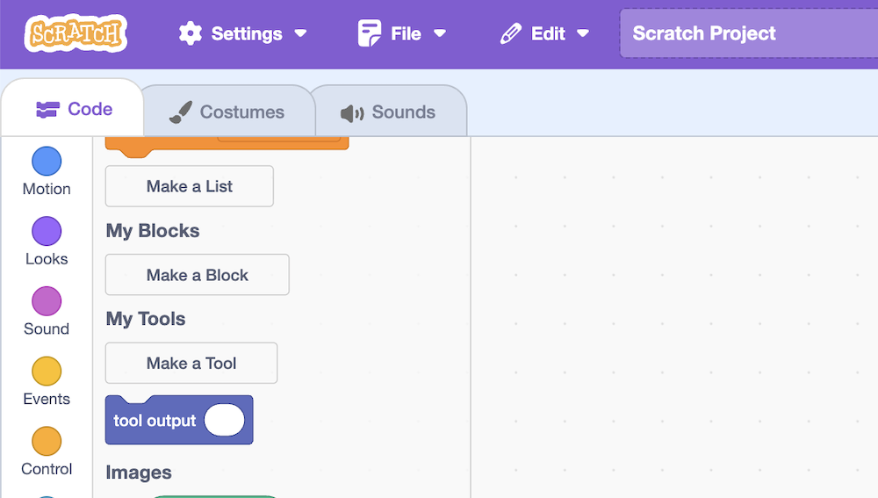
- Give your tool a name and description
Detail is useful – it helps the model know when to use your tool.
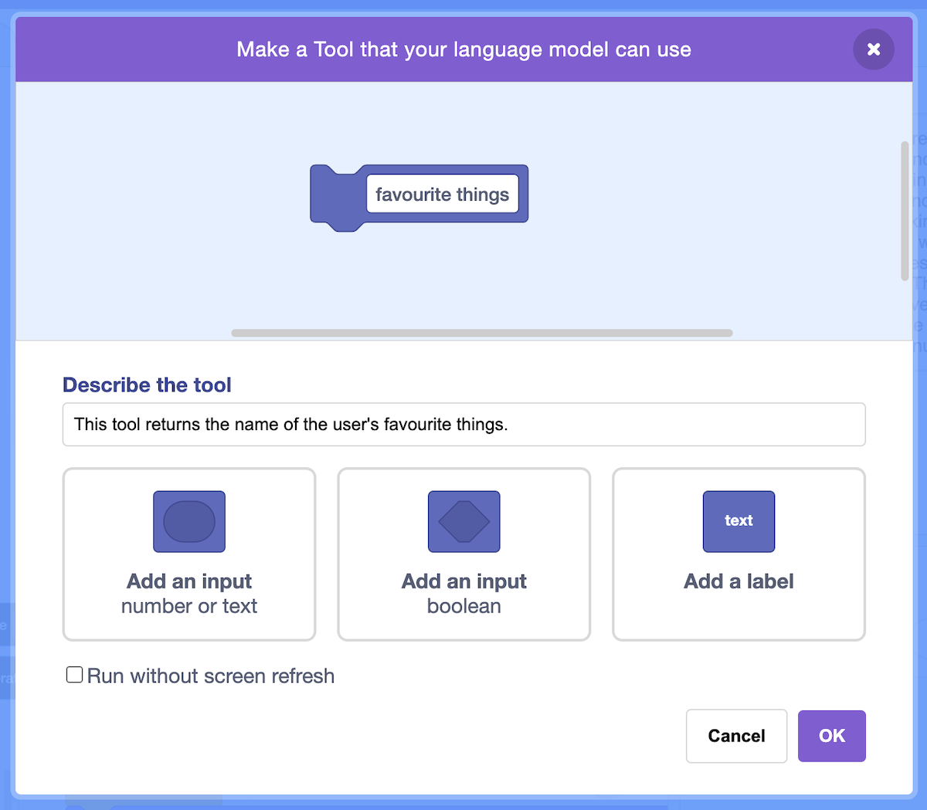
- Click on Add an input to include values the model should provide
- Give every input value a name and description
Detail is useful – it helps the model know what to give your tool.
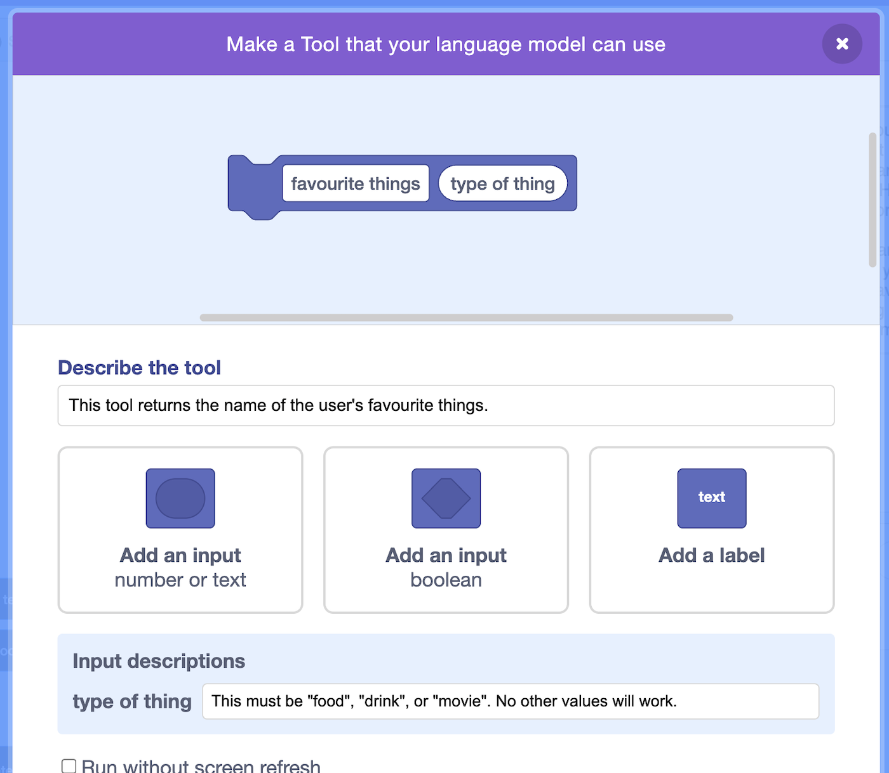
- Write the code for your tool.
If you want the tool to return some data to the model, use the tool output
Tools don’t have to return data, they can just do something instead.
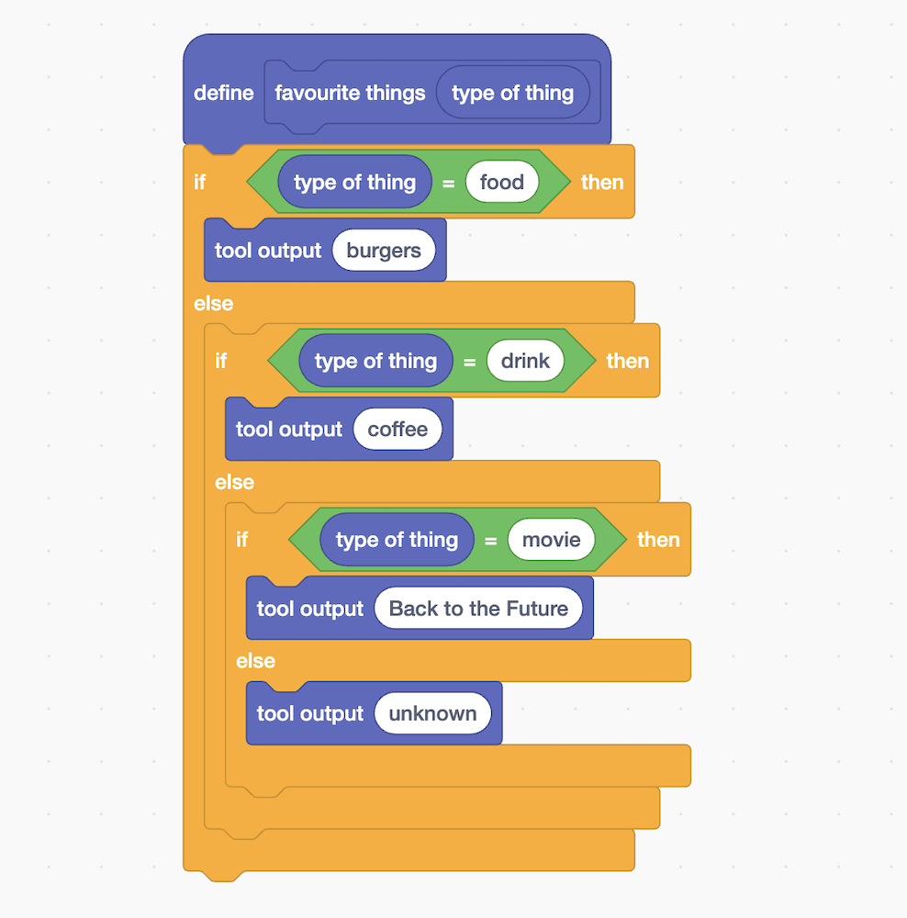
- Update the project to tell the model it should use tools
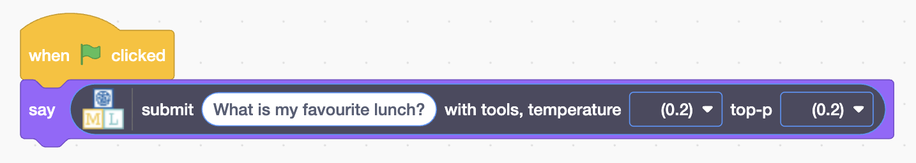
- Test your project

Time to make the UK Places Quiz.
This project will let the model use tools in a different way: to move sprites
- Click on Project templates and choose the UK Map template
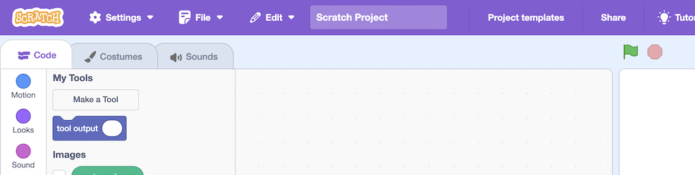
- Create a tool
name: go to UK place
description: This tool moves the sprite to a location in the United Kingdom
- Add two inputs
latitude = how far north or south the place is, e.g. 51.5 for London
longitude = how far east or west the place is, e.g. -0.1 for London
- Click OK
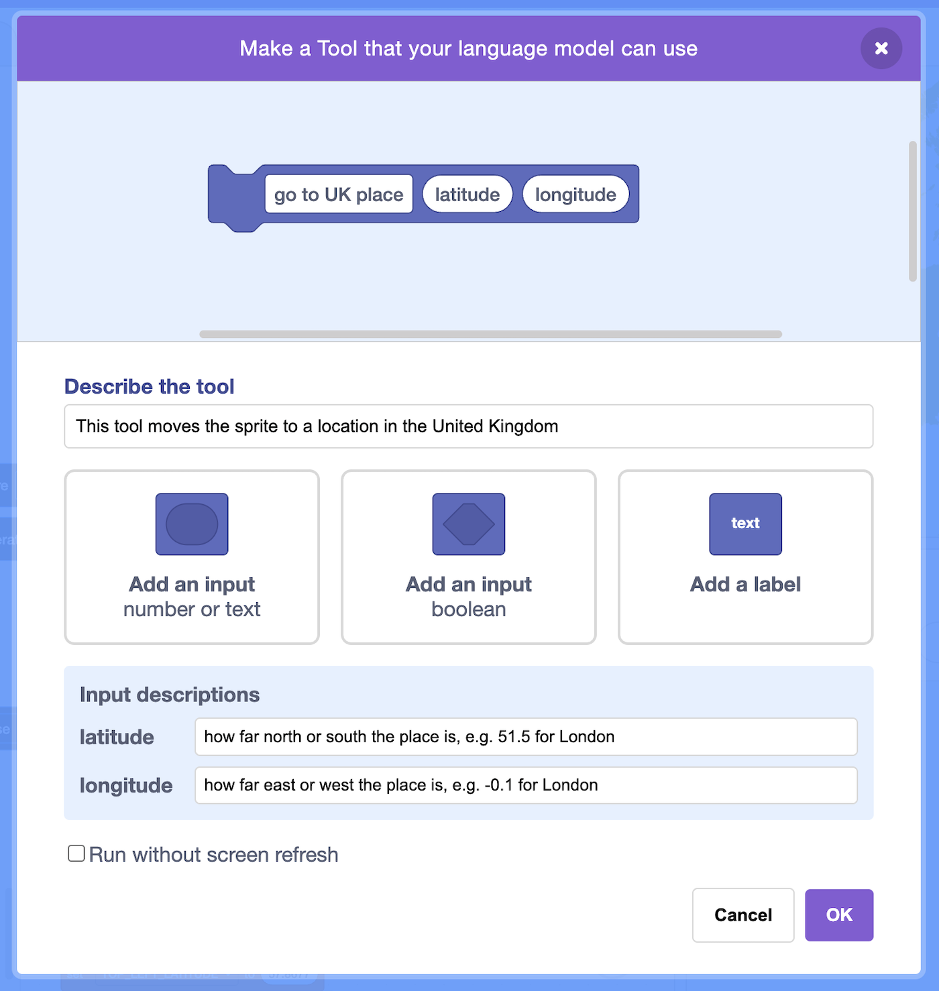
- Find the code that is prepared for you and connect it to your tool
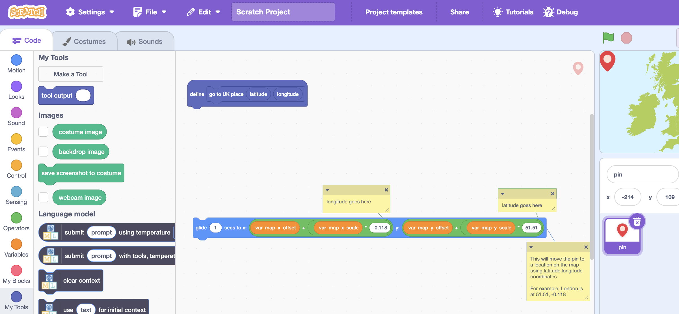
- Add the tool inputs into the code
The comment notes are there to help you
You don’t have to add a tool output
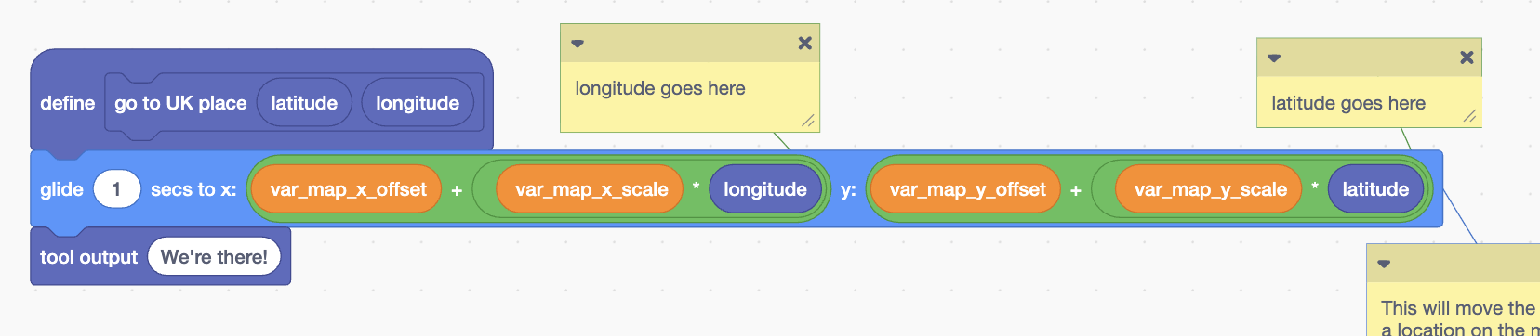
- Add this new code
Make sure you pick the version of the model that tells it to use tools
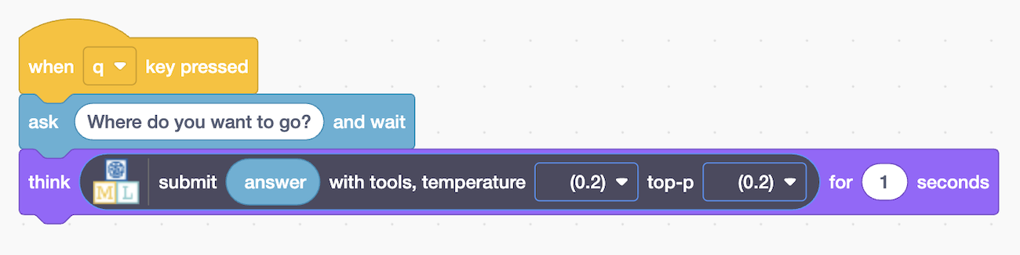
It’s time to test!
- Press Q then enter a prompt
Make sure the prompt describes going to a place, so the model decides to use your tool
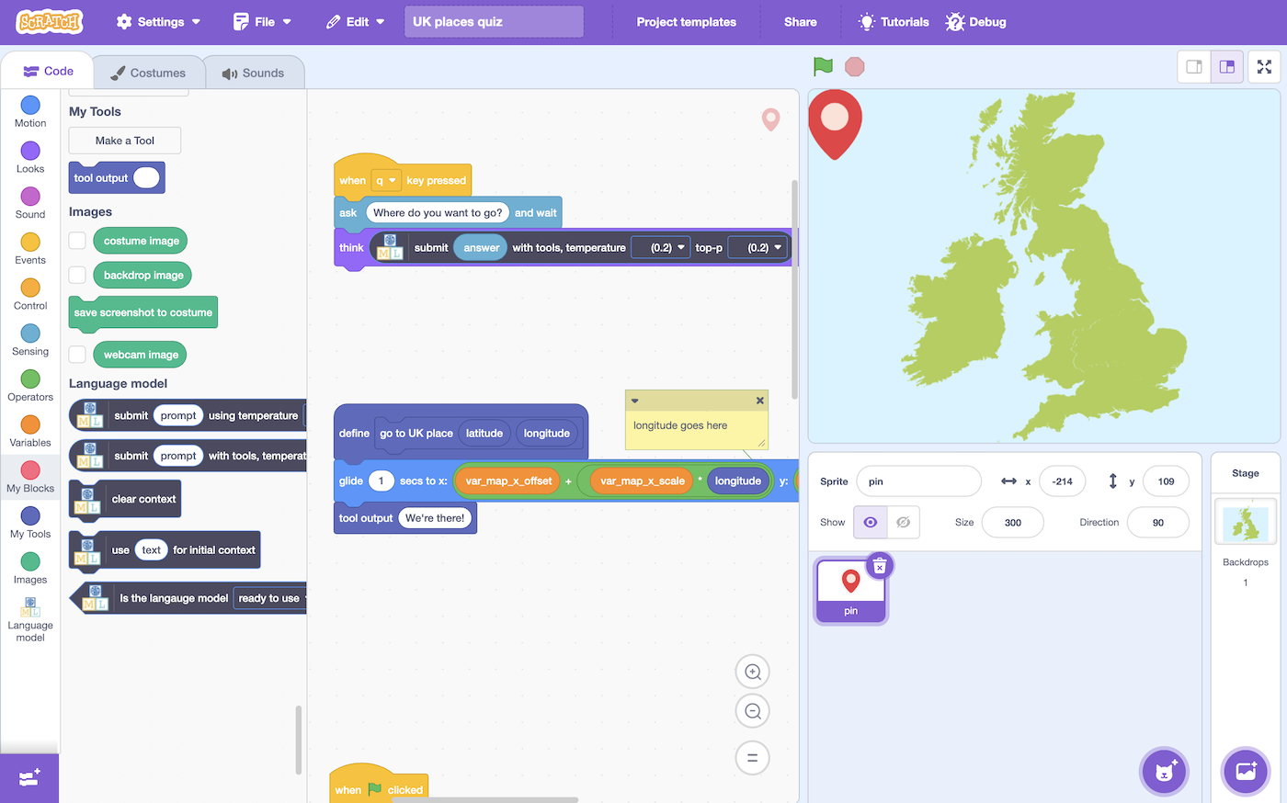
For example:
take me to the birth place of The Beatles
let’s go to where Nessie is hiding
I want to go and meet the King
These prompts mention going somewhere, so the model should decide to use it’s “go to UK place” tool. The tool description tells the model that it needs a latitude and longitude, so it should use its knowledge to provide the right latitude and longitude as inputs to the tool.
Your tool will move the sprite on the map when the model calls it.
Next, you’ll combine this with a traditional non-tool use of the language model.
- Add this code to your project
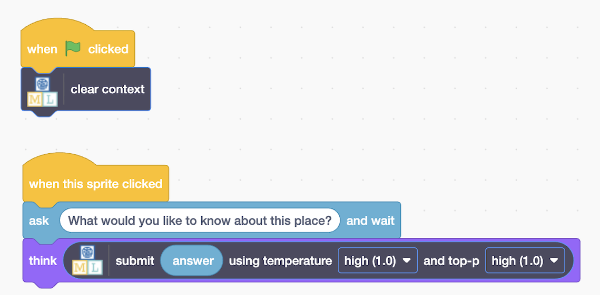
- Time to test!
1. click on the fullscreen button
2. click the Green Flag
3. press Q
4. enter a prompt like
let’s go to where UK politicians meet to debate and pass laws
5. click on the map pin sprite
6. enter a question like
When was it built?
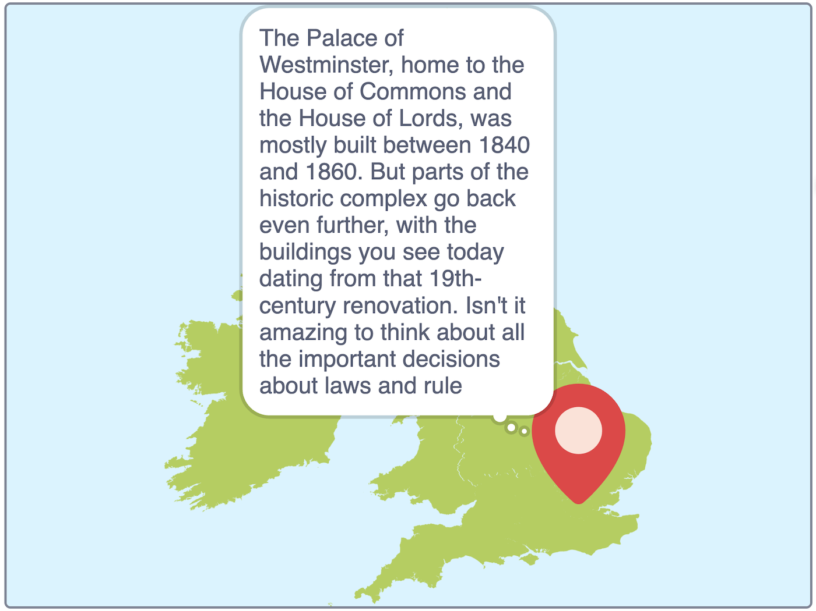
How language models use tools

A few years ago, if you asked ChatGPT what day it was, it would not be able to give a useful answer.
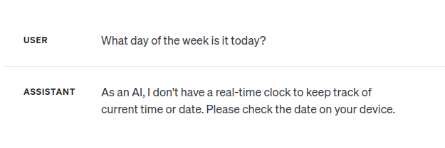

If you do that today, you get a helpful answer.

The difference is tools.
Giving language models the ability to call tools has transformed the way that we use generative AI.
Tools let models look up current or custom information that couldn’t possibly be in their knowledge, and take actions on our behalf by calling external systems.
The tools that the AI systems use do not have to use machine learning themselves, and can be simple rules-based actions, as you did in your projects.

Ideas and Extensions

Now that you’ve finished, why not give one of these ideas a try?

Idea

idea

Idea

Idea

Idea

Idea

Idea

Idea
https://machinelearningforkids.co.uk/scratch/?url=https://machinelearningforkids.co.uk/api/scratch/Hermes-3-Llama-3.1-8B-q4f16_1-MLC/8192/extensionslm.js

