AI Exposure and Political Affiliation: A Correlation Analysis
An exploratory analysis of the relationship between occupational AI exposure
and political leaning across the 50 largest U.S. occupations

Introduction
As artificial intelligence reshapes the labor market, a natural question arises: does AI exposure correlate with the political characteristics of affected workers? This analysis explores whether occupations more exposed to AI capabilities tend to lean toward one political party or the other. Understanding this relationship has implications for the political economy of AI regulation and the distributional impacts of technological change.
We examine this question by combining two datasets: (1) occupation-level AI exposure scores from Eloundou et al. (2024), published in Science as "GPTs are GPTs: Labor market impact potential of large language models," which measures the degree to which GPT-4-class models can assist with occupational tasks; and (2) political affiliation data derived primarily from Federal Election Commission (FEC) campaign contribution records, as analyzed by Verdant Labs, OpenSecrets, and Zippia. The 50 largest U.S. occupations by employment were selected following the framework in Manning & Aguirre (2026), NBER Working Paper 34705.

Data and Methods

AI Exposure Scores
AI exposure is measured using the beta (β) score from Eloundou et al. (2024), defined as E1 + 0.5 × E2, where E1 represents tasks directly exposed to large language models (LLMs) and E2 represents tasks exposed when LLMs are augmented with complementary software tools. Scores are based on GPT-4 ratings of O*NET task descriptions and range from 0 (no exposure) to 1 (full exposure). This measure captures both direct LLM applicability and the broader ecosystem of AI-powered tools. Data were obtained from the publicly available repository at github.com/openai/GPTs-are-GPTs.

Political Affiliation
Political leaning is measured as the Democratic share of campaign contributions by occupation, transformed to a scale from -1 (fully Republican) to +1 (fully Democrat). The primary sources are:
- Verdant Labs (2015): Aggregated FEC individual contribution data by self-reported occupation. Provides direct measurements for teachers (79% Dem), truck drivers (31% Dem), carpenters (64% Dem), and other occupations.
- OpenSecrets (2024): FEC contribution analysis by industry and occupation category. Provides data for nurses (~67% Dem), education sector (>70% Dem), and sector-level splits.
- Zippia/Voronoi (2023): FEC contribution analysis covering 180 occupations from 521 job titles. Used for cross-validation and gap-filling.
- Academic research: Pew Research Center party identification surveys, General Social Survey, and Chinoy (2024) on political sorting in the labor market.
Each occupation was assigned a confidence rating: High (H) for occupations with direct, multi-source FEC data; Medium (M) for occupations with sector-level data and consistent patterns across sources; and Low (L) for occupations estimated from broader category patterns. Of the 47 matched occupations, 7 have high confidence, 25 have medium confidence, and 15 have low confidence ratings.

Methodology Limitations
Several important caveats apply to this analysis:
- FEC donation data captures only individuals who contribute to political campaigns, which represents a small and potentially unrepresentative subset of workers. Low-wage occupations (cashiers, janitors, fast food workers) have very few donors, making their political estimates less reliable.
- Self-reported job titles on FEC forms vary in specificity and accuracy, creating noise in the occupation-level matching.
- The Verdant Labs methodology assumes equal per-capita donation rates across parties within each occupation. If Republican or Democratic workers donate at different rates, the ratios would be skewed.
- Union membership significantly affects donation patterns. Carpenters, for example, show 64% Democrat in FEC data, likely driven by organized labor contributions, which may not reflect the broader carpenter population.
- AI exposure scores reflect potential task automation, not realized displacement. High exposure does not necessarily mean job loss.
- This is an ecological correlation (occupation-level), not an individual-level analysis. The occupations in this sample are the 50 largest by employment, not a random sample of all occupations.

Results
The analysis reveals a weak positive but statistically non-significant correlation between AI exposure and Democratic political leaning across the 47 matched occupations. The Pearson correlation coefficient is r = 0.174 (p = 0.243), well above the conventional p < 0.05 threshold for statistical significance. The Spearman rank correlation is ρ = 0.157 (p = 0.292), also non-significant. When weighted by employment, the correlation increases slightly to r = 0.225, suggesting that larger occupations may exhibit a somewhat stronger pattern. However, with only 47 observations and substantial measurement uncertainty in the political data, these results should be interpreted cautiously. When restricted to the 8 high-confidence occupations only, the correlation drops to r = 0.100 (p = 0.814), essentially disappearing.
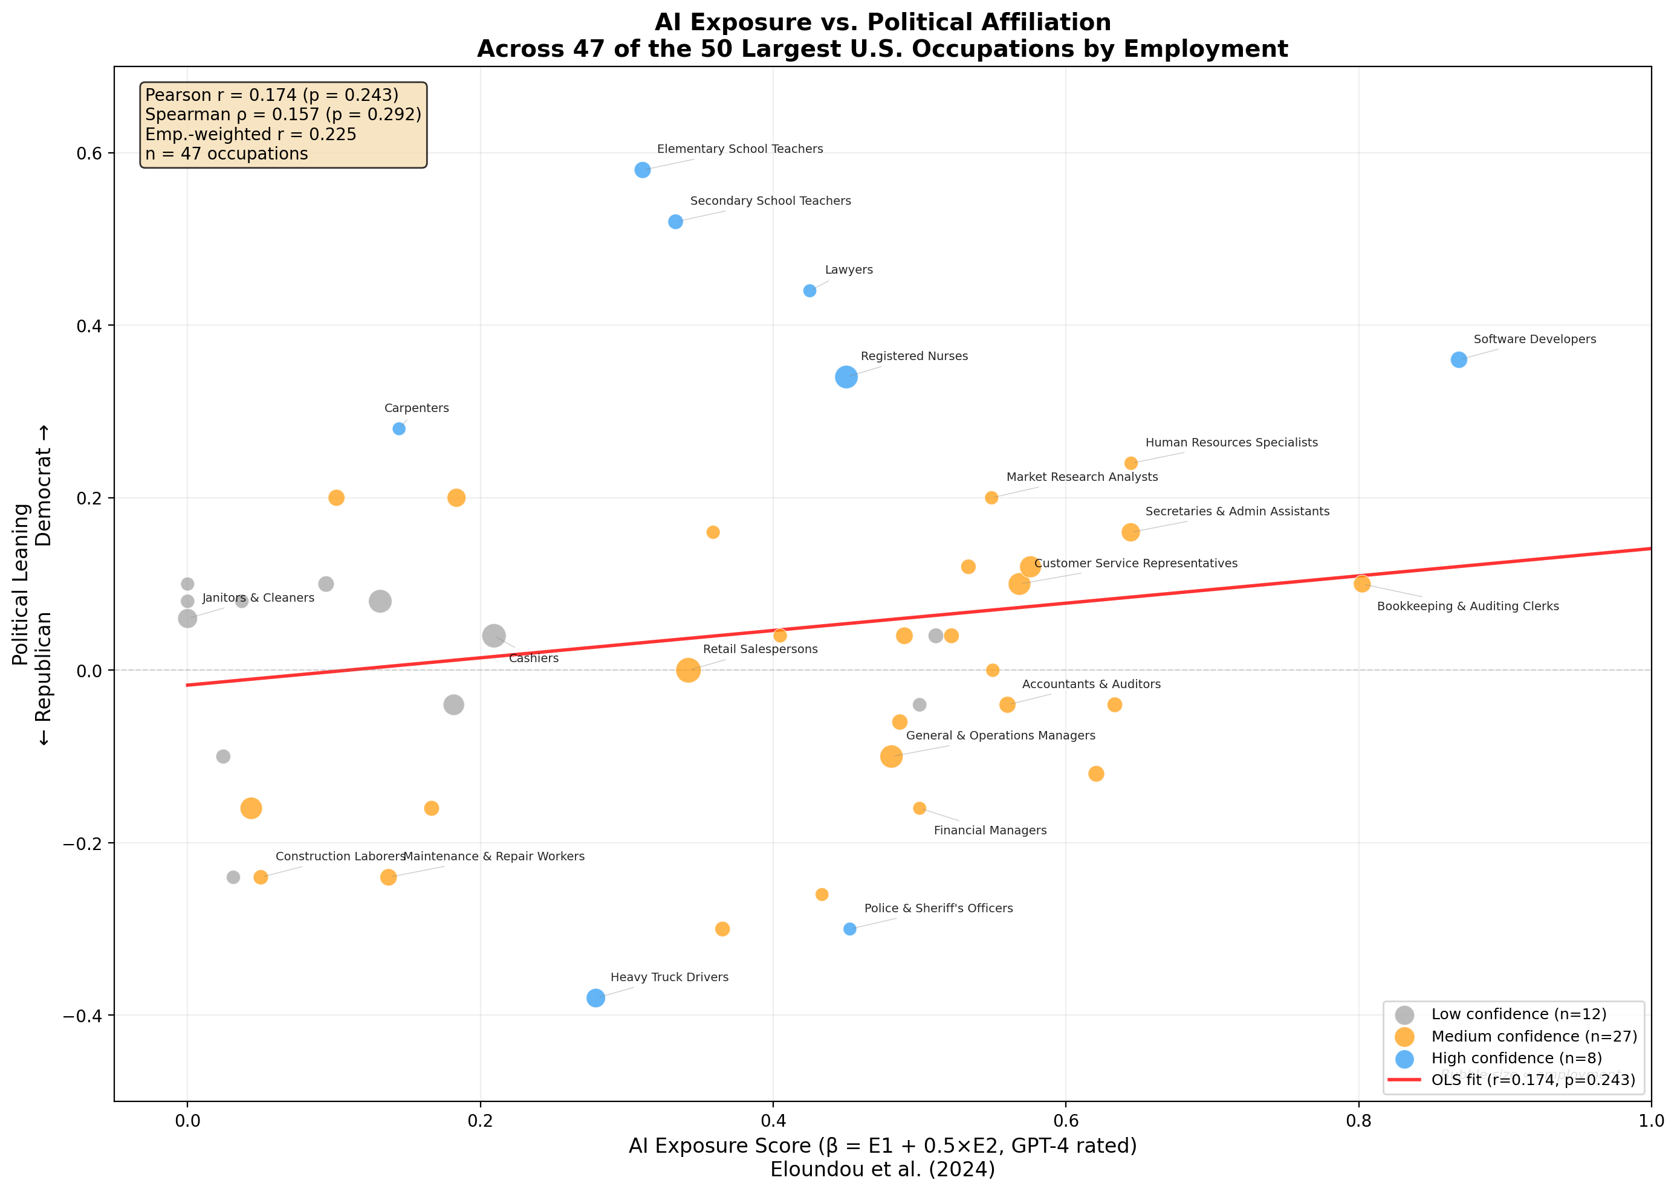
Figure 1: AI Exposure (β score) vs. Political Leaning across the 50 largest U.S. occupations. Bubble size proportional to employment. Colors indicate data confidence level.
Despite the lack of statistical significance, the scatter plot reveals interesting structural patterns in how occupations cluster by AI exposure and political leaning:
- High-exposure, Democratic-leaning occupations: Software developers (AI exposure: 0.87, lean: +0.36), elementary school teachers (0.31, +0.58), lawyers (0.43, +0.44), bookkeeping clerks (0.80, +0.10), and secretaries/admin assistants (0.64, +0.16). These are primarily white-collar knowledge workers and educated professionals.
- Low-exposure, Republican-leaning occupations: Heavy truck drivers (0.28, -0.38), construction laborers (0.05, -0.24), maintenance workers (0.14, -0.24), police officers (0.45, -0.30), and industrial truck operators (0.03, -0.24). These are predominantly blue-collar, manual, or outdoor occupations.
- Moderate-exposure, mixed occupations: General managers (0.48, -0.10), accountants (0.56, -0.04), retail supervisors (0.49, -0.06), and project managers (0.55, 0.00) cluster near the center with moderate AI exposure and relatively balanced political leanings.

Regression Results
Statistic | Value
Pearson r | 0.1736
p-value (two-tailed) | 0.2433
Spearman ρ | 0.1568
Employment-weighted r | 0.2250

Discussion
The weak and non-significant correlation (r = 0.174, p = 0.243) suggests that, among the largest U.S. occupations, AI exposure does not strongly predict political affiliation. This null-ish result is itself informative: despite intuitions that AI might disproportionately affect workers of one political persuasion, the reality across major occupations is more heterogeneous.
Several factors help explain the lack of a strong relationship. Occupations most exposed to AI tend to be cognitive, white-collar roles -- but these span the political spectrum. Bookkeeping clerks (AI exposure: 0.80) are near-neutral politically, while sales representatives (0.63) lean slightly Republican, and secretaries (0.64) lean slightly Democratic. The high-exposure tier includes both strongly Democratic software developers and near-neutral administrative roles.
At the same time, interesting structural patterns emerge in the scatter plot. Low-exposure occupations (AI < 0.2) include both Republican-leaning manual workers (construction laborers, industrial truck operators) and Democratic-leaning service workers (nursing assistants, waiters). This floor-level variation washes out any linear trend. Similarly, mid-range exposure (0.3-0.5) includes the starkly opposed police officers (-0.30) and registered nurses (+0.34), demonstrating that occupational culture and workforce demographics can overwhelm any AI-exposure signal.
Notable outliers deserve attention. Police officers have moderate-to-high AI exposure (0.45) but lean strongly Republican (-0.30), reflecting law enforcement's distinctive political culture. Carpenters show low AI exposure (0.14) but lean Democratic (0.28), likely inflated by union carpenters who are overrepresented in FEC contribution data. Teachers have moderate AI exposure (0.31-0.33) but are among the most strongly Democratic occupations (+0.52 to +0.58), driven by education-sector culture and unionization rather than AI-related factors.
It is crucial to emphasize that this analysis captures correlations at the occupation level, not causal relationships. The political leaning of an occupation is shaped by numerous factors beyond AI exposure, including education requirements, unionization, urbanization, gender composition, racial demographics, and industry culture. The FEC-based political data has significant limitations, particularly for low-wage occupations where few workers make campaign contributions. A more rigorous analysis would require individual-level data and multivariate controls.

Conclusion
This exploratory analysis finds a weak positive but statistically non-significant correlation (r = 0.174, p = 0.243) between occupational AI exposure and Democratic political leaning across the 50 largest U.S. occupations. While there is a directional tendency for higher-AI-exposure occupations to lean somewhat more Democratic, the relationship is not strong enough to reach statistical significance, and it essentially vanishes (r = 0.10) when restricted to high-confidence data points. The scatter plot reveals substantial heterogeneity: occupations at similar AI exposure levels can lean in opposite political directions, suggesting that workforce demographics, occupational culture, unionization, and education level are far more powerful predictors of political affiliation than AI exposure. Future research should employ individual-level data from voter registration records (e.g., the Chinoy 2024 "VRscores" dataset) merged with O*NET task data, along with multivariate controls, to better isolate any relationship between AI exposure and political orientation.

Data Sources
- Eloundou, T., Manning, S., Mishkin, P., & Rock, D. (2024). GPTs are GPTs: Labor market impact potential of large language models. Science, 384(6702), 1306-1308. Data: github.com/openai/GPTs-are-GPTs
- Manning, S. & Aguirre, T. (2026). How Adaptable Are American Workers to AI-Induced Job Displacement? NBER Working Paper 34705.
- Bureau of Labor Statistics, Occupational Employment and Wage Statistics (OES), May 2021.
- Verdant Labs (2015). Democratic vs. Republican Occupations. FEC individual contribution data. verdantlabs.com/politics_of_professions/
- OpenSecrets (2024). Industry and sector contribution data. opensecrets.org
- Zippia (2023). Democratic vs. Republican Jobs. FEC contribution analysis. zippia.com/advice/democratic-vs-republican-jobs/
- Chinoy, S. (2024). Political Sorting in the U.S. Labor Market: Evidence and Explanations.

Appendix: Full Dataset
Table A1: AI Exposure and Political Leaning for 47 Matched Occupations
Occupation | Employment | AI Exposure (β) | Dem Share | Confidence
Software Developers | 1,364,180 | 0.868 | 68% | H
Bookkeeping & Auditing Clerks | 1,509,370 | 0.802 | 55% | M
Human Resources Specialists | 740,830 | 0.644 | 62% | M
Secretaries & Admin Assistants | 1,825,980 | 0.644 | 58% | M
Sales Reps (Services) | 1,026,390 | 0.633 | 48% | M
Sales Reps (Wholesale) | 1,242,490 | 0.621 | 44% | M
Office Clerks, General | 2,578,180 | 0.576 | 56% | M
Customer Service Representatives | 2,787,070 | 0.568 | 55% | M
Accountants & Auditors | 1,318,550 | 0.560 | 48% | M
Project Management Specialists | 743,860 | 0.550 | 50% | M
Market Research Analysts | 727,540 | 0.549 | 60% | M
Receptionists & Info Clerks | 983,150 | 0.533 | 56% | M
Business Operations Specialists | 1,030,330 | 0.522 | 52% | M
Supervisors of Food Prep Workers | 1,040,600 | 0.511 | 52% | L
Shipping & Receiving Clerks | 795,360 | 0.500 | 48% | L
Financial Managers | 681,070 | 0.500 | 42% | M
Supervisors of Office/Admin Workers | 1,443,630 | 0.490 | 52% | M
Supervisors of Retail Workers | 1,143,260 | 0.486 | 47% | M
General & Operations Managers | 2,984,920 | 0.481 | 45% | M
Police & Sheriff's Officers | 665,380 | 0.452 | 35% | H
Registered Nurses | 3,047,530 | 0.450 | 67% | H
Supervisors of Construction Workers | 665,870 | 0.433 | 37% | M
Lawyers | 681,010 | 0.425 | 72% | H
Management Analysts | 768,450 | 0.405 | 52% | M
Light Truck Drivers | 1,010,040 | 0.365 | 35% | M
Medical Assistants | 727,760 | 0.359 | 58% | M
Retail Salespersons | 3,693,490 | 0.342 | 50% | M
Secondary School Teachers | 1,020,240 | 0.333 | 76% | H
Elementary School Teachers | 1,329,280 | 0.311 | 79% | H
Heavy Truck Drivers | 1,903,420 | 0.279 | 31% | H
Cashiers | 3,318,020 | 0.209 | 52% | L
Waiters & Waitresses | 1,804,030 | 0.184 | 60% | M
Stockers & Order Fillers | 2,451,430 | 0.182 | 48% | L
Security Guards | 1,057,100 | 0.167 | 42% | M
Carpenters | 668,060 | 0.144 | 64% | H
Maintenance & Repair Workers | 1,416,740 | 0.137 | 38% | M
Fast Food & Counter Workers | 3,095,120 | 0.132 | 54% | L
Nursing Assistants | 1,314,830 | 0.102 | 60% | M
Cooks, Restaurant | 1,193,860 | 0.095 | 55% | L
Construction Laborers | 968,760 | 0.050 | 38% | M
Laborers & Freight Movers | 2,729,010 | 0.043 | 42% | M
Food Preparation Workers | 783,350 | 0.037 | 54% | L
Industrial Truck Operators | 758,290 | 0.031 | 38% | L
Landscaping Workers | 892,450 | 0.024 | 45% | L
Janitors & Cleaners | 2,036,680 | 0.000 | 53% | L
Cooks, Fast Food | 768,130 | 0.000 | 54% | L
Maids & Housekeeping Cleaners | 723,430 | 0.000 | 55% | L

