

Smart Barangay Portal with QR Profiling and SMS Alerts for Barangay Luna
A Capstone Project Manuscript
Presented to the
Faculty of the College of Information Technology
Northeastern Mindanao Colleges
In Partial Fulfillment
of the Requirements for Capstone Project and Research
By
Calang, April John B.
Deloy, Christian
Deloy, Lorlie D.
October 2026

TABLE OF CONTENTS
ABSTRACT iii
CHAPTER 1 1
Project Context 1
Purpose and Description 1
Objectives of the Study 2
Scope and Limitation 3
1.5 Additional Implemented System Features 4
CHAPTER 2 6
Related Literature 6
Related Studies 7
Related Systems 8
Synthesis of the Study 9
CHAPTER 3 10
Conceptual Framework 10
Methodology 11
System Requirements 14
System Architecture 15
Process Model and Data Design 15
Revenue Streams 21
3.8 Additional Details of the Implemented System 22
CHAPTER 4 37
4.1 Development and Testing 37
4.2 System Modules and Features 38
4.3 System Testing Procedures 38
4.4 Test Cases and Corrective Actions 39
4.5 Results and Discussion of the Implemented Workflow 41
4.6 User Evaluation Results 42
4.7 User Acceptance and Operational Readiness 48
4.8 Implementation Plan 49
4.9 Risk Management 50
CHAPTER 5 51
5.1 Summary of the Project 51
5.2 Conclusions 51
5.3 Recommendations 52
REFERENCES 54
APPENDIX A: Preliminary Requirements Questionnaire 60
APPENDIX B: Historical Preliminary Survey Results 62
APPENDIX C: Original Requirements Interview Transcripts 64
APPENDIX D: Current User Evaluation Questionnaire 68
APPENDIX E: Current Evaluation Tally and Source Audit 71
APPENDIX F: Regression Verification Record 75

ABSTRACT
The Smart Barangay Portal with QR Profiling and SMS Alerts for Barangay Luna was developed to organize resident records, document requests, document preparation, cash payments, complaints, announcements, and service reports in one web application. Requirements were informed by the April 2026 interviews and preliminary survey documented in the original proposal. The system uses PHP, MySQL, HTML, CSS, and JavaScript in a Laragon development environment. Authorized personnel create resident accounts and maintain profiles; residents can preview and submit requests, monitor their status, and provide feedback. Staff can process online or walk-in applications, generate documents from DOCX templates, record cash payments, and confirm release. QR lookup and configured SMS notifications supplement these processes.
Evaluation included 13 personally completed questionnaires from 10 residents, two barangay staff members, and one administrator. Staff and administrator testing took place at the barangay hall. The resident mean was 4.42, the staff mean was 4.45, and the administrator mean was 4.47. Across 388 valid ratings, the combined mean was 4.43, interpreted as agree. Selected automated regression checks supported the request, issuance, payment, template, and interface behavior. The findings support further refinement and a controlled pilot; formal operational adoption requires a separate readiness decision.

LIST OF TABLES
Table 1 14
Table 2 14
Table 3 Proposed Revenue Streams 21
Table 4 Detailed flows supporting the level one model 33
Table 5 Core stored records in the current schema 34
Table 6 Interpretation of rating means 36
Table 7 Implemented modules and resulting behavior 38
Table 8 Verified regression scenarios in the current build 39
Table 9 Reported development issues and current disposition 41
Table 10 Composition of the current evaluation 42
Table 11 Primary resident assessment by dimension 43
Table 12 Resident item means for functionality 44
Table 13 Resident item means for usability 45
Table 14 Resident item means for reliability 45
Table 15 Resident item means for performance 45
Table 16 Resident item means for security 46
Table 17 Resident item means for overall satisfaction 46
Table 18 Evaluation results across all user groups 47
Table 19 Comments transcribed or translated from the supplied pages 48
Table 20 Proposed controlled implementation sequence 49
Table 21 Operational risks and proposed controls 50
Table 22 Current manual process assessment 61
Table 23 Proposed system features 61
Table 24 Historical preliminary respondent profile 62
Table 25 Historical manual process responses 62
Table 26 Historical proposed feature responses 62
Table 27 Evaluation instrument functionality 68
Table 28 Evaluation instrument usability 68
Table 29 Evaluation instrument reliability 69
Table 30 Evaluation instrument performance 69
Table 31 Evaluation instrument security 69
Table 32 Evaluation instrument overall satisfaction 70
Table 33 Raw responses by evaluator and dimension 71
Table 34 Resident frequency audit for functionality 72
Table 35 Resident frequency audit for usability 72
Table 36 Resident frequency audit for reliability 72
Table 37 Resident frequency audit for performance 72
Table 38 Resident frequency audit for security 73
Table 39 Resident frequency audit for overall satisfaction 73
Table 40 Rating photograph identifiers by questionnaire 73
Table 41 Regression scripts and verified scope 75

LIST OF FIGURES
Figure 1 Original conceptual framework 10
Figure 2 Original RAD methodology 11
Figure 3 Original system architecture 15
Figure 4 Original existing context diagram 16
Figure 5 Original existing data flow diagram 17
Figure 6 Original proposed context diagram 18
Figure 7 Proposed data flow diagram based on the implemented system 20
Figure 8 Original development schedule March to May 21
Figure 9 Original development schedule August to October 21
Figure 10 Updated Input process output framework 23
Figure 11 Updated Architecture of the implemented portal 24
Figure 12 Updated Existing certificate workflow from the staff interview 25
Figure 13 Updated Online and walk-in document preparation payment and release 29
Figure 14 Updated Logical context diagram with input and output descriptions 32
Figure 15 Updated Level one logical data flow with grouped data stores 33

CHAPTER 1
INTRODUCTION
This chapter presents the project context, purpose and description, objectives and the scope and limitation of the study.

Project Context
Barangays are the primary government units responsible for issuing essential certifications, including clearances and certificates of residency or indigency. Currently, Barangay Luna relies on manual, paper-based processes, resulting in operational inefficiencies such as long wait times, data redundancy, and misplaced records. The lack of a real-time notification system further necessitates multiple physical visits by residents. To address these challenges, this study proposes the Smart Barangay Portal with QR Profiling & SMS Alerts For Barangay Luna. This web-based platform automates document processing and record management to enhance service delivery, transparency, and administrative organization.

Purpose and Description
The study aims to digitalize Barangay Luna’s governance by providing a centralized platform for document requests and resident data management. The system enables residents to create digital profiles and apply for various certifications—such as Barangay Clearances and Certificates of Indigency—online. A key feature is the integration of QR-based identification, assigning each resident a unique code for rapid data retrieval and document verification to prevent fraud. For administrators, the system provides a dashboard to manage records, process applications, and monitor service analytics. Automated SMS notifications are integrated to provide residents with real-time updates, reducing physical bottlenecks at the Barangay Hall.

Objectives of the Study

General Objective
To develop a Smart Barangay Portal with QR Profiling & SMS Alerts For Barangay Luna that streamlines document processing, improves data integrity, and enhances service accessibility.

Specific Objectives
The study specifically aims to:
1. To design a module that can manage resident profiles, staff accounts, barangay services, document templates, complaint records, announcements, and data analytics for revenue and service monitoring.
2. To design and develop a resident management module that generates unique QR codes for secure profiling and identity verification.
3. To design and develop an online document request module that enables digital applications and provides real-time updates via an integrated SMS notification system.
4. To implement a transaction and payment module for recording walk-in payments and maintaining digital financial records.
5. To develop the system using a technical stack comprising HTML, CSS, and JavaScript for the frontend; PHP and for the backend; and MySQL for data management within a Laragon local server environment.

Scope and Limitation

Scope
This study focuses on the development of a Smart Barangay Portal with QR Profiling & SMS Alerts For Barangay Luna designed to improve the efficiency of barangay document processing and resident service management. The system includes the following features:
- The system maintains a digital database of resident profiles and generates unique QR codes for secure identification.
- The system provides a web-based portal for the online requesting of various barangay certifications.
- The system implements QR-scanning functionality for officials to verify document authenticity and retrieve resident data.
- The system features an administrative dashboard for request processing, account management, and community announcements.
- The system utilizes an SMS gateway to automate status updates for residents.
- The system records walk-in payments to ensure financial transparency and transaction tracking.
- The system enables digital filing of complaint records and the collection of resident feedback.
- The system provides a data analytics module to monitor revenue and service trends.

Limitation
The proposed system has the following limitations:
- The system does not support online payment processing; all fees must be settled via walk-in transactions.
- The system is focused on administrative document services and does not include emergency response or law enforcement modules.
- The system is limited to the predefined document types configured within the system settings.

1.5 Additional Implemented System Features
The following implementation details supplement the proposed features described in this chapter. They describe the functions available in the current system.
Authorized barangay staff or the administrator create resident accounts and encode identity, location, and registration requirements. Successful registration activates the account and QR profile and marks the resident record Verified. Residents use the assigned account to request services; public self-registration is not part of the current implementation.
Residents can preview a document request, confirm its details and number of copies, monitor its status, and view their own service updates. Multiple copies of one document type are supported. Requesting several different document types in one transaction remains a proposed enhancement. Staff can also assist registered or unregistered walk-in applicants through resident search, optional QR lookup, or manual applicant encoding.
Staff prepare printable documents from managed DOCX templates, record cash payments at the barangay office, and use Confirm Release to record the completed handover. A prepared document is not yet a released certificate. The administrator manages fees, staff access, templates, settings, audit records, backups, and service and collection reports. SMS notifications depend on the configured gateway and network availability.

CHAPTER 2
REVIEW OF RELATED LITERATURE
The Review of Related Literature (RRL) provides a comprehensive overview of existing research and systems relevant to the development of the Smart Barangay Portal with QR Profiling & SMS Alerts For Barangay Luna. This chapter examines local and foreign perspectives on e-governance and digital record management to identify best practices and technological gaps. The literature presented highlights the transition from manual to automated processes, emphasizing the roles of web platforms, QR code identification, and data analytics in enhancing public service delivery.

Related Literature
In the global landscape of e-governance, Decarli (2024) describes the myCIVIS portal in Italy as a critical interface that bridges national systems with local administrative needs through user-centric design. This necessity for evolution is supported by Andréasson (2023), who explores rural digitalization trends and asserts that grassroots governance must adopt new technologies to ensure continued social development. Furthermore, Qin (2023) provides a theoretical framework on the legal aspects of grassroots governance, highlighting digital transformation as a requirement for sustainable development and social cohesion. In the context of urban administration, Idrus et al. (2022) emphasizes that innovative administrative systems are vital for modernizing population records and village-level services through electronic applications. These concepts are exemplified by Yuwono et al. (2020), who showcases the Banyuwangi model in Asia as a standard for re-engineering government governance to be more efficient and transparent at the grassroots level.
In the Philippines, the push for digitalization is supported by national initiatives aimed at streamlining public service delivery. Caotivo (2025) argues that digitalizing frontline services and capacitating digital frontliners are essential priorities for sustainable LGU operations. Albano (2024) supports this by advocating for the use of open-source tools as a cost-effective method for LGUs to build dynamic web-based information systems even in resource-limited settings. The practical implementation of such systems is discussed by Morrison (2023), who highlights the Unified Barangay E-Services System and its use of augmented analytics to monitor service usage patterns. This drive toward accountability is further cited by Daga-ang et al. (2023), who identifies automated profiling as a key step toward achieving the "Seal of Good Local Governance for Barangays." Finally, Sardan et al. (2023) emphasizes that digitizing services through programs like the BEGin initiative in Bacoor City significantly increases public trust and improves accessibility during administrative crises.

Related Studies
Recent foreign studies demonstrate the practical application of mobile and web technologies in village administration. Suriyani et al. (2024) developed the siPalui application in Indonesia to shift services to electronic formats, noting that while it improved convenience, network stability remains a primary challenge. Similarly, Pertiwi et al. (2024) developed a Village Citizen Reporting Website and found that online platforms significantly enhance the speed of administrative response. Technological integration is further explored by Budiarto et al. (2024), who proved that web-based designs in the Pakuhaji District streamline multi-village interactions. In Surabaya, Ayuningtyas et al. (2022) supported "Smart City" initiatives by centralizing resident data and service requests through a unified website. These studies are complemented by Hanafiah et al. (2021), who demonstrated that utilizing G-Suite with QR codes for administrative services improved accessibility by allowing services to be performed at any time.
Local studies have extensively explored barangay management systems tailored to Philippine needs. The Kabataan-Konek (2025) study developed a youth information system integrating QR codes for document verification, achieving high marks for reliability. In Pasig City, Enaño et al. (2025) utilized linear regression algorithms in the BarangayConnect portal for demographic forecasting, which resulted in reduced manual workloads. Evaluation of these tools is provided by Rey et al. (2024), who used the Technology Acceptance Model to confirm that residents perceive web-based e-governance as useful and easy to navigate. Furthermore, Duco et al. (2023) tested a framework for a mobile and web platform in Mandaluyong City, receiving high satisfaction ratings for its digital profiling capabilities. This is supported by Alegado (2023), who found that the Docu-Go system serves as a secure and efficient modern alternative to traditional record-keeping.

Related Systems
Several existing systems offer benchmarks for the Smart Barangay Citizen Portal, such as WeBarangay in Quezon City, which is noted for its high-speed performance, and BarangayConnect in Pasig City, which automates document requests and community planning. International systems like siPalui in Indonesia provide smartphone-based document services, while the BALANGAY System aids in incident reporting through decision-support heatmaps. Additionally, the One Barangay system serves as a mobile and web-based solution designed for secure data management and service productivity in the City of Manila.

Synthesis of the Study
The reviewed literature and studies emphasize that digital transformation is essential for improving the efficiency and transparency of local government services. Existing platforms primarily focus on digitizing traditional processes such as record management and document requests to reduce manual workloads. However, while these systems contribute to administrative efficiency, many remain limited to basic automation and lack integrated mechanisms for secure identity verification and real-time notification.
The proposed Smart Barangay Portal with QR Profiling & SMS Alerts For Barangay Luna differentiates itself by integrating QR-based resident profiling and an SMS notification system into a single platform. The use of QR codes enables fast and secure identification, prevents duplicate records, and supports document verification through scanning, which improves data integrity. Furthermore, the inclusion of an SMS gateway strengthens communication by providing residents with real-time updates on the status of their requests. Unlike traditional systems that depend on manual follow-ups, this project incorporates a feedback mechanism and a data analytics module for revenue monitoring. These enhancements provide a more secure, transparent, and user-centered solution, contributing to the advancement of smart governance at the local level.

CHAPTER 3
TECHNICAL BACKGROUND

Conceptual Framework
The conceptual framework of this study follows the Input–Process–Output (IPO) model to define the operational logic of the Smart Barangay Portal with QR Profiling & SMS Alerts For Barangay Luna. This model delineates the flow of data from user entry through technical execution to the generation of administrative outputs. By structuring the system into these three distinct phases, the framework demonstrates how resident data, document requests, and payment details are systematically transformed into secure QR profiles, real-time notifications, and analytical reports.
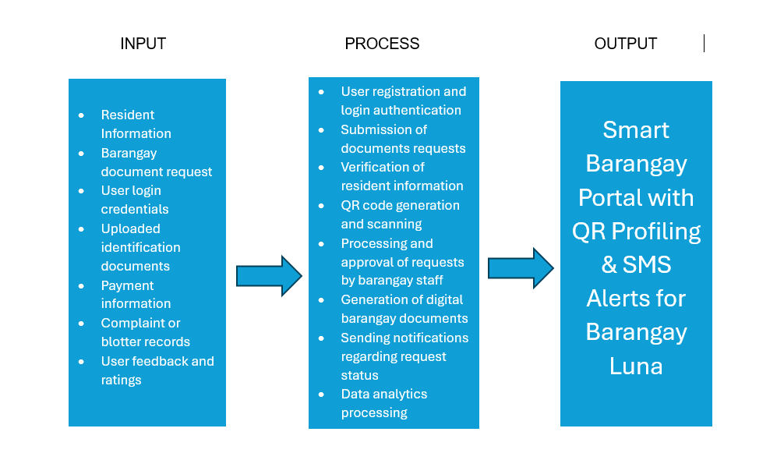
Figure 1 Original conceptual framework
Through this framework, the system enables residents to conveniently request documents online while allowing barangay personnel to efficiently manage records and service requests in a centralized and organized digital platform.

Methodology
The researchers adopted the Rapid Application Development (RAD) methodology to prioritize iterative prototyping and continuous user feedback over traditional, linear development. This methodology is divided into four distinct phases: Requirements Planning, User Design, Construction, and Cutover. By utilizing RAD, the researchers can rapidly develop and refine the system’s core features—such as the QR code generator and SMS module—ensuring the final portal aligns with the operational requirements of Barangay Luna and the accessibility needs of its residents.
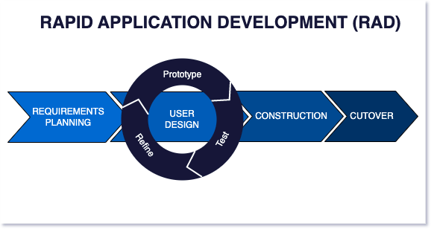
Figure 2 Original RAD methodology
This study will utilize the Rapid Application Development (RAD) model in developing the Smart Barangay Portal with QR Profiling & SMS Alerts For Barangay Luna. RAD is a software development approach that emphasizes fast development, user involvement, and iterative prototyping. It is suitable for this study because the system requires continuous feedback from users and quick modifications during development.

1. Requirements Planning Phase
During the Requirements Planning Phase, the researchers identified the objectives, scope, and requirements of the system. Data was gathered through informal discussions, observation, and a review of existing barangay processes. The researchers analyzed the current manual system for barangay document requests and identified common problems, including:
- Long waiting time
- Manual record-keeping
- Lack of tracking system
Based on these findings, the necessary system features are defined, including:
- Online document request
- QR code-based resident profile
- Notification system
- Feedback system

2. User Design Phase
During this phase, the researchers will design and develop initial prototypes of the system based on the identified requirements. These prototypes will include system interface designs, flowcharts, and basic system functionalities. The development process will follow an iterative cycle consisting of:
- Prototype – Initial versions of the system will be created to demonstrate how the system works.
- Test – The prototypes will be evaluated to identify errors, usability issues, and missing features.
- Refine – Necessary improvements and revisions will be made based on the results of testing and feedback.
This cycle will be repeated several times to ensure that the system design meets user requirements and is easy to use.

3. Construction Phase
In this phase, the actual development of the system will be carried out. The researchers will translate the approved designs into a working system using appropriate technologies. The system will include:
- Frontend interface for residents and administrators
- Backend processing for managing requests and data
- Database for storing resident information and transactions
Testing will also be conducted in this phase to identify and fix errors. The system will be continuously improved based on testing results.

4. Cutover Phase
This is the final phase where the system will be prepared for deployment and use. The researchers will conduct final testing and ensure that the system meets the required functionality.
Activities in this phase will include:
- System testing and debugging
- Data preparation
- User orientation or demonstration
The system will be evaluated based on usability, efficiency, and performance to ensure that it meets the objectives of the study.

System Requirements
The system requirements describe the necessary hardware, software, and user-side requirements needed to develop, operate, and access the Smart Barangay Portal with QR Profiling & SMS Alerts For Barangay Luna.
Table 1
Hardware Requirements (Admin/Development Side)
Hardware | Specification
Processor | Intel Core i3 or higher
RAM | 8GB minimum
Storage | 256GB SSD, or higher
These hardware components ensure smooth system development, deployment, and operation within the barangay office.
Table 2
Software Requirements (Admin/Development Side)
Software | Purpose
Operating System | Windows 10 or higher
Web Browser | Google Chrome / Firefox
Programming Language | HTML, CSS, JavaScript, PHP
Database | MySQL
Local Server Environment | Laragon
These software tools are essential for developing, managing, and maintaining the system.

System Architecture
The system utilizes a three-tier client-server architecture, comprising presentation, application, and data layers. Admins and users interact with the system via devices, sending requests to the web server which processes application logic and communicates with the MySQL database. The web server then returns the processed data to the users, ensuring efficient, centralized data management and information flow.
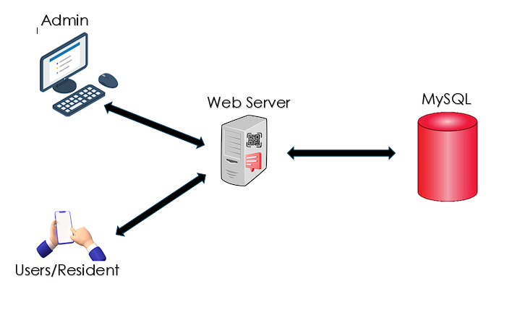
Figure 3 Original system architecture

Process Model and Data Design
The Existing Context Diagram delineates the manual administrative workflow of Barangay Luna. Labeled as the Barangay Manual Processing System, the current model involves two primary external entities: the Resident and the Barangay Staff. The resident serves as the data source for physical inputs, including handwritten personal profiles, document applications, and cash payments. Conversely, the Barangay Staff functions as the manual processor, responsible for physical record verification and document issuance. This diagram identifies a significant technological gap, as data at rest is stored in physical logbooks rather than a digital database, leading to systemic inefficiencies in data retrieval, transaction tracking, and resident communication.
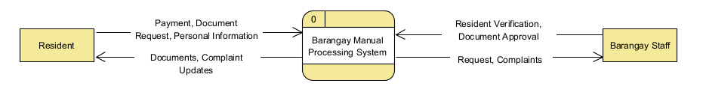
Figure 4 Original existing context diagram

Existing Data Flow Diagram
The Existing Data Flow Diagram provides a functional decomposition of the current manual operations in Barangay Luna. The data flow initiates with the Resident providing "Document Request Data" or "Complaint Details" to the Initial Intake Process. This data is then transmitted to the Verification Phase, where the Barangay Staff manually cross-references the information against existing paper files.
Upon validation, the data is written into a Physical Logbook, which acts as the system's primary Data Store. This "Data at Rest" is later retrieved by staff to facilitate the Document Preparation or Resolution Process. The final "Output Data"—in the form of a physical certification or a complaint update—is then released to the Resident. This diagram underscores the systemic vulnerabilities of the current model, specifically the high latency in data retrieval and the risk of data loss inherent in a non-redundant, paper-based storage system.
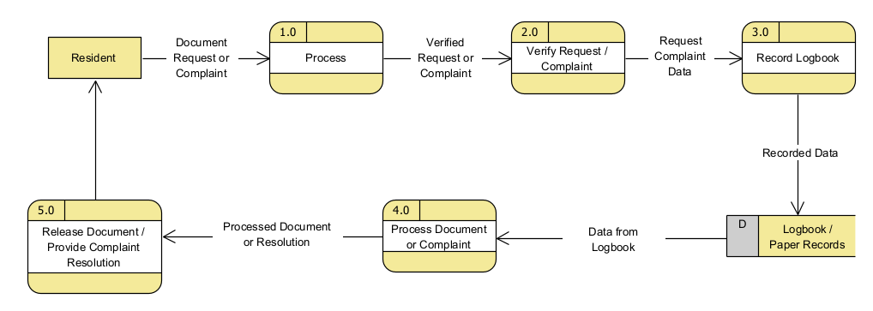
Figure 5 Original existing data flow diagram

Proposed Data Context Diagram
The Proposed Data Context Diagram illustrates the high-level operational structure of the Smart Barangay Portal with QR Profiling & SMS Alerts For Barangay Luna. Centered as a single automated process, the system acts as a unified data hub for three primary external entities: the Resident, Barangay Staff, and Administrator. The Resident acts as the primary data source, providing "Profile Information," "Digital Requests," and "Payment Proof," while receiving high-value outputs such as "Unique QR Identifiers," "Automated SMS Notifications," and "Electronic Document Previews." The Barangay Staff manages the operational flow by processing "Verification Commands" and "Transaction Updates," receiving "Real-time Task Summaries" in return. The Administrator interacts with the system for high-level monitoring, inputting "Report Parameters" to generate "Statistical Analytics" and "Revenue Visualizations." This diagram characterizes the shift from a fragmented manual workflow to an integrated, data-driven environment designed to optimize administrative transparency and service speed.
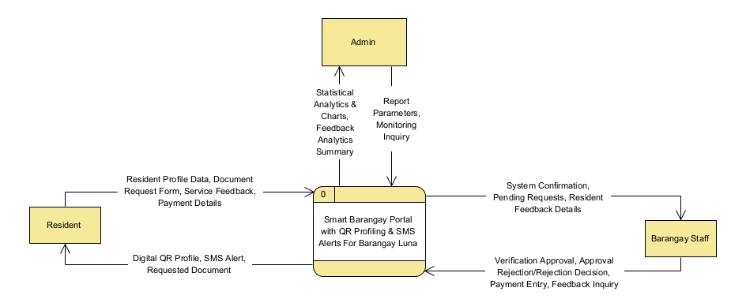
Figure 6 Original proposed context diagram

Proposed Data Flow Diagram
The Proposed Data Flow Diagram (Level 1) illustrates six processes within the Smart Barangay Portal with QR Profiling and SMS Alerts for Barangay Luna. Process 1.0, Account registration, profile and QR management, receives login or profile details from residents and identity, location, and registration requirements from barangay staff. Authorized staff register residents and maintain their records. Account, resident, and requirement data are stored in D1, while the system returns account access and a QR profile to the resident. Resident data support document request submission and review.
Process 2.0, Document request submission and staff review, receives the resident’s reviewed request, purpose, and number of copies, together with the staff’s review or rejection reason. Requests and their statuses are stored in D2, and residents receive status updates. Reviewed online requests proceed to Process 3.0, Document preparation (online or walk-in). Staff supply applicant details and checked requirements, while D3 provides the active document template and configured fee. Preparation creates the printable document and payment due in D4 and updates the request’s Processing or Ready for Pickup status in D2. Walk-in applicants can also be served through staff-assisted preparation.
Process 4.0, Cash payment recording and confirmed release, receives the prepared issuance and amount due. Staff record cash received and use Confirm Release after any required payment is complete. D4 stores payment and release records, and the linked request in D2 is updated to Released. Printing alone does not confirm release. Process 5.0, Community services and SMS notifications, receives resident complaints and feedback, staff announcements and complaint actions, and request or release notification data. Community records and SMS logs are stored in D5. The SMS gateway receives the recipient’s mobile number and message and returns a send response; published posts and service updates are made available to residents.
Process 6.0, Reports and system administration, receives report requests from staff and report, settings, or template requests from the administrator. It reads operational data from D1–D5 to produce service and cash collection reports. The administrator’s template and fee updates are stored in D3, while settings, audit records, and backup records are maintained in D6. The diagram connects resident services with staff processing and administrative oversight. The usual online request sequence is Pending, Processing, Ready for Pickup, and Released, with document preparation, cash recording, and confirmed release represented as separate processes.
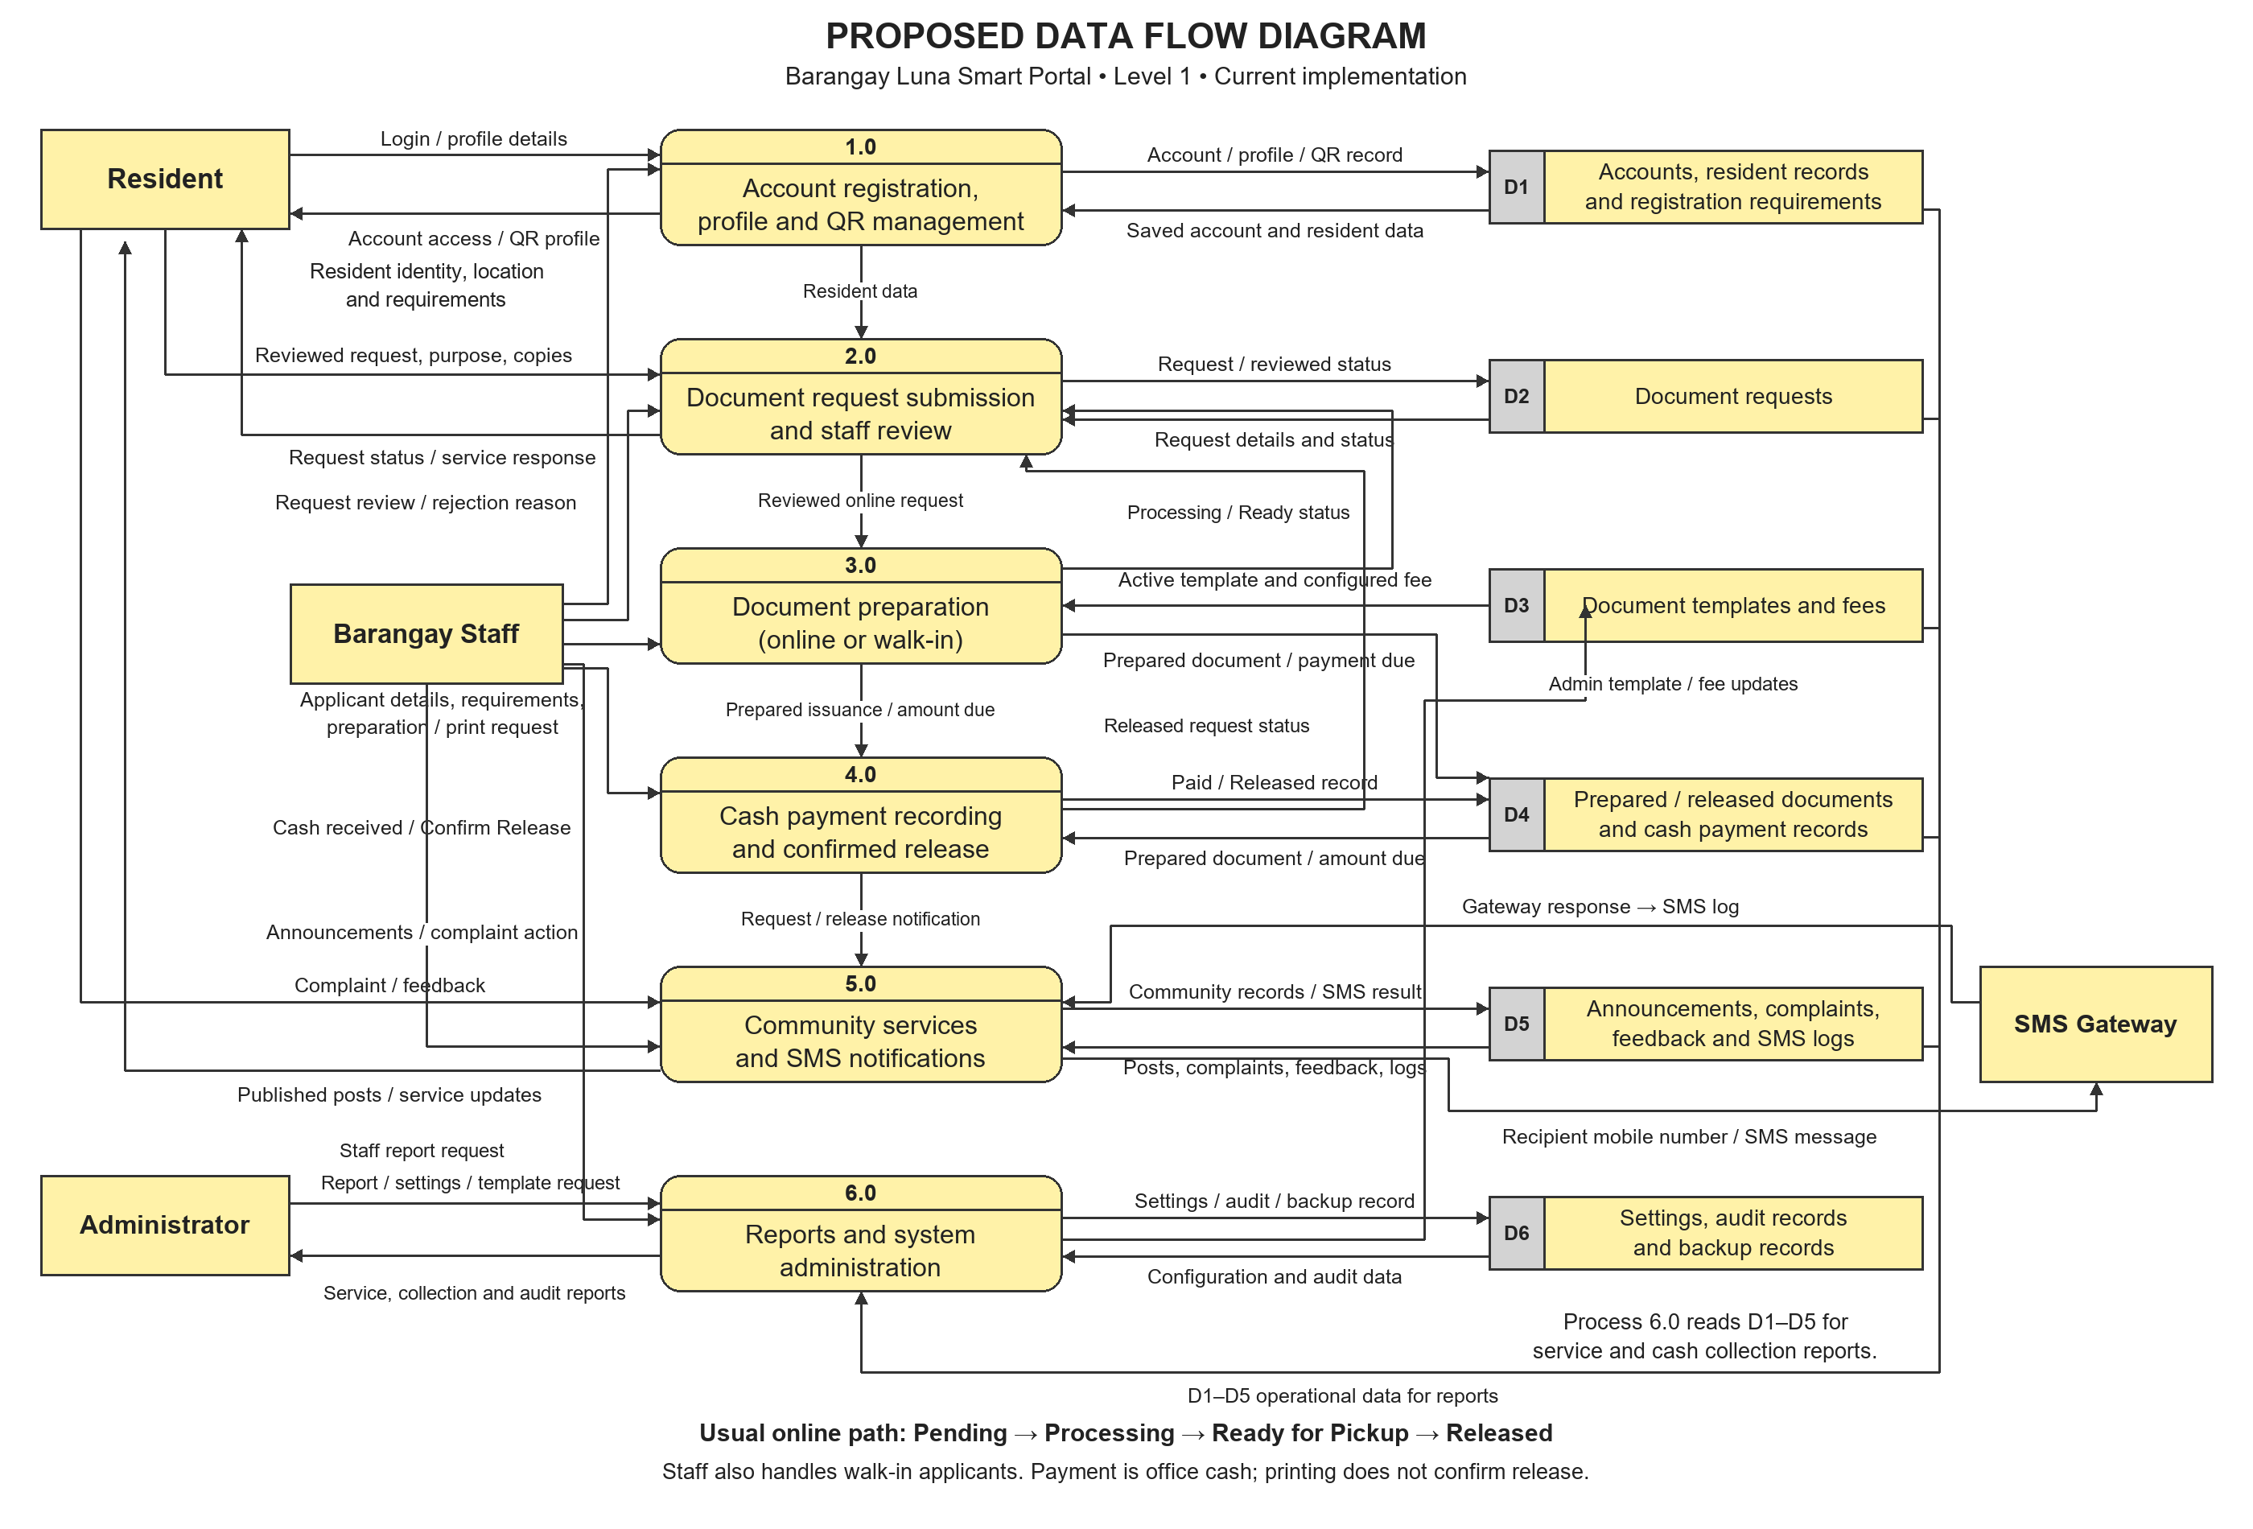
Figure 7 Proposed data flow diagram based on the implemented system
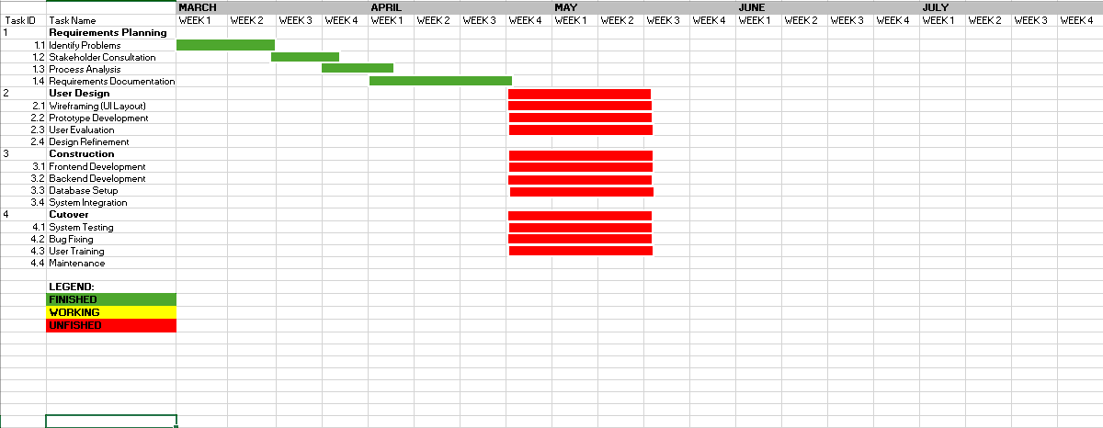
Figure 8 Original development schedule March to May

Figure 9 Original development schedule August to October

Revenue Streams
Table 3 Proposed Revenue Streams
Revenue Source | Description
System Subscription | Monthly or annual fee for using the system (e.g., ₱500–₱1,000/month).
Customization Fee | One-time payment for additional or barangay-specific features such as custom reports, additional modules, or interface adjustments.
Support and Maintenance | Optional yearly fee for system updates, technical support, data backup, and system monitoring (e.g., ₱3,000/year).
Training Service | Optional training sessions for barangay staff on how to use the system efficiently (e.g., ₱1,000–₱2,000/session).
Setup/Installation Fee | One-time fee for system installation, configuration, and initial deployment in the barangay (e.g., ₱5,000–₱10,000).

3.8 Additional Details of the Implemented System
The following sections describe the current implementation and supplement the proposal-stage architecture and process diagrams presented above. The current request, account, cash payment, document preparation, and release behavior is represented in the additional diagrams. The subscription and service prices previously presented under Revenue Streams remain proposal estimates; the implemented collection reports record actual document-service cash payments.
The April requirements interview describes staff preparing certificates through ready-made Microsoft Word documents and saving completed files, with identity and location checked through local personnel when necessary. This existing workflow is represented below. The current portal retains personnel verification while connecting resident records, requests, document preparation, and payments.

3.8.1 Conceptual Framework
The input-process-output framework connects the requirements and data used by the portal to its administrative functions and resulting records. Inputs include interview requirements, resident information, applicant details, requests, document templates, fee settings, and user actions. Processes apply validation, authorization, review, document generation, payment recording, release confirmation, and communication. Outputs include searchable profiles, request statuses, printable certificates, cash records, notices, and reports.
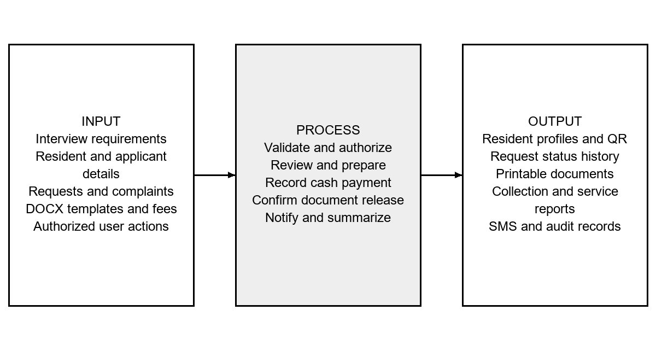
Figure 10 Updated Input process output framework
Feedback from evaluation leads to revisions of the forms, confirmations, templates, and interface behavior. The framework describes how the system is intended to support organized service delivery; it does not by itself prove faster processing or greater security.

3.8.2 System Architecture
The system follows a browser-server-database arrangement. The browser displays the role interface and sends authenticated requests. PHP checks session access and input, applies the relevant workflow, and reads or updates MySQL. Uploaded templates and generated files are stored through the application’s file facilities. The SMS gateway is an external communication component, so the database records the application’s sending outcome independently of document preparation or release.
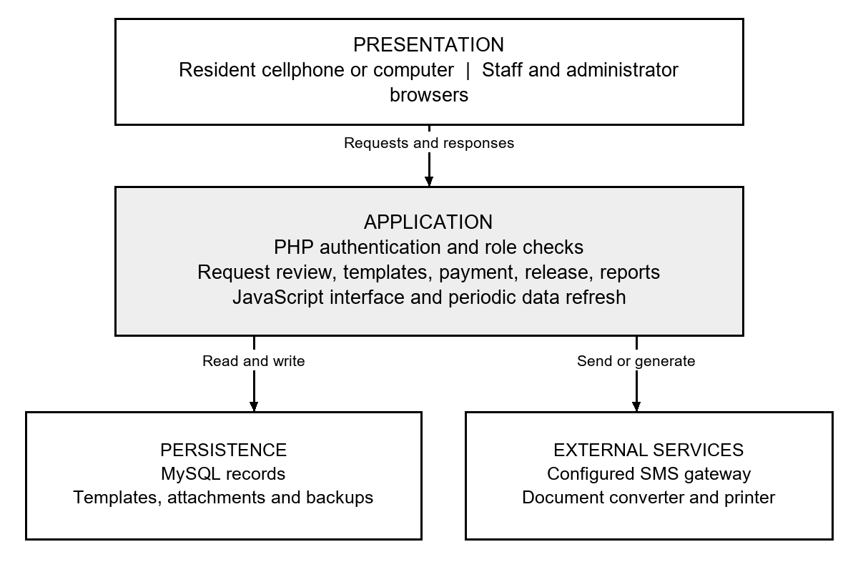
Figure 11 Updated Architecture of the implemented portal
A localhost installation is suitable for development but does not make QR verification links or resident pages reachable from arbitrary phones. Operational use requires an approved network or hosted address, appropriate access configuration, and a working document conversion and SMS setup. Browser updates do not guarantee immediate SMS delivery or continuous availability.

3.8.3 Current Barangay Workflow
The existing workflow is reconstructed from the April staff interview rather than assumed from a generic manual system. A resident approaches the barangay, states the needed certificate, and supplies information. Staff clarify the document type and confirm identity or location through local personnel when needed. Staff fill a ready-made Word document, print the certificate, and save the completed document. Complaints are handled through personal discussion with notes by the responsible personnel. The interview does not establish a specific existing cash ledger or a measured average service time.
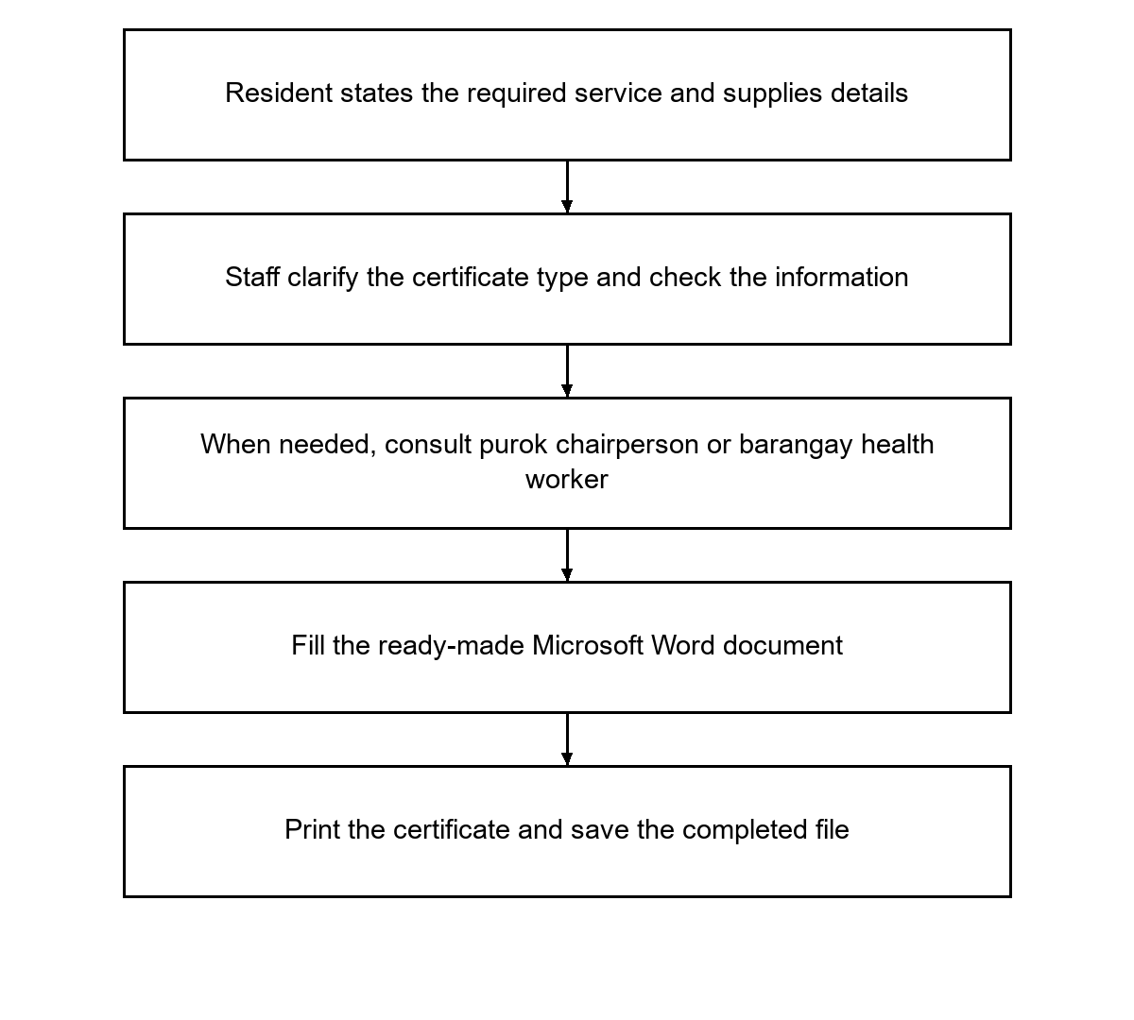
Figure 12 Updated Existing certificate workflow from the staff interview

3.8.4 Implemented System Workflow

3.8.4.1 Account and Resident Profiling
An authorized staff member or administrator creates the resident account and encodes the information required for the profile. The operator checks identity and location information according to barangay procedures. The system stores the account and profile fields in the users record and associated location and requirement records. Successful staff-assisted registration marks the account Active, the profile Verified, and the QR Active. A resident cannot create a new account through a public self-registration workflow.
QR information is linked to the existing resident record. Staff can retrieve a profile through name search or supported QR input, but they must still confirm that the displayed record belongs to the applicant. New or unregistered walk-in applicants can be served through manual applicant encoding. The system therefore supports both registered resident access and office-assisted service.

3.8.4.2 Resident Online Request
The resident logs in, chooses a configured document type, supplies the purpose and any document-specific information, and reviews a preview. Profile-derived information is filled from the account. The preview is for checking content and does not create a released certificate. Before submission, the resident reviews the request and confirms the number of copies. Large quantities receive an additional warning and acknowledgement. The server rejects a submission whose reviewed quantity has been changed without renewed confirmation.
A submitted request is stored as Pending. The resident can inspect its current status and available remarks. An owner may remove a request only while it remains Pending and has no prepared issuance protecting it. A complaint may similarly be removed only while it is the resident’s own Open submission. These removals preserve audit information. Requests or complaints already handled by staff are protected from this resident action.

3.8.4.3 Staff Processing and Document Preparation
Authenticated staff and administrator request views retrieve new or changed requests through periodic polling, ordinarily every five seconds while the page is active. The list is refreshed without discarding text being entered in an open rejection form. This is periodic synchronization rather than a guarantee of instantaneous updates. Network and page state affect the time at which a new request becomes visible.
Staff open the application, check the applicant and required details, and move the request through the appropriate processing states. Rejection requires a reason. For an online application, the issuance form can load the selected request; for a walk-in applicant, staff can select a registered resident or enter unregistered applicant details. Staff choose an active template, check the filled document and fee, and prepare the printable certificate. Preparation creates a Ready for Pickup record and a pending payment entry when a fee is due. Printing or previewing does not confirm release.
The supported online request statuses are Pending, Processing, Approved, Ready for Pickup, Released, and Rejected. The current successful sequence is Pending → Processing → Ready for Pickup → Released. The staff preparation action moves an eligible request to Processing; preparing its printable document moves it to Ready for Pickup; Confirm Release records completed handover. Approved is also supported as a state from which preparation can restart, including after removal of the only valid unreleased preparation. Rejected records a refused application and its reason.

3.8.4.4 Cash Payment and Confirmed Release
The payable amount is based on the configured unit fee and the number of copies. Cash is collected at the office. Staff record the amount and payment details, then use Confirm Release. A fee-bearing document cannot be released with an incomplete payment. For a free document, the workflow does not require a cash payment entry. The release action records the actual release and synchronizes the linked online request. Repeated release does not create another collection.
Prepared documents remain in a queue so staff can reopen them without generating duplicate records. An unreleased preparation may be removed when it is no longer needed; its unpaid pending payment is voided, while an already collected payment is retained. A released document cannot be removed through that preparation action. When a linked online request has no other valid preparation, it becomes available for preparation again. Reports count released documents and recorded paid collections according to their relevant dates.
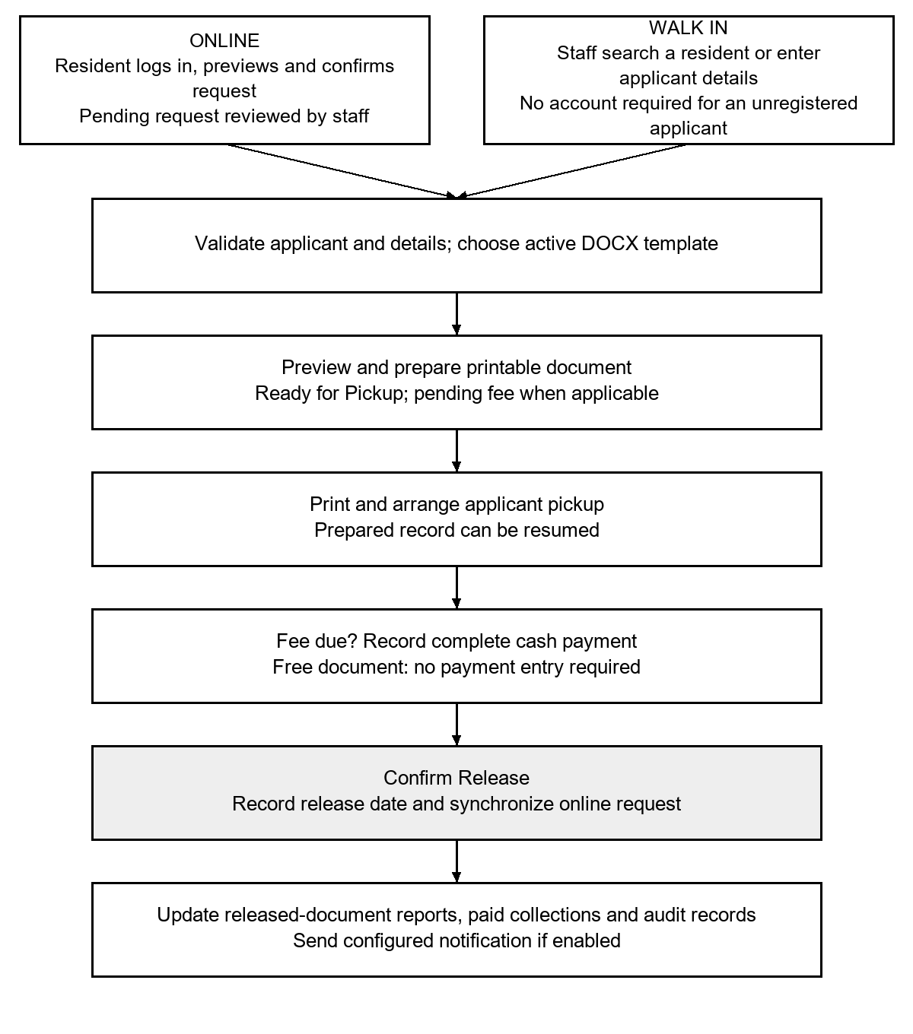
Figure 13 Updated Online and walk-in document preparation payment and release
If validation or payment fails, the action returns an error and the document is not released. The displayed sequence represents the successful path; rejected requests and removed preparations are retained as non-released outcomes. SMS failure does not reverse a valid document transaction.

3.8.4.5 Templates and Document Verification
Authorized operators upload and maintain DOCX templates for a document type and year. Saving a replacement for the same type and year replaces the active file rather than presenting another duplicate in the saved list. The list displays uploaded templates for inspection. A new document year remains a separate template entry. Template-based values include the resident’s information, purpose, control number, date, and document-specific details.
Where a certificate identifies a parent and a child, the parent’s pronoun is based on the parent’s stored gender. The beneficiary relationship, such as son or daughter, is kept separate. This prevents a child’s relationship selection from changing the parent’s pronoun. A document verification QR links to the configured verification page for the stored issuance record. The verification view must be interpreted with the record’s status and configured access rules; it is not a security certificate or a substitute for an authorized signature.

3.8.4.6 Communication Complaints and Reporting
The announcement module publishes community information. Residents can submit a complaint and staff can track it through Open, In Progress, Resolved, or Closed as appropriate. Feedback stores resident service observations. SMS functions use configured message and gateway settings; the system records Pending, Sent, or Failed application outcomes. Residents view their own update history. Gateway responses and message logs are useful operational evidence but do not prove that every recipient read a message.
The reporting functions summarize document activity, elapsed request periods, and cash collections. A request-to-release duration can include waiting for payment and pickup, overnight periods, or other delays, so it should not be interpreted solely as staff working time. Revenue exports are based on recorded paid collections. Audit logs support traceability of administrative actions, and backups support planned recovery.

3.8.5 Process and Data Design

3.8.5.1 Context Diagram
The context diagram treats the portal as one process. Residents provide account credentials, requests, complaints, and feedback and receive statuses and service information. Staff supply checked applicant details, templates, document actions, and cash records and receive work queues and reports. The administrator provides account and configuration actions and receives oversight information. The gateway receives outbound SMS requests and returns application-level sending responses.
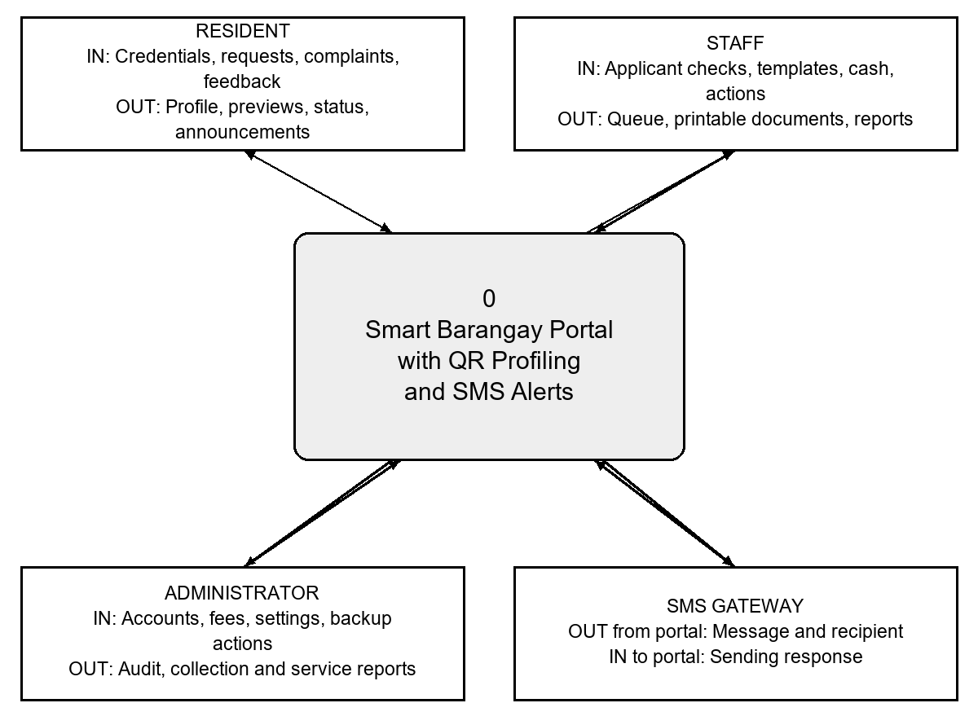
Figure 14 Updated Logical context diagram with input and output descriptions

3.8.5.2 Level One Data Flow
The level one model divides the portal into five logical processes. The grouped stores in the diagram correspond to actual database tables and file facilities; the grouping is for readability, not an assertion that each group is a single physical table. Each process receives authorized data, applies checks, and produces stored records or a response. A double-direction connection denotes reads and writes whose individual flows are detailed in Table 4.
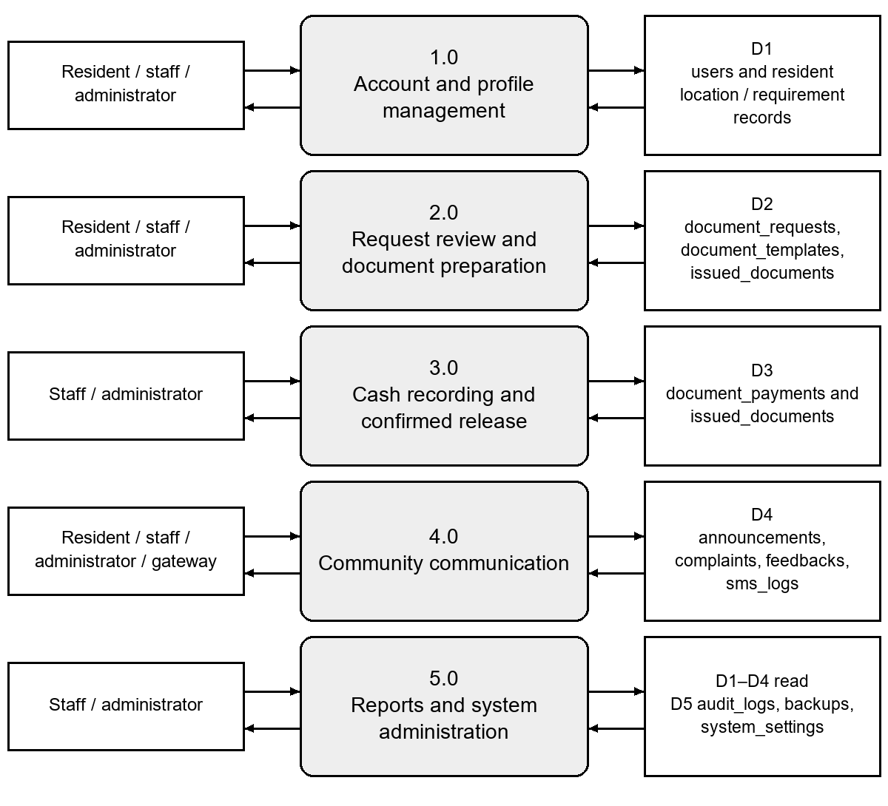
Figure 15 Updated Level one logical data flow with grouped data stores
Table 4 Detailed flows supporting the level one model
Process | Incoming or read data | Outgoing or written data
1.0 Accounts and profiles | Credentials; operator-checked identity and location; existing user record. | Account and profile changes; QR-related record; authorized profile view.
2.0 Requests and preparation | Resident request and confirmation; template and fee; staff review or rejection reason. | Request status and remarks; filled preview; prepared issuance and verification reference.
3.0 Payment and release | Prepared issuance; due amount and copies; cash details; release action. | Paid or voided payment outcome; released issuance and request; audit entry.
4.0 Communication | Complaint or feedback; operator update; announcement; notification event; gateway response. | Community records; visible status; outbound SMS and stored sending result.
5.0 Reporting and administration | Operational records; date filters; account and setting actions; backup request. | Service and collection summaries; export; settings and backup records; audit information.

3.8.5.3 Data Storage and Relationships
The users table contains account and resident profile fields. A document request belongs to a resident user; issued documents may reference a resident or retain manually encoded applicant details for a walk-in transaction. Issuance links to request and document identifiers where applicable. Payment records carry the collection status and relevant transaction reference. This arrangement allows registered online requests and unregistered walk-in services to share the issuance and reporting workflow.
Table 5 Core stored records in the current schema
Record group | Main tables or files | Purpose
Access and profile | users, roles, resident_districts, resident_puroks, resident_requirements | Account access, resident information, location and requirement records.
Document service | document_requests, document_templates, document_fees, issued_documents; DOCX files | Requests, template references, configured fees, preparation and release.
Cash collections | document_payments | Pending, paid and voided payment records linked to services.
Communication | announcements, complaints, feedbacks, sms_logs | Community information, concerns, feedback and sending outcomes.
Traceability and administration | qr_scan_logs, audit_logs, backups, system_settings, notification_seen_state | Lookup history, actions, configuration, recovery records and notification state.

3.8.6 Service Fees and Deployment Resources
The current revenue function records service collections from document transactions; it is not a commercial subscription billing module. Authorized personnel configure document fees, and staff collect cash at the office. Only recorded paid collections belong in collection totals. Removed unpaid preparations are excluded from paid revenue, while previously collected payments remain traceable.
Hosting, connectivity, SMS charges, printer supplies, training, and maintenance are potential deployment expenses. Their actual costs require an approved arrangement and quotations. The proposal’s illustrative subscription, customization, and training prices are not treated as implemented barangay income or committed project charges.

3.8.7 Evaluation Procedure and Data Analysis
The supplied evaluation questionnaire contains 30 statements in six dimensions, with five items per dimension. Participants choose one response from 1 to 5, or N/A for a feature not used or observed. The dimensions are functionality, usability, reliability, performance, observed security behavior, and overall satisfaction. English and Cebuano versions use the same item codes and scale. The instrument is a project questionnaire and is not claimed to be an independently validated standardized test.
The current evaluation included 10 resident questionnaires, two barangay staff questionnaires, and one administrator questionnaire. The actual participants completed their own questionnaire responses based on their experience using the system. Staff and administrator testing and questionnaire completion were conducted at the barangay hall. Results are reported by group and as a combined descriptive summary. The earlier April interviews remain historical requirements evidence and are distinct from the current system evaluation.
The photographs were grouped by the numbered resident cover pages and adjoining rating pages. The 46 supplied images contain 39 rating pages, six comment pages, and one duplicate image. The duplicate reliability/performance photograph was counted once. R10 marked C1 and E5 as N/A. Enlarged inspection confirmed the faint response marks for R04 E1–E3 and R08 E1 in column 4. All remaining rating items were assigned a visible selected response. N/A values were excluded rather than converted to zero.
For each item, the weighted mean is the sum of the rating multiplied by its frequency, divided by the number of valid responses: WM = (5f5 + 4f4 + 3f3 + 2f2 + f1) / n. Dimension and overall means pool all valid item responses within the stated group. They are not averages of already rounded item means. Counts and means are presented descriptively; no significance test or population-level estimate is made. Classifications use the unrounded mean and the bands in Table 6.
Table 6 Interpretation of rating means
Mean interval | Interpretation
4.50–5.00 | Strongly agree
3.50–less than 4.50 | Agree
2.50–less than 3.50 | Neutral
1.50–less than 2.50 | Disagree
1.00–less than 1.50 | Strongly disagree

Security ratings describe behavior observed by users, such as login restrictions and hidden passwords. They do not measure encryption strength, attack resistance, or complete technical security. Comments were transcribed or translated by meaning and grouped into interface, document wording, and transaction suggestions. These observations guide improvements but do not establish that each reported issue remains in the current build.

CHAPTER 4

RESULTS AND DISCUSSION
This chapter presents the implemented system, verified regression checks, and evaluation results from residents, barangay staff, and the administrator. The 13 questionnaires cover the three intended user groups. All participants completed their own questionnaires. The actual barangay staff and administrator used the system and filled out their questionnaires at the barangay hall. Development outcomes, test cases, user perceptions, operational readiness, implementation steps, and risks are discussed in relation to the current prototype.

4.1 Development and Testing
The resulting prototype integrates resident information, document requests, template-based preparation, cash payment, and confirmed release. Development revisions focused on matching the office workflow and reducing avoidable interface mistakes. The current code preserves the separation between a preview, a prepared printable document, and a released document. The request list updates periodically so authorized operators can see new submissions while preserving an open rejection reason being entered.
Regression verification for this manuscript was completed on October 13, 2026. The PHP database tests used temporary isolated databases and removed their fixtures after completion. The JavaScript tests simulated the relevant interface behavior. These checks validate selected scenarios in the current build; they are distinct from a full office deployment, live SMS delivery, or a production capacity test.

4.2 System Modules and Features
Table 7 Implemented modules and resulting behavior
Module | Current behavior
Accounts and resident profiles | Authorized account creation; resident directory, location information and role-controlled views.
QR lookup and verification | Optional resident retrieval and document verification references; human verification remains necessary.
Resident requests | Autofilled profile information, document preview, reviewed copies and Pending request tracking.
Staff document service | Online request selection and walk-in encoding; managed DOCX templates and printable preparation.
Cash payment and release | Fee based on copies; payment record; explicit release; protected released records.
Communication | Announcements, complaints, feedback and configured SMS history.
Reports and oversight | Released-document counts, paid collections, exports, audit information, settings and backups.

These modules operate as connected services. For example, a request generates a work item, preparation creates an issuance record, payment establishes the collection state, and release changes the record counted by reports. Combining the modules is useful only if these transitions remain consistent. The regression tests therefore emphasize state changes and duplicate prevention as well as the presence of screens.

4.3 System Testing Procedures

4.3.1 Function and Integration Checks
Function-level checks examined template values and the separate handling of parent gender and beneficiary relationship. Database integration checks examined request ownership, review confirmation, template replacement, payment and release, request feeds, and collection exports. Rejection paths were included, such as incomplete payment, missing confirmation, changing copies after review, and resident access to another user’s data.

4.3.2 Interface Regression Checks
JavaScript regression checks examined new request rows during editing, safe status refresh, network recovery, account isolation, explicit acknowledgement of a high copy count, dashboard synchronization, and reopening a prepared document without duplicate generation. Modal layering was checked separately to ensure the dialog is attached at the body level, receives focus, and retains entered values. These are simulated regression checks and should be complemented by task observation with office users.

4.3.3 Performance and Communication Checks
The questionnaire records whether users perceived loading and responses as acceptable. It does not supply elapsed response measurements. The default request refresh interval is approximately five seconds while active, but this interval is not a measured page load time. No concurrency benchmark or production network test is reported. The issuance test confirmed that disabled SMS does not undo a completed document transaction; no external messages were sent during the isolated test. Live gateway delivery and failure recovery require further operational testing.

4.4 Test Cases and Corrective Actions
Table 8 Verified regression scenarios in the current build
Test area | Verified scenario and outcome | Result
Issuance and payment | Unpaid fee-bearing release rejected; paid and free releases recorded correctly; repeated release did not duplicate collections. | Passed
Prepared records | Unreleased preparation can be removed; unpaid entry voided; collected payment retained; released record protected. | Passed
Template replacement | Repeated saves replaced the same type/year; new years stayed separate; empty upload retained the file; saved list was read-only. | Passed
Submission and ownership | Own Pending request or Open complaint removal allowed; handled records and other users’ records protected; CSRF and review checks enforced. | Passed
Request feed | Staff/admin received the authenticated feed; new, changed and removed requests appeared; resident feed access denied. | Passed
Live request list | New rows and status changes refreshed safely; editing text remained; account isolation and connection recovery verified. | Passed
Quantity review | 20-copy request required a warning acknowledgement and submitted the reviewed quantity once. | Passed
Dashboard and popup | Overview refresh and prepared-popup resumption preserved state and avoided duplicate generation. | Passed
Revenue export | Date ranges, totals, amounts, receipt identifiers, Unicode, formula safety and empty periods verified. | Passed
Parent pronouns | Female and male parent pronouns stayed tied to parent gender for son and daughter selections. | Passed
Modal positioning | Dialog opened at body level, received focus and retained input values. | Passed

Passed means that the named regression script completed without an assertion failure in the verification run. It does not mean every possible input, browser, network condition, or security scenario has been tested. The test filenames and their scope are retained in Appendix F so that the checks can be reproduced.
Table 9 Reported development issues and current disposition
Reported issue | Current correction or disposition | Evidence or next step
Saved templates and dialogs behind header/sidebar | Template replacement and body-level modal positioning were implemented. | Replacement and modal regression checks passed; repeat with office users.
Child relationship affected parent pronoun | Parent gender and beneficiary relationship now use separate values. | All four parent/relationship combinations passed.
Forms cover work or some actions are confusing | Prepared-popup state and interface behavior were revised. | Popup regression passed; overall clarity still needs independent task observation.
Repeated requests for different documents | Multiple copies of one type are supported; different document types in one transaction remain a proposed enhancement. | Gather requirements and design a grouped transaction before implementation.

The issue table records observations and their disposition, not a numerical failure rate. The supplied photographs do not provide dated pre-fix and post-fix questionnaires or controlled retest results. It would therefore be inaccurate to present a percentage reduction in defects or a measured increase in satisfaction after the corrections.

4.5 Results and Discussion of the Implemented Workflow
The tests support the consistency of the main document lifecycle. Preparation does not add to released-document counts; Confirm Release records the actual release and synchronizes linked requests. The payment checks prevent a fee-bearing release without sufficient recorded payment. Removing an unpaid preparation excludes it from collections while retaining paid records. These outcomes support the correctness of selected accounting and state transitions in the prototype.
The request synchronization checks show that updated work items can be displayed while staff continue editing a rejection reason. Template checks reduce duplicate active template entries for the same type and year. Pronoun tests confirm that beneficiary choices do not overwrite a parent’s profile-derived gender. These verified behaviors respond to practical feedback, but they cannot establish the frequency of such errors in normal barangay operations.

4.6 User Evaluation Results

4.6.1 Evaluator Composition and Data Quality
Table 10 Composition of the current evaluation
Group | Forms | Actual participation | Use in analysis
Resident | 10 | Actual resident users; questionnaires completed by residents | Resident descriptive evaluation
Barangay staff | 2 | Actual barangay staff; personally completed questionnaires during system testing | Staff descriptive evaluation
Administrator | 1 | Actual administrator; personally completed questionnaire during system testing | Administrator descriptive evaluation
Total | 13 | 10 residents, 2 staff members and 1 administrator | Group results and combined descriptive summary

Nine resident questionnaires list a cellphone and one lists a computer. The two staff questionnaires and the administrator questionnaire list a computer. Age and gender statistics are not reported for this evaluation because the supplied forms do not provide a complete demographic dataset. The earlier proposal’s gender counts belong to a separate preliminary survey and are not transferred to the current sample.
The resident dataset contains 300 possible item responses, of which 298 are valid numeric ratings and two are N/A. C1 and E5 therefore have nine resident ratings each; all other resident items have ten. The two staff questionnaires contain 60 valid ratings and the administrator questionnaire contains 30. All 13 questionnaires therefore provide 388 valid ratings out of 390 possible responses. The duplicate photograph was excluded before tallying. The item and evaluator audit tables are retained in Appendix E.

4.6.2 Resident Dimension Results
Table 11 Primary resident assessment by dimension
Dimension | Valid ratings | Mean | Interpretation
Functionality | 50 | 4.32 | Agree
Usability | 50 | 4.42 | Agree
Reliability | 49 | 4.33 | Agree
Performance | 50 | 4.32 | Agree
Security | 49 | 4.55 | Strongly agree
Overall satisfaction | 50 | 4.58 | Strongly agree
Overall pooled assessment | 298 | 4.42 | Agree

Functionality obtained a mean of 4.32 (agree). Residents generally agreed that available features supported their required tasks. The strongest functionality responses concerned correct information and available services, while completion and status information still merit observation in real transactions.
Usability obtained a mean of 4.42 (agree). Usability responses were favorable, but individual neutral ratings show that navigation and device layout were not equally clear to everyone. This is consistent with comments about forms and confusing functions and supports further task-based review.
Reliability obtained a mean of 4.33 (agree). Reliability responses describe resident experience with saved information, repeated tasks, and correction messages. One resident marked unexpected-error behavior as N/A. These observations do not prove uninterrupted operation or replace recovery testing.
Performance obtained a mean of 4.32 (agree). Performance reflects perceived response speed. Page-loading acceptability received lower ratings than several other timing items. The result identifies a useful focus for measured testing on real phones and the planned network.
Security obtained a mean of 4.55 (strongly agree). Observed security behavior received favorable ratings for access and password-related interactions. One current-password item was marked N/A. This dimension cannot establish encryption quality, resistance to attacks, or complete privacy compliance.
Overall satisfaction obtained a mean of 4.58 (strongly agree). Overall satisfaction was favorable and included willingness to use the portal again. Recommendation ratings were lower than several other satisfaction items, indicating that willingness to recommend should be discussed separately from general satisfaction.

4.6.3 Resident Item Results
Table 12 Resident item means for functionality
Item | Statement | n | Mean | Interpretation
A1 | The features available to my user role work as expected. | 10 | 4.30 | Agree
A2 | I can complete the tasks I need to perform using the system. | 10 | 4.10 | Agree
A3 | The system displays the correct information after I complete an action. | 10 | 4.50 | Strongly agree
A4 | The system provides useful information about the status of my transactions. | 10 | 4.40 | Agree
A5 | The system provides the features I need for my barangay transactions or assigned duties. | 10 | 4.30 | Agree

Table 13 Resident item means for usability
Item | Statement | n | Mean | Interpretation
B1 | The system is easy to learn. | 10 | 4.50 | Strongly agree
B2 | Menus, buttons, and labels are easy to understand. | 10 | 4.50 | Strongly agree
B3 | Forms and instructions are clear. | 10 | 4.60 | Strongly agree
B4 | The layout is easy to use on the device I used during the evaluation. | 10 | 4.40 | Agree
B5 | I can navigate between sections without becoming confused. | 10 | 4.10 | Agree

Table 14 Resident item means for reliability
Item | Statement | n | Mean | Interpretation
C1 | The system operates without unexpected errors during my tasks. | 9 | 4.22 | Agree
C2 | Information I save remains available when I return to it. | 10 | 4.20 | Agree
C3 | Repeating a task produces consistent results. | 10 | 4.30 | Agree
C4 | When I enter invalid information, the system gives a clear message and lets me correct it. | 10 | 4.60 | Strongly agree
C5 | The system completes my transactions without losing the information I submitted. | 10 | 4.30 | Agree

Table 15 Resident item means for performance
Item | Statement | n | Mean | Interpretation
D1 | Pages load within an acceptable amount of time. | 10 | 3.90 | Agree
D2 | The system responds promptly when I click buttons or open menus. | 10 | 4.40 | Agree
D3 | Searches and filters display results promptly. | 10 | 4.40 | Agree
D4 | Saving or submitting information completes within an acceptable amount of time. | 10 | 4.50 | Strongly agree
D5 | The system remains responsive while I complete several tasks in succession. | 10 | 4.40 | Agree

Table 16 Resident item means for security
Item | Statement | n | Mean | Interpretation
E1 | I am required to log in before accessing account-related features. | 10 | 4.70 | Strongly agree
E2 | Passwords are hidden while I type them unless I choose to display them. | 10 | 4.60 | Strongly agree
E3 | The features available to my account are appropriate for my user role. | 10 | 4.50 | Strongly agree
E4 | After logging out, I cannot access protected account pages without logging in again. | 10 | 4.50 | Strongly agree
E5 | The system asks me to enter my current password before changing my password. | 9 | 4.44 | Agree

Table 17 Resident item means for overall satisfaction
Item | Statement | n | Mean | Interpretation
F1 | Overall, I am satisfied with the system. | 10 | 4.60 | Strongly agree
F2 | The system is useful for the barangay services or tasks I need. | 10 | 5.00 | Strongly agree
F3 | I would be willing to use the system for future transactions or work. | 10 | 4.60 | Strongly agree
F4 | I would recommend the system to other intended users. | 10 | 4.20 | Agree
F5 | The system meets my expectations for an online barangay service portal. | 10 | 4.50 | Strongly agree

The lowest resident item mean was D1 at 3.90. This identifies a priority for further examination, not evidence of a measured operational failure. Item means should be interpreted alongside the small sample, the actual features used, and the comments. A favorable pooled mean does not remove the need to address specific neutral responses.

4.6.4 Staff Administrator and Combined Evaluation Results
Table 18 Evaluation results across all user groups
Dimension | Resident mean  n = 10 | Staff mean  n = 2 | Admin mean  n = 1 | Combined mean  n = 13
Functionality | 4.32 | 4.20 | 4.60 | 4.32
Usability | 4.42 | 4.30 | 4.80 | 4.43
Reliability | 4.33 | 4.40 | 4.20 | 4.33
Performance | 4.32 | 4.50 | 4.40 | 4.35
Security | 4.55 | 5.00 | 5.00 | 4.66
Overall satisfaction | 4.58 | 4.30 | 3.80 | 4.48
Overall | 4.42 | 4.45 | 4.47 | 4.43

The two barangay staff questionnaires obtained an overall mean of 4.45, and the administrator questionnaire obtained 4.47; both are interpreted as agree. Together, their 90 ratings produced a pooled mean of 4.46. The actual barangay staff and administrator personally completed these questionnaires while testing the system at the barangay hall. Their responses describe their assessment of the system’s functionality, usability, reliability, performance, observed security behavior, and overall satisfaction. Their results are presented by user group and included in the combined summary.
The combined mean of 4.43 is calculated from the sum of all 388 valid item ratings divided by 388. N/A responses are excluded. This calculation weights each valid item response equally rather than averaging rounded group means. Table 18 retains the separate group means to show the evaluation of each intended user group alongside the combined result. The small number of staff and administrator questionnaires limits generalization and does not establish differences between occupational groups.

4.6.5 Comments and Suggestions
Table 19 Comments transcribed or translated from the supplied pages
Source | Observation | Suggested action
TS1 barangay staff | Saved template or popup placement affected visibility around the sidebar and header. | Correct errors and check dialog positioning.
TS2 barangay staff | No problem reported on the supplied comment page. | No suggestion reported.
TA1 administrator | Indigency document wording associated with a child affected parent gender or pronoun. | Correct the document wording behavior.
R04 resident | None reported. | None reported.
R03 resident | Some forms covered the work and some functions were confusing. | Fix errors and improve clarity.
R02 resident | “Wala” meaning none. | Allow several different documents in one transaction to avoid repeated requests.

Only six comment pages were supplied. The absence of a comment page for another questionnaire is not counted as “no problem.” Cebuano comments are translated by meaning rather than presented as verbatim English statements. The source images remain the basis for the transcription. The different-document transaction suggestion is retained as future work because the current copy selector applies to one document type.

4.7 User Acceptance and Operational Readiness
The resident, staff, and administrator findings support a favorable initial assessment of the prototype among the participating users. Across the 13 questionnaires, the combined mean was 4.43, interpreted as agree. The actual staff and administrator completed their own questionnaires while using the system at the barangay hall. This initial evaluation is distinct from formal deployment acceptance; no signed acceptance form or official authorization for operational adoption is inferred from the questionnaire ratings.
A follow-up evaluation should record completion of concrete tasks: create and verify a resident account, find a profile, review a request, reject it with a reason, prepare a certificate, check parent and child wording, collect cash, confirm release, inspect reports, and restore a backup in a test environment. Record errors, assistance needed, and readiness decisions. Resident tests should also cover phone access, status comprehension, error correction, and the intended network conditions.

4.8 Implementation Plan
Table 20 Proposed controlled implementation sequence
Stage | Work to complete | Evidence before proceeding
Authorization | Obtain authorization and agree on a controlled pilot with the designated barangay personnel. | Agreed scope, responsible personnel and evaluation schedule.
Configuration | Confirm reachable server address, supported software, fees, templates and gateway settings. | Working role access, reviewed templates and test notifications.
Data and recovery | Validate resident records, access permissions and backup handling. | Checked sample data and successful test restoration.
Training and follow-up testing | Train staff and administrator; observe complete document and payment tasks. | Recorded task results and issues with responsible operators.
Limited pilot | Use an approved small operational scope and monitor logs, delays and user feedback. | Resolved blocking issues and documented readiness decision.
Maintenance | Assign ownership for updates, template review, accounts and backups. | Regular review schedule and recovery responsibility.

No launch date or operational commitment is assigned in this plan. Each stage depends on the barangay’s approval and the completion of its preceding checks. Continued manual or Word-based service should remain available during a limited pilot so that a portal outage does not prevent essential service.

4.9 Risk Management
Table 21 Operational risks and proposed controls
Risk | Effect | Control or verification
Unverified applicant details | Incorrect resident or certificate information. | Keep staff identity checks and resolve location discrepancies before issuance.
Network or gateway failure | Unavailable pages or delayed notices. | Monitor failures, retry appropriately and retain office follow-up procedures.
Incorrect fees or templates | Wrong certificate wording or payable amount. | Review settings with authorized personnel and test sample documents.
Unauthorized access or data exposure | Inappropriate access to personal information. | Review permissions, sessions, hosting configuration and minimal verification output; conduct security testing.
Loss of files or database | Interrupted service and missing transaction history. | Regular backups with tested restoration and defined retention.
User confusion or limited access | Incorrect submissions or inability to use the portal. | Clear instructions, office assistance, accessible layout and task observation.
Misinterpreted reports | Counts or elapsed durations used incorrectly. | Distinguish preparation from release, paid collections from pending amounts, and total elapsed time from staff working time.

The risk controls identify work required for responsible deployment. Favorable questionnaire ratings do not close these risks automatically. In particular, the access and password items reflect observed behavior rather than a technical security audit.

CHAPTER 5

SUMMARY CONCLUSIONS AND RECOMMENDATIONS

5.1 Summary of the Project
The project developed a Smart Barangay Portal with QR Profiling and SMS Alerts for Barangay Luna. The requirements were informed by interviews with the barangay captain and a staff member and by a preliminary resident survey. The documented existing service used ready-made Word certificates, local verification of resident identity and location, and saved document files. The portal organizes these requirements into connected account, request, document, cash, and communication functions.
The implementation uses PHP, MySQL, HTML, CSS, and JavaScript in a Laragon development environment. Authorized operators create resident accounts. Residents can review and submit requests and view progress. Staff support online and walk-in applicants, maintain templates, prepare printable documents, record cash payments, and confirm release. The administrator manages accounts, settings, backups, and oversight records. Optional QR lookup and configured SMS updates complement the administrative workflow.
The evaluation included 13 personally completed questionnaires from 10 residents, two barangay staff members, and one administrator. Staff and administrator testing took place at the barangay hall. The resident forms supplied 298 valid ratings and two N/A responses; the staff and administrator forms supplied 90 valid ratings. The overall means were 4.42 for residents, 4.45 for staff, and 4.47 for the administrator. The combined mean across 388 valid ratings was 4.43, interpreted as agree. Selected functional and interface regression checks also passed. Formal operational adoption requires a separate readiness decision.

5.2 Conclusions
The project achieved an implemented prototype that links resident profiling, document requests, preparation, cash records, release, and reporting. The verified regression scenarios support selected workflow requirements, including preventing unpaid fee-bearing release, avoiding duplicate release collections, protecting handled requests from resident deletion, replacing duplicate template saves, and keeping parent pronouns separate from beneficiary relationships.
The participating residents gave a favorable assessment, with a pooled mean of 4.42. This supports the conclusion that the prototype was perceived positively by the 10 intended users who answered the questionnaire. The result is descriptive and should not be generalized to all Barangay Luna residents. Specific ratings and comments still identify needs for clearer interactions and measured page-load testing.
The staff and administrator means of 4.45 and 4.47 indicate a favorable assessment of office functions. Both groups personally completed their questionnaires during testing at the barangay hall. The combined mean of 4.43 across all 13 questionnaires supports a favorable initial evaluation. The small sample limits generalization. Operational use still depends on accurate data, personnel training, connectivity, document conversion, and gateway configuration.
The available evidence does not establish a quantified reduction in processing time or office visits, elimination of errors, production-scale reliability, or comprehensive security. QR and SMS features provide useful lookup and communication mechanisms, but their effectiveness must be tested within actual deployment conditions. The overall conclusion is that the prototype is suitable for further controlled evaluation and refinement before operational adoption.

5.3 Recommendations

5.3.1 For Barangay Luna and Intended Users
Review the evaluation findings and proposed improvements with the participating staff and administrator. Review resident registration rules, identity verification, document fees, template wording, approval responsibilities, and release procedures. Obtain a documented readiness decision and the required authorization before introducing live resident and transaction data into an operational deployment.
Provide orientation and office-assisted access for residents who have difficulty using a phone, reading forms, or identifying their location. Keep clear explanations of document purpose, copies, payment at the office, rejection remarks, and pickup status. Maintain a service alternative during connection or system outages. Verify that public QR links disclose only the information needed for their purpose.

5.3.2 For the Project Team and System Maintainers
Retest corrected popup, template, and pronoun behaviors with actual office personnel. Observe complete tasks rather than relying only on ratings. Measure page-load and submission response times on representative phones and the intended network, including poor connection conditions. Test end-to-end SMS delivery, unsuccessful sends, and follow-up handling with an approved gateway.
Review access controls, session behavior, deployment settings, backup restoration, and document verification output before launch. Establish regular maintenance of accounts, fees, templates, logs, and backups. Record defects and their retest evidence so that later manuscripts or deployment reports can distinguish implemented fixes from suggestions.
Assess the resident suggestion for requesting several different document types in one transaction. A future design should link each document to its own template, fee, copy count, status, and release event while presenting a clear combined transaction summary. Maintain the existing separation between pending preparation and completed cash collection when extending the service.

5.3.3 For Future Researchers
Expand evaluation to additional residents and barangay personnel using documented sampling and task procedures. Retain personally completed questionnaires and task records. To study operational improvement, compare baseline and portal measurements of processing time, follow-up visits, errors, and completion rates. Treat the preliminary feature-preference survey and later system evaluation as separate measures.
Investigate accessibility, assisted service, load handling, privacy, and maintenance during a sustained pilot. Test security and availability separately from user ratings. Validate the questionnaire and preserve anonymized response and task records for reproducible future analysis.

REFERENCES

References from the Original Proposal
[1] M. Decarli, "myCIVIS: lokales eGovernment im Spannungsfeld nationaler Systeme," *E-Government Review*, 2024. DOI: (https://doi.org/10.57708/bcuobvlxzqeopb4vvbpqk2g). Retrieved March 2026
[2] K. Andréasson, "Polska wieś 2044 – wizja niespecjalisty," in *Vision of Rural Poland*, 2023. DOI: (https://doi.org/10.53098/978-83-89900-71-5_6). Retrieved March 2026
[3] S. Qin, "Grassroots governance and social development: theoretical and comparative legal aspects," *Humanities & Social Sciences Communications*, vol. 10, 2023. DOI: (https://doi.org/10.1057/s41599-023-01830-8). Retrieved March 2026
[4] M. Idrus et al., "Inovasi Sistem Manajemen Administrasi Kependudukan Warga Berbasis Infomasi Elektronik Pada Aplikasi Pelayanan Dinas Kependudukan dan Pencatatan Sipil DKI Jakarta," *Journal of Political Issues*, vol. 3, no. 2, 2022. DOI: (https://doi.org/10.33019/jpi.v3i2.69). Retrieved March 2026
[5] H. Yuwono et al., "Semua Berawal dari IT: Terobosan Banyuwangi dalam Menata Ulang Tatakelola Pemerintahan," *Jurnal Politika*, vol. 11, no. 2, 2020. DOI: (https://doi.org/10.14710/POLITIKA.11.2.2020.148-162). Retrieved March 2026
[6] G. Caotivo, "Efforts on Digitalization of Frontline Services in the Philippine Government Setting," *Environmental and Instructional Review*, 2025. DOI: (https://doi.org/10.62596/eir.4a9t8g56). Retrieved March 2026
[7] R. Albano, "Empowering Local Government Units with Open-Source Tools: Building A Dynamic Web-Based Information System," *Journal of Engineering and Computer Technology*, vol. 1, no. 1, 2024. DOI: (https://doi.org/10.65141/ject.v1i1.n1). Retrieved March 2026
[8] P. J. Morrison, "Unified Barangay E-Services System with Augmented Analytics," *Zenodo Repository*, 2023. DOI: [10.5281/zenodo.7796702] (https://doi.org/10.5281/zenodo.7796702). Retrieved March 2026
[9] J. Daga-ang et al., "Digital Management Information System for Streamlining Seal of Good Local Governance for Barangays (SGLGB) Compliance in the Philippines," 2023. DOI: (10.46382/mjbas.2026.10101). Retrieved March 2026
[10] J. Sardan et al., "Let's BEGin Bacoor City! – Policy analysis of the barangay e-governance innovation network program amidst a global health pandemic," *Social Science Research Network*, 2023. DOI: [10.5281/zenodo.8254298] (https://doi.org/10.5281/zenodo.8254298). Retrieved March 2026
[11] E. Suriyani et al., "Innovation Of Administrative Services In Pemurus Village In South Banjarmasin Sub-District, Banjarmasin City," *International Journal of Educational Research and Social Sciences*, vol. 5, no. 2, 2024. DOI: [10.51601/ijersc.v5i2.806] (https://doi.org/10.51601/ijersc.v5i2.806). Retrieved March 2026
[12] D. Pertiwi et al., "Development of a Village Citizen Reporting Website for Smart Village Village Public Services," *Abdi Masyarakat*, vol. 6, no. 2, 2024. DOI: [10.58258/abdi.v6i2.7491] (https://doi.org/10.58258/abdi.v6i2.7491). Retrieved March 2026
[13] A. Budiarto et al., "Digital Transformation of Local Government: Design and Development of the Pakuhaji District Community Service Information System Website," *International Journal of Cyber and IT Service Management*, vol. 4, no. 1, 2024. DOI: [10.34306/ijcitsm.v4i1.143] (https://doi.org/10.34306/ijcitsm.v4i1.143). Retrieved March 2026
[14] D. Ayuningtyas et al., "Rancang Bangun Website untuk Administrasi Warga Gubeng Kertajaya Surabaya untuk mendukung Penerapan Smart City," *Journal of Technology and Informatics (JoTI)*, vol. 4, no. 1, 2022. DOI: [10.37802/joti.v4i1.238 ](https://doi.org/10.37802/joti.v4i1.238). Retrieved March 2026
[15] N. Hanafiah et al., "Assistance and utilization of g-suite with qr-code in improving administrative services for rt residents," *International Journal of Engagement and Empowerment*, vol. 1, no. 3, 2021. DOI: [10.53067/ije2.v1i3.35] (https://doi.org/10.53067/ije2.v1i3.35). Retrieved March 2026
[16] "Kabataan-Konek: A Barangay Web-Based Youth Information Management System with Data Analytics," *International Journal of Science and Applied Information Technology*, 2025. DOI: [10.30534/ijsait/2025/011432025] ( https://www.warse.org/IJSAIT/static/pdf/file/ijsait011432025.pdf). Retrieved March 2026
[17] J. V. Enaño et al., "BarangayConnect: A Web-Based Information Portal for Resident Data, Administrative Services, and Community Records Using Data Analytics and Linear Regression Algorithms," *International Journal of Research and Innovation in Social Science*, vol. 9, 2025. DOI: [10.47772/ijriss.2025.910000127] (https://www.researchgate.net/publication/397316875_BarangayConnect_A_Web-Based_Information_Portal_for_Resident_Data_Administrative_Services_and_Community_Records_Using_Data_Analytics_and_Linear_Regression_Algorithms). Retrieved March 2026
[18] W. P. Rey et al., "WeBarangay: A Local E-Government Services Web Application for N.S. Amoranto in Quezon City, Philippines," in *Proc. ICCT*, 2024. DOI: [10.1145/3641181.3641199] (https://doi.org/10.1145/3641181.3641199). Retrieved March 2026
[19] C. A. Duco et al., "A Framework for a Mobile and Web Platform for Barangay Remote Services, Collaboration and Disaster Response with Web Analytics in Mandaluyong City," in *Proc. HNICEM*, 2023. DOI: [10.1109/hnicem60674.2023.10589069] (https://doi.org/10.1109/hnicem60674.2023.10589069). Retrieved March 2026
[20] R. T. Alegado, "Docu-Go: The Development and Assessment of a Web-Based Barangay Document Requesting System," *International Journal of IT & Computer*, vol. 3, no. 4, 2023. DOI: [10.55529/ijitc.34.40.49] (https://doi.org/10.55529/ijitc.34.40.49). Retrieved March 2026
[21] W. P. Rey et al., "Optimizing WeBarangay: A Comprehensive Performance and Security Audit," in *Proc. ICCTech*, 2024. DOI: [10.1109/icctech61708.2024.00024] (https://ui.adsabs.harvard.edu/abs/2024jsgd.conf...22R/abstract). Retrieved March 2026
[22] B. A. Guadagnolo, "BALANGAY: A Web-Based Document Request and Incident Reporting System with Decision Support for Barangay Program Development," in *Intelligent Systems and Applications*, 2023. DOI: [10.1007/978-981-19-7663-6_13] (https://doi.org/10.1007/978-981-19-7663-6_13). Retrieved March 2026
[23] B. Jamis et al., "One Barangay: A Mobile And Web Barangay Management System," in *Proc. iCORE*, 2022. DOI: [10.1109/iCORE58172.2022.00055] ( https://www.researchgate.net/publication/369611901_One_Barangay_A_Mobile_And_Web_Barangay_Management_System). Retrieved March 2026
[24] "Community Request Queue Management System for Local Government Unit of Cabanatuan City," *International Journal of Advanced Trends in Computer Science and Engineering*, vol. 11, no. 6, 2022. DOI: [10.30534/ijatcse/2022/091162022] (https://doi.org/10.30534/ijatcse/2022/091162022). Retrieved March 2026

Additional References
Ayuningtyas, Gunawan, M. C., Zulfitra, S. R., Pratama, I. B., & Juniawan, A. A. (2022). Rancang Bangun Website untuk Administrasi Warga Gubeng Kertajaya Surabaya untuk mendukung Penerapan Smart City. Journal of Technology and Informatics, 4(1), 1–6. https://doi.org/10.37802/joti.v4i1.238
Hanafiah, H., & Gunadi, D. (2021). Assistance and utilization of G-Suite with QR-code in improving administrative services for RT residents 002/027 at Taman Graha Asri Housing Graha Minimalist Block Serang City. International Journal of Engagement and Empowerment, 1(3), 155–162. https://doi.org/10.53067/ije2.v1i3.35
Pastoril, J. G. (2023). Unified Barangay E-Services System with Augmented Analytics [Capstone/Special Project, University of the Philippines Open University]. UPOU Repository. https://hdl.handle.net/20.500.13073/1571
Taruc, F. S., Martin, T. A. S., Olipas, C. N. P., & Alegado, R. T. (2023). Docu-Go: The development and assessment of a web-based barangay document requesting system. International Journal of Information Technology & Computer Engineering, 3(4), 40–49. https://doi.org/10.55529/ijitc.34.40.49
United Nations Department of Economic and Social Affairs. (2024). UN E-Government Survey 2024. https://desapublications.un.org/publications/un-e-government-survey-2024
World Bank. (2022). 2022 GovTech Maturity Index update. https://www.worldbank.org/en/programs/govtech/2022-gtmi
World Wide Web Consortium. (2024). Web Content Accessibility Guidelines (WCAG) 2.2. https://www.w3.org/TR/WCAG22/

APPENDIX A

Preliminary Requirements Questionnaire
This appendix retains the predevelopment questionnaire from the original proposal. It asks about the existing process and the perceived usefulness of proposed features. It is distinct from the current system evaluation questionnaire in Appendix D. Its wording is retained as historical instrument content and is not used to characterize all existing barangay records as paper-only.
Survey-Questionnaire
Project Title: Smart Barangay Portal with QR Profiling & SMS Alerts For Barangay Luna.
Respondents: Registered Residents of Luna, Surigao City, Surigao del Norte
Purpose: To evaluate the current manual document request process and determine the potential impact of the Smart Barangay Portal with QR Profiling & SMS Alerts For Barangay Luna.
Instructions
Please read each statement carefully and check (☑) the box that best reflects your level of agreement. All responses are confidential and will be used for academic purposes only.
Respondent Profile
Part I: Profile
1. Name (Optional): __________________________
2. Age: ____
3. Gender: [ ] Male [ ] Female
4. Do you own a smartphone? [ ] Yes [ ] No
Table 22 Current manual process assessment
Statement | 5 | 4 | 3 | 2 | 1
1. I spend a long time waiting in line at the Barangay Hall. | □ | □ | □ | □ | □
2. Filling out physical paper forms is a hassle. | □ | □ | □ | □ | □
3. I find it difficult to check if my document is ready for pickup. | □ | □ | □ | □ | □
4. I have experienced going to the hall only to find out the office is closed or the staff is busy. | □ | □ | □ | □ | □
5. I think the current paper-based system is slow and outdated. | □ | □ | □ | □ | □

Table 23 Proposed system features
Statement | 5 | 4 | 3 | 2 | 1
1. Online Request: Being able to request documents using my phone. | □ | □ | □ | □ | □
2. QR Code Profiling: Using a QR code so the staff can find my info instantly. | □ | □ | □ | □ | □
3. SMS Notification: Receiving a text message when my document is ready. | □ | □ | □ | □ | □
4. Feedback System: Being able to give a rating or comment about the service. | □ | □ | □ | □ | □
5. Status Tracking: Checking the progress of my request without leaving home. | □ | □ | □ | □ | □

Part IV: General Recommendation
1. Would you prefer using a digital portal over the current manual process?
[ ] Yes [ ] No [ ] Undecided
2. Any suggestions for the system?
________________________________________________
________________________________________________

APPENDIX B

Historical Preliminary Survey Results
These results are retained from the original proposal as preliminary requirements evidence. The original proposal reports 10 respondents, four male and six female, with all ten reporting smartphone access. These are not the demographic characteristics of the October evaluation. The individual preliminary forms were not supplied for this revision, so the frequency tables are reproduced as source-reported historical data.
Table 24 Historical preliminary respondent profile
Variable | Frequency | Percentage
Male | 4 | 40%
Female | 6 | 60%
Smartphone access yes | 10 | 100%

Table 25 Historical manual process responses
Item | 5 | 4 | 3 | 2 | 1 | n | Mean
1 | 4 | 0 | 0 | 0 | 0 | 4 | 5.00
2 | 3 | 4 | 2 | 1 | 0 | 10 | 3.90
3 | 4 | 3 | 1 | 2 | 0 | 10 | 3.90
4 | 3 | 2 | 1 | 4 | 0 | 10 | 3.40
5 | 2 | 2 | 3 | 2 | 1 | 10 | 3.20

Table 26 Historical proposed feature responses
Item | 5 | 4 | 3 | 2 | 1 | n | Mean
1 | 4 | 3 | 2 | 1 | 0 | 10 | 4.00
2 | 3 | 5 | 1 | 1 | 0 | 10 | 4.00
3 | 4 | 5 | 1 | 0 | 0 | 10 | 4.30
4 | 2 | 3 | 4 | 1 | 0 | 10 | 3.60
5 | 5 | 2 | 1 | 1 | 1 | 10 | 3.90

The first manual-process item has four recorded ratings rather than ten. The proposal’s overall manual value of 3.88 is the unweighted average of the five item means. Pooling its 44 recorded responses instead gives 3.73; neither value is a measured processing-time baseline. The proposed-feature table has 50 responses and a pooled mean of 3.96. These historical measures are not comparable before-and-after scores against the different current evaluation instrument.

APPENDIX C

Original Requirements Interview Transcripts
The following transcripts are retained from the supplied proposal. They document April 2026 requirements consultation with actual barangay personnel. They do not constitute staff or administrator acceptance of the current implementation. Answers are reproduced in their original wording.
Interviewee: Niel Vincent B. Aldonza
Position: Barangay Captain
Location: Km. 4 Brgy. Luna, Surigao, Surigao del Norte
Date: April 15, 2026
Time Start: 10:00 a.m
Time End: 10:30 a.m
Question 1: How do you monitor the overall performance of barangay services?
Answer: They were properly monitored though focal person assigned in different services
Question 2: What Challenges do you face in managing records and services?
Answer: Identification on new residents, through updates
Question 3: How do you track the number of issued documents and services?
Answer: Through our focal person / staff in-charge
Question 4: Is revenue tracking from barangay services important to you? Why?
Answer: Extremely important, for a better way of providing services, project, and support
Question 5: What is your opinion about implementing a web-based barangay system?
Answer: Highly a big of help
Question 6: How important is transparency in barangay operations?
Answer: Transparency is important in building trust and accountability
Question 7: Would a system with revenue monitoring and analytics be useful?
Answer: Yes
Question 8: What do you think about QR-based resident identification?
Answer: QR-Based codes can easily be accessed
Question 9: How do you currently inform residents about announcements or events?
Answer: Highly important, a faster way of information
Question 10: How do you currently inform residents about announcements or events?
Answer: Announcements through bandelio – patrol vehicle
Question 11: Would an announcement dashboard improve communication?
Answer: We have proposals about this already
Question 12: What features do you expect from a “Smart Barangay System”?
Answer: Easy access, proper identification, faster updates, compilation
Question 13: How important is accurate resident identification in barangay services?
Answer: Strictly Important for proper identification
Question 14: What issues have you encountered regarding incorrect or duplicate resident records?
Answer: Complaints, Misspelled, Not properly compiled
Question 15: What is your opinion on implementing a QR-based resident identification system?
Answer: It can be easily accessed
Question 16: Do you think QR codes can help improve security and prevent fake or unauthorized document requests?
Answer: Yes, through proper implementation
Question 17: How beneficial would a digital profiling system be for monitoring residents and services?
Answer: Beneficial both the LGU and the residents
Interviewee: Savor Bantuas
Position: Barangay Staff
Location: Km. 4 Brgy. Luna, Surigao, Surigao del Norte
Date: April 15, 2026
Time Start: 10:45 a.m
Time End: 11:15 a.m
Question 1: How do you currently process barangay document requests (e.g., clearance, indigency)?
Answer: We have a ready-made documents regarding the issuance of certificates such as clearances, indigency, through MS-word.
Question 2: What are the common problems you encounter in handling requests?
Answer: Misspelled from the residents and they don’t know what certificate they need.
Question 3: How do you manage and store resident records?
Answer: We save each document for the records.
Question 4: Do you experience delays in processing requests? What causes them?
Answer: Mostly delays are from the residents, mostly spellings and the proper identification of the purok they belong.
Question 5: How do you verify resident information before issuing documents?
Answer: We verify resident’s information through our purok chairmans, BHW, and district kagawads.
Question 6: Have you experienced issues like lost records or duplicate entries?
Answer: So far no issues on records, we saved each document.
Question 7: Do you think a system that auto-fills resident information would help your work?
Answer: That would be great for an automated info system, a faster way in identifying residents.
Question 8: How helpful would it be if documents can be generated automatically and printed?
Answer: If it will be generated (Automated) automatically and printed, it’s a less-hassle for the staff and residents.
Question 9: What do you think about having a QR-based resident profile?
Answer: QR-based resident profile would be great but needs proper authority before implementation.
Question 10: How are complaints currently handled in the barangay?
Answer: Complaints in this barangay handled one-on-one discussion and manually notes taken by the in-charge personnel.
Question 11: Would a digital complaint system with photo/video evidence improve the process?
Answer: A discussion should be discussed first between the LGU and the residents before implementation.
Question 12: What features would you like to see in a barangay system?
Answer: Proper identification of residents, separate identification by purok, cases filed thru compilation Civil Cases and Criminal Cases.
Question 13: How do you currently verify the identity of residents when processing requests?
Answer: We identify them through our active purok chairman and BHW’s.
Question 14: Do you experience difficulty in locating resident records?
Answer: Difficulty refers to new residents because they cannot identify their purok and district.
Question 15: What problems occur when verifying resident information manually?
Answer: Problem occurs only on senior citizens and uneducated person (no-read / no-write).
Question 16: Do you think a QR code system that instantly shows resident information would help your work?
Answer: A breach of information case might be raise so it should be discussed / deliberated properly.
Question 17: How useful would it be if scanning a QR code automatically fills in resident details in forms?
Answer: Faster, proper identity, Hassle-free.
Question 18: Do you think QR-based profiling can help reduce duplicate records or errors?
Answer: A big help, it will lessen duplicate records and errors.

APPENDIX D

Current User Evaluation Questionnaire
System: Barangay Luna Smart Portal
Role: Resident / Barangay Staff / Administrator
Date: __________________ Device used: __________________
Select one response per statement based on your actual experience. Use N/A for features not used or not observed. The supplied English and Cebuano forms use matching item codes. The English wording is reproduced below for the manuscript.
5 Strongly Agree; 4 Agree; 3 Neither Agree nor Disagree; 2 Disagree; 1 Strongly Disagree; N/A Not applicable or not observed.
Table 27 Evaluation instrument functionality
Item | Statement | 1 | 2 | 3 | 4 | 5 | N/A
A1 | The features available to my user role work as expected. | □ | □ | □ | □ | □ | □
A2 | I can complete the tasks I need to perform using the system. | □ | □ | □ | □ | □ | □
A3 | The system displays the correct information after I complete an action. | □ | □ | □ | □ | □ | □
A4 | The system provides useful information about the status of my transactions. | □ | □ | □ | □ | □ | □
A5 | The system provides the features I need for my barangay transactions or assigned duties. | □ | □ | □ | □ | □ | □

Table 28 Evaluation instrument usability
Item | Statement | 1 | 2 | 3 | 4 | 5 | N/A
B1 | The system is easy to learn. | □ | □ | □ | □ | □ | □
B2 | Menus, buttons, and labels are easy to understand. | □ | □ | □ | □ | □ | □
B3 | Forms and instructions are clear. | □ | □ | □ | □ | □ | □
B4 | The layout is easy to use on the device I used during the evaluation. | □ | □ | □ | □ | □ | □
B5 | I can navigate between sections without becoming confused. | □ | □ | □ | □ | □ | □

Table 29 Evaluation instrument reliability
Item | Statement | 1 | 2 | 3 | 4 | 5 | N/A
C1 | The system operates without unexpected errors during my tasks. | □ | □ | □ | □ | □ | □
C2 | Information I save remains available when I return to it. | □ | □ | □ | □ | □ | □
C3 | Repeating a task produces consistent results. | □ | □ | □ | □ | □ | □
C4 | When I enter invalid information, the system gives a clear message and lets me correct it. | □ | □ | □ | □ | □ | □
C5 | The system completes my transactions without losing the information I submitted. | □ | □ | □ | □ | □ | □

Table 30 Evaluation instrument performance
Item | Statement | 1 | 2 | 3 | 4 | 5 | N/A
D1 | Pages load within an acceptable amount of time. | □ | □ | □ | □ | □ | □
D2 | The system responds promptly when I click buttons or open menus. | □ | □ | □ | □ | □ | □
D3 | Searches and filters display results promptly. | □ | □ | □ | □ | □ | □
D4 | Saving or submitting information completes within an acceptable amount of time. | □ | □ | □ | □ | □ | □
D5 | The system remains responsive while I complete several tasks in succession. | □ | □ | □ | □ | □ | □

Table 31 Evaluation instrument security
Item | Statement | 1 | 2 | 3 | 4 | 5 | N/A
E1 | I am required to log in before accessing account-related features. | □ | □ | □ | □ | □ | □
E2 | Passwords are hidden while I type them unless I choose to display them. | □ | □ | □ | □ | □ | □
E3 | The features available to my account are appropriate for my user role. | □ | □ | □ | □ | □ | □
E4 | After logging out, I cannot access protected account pages without logging in again. | □ | □ | □ | □ | □ | □
E5 | The system asks me to enter my current password before changing my password. | □ | □ | □ | □ | □ | □

Table 32 Evaluation instrument overall satisfaction
Item | Statement | 1 | 2 | 3 | 4 | 5 | N/A
F1 | Overall, I am satisfied with the system. | □ | □ | □ | □ | □ | □
F2 | The system is useful for the barangay services or tasks I need. | □ | □ | □ | □ | □ | □
F3 | I would be willing to use the system for future transactions or work. | □ | □ | □ | □ | □ | □
F4 | I would recommend the system to other intended users. | □ | □ | □ | □ | □ | □
F5 | The system meets my expectations for an online barangay service portal. | □ | □ | □ | □ | □ | □

Security ratings describe behavior observed by users. Encryption, attack resistance, and other technical protections require separate technical testing.
Comments and suggestions
What problems did you encounter?
________________________________________________
What improvements would you suggest?
________________________________________________

APPENDIX E

Current Evaluation Tally and Source Audit
R01–R10 identify the handwritten resident numbers 1–10. TS1 and TS2 identify the two staff questionnaire sets, and TA1 identifies the administrator questionnaire set. These identifiers are retained for traceability to the source photographs. The actual staff and administrator personally completed their questionnaires while using the system at the barangay hall. The continuation pages are grouped with their adjoining cover pages in the supplied image sequence. Each row below lists the five item responses in item order. NA is excluded from numeric means. The duplicated photograph labelled Image 23 and Image 24 is counted only once.
Table 33 Raw responses by evaluator and dimension
ID | A1–A5 | B1–B5 | C1–C5 | D1–D5 | E1–E5 | F1–F5
R01 | 5 5 4 3 5 | 5 4 5 3 5 | 5 4 3 5 5 | 4 5 3 4 5 | 5 4 4 5 4 | 5 5 4 3 4
R02 | 4 4 5 5 4 | 4 4 5 5 4 | 4 4 5 5 4 | 4 4 5 5 4 | 5 5 5 5 5 | 4 5 5 4 5
R03 | 4 4 4 4 5 | 5 5 5 5 4 | 5 4 4 5 4 | 4 4 4 5 5 | 5 5 4 4 4 | 5 5 4 5 5
R04 | 4 5 4 4 4 | 4 4 4 4 4 | 3 4 4 4 4 | 4 4 4 4 4 | 4 4 4 4 4 | 5 5 4 4 4
R05 | 4 4 5 4 4 | 5 5 4 4 5 | 4 4 4 5 4 | 4 4 5 4 5 | 5 4 5 4 4 | 4 5 5 4 5
R06 | 3 4 5 5 5 | 3 4 4 4 3 | 5 3 4 5 3 | 3 4 4 4 4 | 5 5 5 5 5 | 4 5 5 4 4
R07 | 5 3 4 5 3 | 5 5 5 5 5 | 4 5 4 5 5 | 5 5 5 5 4 | 5 5 4 5 4 | 5 5 4 5 5
R08 | 5 4 4 5 4 | 5 4 5 5 4 | 4 4 5 4 5 | 5 4 5 4 4 | 4 4 4 5 5 | 5 5 5 5 4
R09 | 4 4 5 4 4 | 4 5 4 5 4 | 4 5 5 3 4 | 3 5 5 5 4 | 4 5 5 4 5 | 4 5 5 4 4
R10 | 5 4 5 5 5 | 5 5 5 4 3 | NA 5 5 5 5 | 3 5 4 5 5 | 5 5 5 4 NA | 5 5 5 4 5
TS1 | 4 5 4 4 4 | 4 4 4 4 4 | 4 5 4 4 5 | 4 5 5 4 4 | 5 5 5 5 5 | 4 5 5 3 4
TS2 | 4 5 4 4 4 | 5 5 5 4 4 | 4 5 4 5 4 | 4 5 5 5 4 | 5 5 5 5 5 | 4 5 5 3 5
TA1 | 4 4 5 5 5 | 5 4 5 5 5 | 4 4 5 4 4 | 3 4 5 5 5 | 5 5 5 5 5 | 4 4 4 3 4

Table 34 Resident frequency audit for functionality
Item | 5 | 4 | 3 | 2 | 1 | NA | n | Sum | Mean
A1 | 4 | 5 | 1 | 0 | 0 | 0 | 10 | 43 | 4.30
A2 | 2 | 7 | 1 | 0 | 0 | 0 | 10 | 41 | 4.10
A3 | 5 | 5 | 0 | 0 | 0 | 0 | 10 | 45 | 4.50
A4 | 5 | 4 | 1 | 0 | 0 | 0 | 10 | 44 | 4.40
A5 | 4 | 5 | 1 | 0 | 0 | 0 | 10 | 43 | 4.30

Table 35 Resident frequency audit for usability
Item | 5 | 4 | 3 | 2 | 1 | NA | n | Sum | Mean
B1 | 6 | 3 | 1 | 0 | 0 | 0 | 10 | 45 | 4.50
B2 | 5 | 5 | 0 | 0 | 0 | 0 | 10 | 45 | 4.50
B3 | 6 | 4 | 0 | 0 | 0 | 0 | 10 | 46 | 4.60
B4 | 5 | 4 | 1 | 0 | 0 | 0 | 10 | 44 | 4.40
B5 | 3 | 5 | 2 | 0 | 0 | 0 | 10 | 41 | 4.10

Table 36 Resident frequency audit for reliability
Item | 5 | 4 | 3 | 2 | 1 | NA | n | Sum | Mean
C1 | 3 | 5 | 1 | 0 | 0 | 1 | 9 | 38 | 4.22
C2 | 3 | 6 | 1 | 0 | 0 | 0 | 10 | 42 | 4.20
C3 | 4 | 5 | 1 | 0 | 0 | 0 | 10 | 43 | 4.30
C4 | 7 | 2 | 1 | 0 | 0 | 0 | 10 | 46 | 4.60
C5 | 4 | 5 | 1 | 0 | 0 | 0 | 10 | 43 | 4.30

Table 37 Resident frequency audit for performance
Item | 5 | 4 | 3 | 2 | 1 | NA | n | Sum | Mean
D1 | 2 | 5 | 3 | 0 | 0 | 0 | 10 | 39 | 3.90
D2 | 4 | 6 | 0 | 0 | 0 | 0 | 10 | 44 | 4.40
D3 | 5 | 4 | 1 | 0 | 0 | 0 | 10 | 44 | 4.40
D4 | 5 | 5 | 0 | 0 | 0 | 0 | 10 | 45 | 4.50
D5 | 4 | 6 | 0 | 0 | 0 | 0 | 10 | 44 | 4.40

Table 38 Resident frequency audit for security
Item | 5 | 4 | 3 | 2 | 1 | NA | n | Sum | Mean
E1 | 7 | 3 | 0 | 0 | 0 | 0 | 10 | 47 | 4.70
E2 | 6 | 4 | 0 | 0 | 0 | 0 | 10 | 46 | 4.60
E3 | 5 | 5 | 0 | 0 | 0 | 0 | 10 | 45 | 4.50
E4 | 5 | 5 | 0 | 0 | 0 | 0 | 10 | 45 | 4.50
E5 | 4 | 5 | 0 | 0 | 0 | 1 | 9 | 40 | 4.44

Table 39 Resident frequency audit for overall satisfaction
Item | 5 | 4 | 3 | 2 | 1 | NA | n | Sum | Mean
F1 | 6 | 4 | 0 | 0 | 0 | 0 | 10 | 46 | 4.60
F2 | 10 | 0 | 0 | 0 | 0 | 0 | 10 | 50 | 5.00
F3 | 6 | 4 | 0 | 0 | 0 | 0 | 10 | 46 | 4.60
F4 | 3 | 6 | 1 | 0 | 0 | 0 | 10 | 42 | 4.20
F5 | 5 | 5 | 0 | 0 | 0 | 0 | 10 | 45 | 4.50

The R08 E1 mark and R04 E1–E3 marks were inspected at enlarged scale and assigned 4. R10 C1 and E5 are the only N/A responses. The date on the R07 cover appears inconsistent with the other October 2026 forms; it was not used to infer a separate evaluation date. Respondent ages and gender were not inferred from handwriting, device use, or the earlier survey.
Table 40 Rating photograph identifiers by questionnaire
ID | Source photograph IDs for A B C D E F
R01 | AB: 838983607_2168358170743088_8775477051827181185_n  CD: 838327829_1566256351927129_3132549158109952971_n  EF: 842784941_988232550973604_7786896282574296696_n
R02 | AB: 843410128_1111925888370924_3876357838011915548_n  CD: 846049817_1603506390679549_4805960671093787277_n  EF: 840263446_1658910409144375_5808230774727576242_n
R03 | AB: 841338961_29869468782642333_7911800190156771830_n  CD: 846319696_1139332311946949_1877730862726785539_n  EF: 840951173_1515429757313855_6979476684122222298_n
R04 | AB: 840922619_2143811039679481_7731470946586881149_n  CD: 838983607_1594739845737035_8103875275365846763_n  EF: 843907673_1064785643222308_5632644806142044930_n
R05 | AB: 845115278_1838063270518134_3797715012364622644_n  CD: 844616222_3178772245646615_4600264718419462246_n  EF: 847549543_1391060419767463_6097338764791975831_n
R06 | AB: 840697313_1132811312622398_6944210156104760603_n  CD: 844358799_980422754395750_7027955403511497935_n  EF: 843907673_1100129219476173_4319505033831440117_n
R07 | AB: 837395891_1847918582869930_9110439192408142183_n  CD: 846528001_2277224209792760_1406597296073774990_n  EF: 847569531_3052383911773863_7697185115402552437_n
R08 | AB: 837798095_1081287054779048_5182424533399623657_n  CD: 844301047_1903327324410143_4386711948320398950_n  EF: 841338961_1129510159607942_1282505525219881702_n
R09 | AB: 843047937_3586242018192060_8618087881830277916_n  CD: 845011945_1788029179098510_6190325096569031781_n  EF: 844460473_1327772842665742_413457631360614642_n
R10 | AB: 843223836_1122173074107702_1902172560250880410_n  CD: 842574275_1110775971676534_2115104418439695908_n  EF: 841165612_2518409131999212_5133690513716325668_n
TS1 | AB: 839930897_1107651104994413_7554935902720300694_n  CD: 843457096_2020338985346499_2465633741465194480_n  EF: 839360719_4725329201065712_5587629752721451249_n
TS2 | AB: 838658556_1060157477052089_33390820064688177_n  CD: 839842215_1027634313667932_8795676474421725501_n  EF: 845730375_2406438133514364_4218663030568657668_n
TA1 | AB: 845115198_1467567575435707_4702976667316920643_n  CD: 846769969_1142083761592511_4544180939055425522_n  EF: 840051600_1411382457861690_3881603659085732566_n

Duplicate source: the photograph for R07 C–D appears both with and without “(1)” in the filename. Matching SHA-256 hashes confirm that it is one image. Six comment photographs are represented in the Chapter 4 comment table. The tally is based on the supplied images and the authors’ clarification of evaluator participation.

APPENDIX F

Regression Verification Record
Verification date: October 13, 2026. PHP tests with database fixtures used isolated temporary databases. The JavaScript scripts used simulated browser objects. A completed script without an assertion failure is recorded as passed. These records do not establish official acceptance, live SMS delivery, or production readiness.
Table 41 Regression scripts and verified scope
Script | Scope | Result
short-issuance-workflow-test.php | Prepare/release distinction, cash/free release, duplicate prevention, removal and disabled SMS behavior. | Passed
template-replacement-test.php | Same type/year replacement, preserved file, separate years and saved-list behavior. | Passed
resident-submission-safety-test.php | Ownership, protected states, review, CSRF and removal audit retention. | Passed
document-request-feed-test.php | Authenticated staff/admin feed and request changes. | Passed
revenue-export-test.php | Collection export fields, totals, dates and output safety. | Passed
beneficiary-gender-test.php | Parent pronouns and beneficiary relationships. | Passed
document-request-live-test.cjs | Periodic request refresh, editing, account isolation and network recovery. | Passed
resident-submission-review-test.cjs | Large quantity acknowledgement and single reviewed submission. | Passed
overview-sync-test.cjs | Overview synchronization and page/account state. | Passed
issuance-popup-state-test.cjs | Prepared popup resume and duplicate prevention. | Passed
modal-layering-test.cjs | Modal placement, focus and retained values. | Passed

