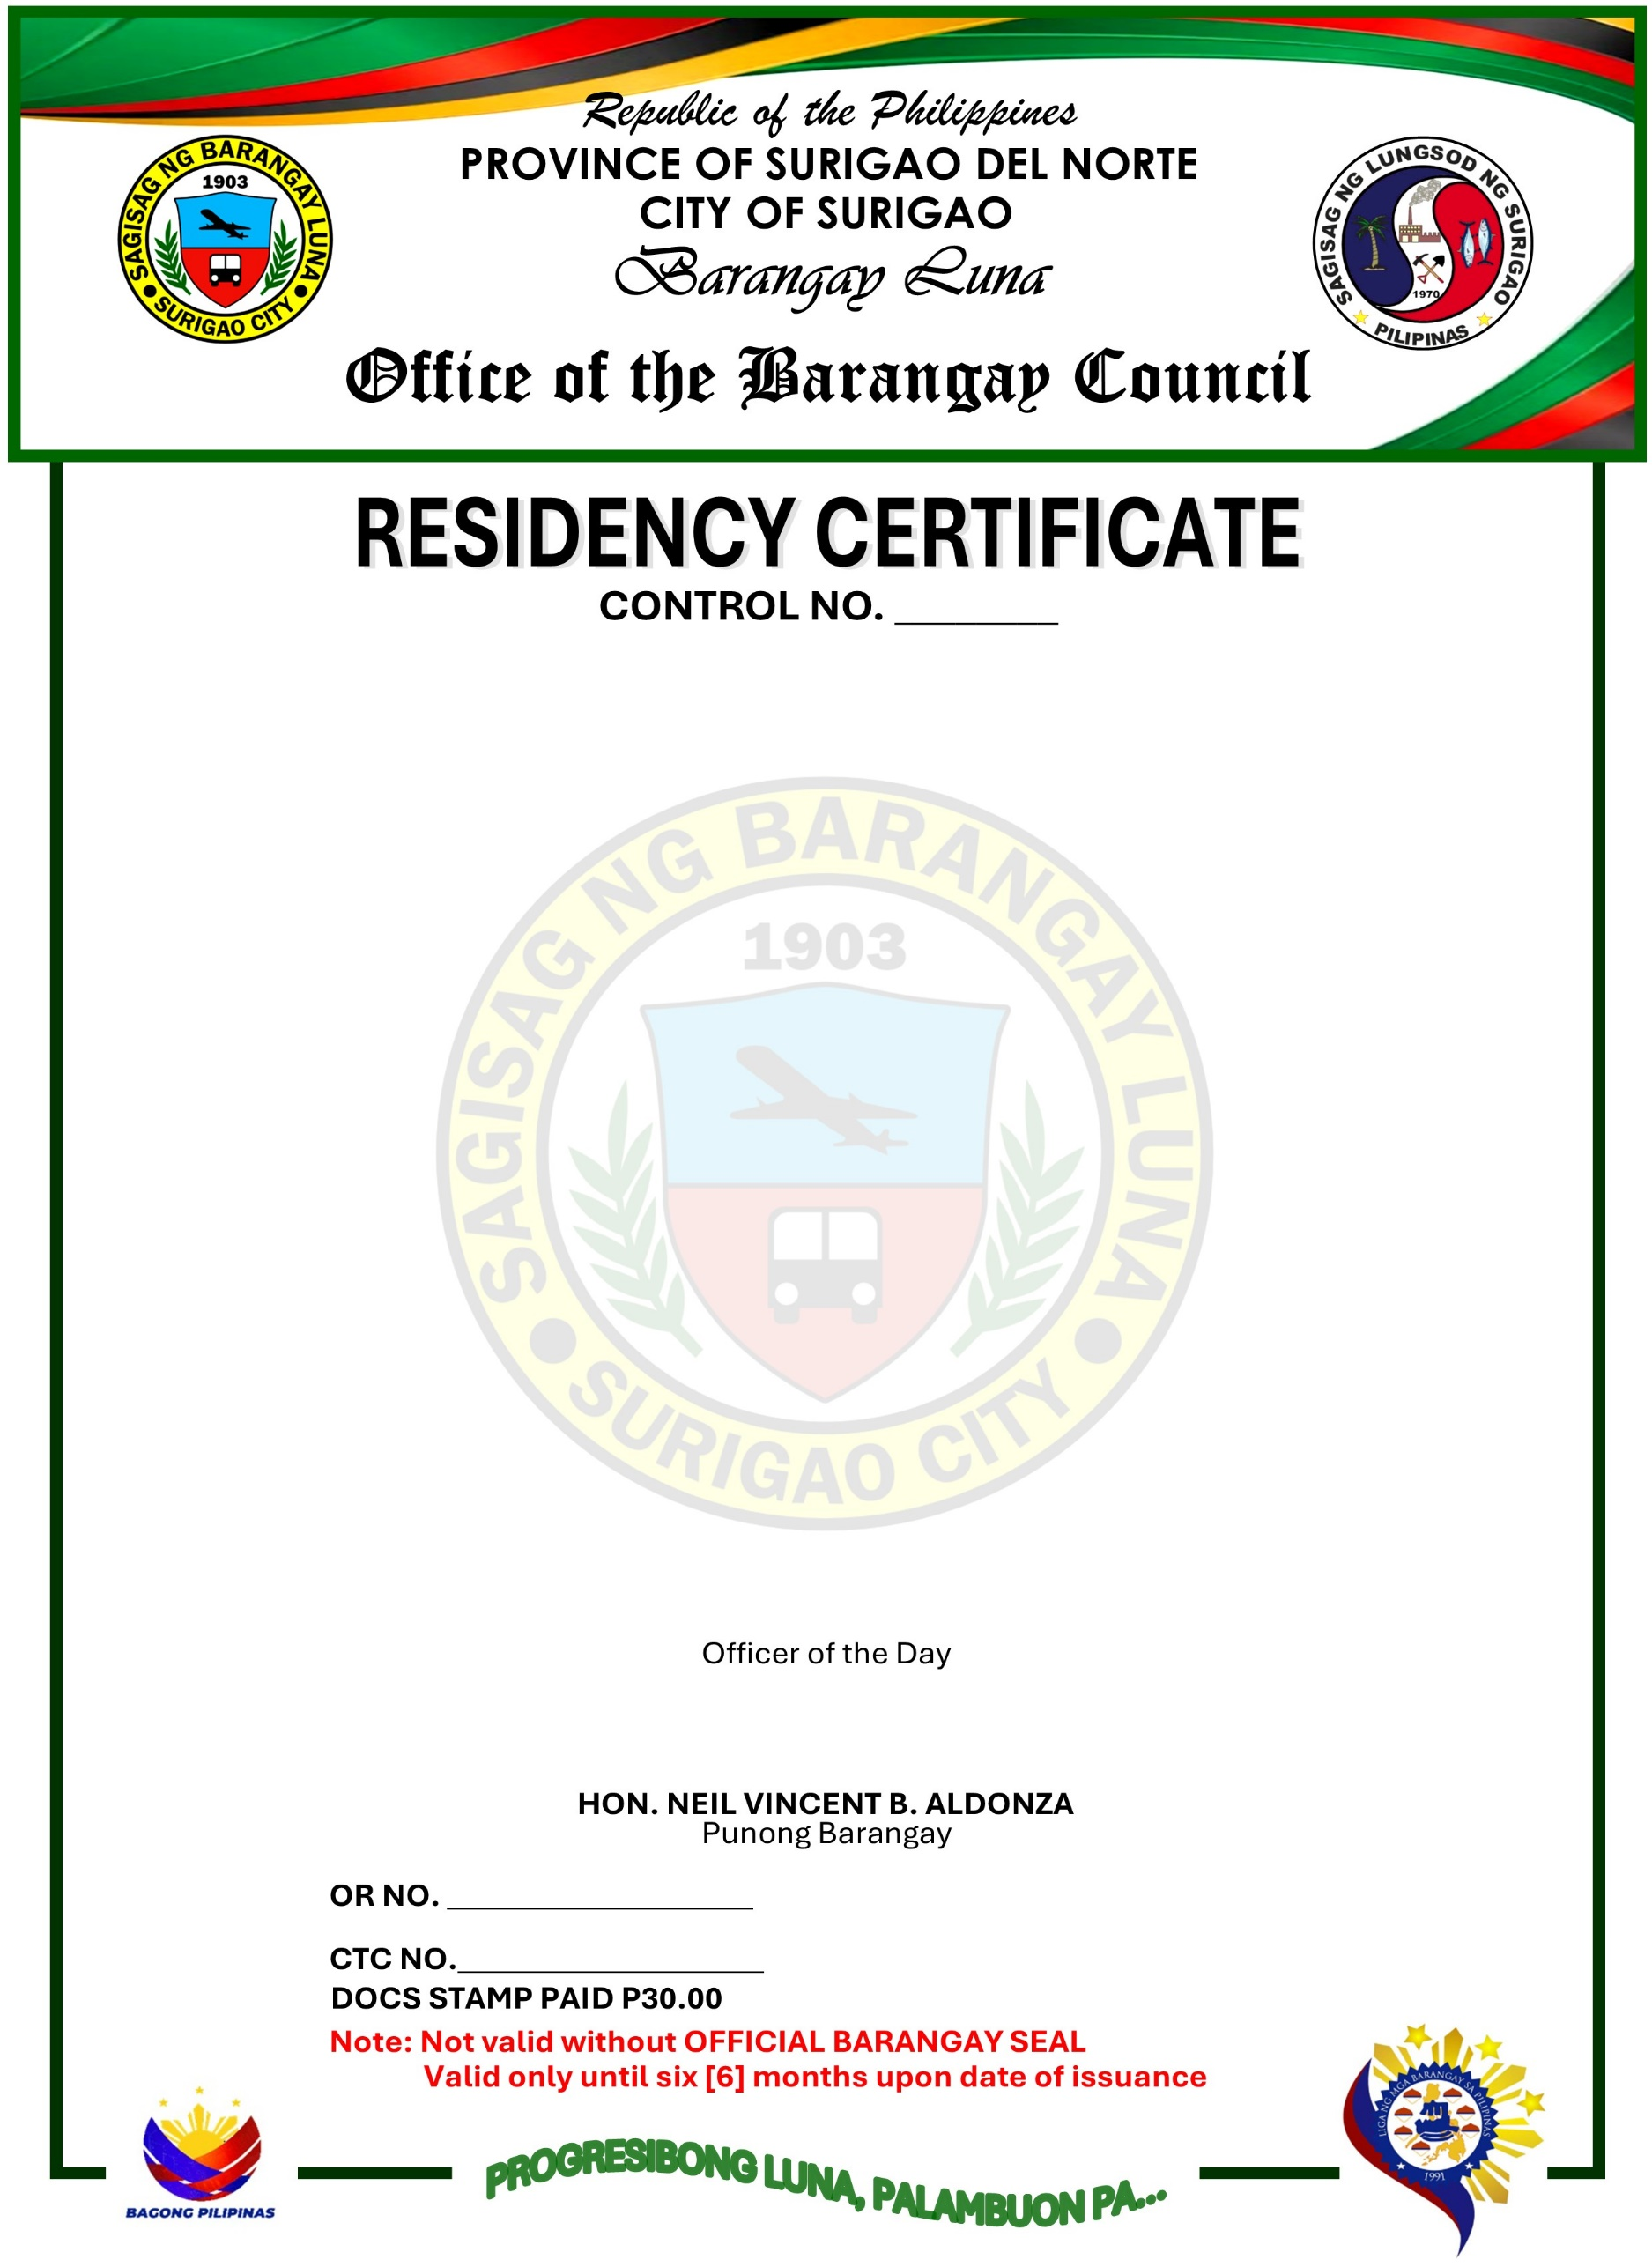

TO WHOM IT MAY CONCERN:
This is to certify that, {{resident_name}}, {{age}} years of age, {{gender}}, {{civil_status}}, a Filipino Citizen, a Bonafide resident of {{resident_address}}.
This is also to certify further that, {{resident_name}} is a person and a resident for {{residency_years_text}} years up to the present time in this Barangay.
This certification is issued upon the request of the above-mentioned person as requirement to support for {{pronoun_possessive}} {{purpose}}.
Issued this {{date_day_ordinal}} day of {{date_month_upper}} {{date_year}} at Barangay Luna, Surigao City, Philippines.

