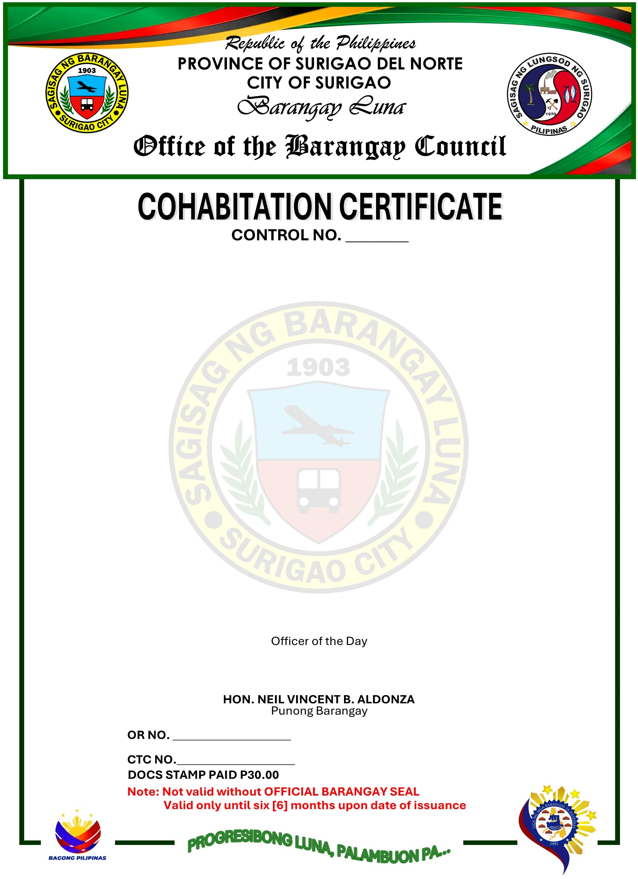
TO WHOM IT MAY CONCERN:
This is to certify that {{resident_name}} and {{partner_name}} have been living together as husband and wife in a common-law relationship for a period of {{cohabitation_years_text}} years since {{cohabitation_start_month_upper}} {{cohabitation_start_year}} at {{resident_address}}.
This certification is issued based on the records of the Barangay and the testimony of neighbors and community members who have personal knowledge of their cohabitation.
This certification is issued upon the request of the above-mentioned name as requirement to support {{purpose}}.
Issued this {{date_day_ordinal}} day of {{date_month_upper}} {{date_year}}, at Barangay Luna, Surigao City, Surigao del Norte, Philippines.

