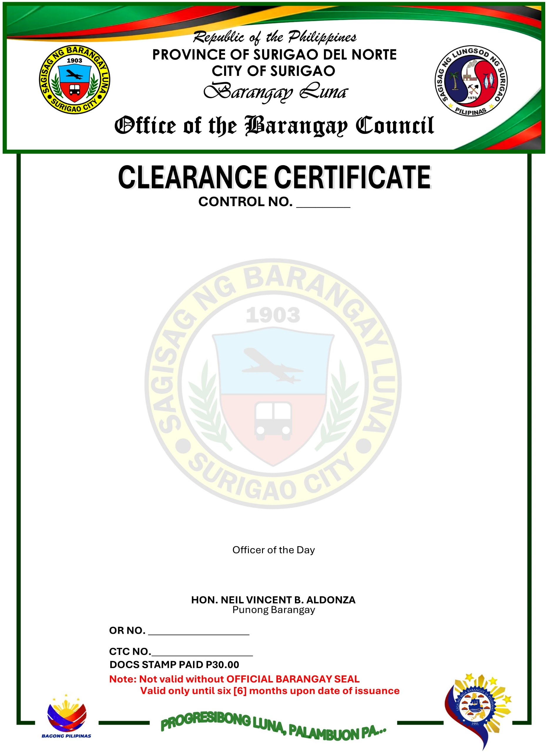
S
TO WHOM IT MAY CONCERN:
THIS IS TO CERTIFY that, CHRISTIAN DELOY, 21 years of age, Male, Single, a Filipino Citizen, a resident of P-Cortes Sitio Looc Exit Barangay Luna Surigao City, is known to me to be a person with Good Moral Character and Good Social Standing in the community.
THIS IS TO CERTIFY FURTHER that he has never been charged with any offense and has no pending case(s) filed before the Lupong Tagapamayapa in this Barangay, either civil or criminal.

This clearance is issued upon the request of the above-mentioned person as requirement for his EMPLOYMENT.
Issued this 24th day of OCTOBER 2026 at Barangay Luna, Surigao City, Surigao del Norte, Philippines.

HON. ALFREDO B. DACURON
Officer of the Day


