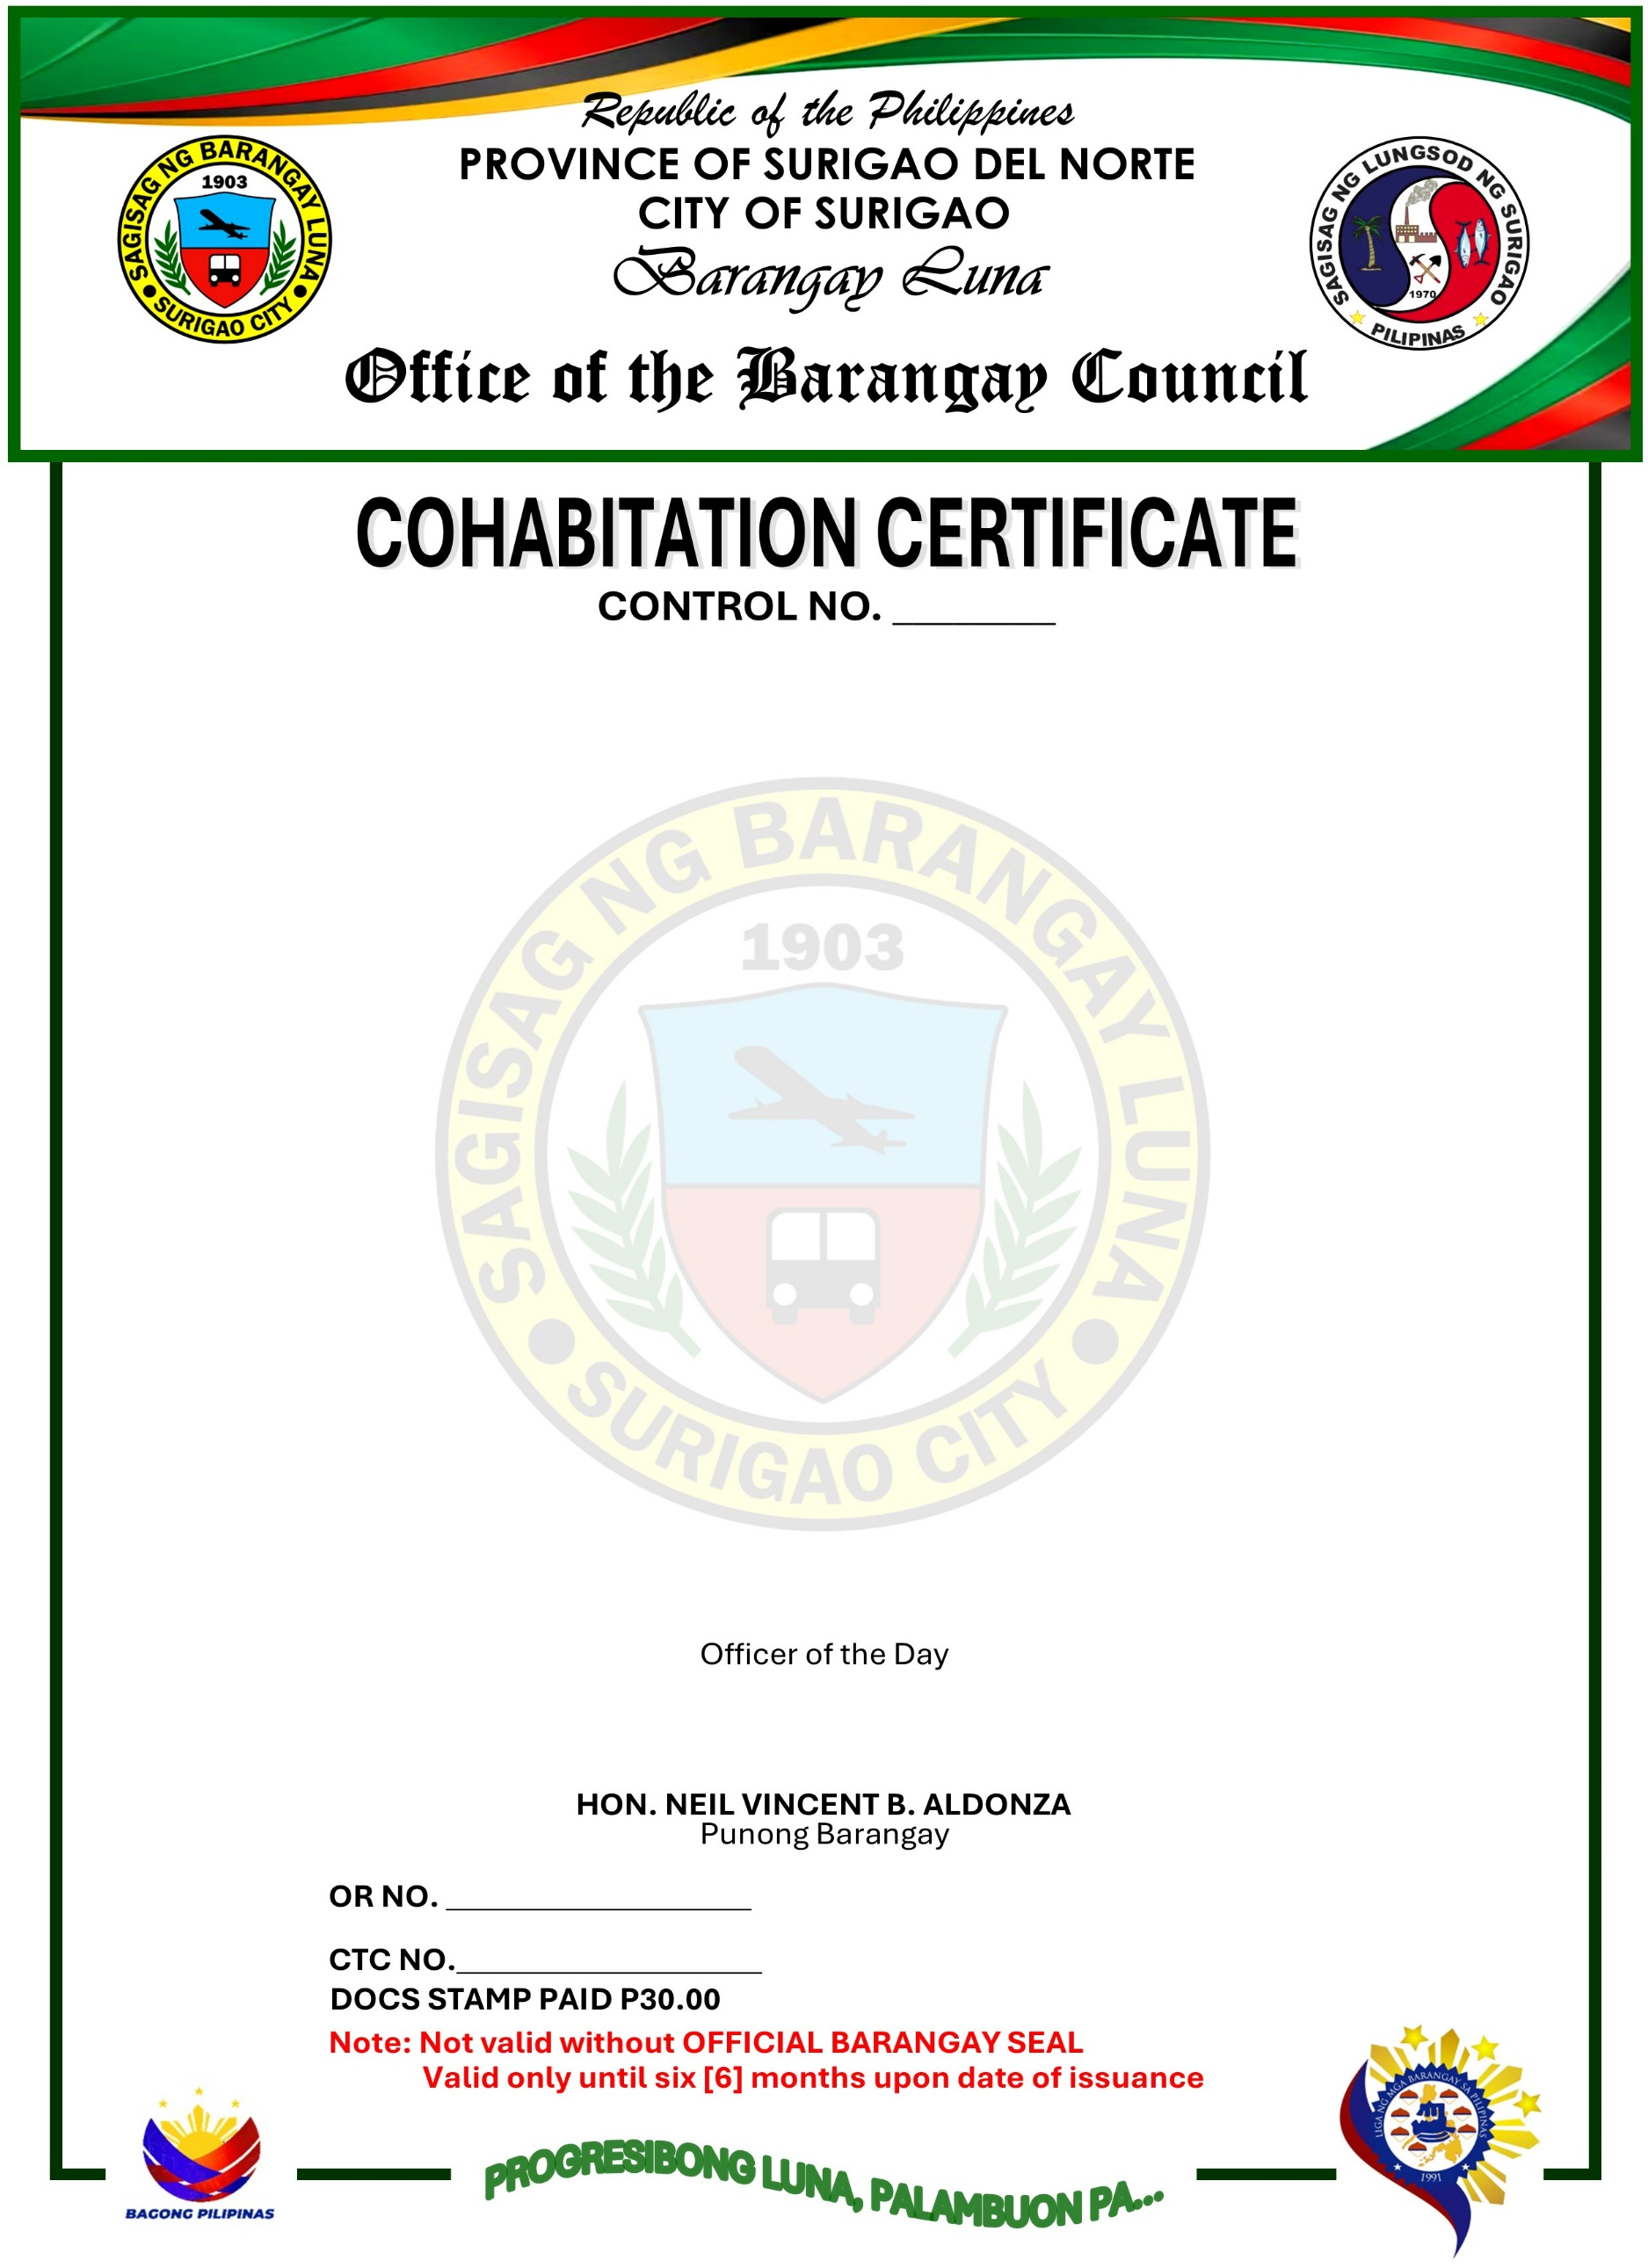
TO WHOM IT MAY CONCERN:
This is to certify that CHRISTIAN DELOY and SIONY have been living together as husband and wife in a common-law relationship for a period of zero (0) years since OCTOBER 2026 at P-Cortes Sitio Looc Exit Barangay Luna Surigao City.
This certification is issued based on the records of the Barangay and the testimony of neighbors and community members who have personal knowledge of their cohabitation.
This certification is issued upon the request of the above-mentioned name as requirement to support ASSISTANCE.
Issued this 24th day of OCTOBER 2026, at Barangay Luna, Surigao City, Surigao del Norte, Philippines.



