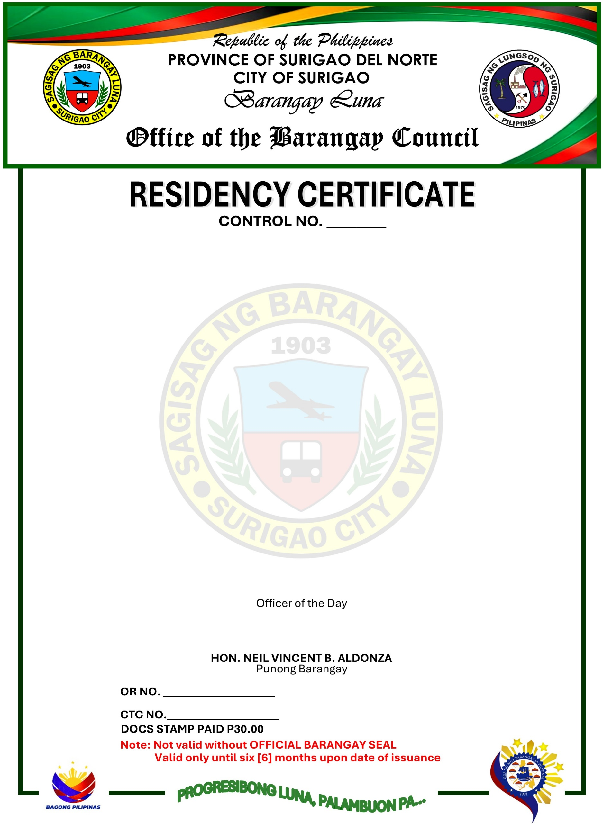

TO WHOM IT MAY CONCERN:
This is to certify that, LORLIE DALUBATAN DELOY, 21 years of age, Female, Single, a Filipino Citizen, a Bonafide resident of P-2 Leyte Surigao City.
This is also to certify further that, LORLIE DALUBATAN DELOY is a person and a resident for zero [0] years up to the present time in this Barangay.
This certification is issued upon the request of the above-mentioned person as requirement to support for her SCHOOL.
Issued this 24th day of OCTOBER 2026 at Barangay Luna, Surigao City, Philippines.



