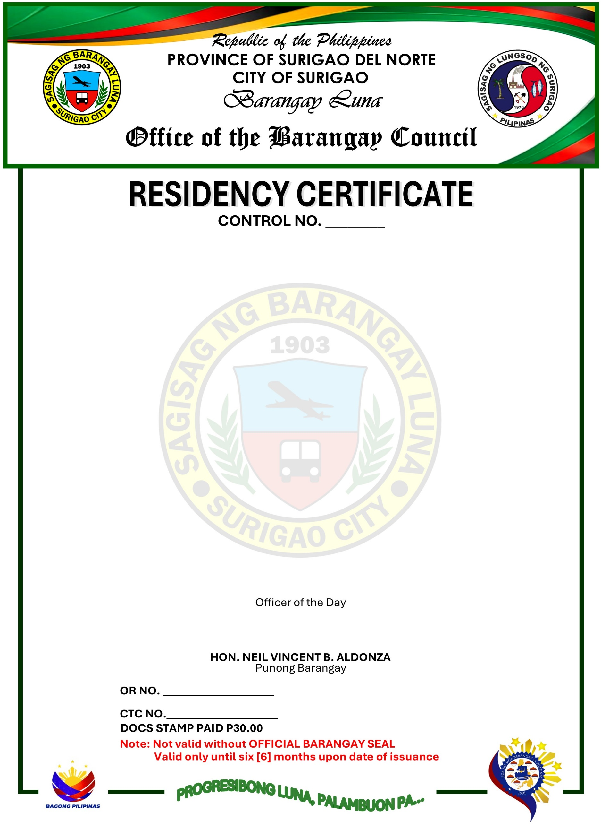

TO WHOM IT MAY CONCERN:
This is to certify that, CHRISTIAN DELOY, 21 years of age, Male, Single, a Filipino Citizen, a Bonafide resident of P-Cortes Sitio Looc Exit Barangay Luna Surigao City.
This is also to certify further that, CHRISTIAN DELOY is a person and a resident for zero [0] years up to the present time in this Barangay.
This certification is issued upon the request of the above-mentioned person as requirement to support for his EMPLOYMENT.
Issued this 24th day of OCTOBER 2026 at Barangay Luna, Surigao City, Philippines.



