**How to Commit and Push Changes in Git: A Visual Guide**

**Committing and Pushing**

* Committing is a term that essentially means ‘to save current changes to local repo’. Pushing means ‘to push the newly updated local repo to the remote repo’. In order to commit anything, there has to be changes (either alterations in the code or additional files added). In order to push, there must have been at least one new commit added to the local repo. Once the changes are pushed to the remote repo everyone else has access to it and can pull it down to their own local repo.
* **IMPORTANT:** There are a number of essential forms of etiquette when committing and pushing that will be discussed below.
* Navigate to the project you are currently working on. I’ll be using the project ‘GitExample’ to demonstrate.

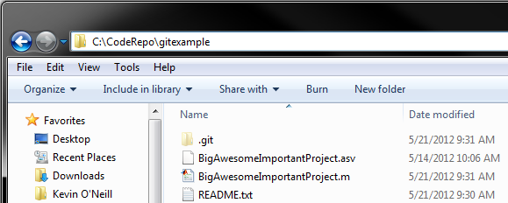

* I have recently edited the ‘BigAwesomeImportantProject.m’ and I have added a README.txt since the last commit. When I right-click and select Git Gui I see the following:

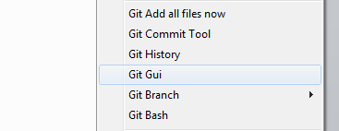

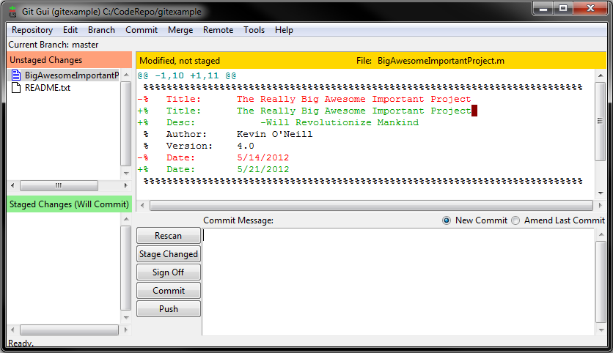

* The Git Gui shows you what additions and deletions have been done to the code. In this case, I added a Description and modified the date of last edit. In order to ‘Stage’ the changes (Select them for a Commit) click on the icon next to their name (It must be the icon, not the name).

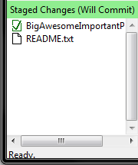

* Once the desired changes are staged please write a descriptive comment about what changed. This is a must; good documentation can help everyone when they wonder why something was changed, and it will help new lab works get up to speed faster in some cases. The following are a template and an example:

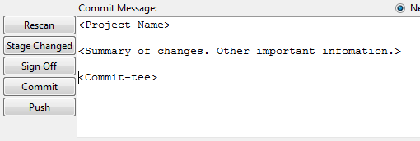

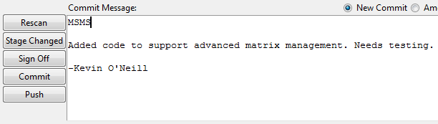

* When a message is completed, click the ‘Commit’ button to the left of the ‘Commit Message:’ box. This will commit the changes to the local repository. Once committed navigate to the PushRepo.ps1 file and right-click it. Select the ‘Run with PowerShell’ option to start the script.

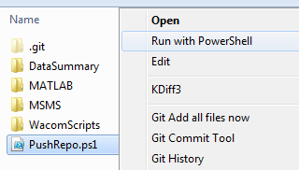

* A PowerShell window should appear that looks similar to the following picture. You only need to type in the password for the server when the prompt is given. The password for the code repo is 1234. Unfortunately there has to be a password for the CodeRepo account on the server or else the server will not operate.

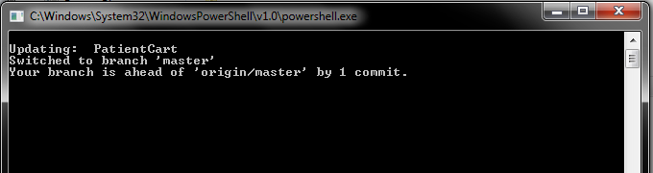

* If there are any errors the command window will tell you, otherwise the command window will say success. Once the window closes you have successfully pushed your changes to the remote repository and everyone can access the files within.