**CHANDIGARH COLLEGE OF ENGINEERING AND TECHNOLOGY**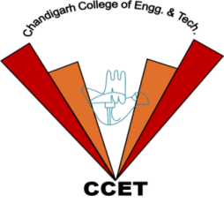

**(DEGREE WING)**

**Government Institute under Chandigarh (UT) Administration | Affiliated to Panjab University , Chandigarh**

**Sector-26, Chandigarh. PIN-160019 | Tel. No. 0172-2750947, 2750943**

**CERTIFICATE**

This is to certify that Mr./Ms. Abhijeet S/D of Mr./Sh./S. Yatish

Roll. No Abhijeet B.E. student of Department of Computer Science and Engineering for securing Abhijeet in Yatish event as a part of ANNUAL ATHLETIC MEET - Abhijeet held on Yatish at Chandigarh College of Engineering and Technology (Degree Wing), Sector-26, Chandigarh .

**Er. Sarabjeet Singh Dr. Radhey Sham Prof.(Dr.) Rajesh Kumar Prof.(Dr.) M. S. Gujral**

**(Sports In-Charge) (President Student Council) (President Student Welfare) (Principal)**