StormPilot
Resilient Dispatch and Agile Delivery Lab
Project report | Prepared 11 October 2026 | Presentation 12 October 2026

Executive Summary
StormPilot is an educational local lab combining a simulated drone-dispatch API with a Scrum and Kanban project workflow. It demonstrates application health and metrics, SQLite-backed work tracking, container hardening, monitoring configuration, Kubernetes recovery patterns, and controlled fault-injection procedures. The project is implemented and has passed its local Python tests and smoke checks; the Docker, monitoring, and Kubernetes demonstrations still require validation in an environment with those tools available.

Purpose and Scope
The scenario models a dispatch service that should remain observable and recoverable during routine failures. Alongside the API, the web interface supports backlog stories, sprints, task assignment, priorities, due dates, and a four-column Kanban board with work-in-progress limits.

System Design
The browser UI calls a dependency-free Python HTTP server. API routes manage stories, sprints, tasks, board state, and WIP limits in SQLite. Operational routes expose health, readiness, dispatch, and Prometheus-formatted metrics. Docker Compose defines the API, Prometheus, and Grafana. Kubernetes manifests define a replicated API deployment, health probes, resource settings, a disruption budget, and an optional CPU HPA.
- Application: Python standard-library HTTP server and JSON API; persistent SQLite data.
- Container: non-root runtime and HTTP health check; Compose API configured read-only with dropped capabilities.
- Observability: request counters and uptime metrics, Prometheus scrape/rules, provisioned Grafana dashboard.
- Resilience lab: Kubernetes reconciliation, guarded one-pod experiment, and optional metrics-server-dependent autoscaling.

Local Demonstration
Start the application from the repository root with `python app/server.py`, then open http://localhost:8080/ui. The captured local board shows the existing task “Kanban” in To Do with Critical priority. No sample records were added for this report.
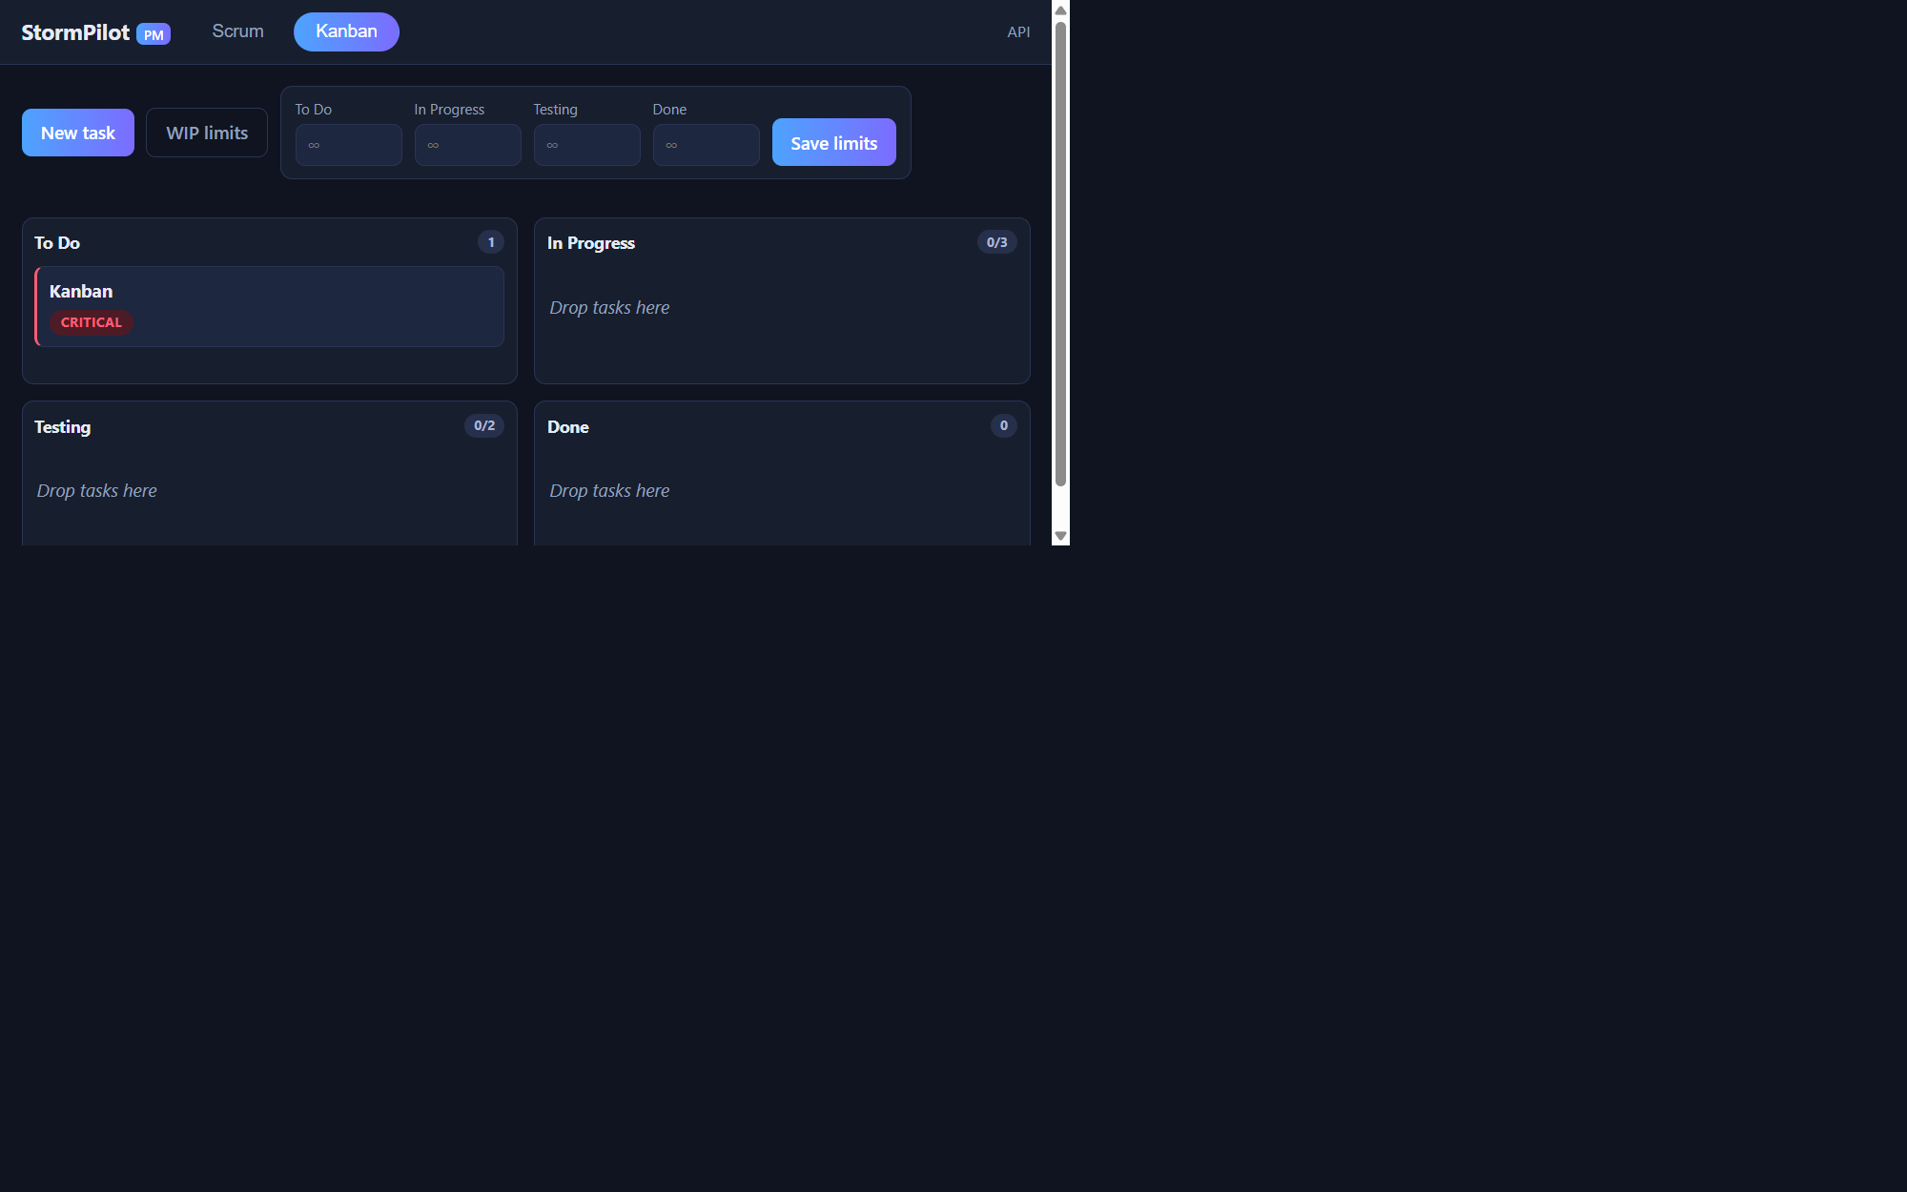
Figure 1. StormPilot Kanban board captured from the running local application.

Validation Evidence
Check | Recorded result
Python integration tests | All six HTTP integration tests passed.
Live API smoke checks | Identity, readiness, health, dispatch, and metrics routes responded.
Bounded local traffic check | 130 successful requests and zero failures during a two-second smoke run; this is not a capacity or uptime claim.
Configuration checks | Bash syntax and all YAML and JSON configuration files parsed successfully.
Browser check | Kanban view displays the existing task; Scrum/Kanban switching and modal hidden-state behavior verified locally.

Limitations and Next Steps
Docker/Compose builds, runtime monitoring and Grafana visual checks, Prometheus rule validation, Kubernetes server-side validation and pod recovery, Trivy scanning, SBOM generation, and registry publishing were not executed in the recorded environment. GitHub repository creation was rejected with HTTP 403, so no repository or image was published. Actual HPA behavior requires metrics-server and has not been tested. This project is an educational lab, not a production service or an availability certification.
- Run Compose and verify API, Prometheus targets, and the Grafana dashboard.
- Use a disposable kind cluster to verify readiness and the guarded single-pod recovery exercise.
- Capture actual CI, scan, replacement-pod, and HPA evidence before making release or reliability claims.

Conclusion
StormPilot provides a coherent local demonstration of product workflow and reliability engineering practices. The strongest presentation is an evidence-led walkthrough: show the working board and local checks, then identify container and Kubernetes experiments as configured next steps until they have been run.
Evidence basis: repository README, VALIDATION.md, docs/DEMO.md, docs/RUNBOOK.md, Dockerfile, and the local browser capture.

