SIMULATION ORDER
Target joint WITHOUT field  Plantar foot | Target joint WITH field  Plantar foot | Target joint WITHOUT field  Dorsal foot | Target joint WITH field  Dorsal foot
(Insert as drawing.) | (Insert as drawing.) | (Insert as drawing.) | (Insert as drawing.)
Caliper Photo: Plantar foot  Measurement: _ cm | Caliper Photo: Dorsal foot  Measurement: _ cm | Treatment Field Drawn on X-ray {finalFieldDesign}
 |  | (Insert as drawing.)

Anticipated Prescription |  |  | - TWO SIMULATION (FOOT IMAGING + SHIELD CREATION) SESSIONS REQUIRED: PRE-SIMULATION 100 kV IMAGING Bring in for FOOT imaging sessions to obtain images to draw target fields  - DIAGNOSTIC IMAGING IS AVAILABLE, SHIELD DRAWN, PROCEED WITH SIM  - CALIPER MEASUREMENT missing. Bring in for caliper measurement
Anticipated Energy | {anticipatedEnergy}
Phase dose per fraction | {dosePerFractionGy} | Gy/Fx
Total fraction per phase | {totalFractions} | fractions
Total Dose | {phaseTotalDoseGy} | Gy
Weekly Fractionation Schedule | {weeklySchedule}

PRE-XRT DOCUMENTATION |  | DEVICES
- Ensure signed consent is present. |  | - Chair: {chairSetup}
- Confirm treatment laterality with patient. |  | - Prone Pillow
- Review plastic template (if available). |  | - Thyroid guard
- Review field w/o plastic template. |  | - Lead Apron
- Review caliper measurement photo. |  | - Flat patient table
FIELD AND SHIELD PREPARATION |  | - Leaded Goggles
- Initial photos w/o markings (Both D+P) |  | - Extended SSD Box Applicator
- Draw treatment fields (Both D+P) |  | - Lead coverings over box
- Take photos with markings (Both D+P) |  | MARKERS
- Create transparent template (Both D+P) |  | - Wire/BB field
- Create custom lead shield (Both D+P) |  | BODY + BEAM POSITION
- Photograph custom shield (Both D+P) |  | - Body Position Sitting Upright
SET-UP PHOTOS |  | - Anticipated Joint Field APPA
- 50 kV x-ray image Palmar without shield |  | SPECIAL PHYSICS
- 50 kV x-ray image Dorsal without shield |  | - In-Vivo Dosimetry/Film/Pacemaker
- 100 kV x-ray image Palmar without shield |  | - Extended SSD Multi beam Orthovoltage
- 100 kV x-ray image Dorsal without shield |  | - Prior radiation cumulative dose to OAR
PRESCRIPTION PHOTO DROP (DOUBLE CHECK) |  | WRITTEN DIRECTIVE
- Target region(s) without field (Both D+P) |  | - Region 1: {targetJoints}
- Target region(s) w/ field (Both D+P) |  | - Region 2: None, no 2nd region
- Box configuration without patient |  | Send images to PACS? Yes. XRAY sim images to PACS
- Caliper photo |  | Outside plan review? No.
- Shielded nozzle shot (Both D+P) |  | Call MD before/during sim? No.
- Side nozzle shot (Dorsal) |  | TOTAL TREATMENTS: 6 fractions
- Side box shot with patient |  | TIMELINE: Rush Priority
- SSD ruler shot from box to skin |  | CAREPATH: 10-day care path
- Styrofoam / cradle set up ruler shot |  | SPECIAL PHYSICS: {specialPhysics}
ARTHRITIS APPLICATOR (BOX) |  | Reason: Select
- MD requests arthritis applicator box |  | WEEKLY PHYSICS: {weeklyPhysics}
- Arrange: Hand: one small opening only |  | Reason:
- Photo of box without patient |  | IN VIVO DOSIMETRY: Yes.
- Light field verification of applicator & SSD |  | Reason:
- Styrofoam to reduce SSD as able
RADIATION ONCOLOGIST: |  | DATE COMPLETED:
{radiationOncologist} |  | {dateCompleted}
Note: Must document all IGRT imaging in fractionation log. Must generate treatment summary incorporating all IGRT images and d

CLINICAL TREATMENT PLAN
ID: {mrn}
ICD 10 Code: _

LESION DETAILS:
ICD code/ Diagnosis: | {diagnosis}
Laterality: | {laterality}
Location: | {site}
REVIEW OF CLINICAL PARAMETERS:
Performance status: | Sufficient
Prior therapies: | No.
Radiation sensitivity factors: | Select
Wound healing risk: | Select
Travel Plans: | No.
RADIATION THERAPY RISK FACTORS:
Prior RT: | No.
Autoimmunity: | No.
Pacemaker: | No.
Other Implanted Devices: | No.
RADIATION THERAPY PLANNING:
Number of targeted regions: | 1 (Simple)
Number of fields: | 3+ (Complex)
Beam complexity: | 1 beam or 2 parallel opposed (simple)
Blocking: | Complex blocking, custom shields (complex)
Type of Radiation: | Depth-Enabled Orthovoltage Radiation Therapy
Medical Necessity Rationale: | - highly complex blocking | - multiple areas/arcs | - modality combination
 | - custom devices | - tangential ports | - dose-volume calculations
 | - Extended SSD | - advanced tests (e.g., PET for localization)
CPT Code: | 77263: Radiation Therapy Planning Complex
Literature Citation Justification: 2015 DEGRO (German Society for Radiation Oncology) Guidelines (PMID: 25238992); European Trial/s (PMID: 37815599)

CONSENT: SIGNATURE | | Within the 90-day validity period?: Yes
CONSENT: LATERALITY
Radiographic/Pathologic confirmation of disease:
Imaging Data Reviewed: Select | KL Grading performed: No.

Toxicity Risks Discussed
Short-term Toxicities:  likely none, but very low risk of the following: | Long-term Toxicities:  likely none, but very low risk of the following:
- Dryness or peeling  - mild swelling  - temporary pain flare. | - skin thinning  - hyperpigmentation/hypopigmentation  - telangiectasia  - subcutaneous fibrosis  - very low theoretical risk of radiation-induced malignancy

Orthovoltage Clinical Treatment Planning Details: The attending radiation oncologist cited above personally performed and oversaw orthovoltage clinical treatment planning activities for the specified radiation type targeting the target condition. These activities are medically necessary due to the medical necessity rationale, ensuring optimal therapeutic outcomes per evidence-based standards, and demonstrate the work typically included in CPT codes 77261 (simple therapeutic radiology treatment planning, defined as planning for a single treatment area encompassed in a single port or simple parallel opposed ports with simple or no blocking), 77262 (intermediate, defined as planning for multiple treatment areas, multiple ports, or special time-dose constraints), or 77263 (complex, defined as planning requiring highly complex blocking, custom shielding blocks, tangential ports, wedges, rotation or arc therapy, or special blocks/compensators) based on complexity.
Simple Clinical Treatment Planning (77261 - Single Area, Simple Ports/Blocking): For simple orthovoltage therapy (e.g., superficial targets with single port or parallel opposed /simple or no blocking), the planning focused on basic integration:
(i)Reviewed patient history, including prior therapies, comorbidities, and the individual parameters, to tailor a straightforward treatment strategy encompassing a single treatment area with simple or no blocking; (ii)Reviewed the imaging data reviewed to verify alignment of a single port or simple parallel opposed ports with the target volume, adjusting patient positioning and/or immobilization devices for reproducibility; (iii)Incorporated factors into the clinical plan, involving low medical decision-making with analysis of the data elements analyzed and assessment of the risk level of complications, balancing the dose and fractionation and the beam energy against the toxicity risks, aligning with the national guidelines and/or the literature citation.
Intermediate Clinical Treatment Planning (77262 - Multiple Areas, Multiple Ports, Special Constraints): For intermediate orthovoltage therapy (e.g., involving multiple treatment areas or ports with special time-dose constraints), the planning involved moderate complexity: (i) Reviewed patient history, including prior therapies, comorbidities, and the individual parameters, to tailor the treatment strategy for multiple areas/ports, incorporating special constraints like fractionation timing or dose limits due to comorbidities; (ii) Reviewed the imaging data reviewed to verify alignment of multiple ports with the target volumes, adjusting patient positioning and/or immobilization devices based on individual parameters such as body habitus, going beyond simple review by incorporating multi-angle verification and/or real-time adjustments; (iii) Incorporated factors into the clinical plan, involving moderate medical decision-making with analysis of the data elements analyzed and assessment of the risk level of complications, balancing the dose and fractionation and the beam energy against the toxicity risks, aligning with the national guidelines and/or the literature citation.
Complex Clinical Treatment Planning (77263 - Highly Complex Blocking, Custom Shielding, Tangential/Rotational Ports):
For complex orthovoltage therapy (e.g., deep targets requiring custom shielding, tangential ports, wedges, or rotational setups), the planning involved high complexity: (i) Reviewed patient history, including prior therapies, comorbidities, and the individual parameters, to tailor the treatment strategy with highly complex blocking, custom shielding, or special compensators for extended fields or irregular anatomy; (ii)Reviewed the imaging data reviewed for detailed contouring and verification of tangential/rotational ports or arc therapy alignments, adjusting patient positioning and/or immobilization devices based on individual parameters, incorporating advanced multi-angle verification and/or real-time adjustments for inhomogeneities; (iii) Incorporated all factors into the clinical plan, involving high medical decision-making with analysis of the data elements analyzed and assessment of the risk level of complications, balancing the dose and fractionation and the beam energy against elevated toxicity risks, aligning with the national guidelines and/or the literature citation.
This orthovoltage clinical treatment planning process is medically necessary and reflects a comprehensive, justified, and individualized patient-centric strategy, separate from technical radiation planning or treatment delivery/management, optimizing outcomes while mitigating risks through evidence-based clinical decision-making.

IMAGING ORDER PRESCRIPTION | {imaging}
X-ray Simulation Imaging Prescription |  | Shield Verification X-ray Prescription
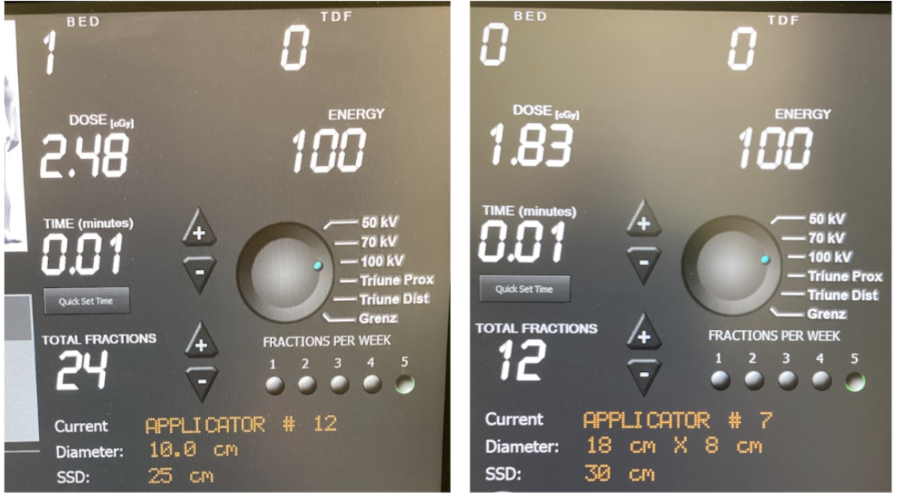  To ensure accurate positioning for treatment, a prescription for non-therapeutic verification X-rays is hereby ordered. Imaging is solely for verifying the foot’s position within the custom apparatus. Prescription valid through current course. |  | 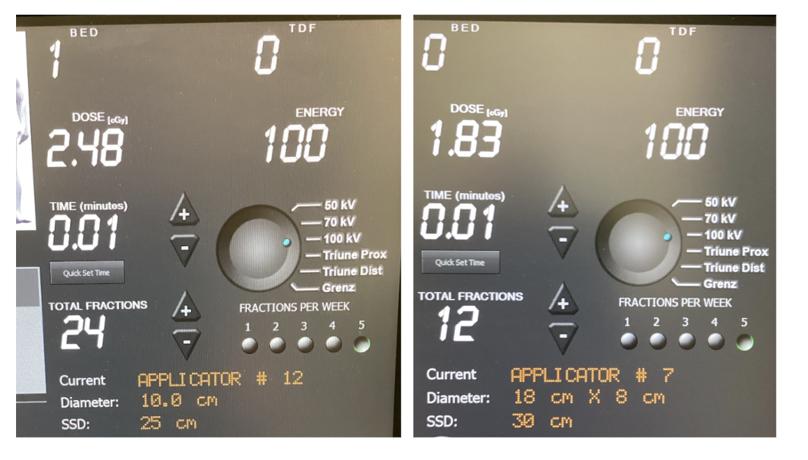  To ensure accurate treatment delivery, a prescription for on-board, non-therapeutic verification x-rays is hereby ordered. Imaging is for verifying the treatment shield's alignment with target anatomy. Prescription valid through current course.
- X-ray Simulation Prescription |  | - Image Guidance X-Ray Prescription
Energy | 100 kV | Energy | 100 kV
Exposure Time | 0.01 minutes | Exposure Time | 0.01 minutes
SSD | 42cm (cabinetry to panel) + 25cm (in applicator) = 67 cm | SSD | 25cm (to applicator edge)
Filter | Aluminum | Filter | Lead
Dose | 2.65 cGy | Dose | 2.48 cGy
Applicator | 8 x 18 cm | Applicator | 8 x 18 cm
A total of twelve (12) exposures are authorized for the full treatment course and requisite simulations and re-simulations, as needed.  X-RAY Imaging prior to SIMULATION  JOINT: _________________  - LEFT  - RIGHT  - BILATERAL  - AP VIEW x ___  - PA VIEW x ___  - LATERAL VIEW x ___ |  | A total of thirty-six (36) exposures are authorized for the treatment course, which account for 12 required images and allow additional films if setup corrections are needed.  Clayton B. Hess MD MPH  Radiation Oncologist  Feb 23, 2026 12:00 PM

As the prescribing radiation oncologist, I authorize the Radiation Therapy Technologist (RTT) to perform the following imaging procedures for treatment planning and image-guided radiation therapy (IGRT) verification. These images are essential for accurate tumor targeting, patient positioning, and minimizing exposure to healthy tissues. The RTT may acquire planning X-ray images during simulation sessions and IGRT images prior to or during treatment fractions as specified. All imaging must be conducted under my supervision or per protocol, with images reviewed by me or a qualified physicist for quality and alignment. Documentation of each session, including date, time, modality, and any adjustments, will be recorded in the patient's record to support medical necessity and billing in each patient’s fractionation log.

